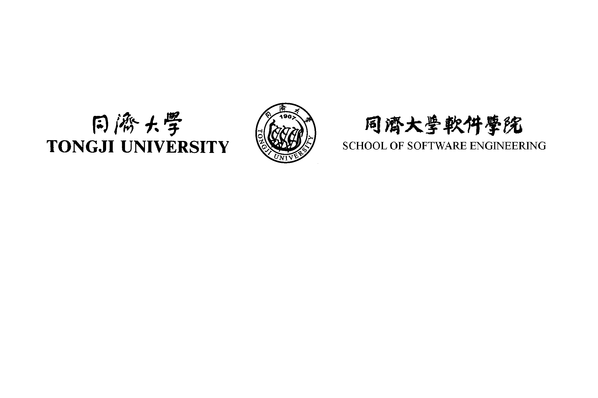

School of Software Engineering

Software Testing

Assignment

BSc (Hons) Software Engineering

Semester 2 2014/2015

Assignment Specification

Date Set: 21th May 2014
Date Due: 16th June 2014
Presentation Date: 18th June 2014

Instructions

This assignment counts as 20 % of the assessed work for the unit.

This assignment simulates small size companies bidding on contracts for the Individualized Curriculum Design (学程) project. Your lecturer and teaching assistant will play as clients and their expert advisories to review your bid and ask questions. You and your team will play as the representatives of the small size companies applying for the bid and answer the questions. Top 5 winners would be considered as contract winners and will be awarded 3 bonus credits for each member.

This unit gives you the opportunity to develop your analysis, design and implementation skills by working in a team on a realistic testing project. You will work in a team of four. This unit guide gives you details of the tasks to be done, an outline of assessment and the key points of your schedule. Within these guidelines you will need to apply your team-working and project management skills.

You should NOT collude with other student groups or plagiarise their work. Appropriate action will be taken, according to Tongji University regulations, if collusion or plagiarism is suspected. In such case, individuals or the entire group concerned may at the discretion of the tutors be caused to withdraw from the unit and hence be zero marked.

TASKS

The referencing document is the Individualized Curriculum Design (学程) Marketing Requirement Document. By this stage you should already completed most of the workshop and in-class exercises based knowledge you learnt from the lectures. This group presentation is the final assessment for this unit.

Based on the referencing document, your detailed jobs are listed as the follows:
- Perform a Review List (with comments and suggestions).
- Perform a Risk Analysis Report for the application
- A high level Test Suite Design Document with Selected Test Techniques for each test suite based on the MRD and Risk Analysis you performed
- Create a Test Plan
- A presentation for bidding, which demonstrates your team’s capability, cost and schedule etc, try to win the contract.

ASSESSMENT
Normally you will receive credit for a group component of each assessment, and an individual component. However, provided the whole group agrees before the start of the first assessment, and then the individual components can be waived for both assessments, so that all members receive the same aggregate mark. Each group member will be asked to confirm their agreement, and if this is not unanimous then the norm will be applied.

The first component of assessment is the structured presentation of the specification. In advance of the presentation you must submit a copy of the tasks; hard copy in the usual manner for assignments. This must not be substantially changed before the assessment, which takes place at the presentation. The document will NOT be returned to you.
Guidelines for the presentation are as follows.
- Duration will be a maximum of 15 minutes (10 minutes for each group + 5 minutes Q&A).
- Your tutor, teaching assistant and other groups whom will be assessed on the same day will role-play your clients: the Individualized Curriculum Design (学程) owner.
- Each person must present a section of the work for which they have had the main responsibility. This must, for each person, include a section of the test strategy or part of the test plan or detailed test case design methods and test cases, etc. You will be marked on “demonstrated competence in software testing design”, so you need to have done some, and show that you have!
- You may use the time in your presentation as you wish. Be sure to allow enough time for each team member to present their work, and for the “clients” to ask questions. The presentation should be driven by you, not the “clients”. But as in real life, they will want clarification of anything which is unclear or problematic, and you will need to deal with this in the time available.
- This assessment has individual and group components - make sure that you are familiar with the marking scheme and use it for guidance in planning your presentation.
- Marking is based entirely on the presentation. The purpose of the document submission is to allow the “clients” to see the material before the event.
- You are not expected to produce any user documentation for your presentation other than the PPT document itself. You may do so if you feel that it would aid the demonstration of your software and can be appreciated during the demonstration period, but note that no marks are allocated to this.

Deliverables:
- A hard copy and an electronic copy to teaching assistant before 12:00 on 16th June 2014.

It will be your team’s decision to have a 100% group assessment or partial group and partial individual assessment as the following:

Group criteria. Max. marks

Quality of submitted document: accuracy with which chosen 20
strategy and methods have been applied, completeness & internal
consistency of design, how well it represents the problem situation.

Thoroughness and difficulty of selected features for detailed design. 10

Comprehensiveness and validity of the abstract and detailed design and 20
implementation (e.g. resource allocation, time, people, etc.) in relation
to the appropriate design methods.

Individual criteria. Max. marks
Comprehensiveness and validity of the individual’s part of 30
the design.
Structure and clarity of presentation; understanding of the work done;
quality of responses to questions about the design and plan. 20

Summary
Group % Individual % Total %
Presentation 50 50 100

Total 50 50 100

Unless the group elects otherwise.

