题目：《图书管理软件设计报告》
- 基本介绍

二、需求分析

2.1该软件主要面向图书管理员和学生用户

2.2管理员可进行图书的添加删除，也可以对书籍借出和库存情况进行统计，还可以添加新的管理员，学生用户可以查询图书的相关信息，然后进行借阅，但借阅时需要再次输入用户名和密码进行确认，归还时也需输入用户名和密码进行确认。

2.3管理员在登陆时输入账号密码选择管理员登陆即可使用统计、添加、删除和添加管理员功能，学生选择用户登录，登陆后即可使用查询借阅归还功能。

三、概要设计

3.1软件功能：
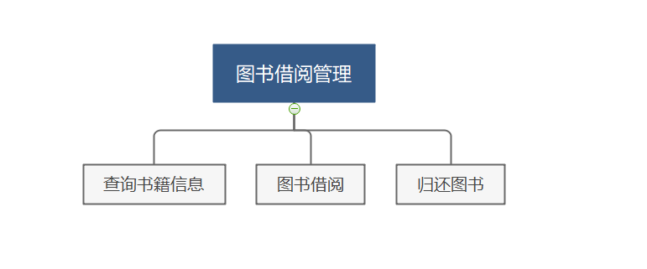
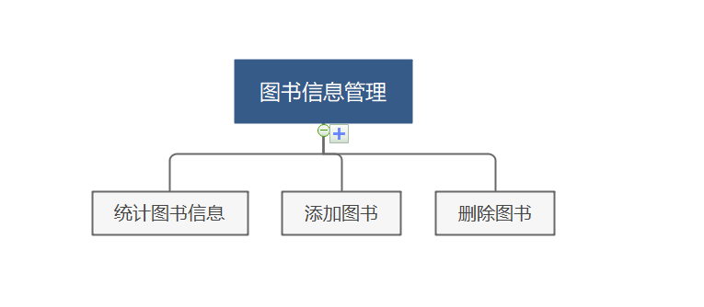
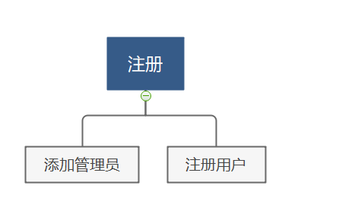

3.2软件操作流程：

学生可借阅图书、归还图书以及查询图书信息，管理员可以添加图书、删除图书以及查询图书库存信息，还可以注册管理员。

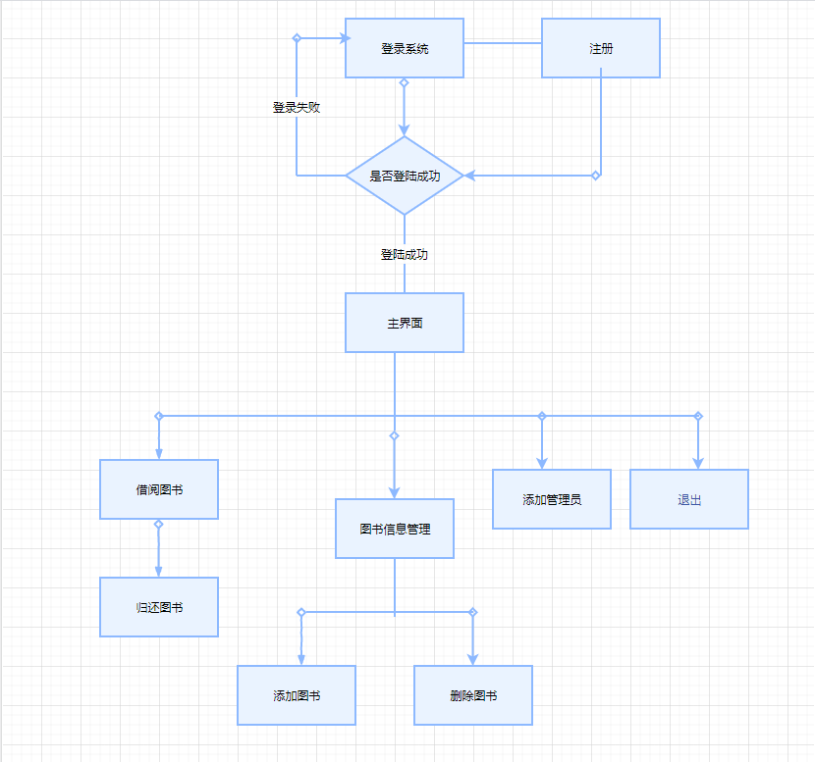

3.3软件界面设计：

登陆界面
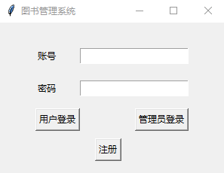

注册界面
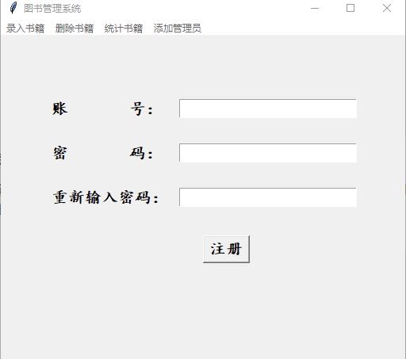

还书界面
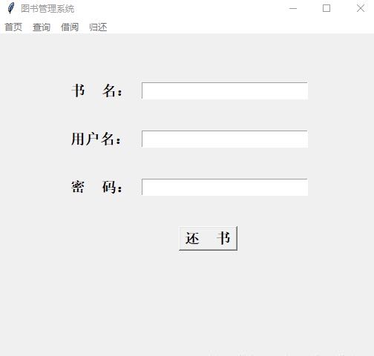

借书界面
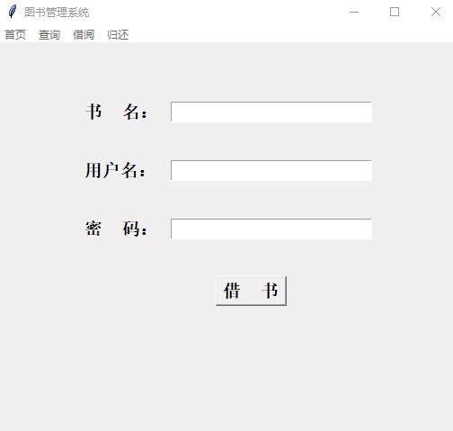

查询界面
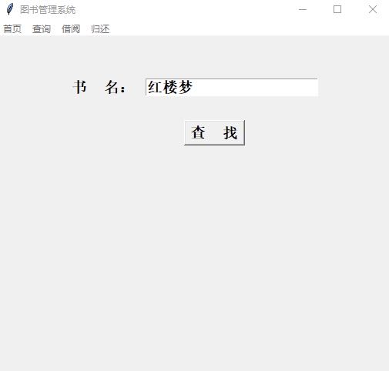

添加界面
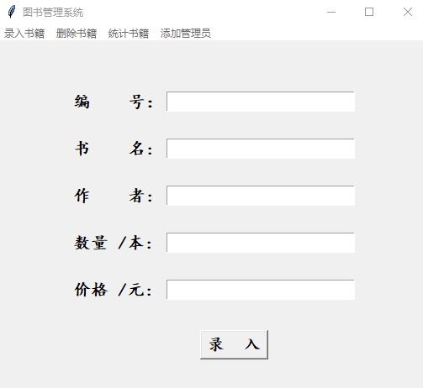

删除界面
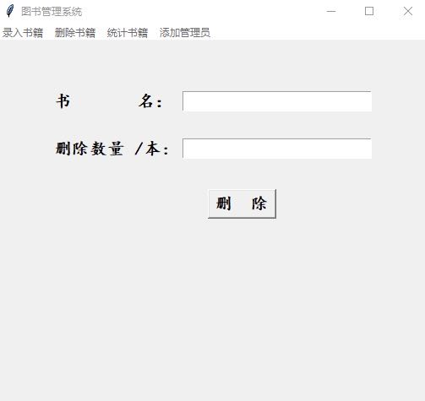

四、详细设计
4.1登陆界面
from tkinter import *
from tkinter.messagebox import *
from User_MainPage import *
from Admir_MainPage import *
from Register_Page import *
class LoginPage(object):
def __init__(self,master = None):
self.root = master #定义内部变量root
self.root.geometry('%dx%d' % (300,200))#设置窗口大小
self.username = StringVar()
self.password = StringVar()
self.createPage()
def createPage(self):
self.page = Frame(self.root) #创建Frame
self.page.pack()
Label(self.page).grid(row = 0,stick = W)
Label(self.page,text = '账号').grid(row = 1,stick = W,pady = 10)
Entry(self.page, textvariable=self.username).grid(row=1, column=1, stick=E)
Label(self.page,text = '密码').grid(row = 2,stick = W,pady = 10)
Entry(self.page, textvariable=self.password, show='*').grid(row=2, column=1, stick=E)
Button(self.page,text = '用户登录',command = self.loginCheck).grid(row = 3,stick =W, pady = 5)
Button(self.page,text = '管理员登录',command = self.admir_loginCheck).grid(row = 3,stick =E,column=1)
Button(self.page,text = '注册',command = self.registerCheck).grid(row = 4,stick =W,column=1,padx = 20,pady = 5)
def loginCheck(self):
name = self.username.get()
password = self.password.get()
f = open('login_true.txt')
for line in f:
str = line.strip()
str2 = ','
user_name = str[:str.index(str2)]
pass_word = str[str.index(str2)+1:]
if name == user_name and pass_word == password:
temp = 1
break
else:
temp = 0
if temp == 1 :
self.page.destroy()
User_MainPage(self.root)
elif temp == 0 :
showinfo(title = '失败', message = '账号或密码错误，重新登录！')
def admir_loginCheck(self):
admir_name = self.username.get()
admir_password = self.password.get()
f1 = open('login_admir.txt')
for line1 in f1:
str = line1.strip()
str1 = ','
admir_name_txt = str[:str.index(str1)]
admir_password_txt = str[str.index(str1)+1:]
if admir_name == admir_name_txt and admir_password == admir_password_txt:
temp = 3
break
else:
temp = 4
if temp == 3:
self.page.destroy()
Admir_MainPage(self.root)
elif temp == 4:
showinfo(title='失败', message='账号或密码错误，重新登录！')
def registerCheck(self):
self.page.destroy()
Register_Page(self.root)
4.2注册界面
from tkinter import *
from tkinter.messagebox import *
class Register_Page(object):
def __init__(self, master=None):
self.root = master #定义内部变量root
self.root.geometry('%dx%d' % (500, 420)) #设置窗口大小
self.username = StringVar()
self.studentId = StringVar()
self.userpassword = StringVar()
self.userpasswordre = StringVar()
self.createPage()
def createPage(self):
self.page = Frame(self.root)
self.page.pack()
Label(self.page).grid(row = 0,stick = W,pady = 20)
Label(self.page, text = '账 号：',font = ("楷体",15,"bold")).grid(row = 1,stick = W,pady = 15)
Entry(self.page,textvariable=self.username,font = ("楷体",15,"bold")).grid(row = 1,column = 1,stick = E)
Label(self.page, text = '学 号： ',font = ("楷体",15,"bold")).grid(row=2, stick=W, pady=15)
Entry(self.page, textvariable=self.studentId,font = ("楷体",15,"bold")).grid(row=2, column=1, stick=E)
Label(self.page, text = '密 码： ',font = ("楷体",15,"bold")).grid(row=3, stick=W, pady=15)
Entry(self.page, textvariable=self.userpassword,font = ("楷体",15,"bold"),show = '*').grid(row=3, column=1, stick=E)
Label(self.page, text = '重新输入密码： ',font = ("楷体",15,"bold")).grid(row=4, stick=W, pady=15)
Entry(self.page, textvariable=self.userpasswordre,font = ("楷体",15,"bold"),show = '#').grid(row=4, column=1, stick=E)
Button(self.page, text='注册',font = ("楷体",15,"bold"),command = self.register_admir).grid(row = 5,stick=W,column=1, pady=20,padx = 30)
def register_admir(self):
name = self.username.get()
id = self.studentId.get()
password = self.userpassword.get()
passwordre = self.userpasswordre.get()
id_str = id[4:6]
f = open('login_true.txt')
temp = 0
for line in f:
l = line.strip().split(',')
if l[0] == name:
showwarning(message='输入用户名已经存在')
temp = 1
break
else:
continue
if temp != 1 and id_str == '41' and password ==passwordre:
fw = open('login_true.txt','a')
fw.write(name+','+password+'\n')
fw.close()
showinfo(message='注册成功！')
elif temp != 1 and password != passwordre:
showwarning(message='两次输入密码不一致')
elif temp != 1 and id_str != '41':
showwarning(message='学号输入有误！')
4.3用户主界面
from tkinter import *
from view_user import *
class User_MainPage(object):
def __init__(self,master = None):
self.root = master #定义内部变量root
self.root.geometry('%dx%d'%(510,475))
self.creatPage()
def creatPage(self):
self.firstPage = FirstFrame(self.root)#首页
self.queryPage = QueryFrame(self.root) #查询界面
self.borrowPage = BorrowFrame(self.root) #借阅界面
self.returnPage = ReturnFrame(self.root) #归还界面
self.firstPage.pack()#默认查询界面
menubar = Menu(self.root)
menubar.add_command(label = '首页',command = self.firstData)
menubar.add_command(label = '查询',command = self.queryData)
menubar.add_command(label = '借阅',command = self.borrowData)
menubar.add_command(label = '归还',command = self.returnData)
self.root['menu'] = menubar #设置菜单栏
def firstData(self):
self.firstPage.pack()
self.queryPage.pack_forget()
self.borrowPage.pack_forget()
self.returnPage.pack_forget()
def queryData(self):
self.firstPage.pack_forget()
self.queryPage.pack()
self.borrowPage.pack_forget()
self.returnPage.pack_forget()
def borrowData(self):
self.firstPage.pack_forget()
self.queryPage.pack_forget()
self.borrowPage.pack()
self.returnPage.pack_forget()
def returnData(self):
self.firstPage.pack_forget()
self.queryPage.pack_forget()
self.borrowPage.pack_forget()
self.returnPage.pack()
4.4管理员主界面from tkinter import *
from view_admir import *
class Admir_MainPage(object):
def __init__(self,master = None):
self.root = master #定义内部变量root
self.root.geometry('%dx%d'%(510,475))
self.creatPage()
def creatPage(self):
self.addPage = AddFrame(self.root)#录入界面
self.deletePage = DeleteFrame(self.root) #删除界面
self.countPage = CountFrame(self.root) #统计界面
self.register_admirPage = Register_admirFrame(self.root) #添加新管理员界面
self.addPage.pack()#默认录入界面
menubar = Menu(self.root)
menubar.add_command(label = '录入书籍',command = self.addData)
menubar.add_command(label = '删除书籍',command = self.deleteData)
menubar.add_command(label = '统计书籍',command = self.countData)
menubar.add_command(label = '添加管理员',command = self.register_admirData)
self.root['menu'] = menubar #设置菜单栏
def addData(self):
self.addPage.pack()
self.deletePage.pack_forget()
self.countPage.pack_forget()
self.register_admirPage.pack_forget()
def deleteData(self):
self.addPage.pack_forget()
self.deletePage.pack()
self.countPage.pack_forget()
self.register_admirPage.pack_forget()
def countData(self):
self.addPage.pack_forget()
self.deletePage.pack_forget()
self.countPage.pack()
self.register_admirPage.pack_forget()
def register_admirData(self):
self.addPage.pack_forget()
self.deletePage.pack_forget()
self.countPage.pack_forget()
self.register_admirPage.pack()
4.5管理员操作界面
from tkinter import *
from tkinter.messagebox import *
class AddFrame(Frame):
def __init__(self,master = None):
Frame.__init__(self, master)
self.root = master #定义内部变量root
self.book_ID = StringVar()
self.book_Name = StringVar()
self.book_Writer = StringVar()
self.book_Num = StringVar()
self.book_Price = StringVar()
self.createPage()
def createPage(self):
Label(self).grid(row = 0,stick = W,pady = 10)
Label(self, text = '编 号：',font = ("楷体",15,"bold")).grid(row = 1,stick = W,pady = 15)
Entry(self,textvariable=self.book_ID,font = ("楷体",15,"bold")).grid(row = 1,column = 1,stick = E)
Label(self, text = '书 名: ',font = ("楷体",15,"bold")).grid(row=2, stick=W, pady=15)
Entry(self, textvariable=self.book_Name,font = ("楷体",15,"bold")).grid(row=2, column=1, stick=E)
Label(self, text = '作 者: ',font = ("楷体",15,"bold")).grid(row=3, stick=W, pady=15)
Entry(self, textvariable=self.book_Writer,font = ("楷体",15,"bold")).grid(row=3, column=1, stick=E)
Label(self, text = '数量 /本: ',font = ("楷体",15,"bold")).grid(row=4, stick=W, pady=15)
Entry(self, textvariable=self.book_Num,font = ("楷体",15,"bold")).grid(row=4, column=1, stick=E)
Label(self, text = '价格 /元: ',font = ("楷体",15,"bold")).grid(row=5, stick=W, pady=15)
Entry(self, textvariable=self.book_Price,font = ("楷体",15,"bold")).grid(row=5, column=1, stick=E)
Button(self, text='录 入',font = ("楷体",15,"bold"),command = self.add_books).grid(row = 6,stick=W,column=1, pady=20,padx = 40)
def add_books(self):
bookid = self.book_ID.get()
bookname = self.book_Name.get()
bookwriter = self.book_Writer.get()
booknum = self.book_Num.get()
bookprice = self.book_Price.get()
f = open('books.txt')
temp = 0
for line in f:
l = line.strip().split(',')
if l[1] == bookname:
temp = 1
break
else:
continue
if temp == 1:#该书已经存在，则修改其数量
with open('books.txt','r') as fr:
lines = fr.readlines()
with open('books.txt','w') as fw:
for line in lines:
v = line.strip().split(',')
if bookname == v[1]:
num = int(booknum)+int(v[3])
num_str = str(num)
fw.write(v[0]+','+v[1]+','+v[2]+','+num_str+','+v[4]+'\n')
else:
fw.write(line)
fr.close()
fw.close()
else:#该书不存在，则添加录入信息
fw = open('books.txt','a')
fw.write(bookid+','+bookname+','+bookwriter+','+booknum+','+bookprice+'\n')
fw.close()
showinfo(message='录入成功！')
class DeleteFrame(Frame):
def __init__(self,master = None):
Frame.__init__(self, master)
self.root = master #定义内部变量root
self.book_Name = StringVar()
self.booknum_Delete = StringVar()
self.createPage()
def createPage(self):
Label(self).grid(row = 0,stick = W,pady = 10)
Label(self, text = '书 名：',font = ("楷体",15,"bold")).grid(row = 1,stick = W,pady = 15)
Entry(self,textvariable=self.book_Name,font = ("楷体",15,"bold")).grid(row = 1,column = 1,stick = E)
Label(self, text = '删除数量 /本: ',font = ("楷体",15,"bold")).grid(row=2, stick=W, pady=15)
Entry(self, textvariable=self.booknum_Delete,font = ("楷体",15,"bold")).grid(row=2, column=1, stick=E)
Button(self, text='删 除',font = ("楷体",15,"bold"),command = self.delete_books).grid(row = 6,stick=W,column=1, pady=20,padx = 30)
def delete_books(self):
bookname = self.book_Name.get()
book_num_delete = self.booknum_Delete.get()
f = open('books.txt')
temp = 0
for line in f:
l = line.strip().split(',')
if bookname == l[1] and int(l[3]) > int(book_num_delete): #要删除的书数量小于库存数量
temp = 1
break
elif bookname == l[1] and int(l[3]) <= int(book_num_delete):#要删除的书数量大于等于库存数量
temp = 2
break
else:
continue
if temp == 1:
with open('books.txt','r') as fr:
lines = fr.readlines()
with open('books.txt','w') as fw:
for line in lines:
v = line.strip().split(',')
if bookname == v[1]:
num = int(l[3]) - int(book_num_delete)
str_value = str(num)
fw.write(l[0]+','+l[1]+','+l[2]+','+str_value+','+l[4]+ '\n')
else:
fw.write(line)
fr.close()
fw.close()
showinfo(message='删除成功！')
elif temp == 2:
with open('books.txt','r') as fr:
lines = fr.readlines()
with open('books.txt','w') as fw:
for line in lines:
v = line.strip().split(',')
if bookname == v[1]:
continue
fw.write(line)
fr.close()
fw.close()
showinfo(message='删除成功！')
else:
showwarning(title = 'Waring',message = '您输入的图书书名有误，请重新输入！')
class CountFrame(Frame):
def __init__(self,master = None):
Frame.__init__(self, master)
self.root = master #定义内部变量root
self.book_Name = StringVar()
self.createPage()
def createPage(self):
Label(self).grid(row = 0,stick = W,pady = 40)
Label(self, text = '书 名：',font = ("楷体",15,"bold")).grid(row = 1,stick = W,pady = 20)
Entry(self,textvariable=self.book_Name,font = ("楷体",15,"bold")).grid(row = 1,column = 1,stick = E)
Button(self, text='统 计',font = ("楷体",15,"bold"),command = self.count_books).grid(row = 6,stick=W,column=1, pady=20,padx = 30)
def count_books(self):
bookname = self.book_Name.get()
f = open('books.txt')
for line in f:
l = line.strip().split(',')
if l[1] == bookname:
count_remain = int(l[3])
break
else:
continue
f1 = open('book_lend.txt')
count_lend = 0
for line1 in f1:
l1 = line1.strip().split(',')
if l1[0] == bookname:
count_lend += 1 #!Python 中是没有 ++ 和 -- 的
else:
continue
count_all = count_remain + count_lend
countWin = Tk()
countWin.title('统计信息')
countWin.geometry('500x400')
Label(countWin).grid(row = 0,stick = W,pady = 20)
Label(countWin, text = '书 名： '+bookname,font = ("楷体",15,"bold")).grid(row=1, stick=W, pady=10,padx = 90)
Label(countWin, text = '总 数： '+str(count_all),font = ("楷体",15,"bold")).grid(row = 2,stick = W,pady = 15,padx = 90)
Label(countWin, text = '借出数量： '+str(count_lend)+'本',font = ("楷体",15,"bold")).grid(row = 3,stick = W,pady = 15,padx = 90)
Label(countWin, text = '剩余数量： '+str(count_remain)+'本',font = ("楷体",15,"bold")).grid(row = 4,stick = W,pady = 15,padx = 90)
class Register_admirFrame(Frame):
def __init__(self,master = None):
Frame.__init__(self, master)
self.root = master #定义内部变量root
self.admir_Name = StringVar()
self.admir_Password = StringVar()
self.admir_Password_repetion = StringVar()
self.createPage()
def createPage(self):
Label(self).grid(row = 0,stick = W,pady = 20)
Label(self, text = '账 号：',font = ("楷体",15,"bold")).grid(row = 1,stick = W,pady = 15)
Entry(self,textvariable=self.admir_Name,font = ("楷体",15,"bold")).grid(row = 1,column = 1,stick = E)
Label(self, text = '密 码： ',font = ("楷体",15,"bold")).grid(row=2, stick=W, pady=15)
Entry(self, textvariable=self.admir_Password,font = ("楷体",15,"bold"),show = '*').grid(row=2, column=1, stick=E)
Label(self, text = '重新输入密码： ',font = ("楷体",15,"bold")).grid(row=3, stick=W, pady=15)
Entry(self, textvariable=self.admir_Password_repetion,font = ("楷体",15,"bold"),show = '#').grid(row=3, column=1, stick=E)
Button(self, text='注册',font = ("楷体",15,"bold"),command = self.register_admir).grid(row = 4,stick=W,column=1, pady=20,padx = 30)
def register_admir(self):
admirname = self.admir_Name.get()
admirpassword = self.admir_Password.get()
admirpasstwo = self.admir_Password_repetion.get()
f = open('login_admir.txt')
temp = 0
for line in f:
l = line.strip().split(',')
if l[0] == admirname:
showwarning(message='输入用户名已经存在')
temp = 1
break
else:
continue
if temp != 1 and admirpassword == admirpasstwo:
fw = open('login_admir.txt','a')
fw.write(admirname+','+admirpassword+'\n')
fw.close()
showinfo(message='注册成功！')
elif temp != 1 and admirpassword != admirpasstwo:
showwarning(message='两次输入密码不一致')
4.6用户操作界面
from tkinter import *
from tkinter.messagebox import *
import datetime
class FirstFrame(Frame):# 继承Frame
def __init__(self,master=None):
Frame.__init__(self,master)
self.root = master
self.createPage()
def createPage(self):
self.photo = PhotoImage(file = "welcome.gif")#tkinter默认只显示gif图片
Label(self,image = self.photo).grid(row=0, column=1, stick=W, padx=3)
class QueryFrame(Frame):
def __init__(self,master=None):
Frame.__init__(self,master)
self.root = master
self.book_Name = StringVar()
self.createPage()
def createPage(self):
Label(self).grid(row=0, stick=W, pady=10)
Label(self, text = '书 名： ',font = ("宋体",14,"bold")).grid(row=1, stick=W, pady=10)
Entry(self, textvariable = self.book_Name,font = ("宋体",14,"bold")).grid(row=1, column=1, stick=E)
Button(self,text = '查 找',font = ("宋体",14,"bold"),command = self.find_book).grid(row = 2,stick=W,column=1, pady=20,padx = 50)
def find_book(self):
bookname = self.book_Name.get()
f2 = open('books.txt')
for line2 in f2:
str1 = line2.strip()
List = str1.split(',')
bookid_txt = List[0]
bookname_txt = List[1]
bookwriter_txt = List[2]
booknum_txt = List[3]
bookprice_txt = List[4]
if bookname_txt == bookname:
temp = 1
break
else:
temp = 2
if temp == 1:
bookWindow = Tk()
bookWindow.title('该图书信息')
bookWindow.geometry('500x300')
Label(bookWindow).grid(row=0, stick=W, pady=8)
Label(bookWindow,text = '编 号：'+bookid_txt,font = ("宋体",14,"bold")).grid(row=1, stick=W, pady=10,padx = 100)
Label(bookWindow,text = '书 名：'+bookname_txt,font = ("宋体",14,"bold")).grid(row=2, stick=W, pady=10,padx = 100)
Label(bookWindow,text = '作 者：'+bookwriter_txt,font = ("宋体",14,"bold")).grid(row=3, stick=W, pady=10,padx = 100)
Label(bookWindow,text = '数 量：'+booknum_txt+' 本',font = ("宋体",14,"bold")).grid(row=4, stick=W, pady=10,padx = 100)
Label(bookWindow,text = '价 格：'+bookprice_txt+' 元',font = ("宋体",14,"bold")).grid(row=5, stick=W, pady=10,padx = 100)
bookWindow.mainloop()
elif temp == 2:
showinfo(message=("您查询的书籍不存在！"))
class BorrowFrame(Frame):
def __init__(self,master=None):
Frame.__init__(self,master)
self.root = master
self.book_Name = StringVar()
self.user_Name = StringVar()
self.user_Password = StringVar()
self.createPage()
def createPage(self):
Label(self).grid(row=0, stick=W, pady=10)
Label(self, text = '书 名： ',font = ("宋体",14,"bold")).grid(row=1, stick=W, pady=20)
Entry(self, textvariable = self.book_Name,font = ("宋体",14,"bold")).grid(row=1, column=1, stick=E)
Label(self, text = '用户名： ',font = ("宋体",14,"bold")).grid(row=2, stick=W, pady=20)
Entry(self, textvariable = self.user_Name,font = ("宋体",14,"bold")).grid(row=2, column=1, stick=E)
Label(self, text = '密 码： ',font = ("宋体",14,"bold")).grid(row=3, stick=W, pady=20)
Entry(self, textvariable = self.user_Password, show='*',font = ("宋体",14,"bold")).grid(row=3, column=1, stick=E)
Button(self,text = '借 书',font = ("宋体",14,"bold"),command = self.borrow_book).grid(row = 4,stick=W,column=1, pady=20,padx = 50)
def borrow_book(self):
f = open('books.txt')
f1 = open('login_true.txt')
bookname = self.book_Name.get()
username = self.user_Name.get()
userpassword =self.user_Password.get()
for line in f1:
str1 = line.strip()
List = str1.split(",")
username_txt = List[0]
userpassword_txt = List[1]
if username == username_txt and userpassword == userpassword_txt:
temp = 1
break
else:
temp = 2
if temp == 1:
for line2 in f:
str1 = line2.strip()
List1 = str1.split(",")
bookname_txt = List1[1]
booknum_txt = List1[3]
if bookname == bookname_txt:
if int(booknum_txt) > 0:
temp1 = 1
else:
temp1 =2
break
else:
temp1 = 0
if temp1 == 0:
showwarning(title = 'Error',message = '该书不存在！')
elif temp1 == 2:
showwarning(title = 'Error',message = '该书已被借完！')
else:
with open('books.txt', 'r') as fr:
lines=fr.readlines()
with open('books.txt', 'w') as fw:
for line in lines:
l = line.strip().split(',')
if bookname == l[1]:
num=int(l[3])-1
str_value = str(num)
fw.write(l[0]+','+l[1]+','+l[2]+','+str_value+','+l[4]+ '\n')
else:
fw.write(line)
fr.close()
fw.close()
borrow_date = datetime.datetime.now().strftime('%Y-%m-%d')
fw1 = open('book_lend.txt','a')
fw1.write(bookname+','+username+','+borrow_date+'\n')
showinfo(title = 'Success',message = '借书成功！')
else:
showwarning(title = 'Error', message = '账号或密码错误，重新登录！')
class ReturnFrame(Frame):
def __init__(self,master=None):
Frame.__init__(self,master)
self.root = master
self.book_Name_re = StringVar()
self.user_Name_re = StringVar()
self.user_Password_re = StringVar()
self.createPage()
def createPage(self):
Label(self).grid(row=0, stick=W, pady=10)
Label(self, text = '书 名： ',font = ("宋体",14,"bold")).grid(row=1, stick=W, pady=20)
Entry(self, textvariable = self.book_Name_re,font = ("宋体",14,"bold")).grid(row=1, column=1, stick=E)
Label(self, text = '用户名： ',font = ("宋体",14,"bold")).grid(row=2, stick=W, pady=20)
Entry(self, textvariable = self.user_Name_re,font = ("宋体",14,"bold")).grid(row=2, column=1, stick=E)
Label(self, text = '密 码： ',font = ("宋体",14,"bold")).grid(row=3, stick=W, pady=20)
Entry(self, textvariable = self.user_Password_re, show='*',font = ("宋体",14,"bold")).grid(row=3, column=1, stick=E)
Button(self,text = '还 书',font = ("宋体",14,"bold"),command = self.return_book).grid(row = 4,stick=W,column=1, pady=20,padx = 50)
def return_book(self):
f = open('books.txt')
f1 = open('login_true.txt')
bookname = self.book_Name_re.get()
username = self.user_Name_re.get()
userpassword =self.user_Password_re.get()
for line in f1:
str1 = line.strip()
List = str1.split(",")
username_txt = List[0]
userpassword_txt = List[1]
if username == username_txt and userpassword == userpassword_txt:
temp = 1
break
else:
temp = 2
if temp == 1:
for line2 in f:
List1 = line2.strip().split(",")
bookname_txt = List1[1]
if bookname == bookname_txt:#若该书存在temp1置为1
temp1 = 1
break
else:
temp1 = 0
if temp1 == 0:
showwarning(title = 'Waring',message = '您输入的图书书名有误，请重新输入！')
elif temp1 == 1:
with open('books.txt','r') as fr:
lines = fr.readlines()
with open('books.txt','w') as fw:
for line in lines:
l = line.strip().split(',')
if bookname == l[1]:
num = int(l[3])+1
str_value = str(num)
fw.write(l[0]+','+l[1]+','+l[2]+','+str_value+','+l[4]+ '\n')
else:
fw.write(line)
fr.close()
fw.close()
sign = 0
with open ('book_lend.txt','r') as fr1:
lines1 = fr1.readlines()
with open ('book_lend.txt','w') as fw1:
for line1 in lines1:
v = line1.strip().split(',')
if v[0] == bookname and v[1] == username and sign == 0:
list2 = v[2].strip().split('-')
date1 = datetime.date(year=int(list2[0]),month=int(list2[1]),day=int(list2[2]))
back_date = datetime.datetime.now().strftime('%Y-%m-%d')
list3 = back_date.strip().split('-')
date2 = datetime.date(year=int(list3[0]),month=int(list3[1]),day=int(list3[2]))
date = (date2-date1).days+1
sign = 1 #设置sign保证只删除1条数据
borrowWin = Tk()
borrowWin.title('借书信息')
borrowWin.geometry('500x300')
Label(borrowWin).grid(row=0, stick=W, pady=8)
Label(borrowWin,text = '书 名：'+bookname,font = ("宋体",14,"bold")).grid(row=1, stick=W, pady=10,padx = 100)
Label(borrowWin,text = '用 户：'+username,font = ("宋体",14,"bold")).grid(row=2, stick=W, pady=10,padx = 100)
Label(borrowWin,text = '借出日期：'+list2[0]+'年'+list2[1]+'月'+list2[2]+'日',font = ("宋体",14,"bold")).grid(row=3, stick=W, pady=10,padx = 100)
Label(borrowWin,text = '借出天数：'+str(date)+' 天',font = ("宋体",14,"bold")).grid(row=4, stick=W, pady=10,padx = 100)
continue
fw1.write(line1)
fr1.close()
fw1.close()
showinfo(title = 'Success',message = '还书成功！')
else:
showwarning(title = 'Error', message = '账号或密码错误，重新登录！')

五、软件测试
软件测试无异常，可正常执行。

六、用户使用说明
管理员账号：admir 密码：123
用户账号：gu 密码：1111（还有部分管理员账号、用户账号，此处仅给出两个范例，其他账号可打开text文件自行注册）
管理员账号和用户账号可以自行注册，所有添加的图书、注册的账号等都会保存在text文件中，运用了文件处理的数据处理的方法，使用tkinter第三方库完成编程。Login-true文件中存储用户账号及密码，login-admir中存储管理员账号及密码，books文件中存储书籍信息，book-lend中存储借出的书籍信息。
login Page为登录界面，register Page为注册界面，user-main page为用户登陆后的主界面，admir main page为管理员登陆后主界面，view user为用户操作的界面，view admir 为管理员操作的界面，打开main.py文件即可运行程序。

七、大作业总结与体会

