17.

Average Ein: 0.14372

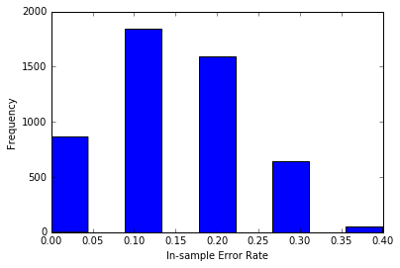

18.

Average Eout: 0.299238512977 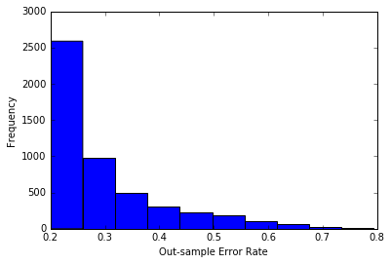

19.

Optimal decision stump: h-1,4,1.6175(x)= -1\*sign(xi-θ)

Ein of the optimal decision stump= 0.25

20

Estimate of Eout by Etest = 0.355