**11**

W = [ 0.01878417]

[-0.01260595]

[ 0.04084862]

[-0.03266317]

[ 0.01502334]

[-0.03667437]

[ 0.01255934]

[ 0.04815065]

[-0.02206419]

[ 0.02479605]

[ 0.06899284]

[ 0.0193719 ]

[-0.01988549]

[-0.0087049 ]

[ 0.04605863]

[ 0.05793382]

[ 0.061218 ]

[-0.04720391]

[ 0.06070375]

[-0.01610907]

[-0.03484607]

Ein: [ 0.475]

Eout: [ 0.466]

**12.**

W=[ 0.01826899]

[-0.01308051]

[ 0.04072894]

[-0.03295698]

[ 0.01498363]

[-0.03691042]

[ 0.01232819]

[ 0.04791334]

[-0.02244958]

[ 0.02470544]

[ 0.06878235]

[ 0.01897378]

[-0.02032107]

[-0.00901469]

[ 0.04589259]

[ 0.05776824]

[ 0.06102487]

[-0.04756147]

[ 0.06035018]

[-0.01660574]

[-0.03509342]

Ein: [ 0.473]

Eout: [ 0.464]

**13.**

Ein = 0.02

Eout = 0.035

**14.**

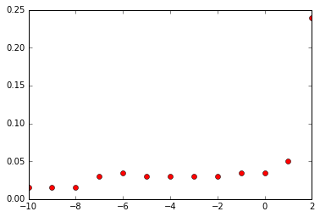

最小Ein = 0.015

對應到的λ = 10-8

對應到的Eout = 0.02

**15**

最小Eout = 0.015

對應到的λ = 10-7

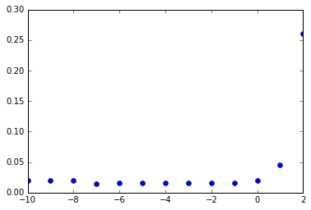

**16.**

Etrain最小= 0

對應到的λ = 10-8

對應到的Eout = 0.025

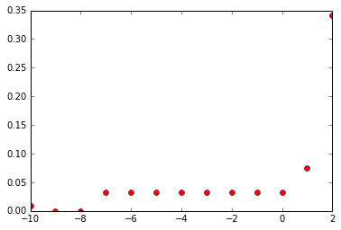

**17.**

Eval 最小 = 0.0375

對應到的λ = 1.0

對應到的Eout = 0.028

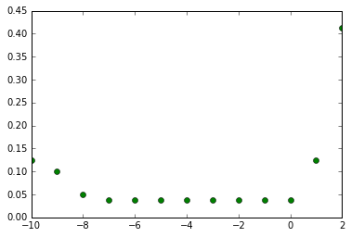

**18**

Ein: 0.035

Eout: 0.02

**19**

Ecv 最小 = 0.03

對應到的λ = 10-8

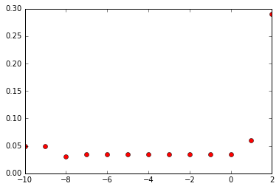

**20.**

Ein = 0.015

Eout = 0.02