Q: What command line is used to create the Javadoc documentation in HW1/doc?

A: the command line Javadoc -d ./doc Counter.java

Q: What command-line flag(s) is/are used to create the author and version entries for the class?

A: the flags –author and –version are used to create the author and version entries for the class

Q: write the command that you used to successfully run the JUnit tests from the command line

A: java org.junit.runner.JUnitCore countertest.CounterTest

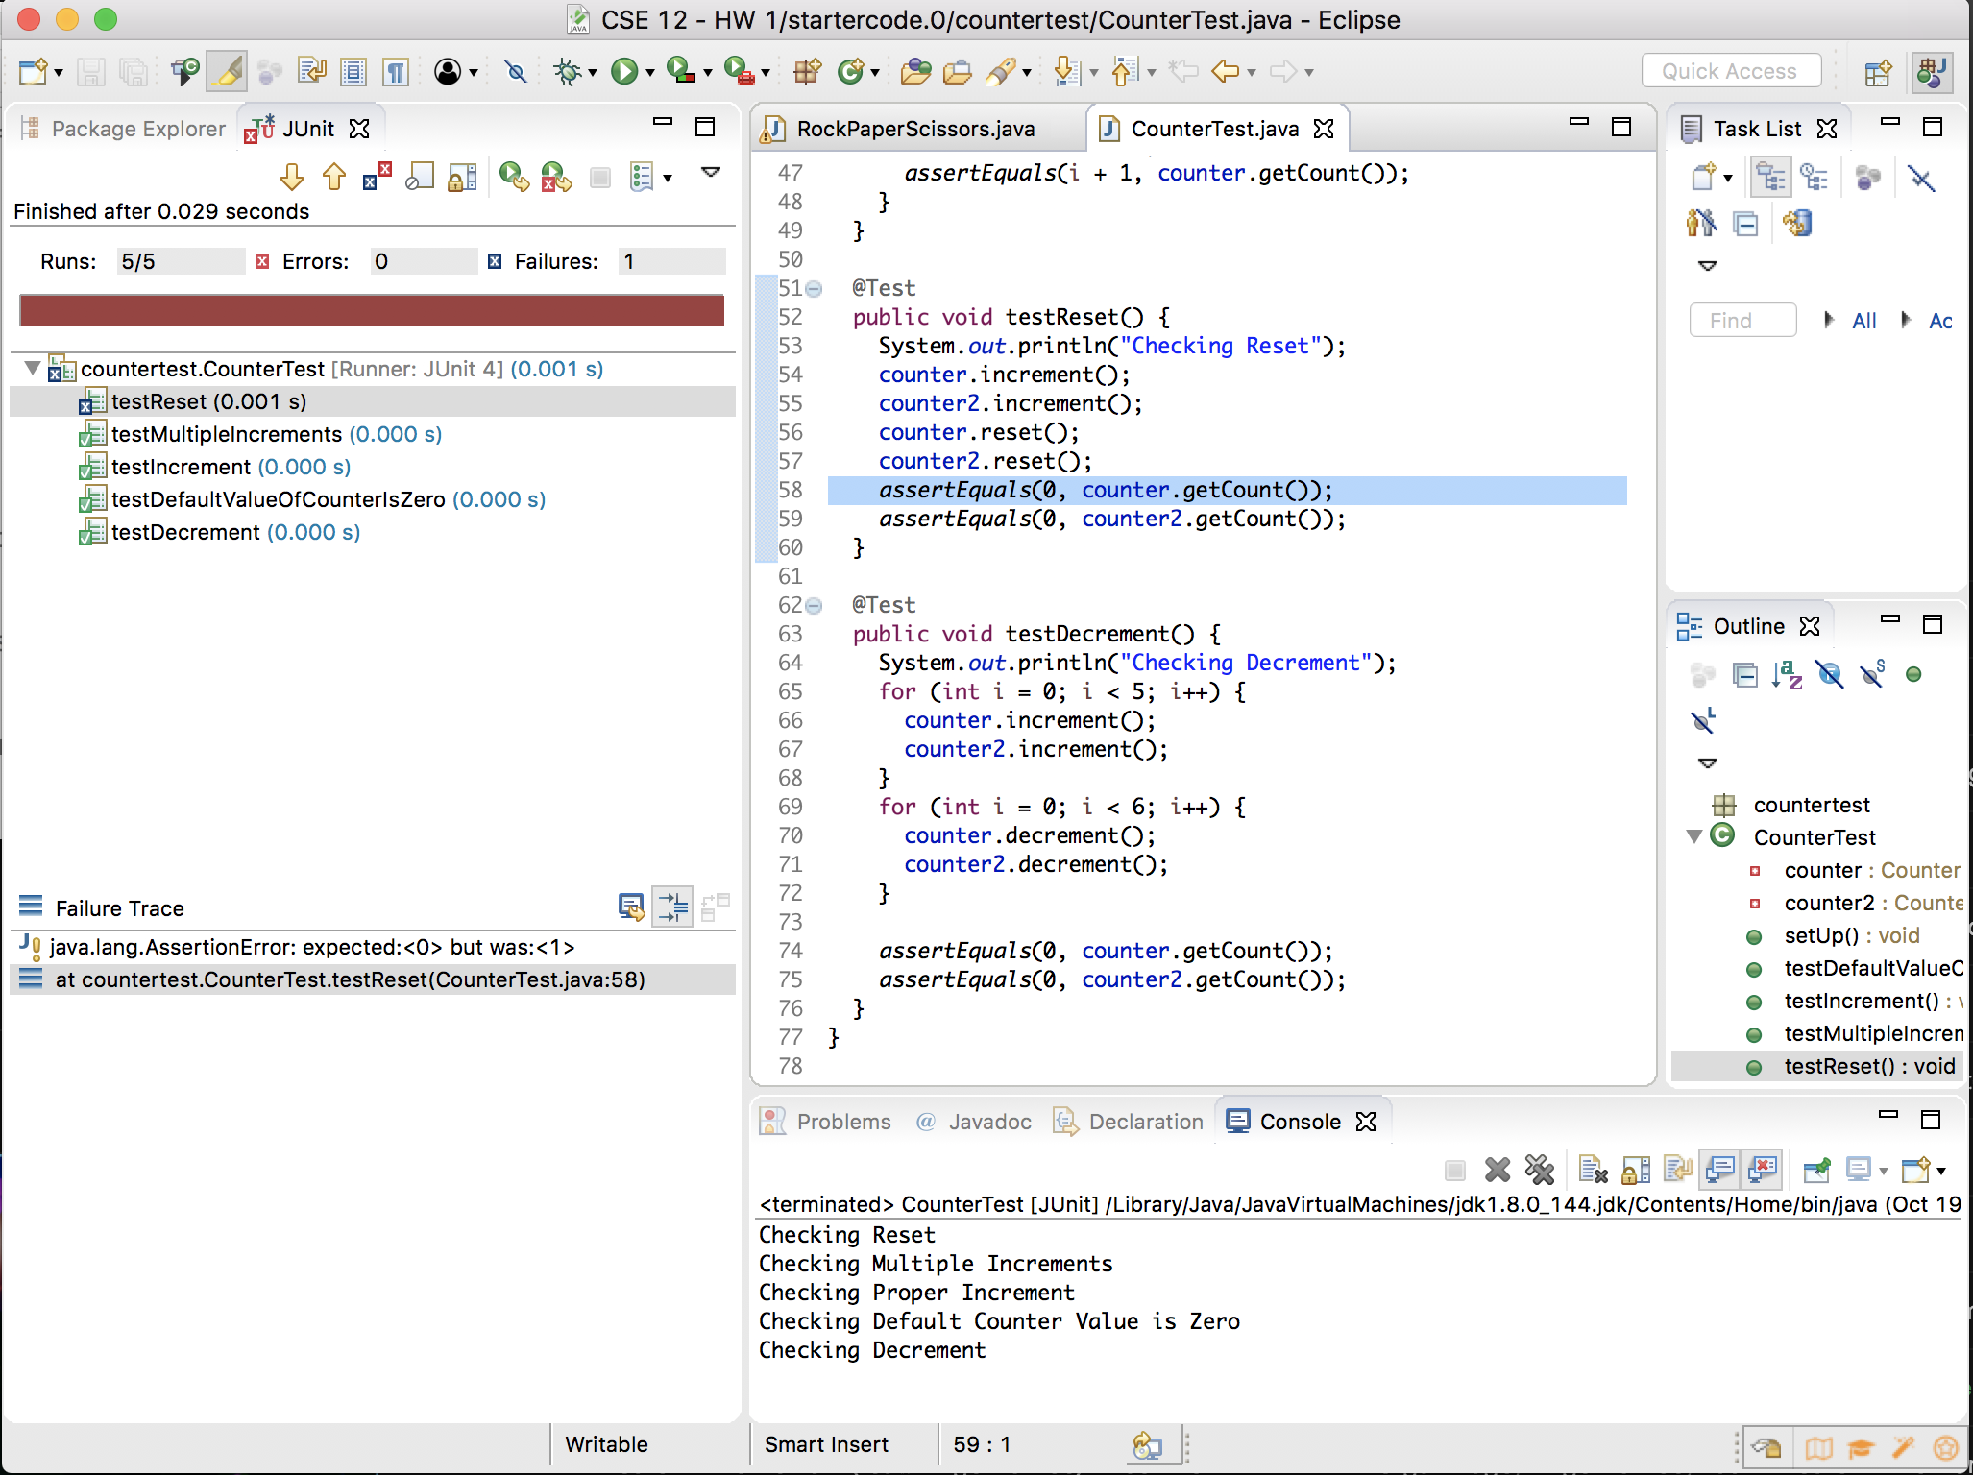

Q: What was the most difficult/confusing part about getting set up in Eclipse?

A: the most difficult part of Eclipse was to set up the project and import the files