JavaScript Assignment 1
Due, Sunday, October 21, 2018 for 100% credit
Monday, October 22, 2018 for 90% credit
Tuesday, October 23, 2018 for 80% credit
Wednesday October 24, 2018 for 70% credit

Scenario
Generate a deck of cards in JavaScript

Tasks
cards.html
Page title | In the <head>, set the title of the page to “Deck of Cards”
Link external JavaScript file | In the <head>, use the <script> tag to link in the external JavaScript file card.js
Link external CSS file | In the <head>, use the <link> tag to link in the external CSS file cards.css
Heading tag | In the <body>, use a heading tag to display “Deck of Cards”
Create a div | In the <body>, use the <div> tag with a unique id attribute that will be referenced by the JavaScript
cards.css
Class card | Create a class called card that sets the following style (you are free to change these values to style of your preference):  border: solid 1px #aaa;  border-radius: 9px;  width: 95px;  height: 150px;  float: left;  background-color: white;  padding: 3px 3px 3px 3px;
Class card with child class value | Create a child class called value to class card that sets the following style (you are free to change these values to style of your preference):  font-size: 24pt;  font-family: sans-serif;
Cards.js
Create a global variable for the card face as an array | The array should include values:  A, K, Q, J, 10, 9, 8, 7, 6, 5, 4, 3, 2
Create a global variable for the card suit as an array | The array should include value:  Diamonds, Hearts, Spades, Clubs
Create an array for the deck of cards | Empty array
Set the onload for the window | For the window object, set the onload event handler equal to the JavaScript function load
Function getDeck() | Write function getDeck so that it does the following:  - Loops through the global variable array representing the suit  - Loops through the global variable array representing the face  - Creates an object called card with properties Value and Suit  - Value is set equal to the global array representing the face using the appropriate looping variable  - Suit is set equal to the global variable array representing the suits using the appropriate looping index  - Push the card object on the global variable representing the deck of cards  - Return the deck of cards
Function shuffle() | Write function shuffle() so that it does the following:  - Loops for some number of times (i.e. 250, 500, 1000, etc..)  - Create a variable to represent one card set equal to Math.floor(Math.random() * deck length))  - Create a variable to represent another card set equal to the same random number generation as above  - Switch the cards in the variable representing the deck
Function renderDeck() | Write a function renderDeck() so that it does the following:  - Loops through the length of the variable representing the deck  - Create a variable called card set equal to document.createElement() passing “div” as an argument  - Create a variable called value set equal to document.createElement() passing “div” as an argument  - Create a variable called suit set equal to function call getCardUi() passing as an argument the current element in the array of the variable representing the deck of cards  - For variable card, set its className equal to “card”  - For variable value, set its className equal to “value”  - For variable card, call method appendChild() passing variable value as an argument  - For variable card, call method appendChild() passing variable suit as an argument  - Referencing the document, call method getElementById() passing “deck” as an argument followed by method call appendChild() passing variable card as an argument
Function getCardUI(card) | Write function getCardUI() so it receives one parameter called card, it should do the following:  - Create a variable set equal to the document calling method createElement() passing “div” as an argument  - Create variable icon set equal to empty single quotes  - Write an if / else if / else statement that evaluates the Suit name of the object card passed in to determine if it is Hearts, Spades, Diamonds, or Clubs  - Set the icon variable to the HTML equivalent image  - For the element object in step 1, set the innerHTML attribute equal to the card object’s Value name concatenated with the icon from step 3  - Return the element object created in step 1
Function load() | Write function load() so it does the following:  - Sets the global variable representing the deck of cards equal to function call getDeck()  - Calls function shuffle()  - Calls function renderDeck()
Test Case 1 | The HTML page should look similar to figure 1 below

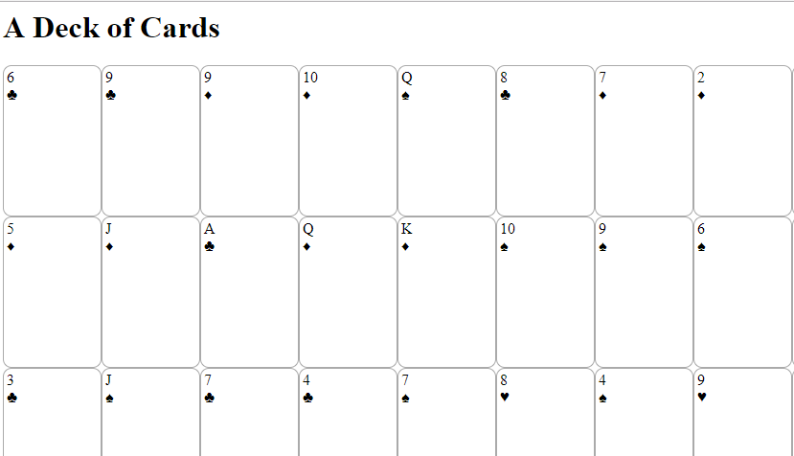
Figure 1Rendered HTML

