Screenshot of app working and files created:  
  
Screenshot of Canada text:  
  
Screenshot of USA text:

Screenshot of code Pprt 1:  
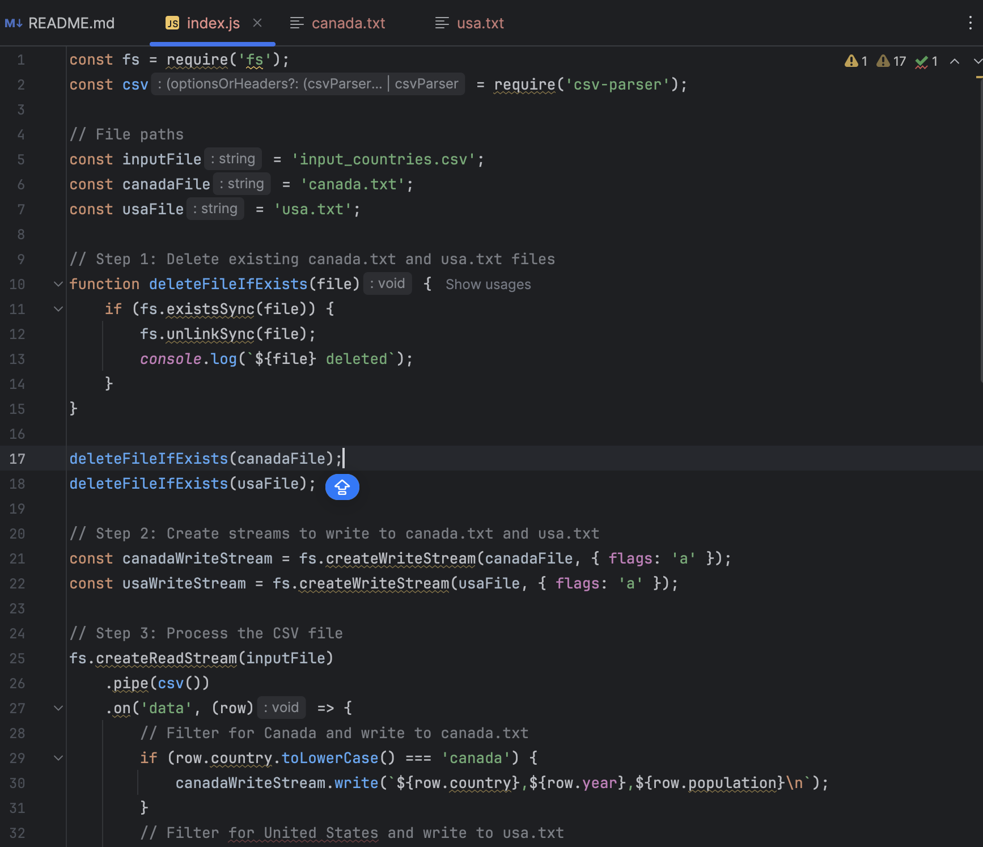

Screenshot of code part 2:

