MIDWA Lab 1
Understanding launch files, parameters and topic remapping
Goals
- To create a launcher that launchs three nodes: one (capture_key_node) for capturing keystrokes from the user's keyboard and publish it in ROS and the other two (move_joint_node) that subscribe to the same type of topic published by the capture_key_node, moving each one a predefined articulation of the robot defined by parameter. The keys used to increment and decrement the position as well as the increment value are defined by parameters in each node move_joint_node.
Deliverables
- This sheet with the answers to the questions
- Launch file of the first task
Send the both files, zipped together, as an attachment to the following address:
salvador_8fb7@sendtodropbox.com
Create a single zip file with all deliverables inside. Naming convention will be Name1_Name2_code.zip where code is a random string of four characters to make sure your submission cannot be overwritten, e.g. « Smith_Baker_xyrt.zip ».

No need to include any message body. Your file will be automatically date-stamped and added to a specific folder of my DropBox account. Beware!
The joints of the Baxter robot
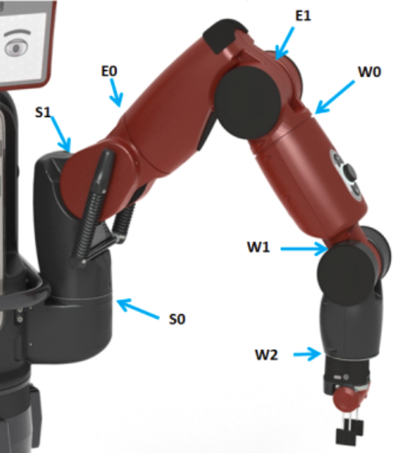
Figure 1. The joints of the Baxter robot
The available packages
You are given the following files, each of which contains a single type of node:
- capture_key.zip Uncompress it in ~/catkin_ws/src (the type of node is capture_key_node)
- move_joint.zip Uncompress it in ~/catkin_ws/src (the type of node is move_joint_node)
- execute « catkin_make » in ~/catkin_ws.
Description of a capture_key node:
- Captures the keystrokes on the computer it is running on.
- Publishes their ASCII codes to a topic called /key_typed.
- No subscription.
Description of a move_joint node:
- Moves a joint of a robot, in position mode, incrementing or decrementing it according to the key which has been typed.
- Subscribes to:
- /key_hit as topic for the incoming key strokes.
- /robot/joint_states for the state variables of the robot.
- Publishes a joint command for the joint, in position mode, to topic /joint_command.
- The joint to move is defined by the string parameter « joint_name ». The parameter does not have a default value.
- The increment and decrement keys are defined by integer parameters « incr_key » and « decr_key », which default to '+' (ASCII code 43) and '-' (ASCII code 45) respectively.
First task: launch files
NOTE : To start creating a launch file you can go to the ROS wiki (http://wiki.ros.org) and type « launch example » in the search box then choose the first link, take a basic example and modify it for your purposes.
Create a launch file to control two of the joints of the Baxter robot, according to the table below (check your group number, which is written on a cardboard label on the PC). The contributions of the whole class will allow controlling most of the joints of the Baxter robot.
group | 1 | 2 | 3 | 4 | 5 | 6 | 7
joints | left_s0  right_s0 | left_e0  right_e0 | left_w0  right_w0 | left_s1  right_s1 | left_e1  right_e1 | left_w1  right_w1 | left_w2  right_w2
First launch file attempt: For this launch file, the <node … /node> section of any node will be minimal: no node naming, no remapping.
What happens when it is launched fron only one PC? Explain how to solve this problem

What happens when the files are launched from several PCs? Coordinate with other groups to solve the problem and explain it here.

Second launch file attempt: Here, the <node … /node> section of the capture_key node will have the name « capture_key_<group number> » , rename also the node move_joint to « move_joint<joint_name> » but there will be no remapping of the topic « /key_typed »
Which problems do we find now? Explain how to solve them.

Third launch file attempt: Now create a launch file which allows each group to control their assigned joints without problems and interferences with other groups. Show the result to the teacher for validation.

At the end of the lab session: backup your work, just in case. Contrary to PCs of the ECN platform, there is no automatic backup.

