**MANUAL / RECOMMENDATIONS**

Open the application which view is close to Windows Explorer.

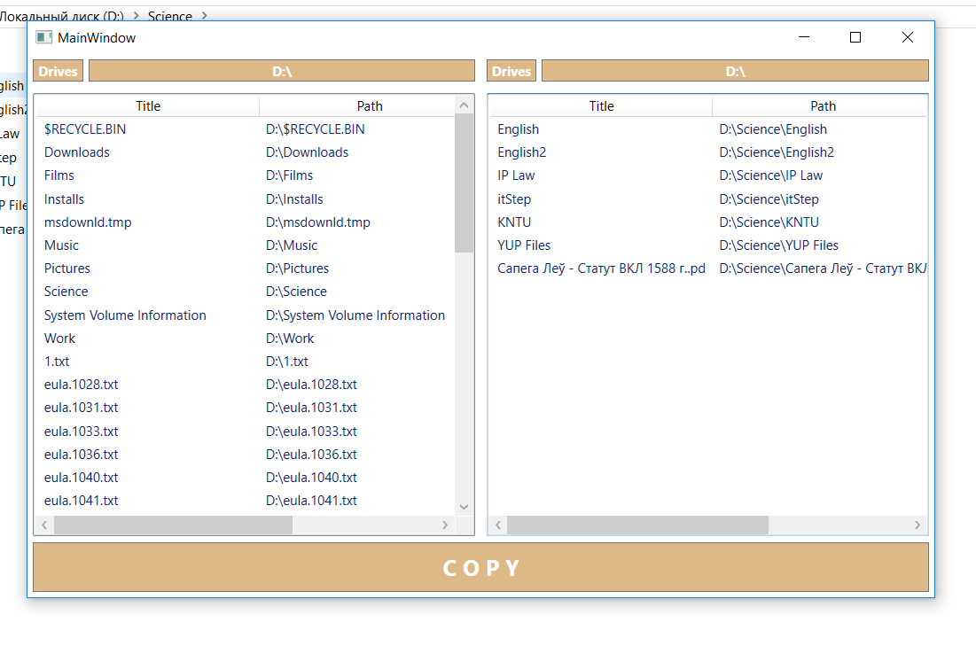

You could choose single file or few files. You can’t choose directory for copying.

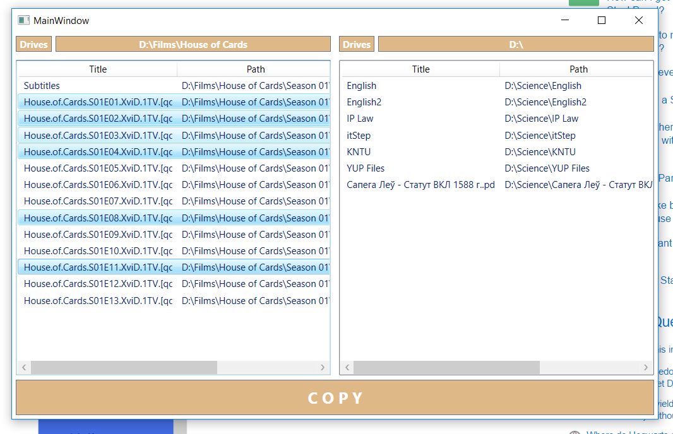

Buttons on the top redirects you to drives or parent directories.

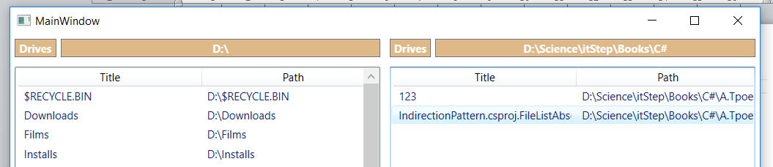

Select specified files and push button COPY in the bottom of the window

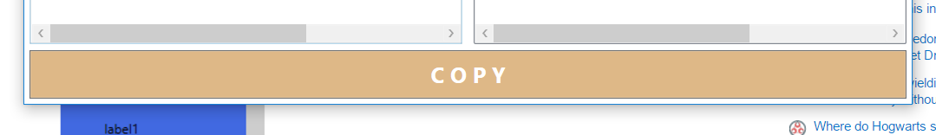

New window with progressbars will be opened.

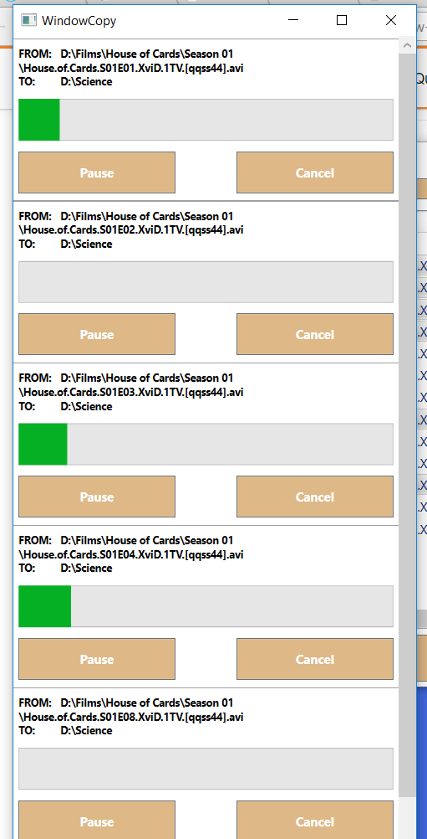

You could press buttons “PAUSE” / “RESUME” to pause and to resume the process of file’s copying.

You could press button “CANCEL” to finish direct process and close ProgressBar.

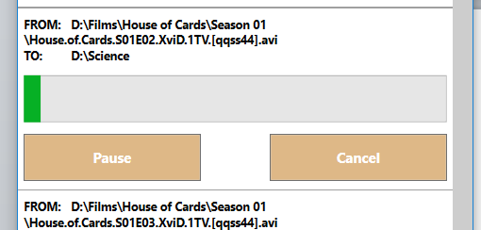

When button “PAUSE” is pressed its Title becomes “RESUME”.

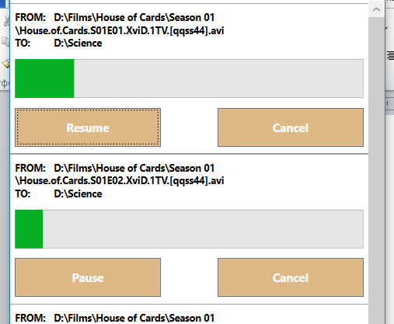

Click “Cancel” to stop the operation.

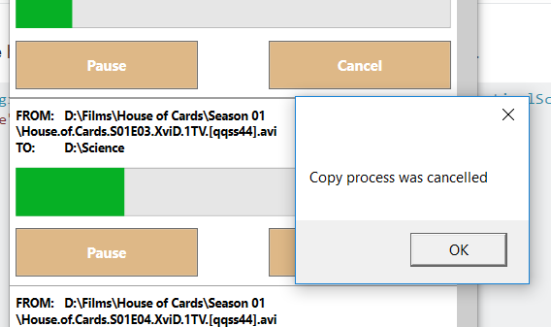

You could add new copy processes dynamically. This will modify WindowCopy.

