 | THE MINISTRY OF SCIENCE, TECHNOLOGY AND ENVIRONTMENT  THE CORPORATION FOR FINANCING AND PROMOTING TECHNOLOGY

Fsoft Recruitment Website
Software Requirement Specification

Project Code: AQUILA
Document Code: AQUILA SRS v1.0

Hanoi, 08-Oct-2004

TABLE OF CONTENTS
1 Introduction 4
1.1 Purpose 4
1.2 Scope 4
2 overal descriptions 5
2.1 Data structure 5
2.2 Actor structure 5
2.3 Use case structure 6
3 Functional Requirements 8
3.1 Login system 8
3.2 Browse (News, FAQ, Job) 10
3.3 Search 13
3.4 Send mail 13
3.5 Register 15
3.6 Manage profile 18
3.7 Manage News letter 21
3.8 Manage job posting 22
3.9 Manage news & events 26
3.10 Manage user 30
4 Other Specific Requirements 34
4.1 Usability 34
4.2 Reliability 34
4.3 Performance 34
4.4 Supportability 34
4.5 Design Constraints 34
4.6 On-line User Documentation and Help System Requirements 34
4.7 Purchased Components 35
4.8 Interfaces 35
4.9 Licensing Requirements 35
4.10 Legal, Copyright, and Other Notices 35
4.11 Applicable Standards 36
5 Supporting Information 37

Introduction

Purpose
AQUILA SRS is the complete and comprehensive description of software requirement. This document describes external behaviour as well as non-functional requirements of AQUILA project. It will be the basic for further analysis and design model.

Scope
AQUILA is a website that manage recruitment of Fsoft, it is useful for students or other candidate can apply to Fsoft via Internet.
All the information in website are showed by Vietnamese language follow customer’s request.

Definitions, Acronyms, and Abbreviations
No | Abbreviations | Description
1
2
3

References
No | Description | Name | Source
1
2
3

overal descriptions

Data structure
TBD in Detail Design

Actor structure
There are 4 actors in the system (as Fig 1) and is divided into 2 groups: Admin and Visitor.
In which, Admin belong to FIST - Fsoft, and Visitor is other. Fig 1 shows actors of AQUILA system separating in different roles. Each role will be granted different permissions on the system.

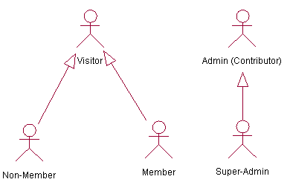
Fig 1: Actors and their roles in AQUILA system

Non-Member role
Non-Member who has not authenticated by the system with follow permissions limit, including:
- Brows: Trang chủ, Tin tức và sự kiện, Tuyển dụng, Giới thiệu Fsoft, Nghề nghiệp, Văn hoá Fsoft – FPT, Hỏi đáp, Liên hệ, Download.

- Register.

Member role
The Member who has authenticated by the system has full permissions of Non-member, further the Member have permission manage own profile.

Admin (Contributor) role
The Contributor has full permissions of user and more permissions follow:
- Manage Job posting.
- Manage News & Events.
- Manage News – letter.
- Manage FAQ, Download

Super- Admin role
The Super-admin has full permission of Contributor, furthermore the Super-admin has permission manage user.

Use case structure
Fig 2 shows the basic functionalities of AQUILA system in a view of use cases.

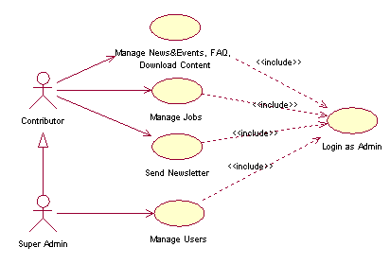
Fig 2: Use case structure of AQUILA system.

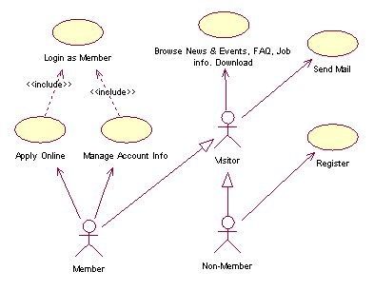
Fig 3: End user

Functional Requirements
This section describes the detailed functional requirements and data model of AQUILA Data model.

Login system

Description
There are 2 kinds of authentication: Admin and Member.
- Admin (include Super-Admin and Contributor): login to system in order to manage user, manage profile, and post information.
- Member (the Visitor who has registered and has had an account): login to system in order to post and get private information.
The address URL for Admin’s login is different Visitor’s.

Pre- Condition
N/A

Primary and Alternate Flow of Event
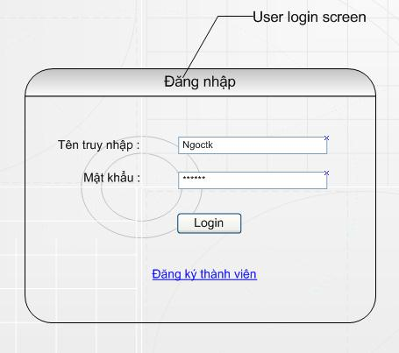
Fig 4: Login User form

After User click on “Login” button:
- If username and password are correct then allow Member logins into system.
- Otherwise eject and show the login form again with error message “Sai Tên truy nhập hoặc mật khẩu! Hãy làm lại”.
Similarly, Login form for Admins is the same Login form for Members.

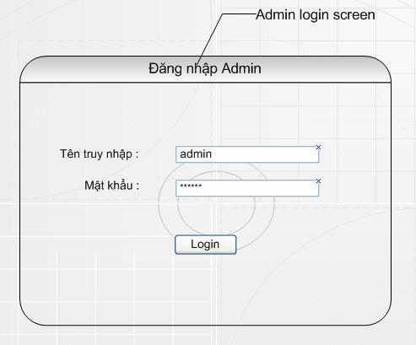
Fig 5: Login Admin form

Post condition
N/A

Browse (News, FAQ, Job)

Description
This use case allows visitors to brows the information follow: Trang chủ, Tin tức và sự kiện, Tuyển dụng, Giới thiệu Fsoft, Nghề nghiệp, Văn hoá Fsoft – FPT, Hỏi đáp, Liên hệ.
The appearance of each web page is look-and-feel like the prototype (approved by FIST, and available at address: http://www.fsoft.com.vn/HR/Training/G0/Aquila/WIP/Forms/AllItems.aspx
filename is AQUILA_Prototype_Main_v1.0)

Pre-Condition
N/A

Primary and Alternate Flow of Event

Browse “Trang chủ” page

This screen shows an image FSOFT with high – performance, professional.
User choose one in tabs by clicking on a tab name, user can go to View screen, which detailed information of the subject.

Browse ” Tin tức và sự kiện” page

This screen display content of page “Tin tức và sự kiện ” with the latest information.
- User links to title of news: System link to detailed contents of each news described in page.
- User clicks “ Chi tiết”: System display content of article as chosen.
- User links to “Quay lại” to turn back.
- User can click “Trang trước” or “Trang sau” to navigate pages.
- User can click “Download”: System download information for him.
- User can link from/link to other pages: System display content of choose page.

Browse ”Tuyển dụng” page

This screen display content of page “Tuyển dụng” with the latest news and the job list (see layout profile: http://www.fsoft.com.vn/HR/Training/G0/Aquila/WIP/Forms/AllItems.aspx
Filename is AQUILA_Prototype_Main_v1.0)
- User chooses link “Apply” at the bottom of content jobs. The “Login“ page is displayed if user has not yet logged in, else Recruit form will be showed.

Browse ”Giới thiệu FSOFT” page

This screen displays content of page ”Giới thiệu FSOFT” in which includes the brief history of FPT and FSOFT, essential info like up-to-date org chart, current status (# of employees, revenue, customer base...)
Following buttons/links are available:
- Essential – view information
- Purpose
- History

Browse “Nghề nghiệp” page

This screen display page “Nghề nghiệp” with general introduction, hypertext to other sections and follow tabs: Intro, Challenges, Career path, Development, Rights, and Employee profile
- User clicks one in tabs: system display content belonging to the chosen sub page
- User can link from/link to: system display content of chosen page

Browse ”Văn hóa” page

This screen display page “Văn hóa” with hypertext to other sections and following tabs: Intro, Youth union, Publications, Events, Clubs, and Fun.
- User clicks on each tabs of this page or link other: System display content of chosen sub page.

Browse ”Hỏi đáp” page

This screen display content of page ”Hỏi đáp” with hypertext to other section
- User send request, message: It seen forum
- User links from /links to other: System display content of chosen page

Browse ”Liên hệ” page
This screen displays page “Liên hệ” with hypertext to other section.
- User clicks on mail address: The “Login” page is shown, request user login. User can check his mail.
- User clicks on page name: System display content of chosen page
- User composes mail, send request: System display “Send mail” page.

Post-condition
N/A

Search
N/A

Send mail

Description
This function allows users easy to contact to FIST through Microsoft Outlook Express that is showed in the content of Contact us page.

Pre-condition
N/A

Primary and Alternate Flow of Event
If Visitors want to ask or send question to FIST, Visitors can contact by 2 ways:
- Click on Email link, Microsoft Outlook Express screen will be showed and default address’s receiver is: Nguyennq@fsoft.com.vn
- Send mail by “Gửi mail” form as fig 6.

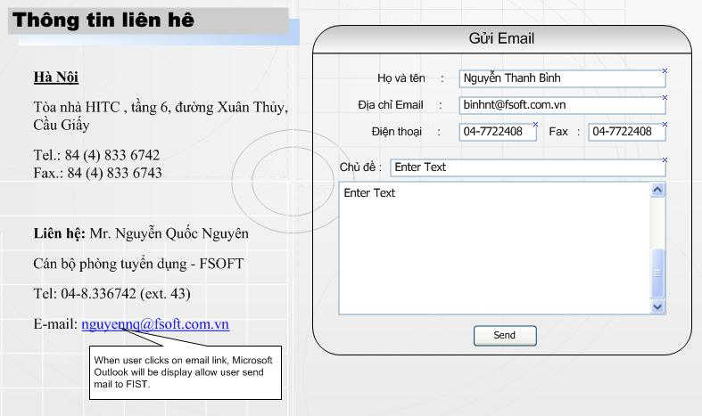
Fig 6: Contact us

Post-condition
N/A

Register

Description
This function allows
- User can register an account (consist of “Tên truy nhập, Mật khẩu, Họ Tên” and “Email” to receive hot jobs news in user’s mailbox from FIST)
- Member can apply for the desired position by inputting all information into “Đăng ký tuyển dụng” form (In order to apply User must have an account)

Pre-condition
N/A

Primary and Alternate Flow of Event
Register an account

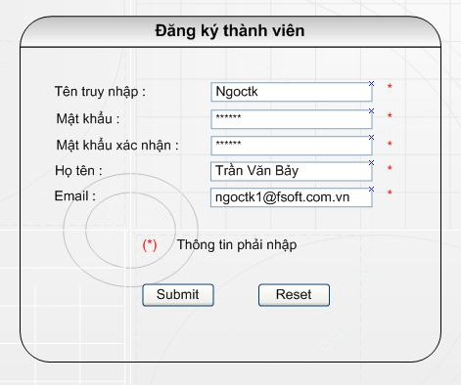

Fig 7: Register form
User has to input all information into forced textbox.
After user click on “Submit” button the system will checks validations:
- “Tên truy nhập” could not be left blank and not exceed 30 characters.
- “Mật khẩu” could not be left blank and not exceed 30 characters.
- “Họ tên” could not be left blank and not exceed 50 characters.
- Email could not be left blank and must be consistent with formatting name@Mailserver.com…
If validation fails
- Displays an error message
- Cancels “Submit” action
Otherwise, all inputted information will be sent to server and saved into database.
“Welcome” form will be showed after user submits successful.
User can click on “Reset” button to re-input information.

Apply job
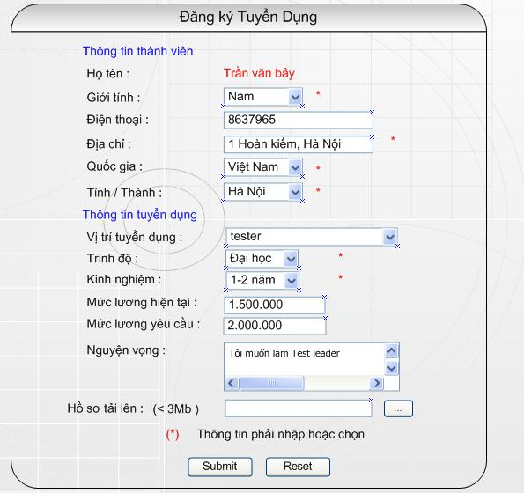
Fig 8: Apply form

Member has to input all information into forced textbox.
After Member click on “Submit” button the system will checks validations:
- “Mức lương hiện tại” textbox must be number
- “Mức lương yêu cầu” textbox must be number
- “Số điện thoại” must be number.
- “Nguyện vọng” textbox not exceed 255 characters.
- In “Hồ sơ tảI lên” textbox,file attach can not exceed 3 Mb.
If validation fails
- Displays an error message
- Cancels “Submit” action
Otherwise, all inputted information will be sent to server and saved into database.
User can click on “Reset” button to re-input information.

Post-condition
N/A

Manage profile

Description
This module allows authorized members to update their own detailed information. For example: Member can change Email or telephone number...

Pre-condition
After Member login successful, the Manage Profile form will display as Fig 9 and in menu bar of page will appear addition “Manage Profile”, “Change Password” and “Logout”.

Primary and Alternate Flow of Event
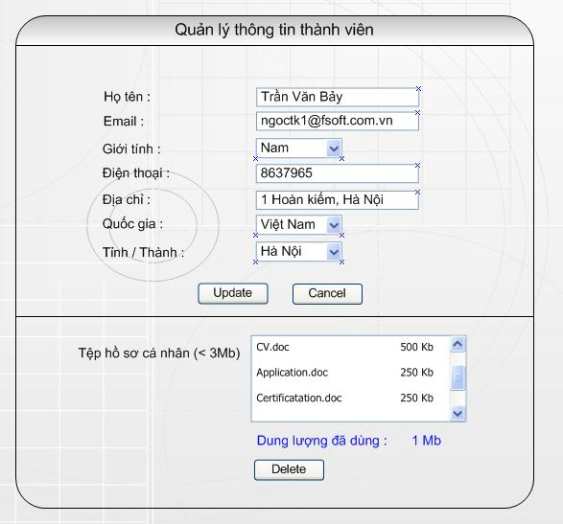

Fig 9: Manage Profile form

User can change the content of textbox and clicks on “Update” button to save that changed, the system will check validations:
- “Email” must be consistent with format Name@mailserver.com or (.net, .org…)
- “Điện thoại” must be number
If validation fails
- Displays an error message
- Cancels “Update” action
Otherwise, all inputted information would be updated.
- Member clicks on “Cancel” button, system will bring member back to previous form.
- Manage Profile form list files and size of memory user used. They can delete file by selecting that file and click on “Delete” button.

One more addition function is that Member can change Password when Member clicks on “Change Password” in menu bar.
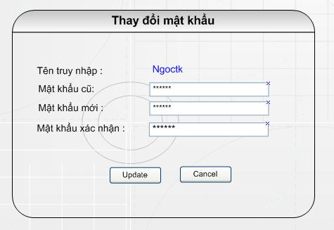

Fig 10: Change password form.

Post-condition
After Member Update successful the System will bring member back to previous page.

Manage News letter

Description
This function allows Super-Admin (FIST) or Contribute send News - letter mail to all members. All members can get News - letter from their own profile.

Pre-condition
In order to use this function, user must login into system by account of super-Admin or Contributor. The “login system” screen for admin is located on Fig 5

Primary and Alternate Flow of Event
The News - letter screen is displayed follow:
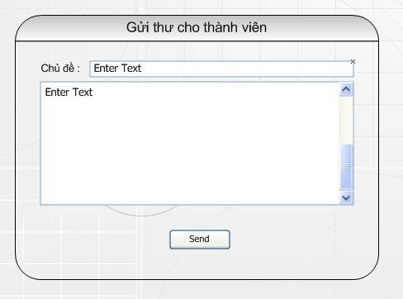
Fig 11: Send email form.

After Admin input subject and content in textbox and listbox, Admin click “Send” button to send mail for all members, after that this screen is displayed again; Contributor may be sending the other information.

Post-condition
N/A

Manage job posting

Description
This section allows Super-admin or Contributor post and manages Recruitment information as: Upload recruitment news, Update recruitment news, and Delete recruitment news.

Pre-condition
In order to use this function, user must login system by account of super-Admin or Contributor.
View the “Login system” screen for admin in Fig 5

Primary and Alternate Flow of Event
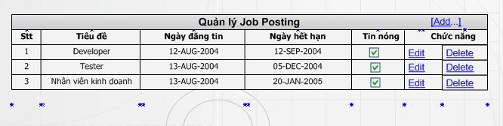
Fig 12: Manage job posting form

There are 3 functions to manage job posting:
- Add (refer to 3.8.4 Add new job)
- Edit (refer to 3.8.5 Edit new job)
- Delete (refer to 3.8.6 Delete job)

Add new job
The screen is displayed follow.
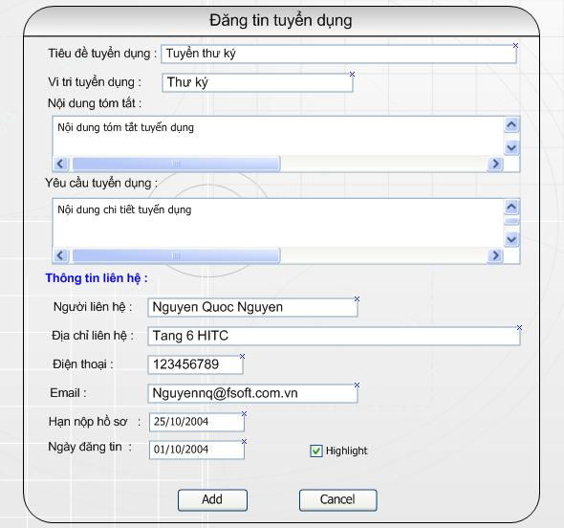
Fig 13: Add new job form

- Input “Tiêu đề tuyển dụng” of recruitment information (mandatory)
- Input “Vị trí tuyển dụng” of recruitment information (mandatory)
- Input “Nội dung tóm tắt” of recruitment information (mandatory)
- Input “Yêu cầu tuyển dụng” of recruitment information (mandatory)
- Input “Ngày đăng tin” (Default current date)
- Input closing day (optional), it is supported by calendar Pickup
- Click highlight checkbox, if you want to make this news is highlight (Default checked).
- Click on “Add” button to post this news. After posting successful, this screen will appear again, it is allowed you post another else click on "Cancel" button to go back manage job posting page. (See the content of “Manage job posting” page in Fig 12: Manage job posting)

Edit new job
The screen is displayed follow:
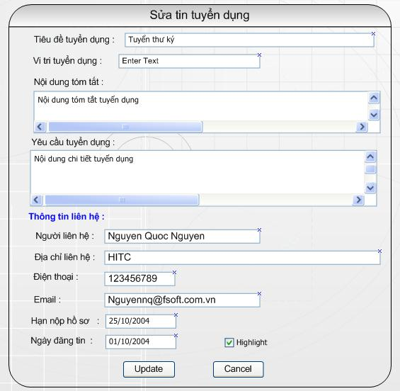
Fig 14: Edit job form.

This function allows you update previous recruitment information. After changed, if you want to update this one, click on "Update" button to save it, else click on "Cancel" button. After then clicks on it "Update" or "Cancel" button, the screen will go back Fig 12: Manage job posting).

Delete job
The screen is displayed follow.
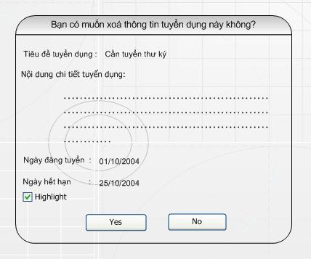
Fig 15: Delete job form.

If you want delete this news, click on "Yes" button to delete this news, else click on "No" button to cancel this function. After click on on "Yes" or "No" button, the screen will go back "manage job posting" page as Fig 12: Manage job posting

Post-condition
N/A

Manage news & events

Description
This session allow super-Admin or Contributor posts and manages news & events.

Pre-condition
In order to use this function, user must login system by account of super-Admin or Contributor
View the “Login system” screen for admin in Fig 5

Primary and Alternate Flow of Event
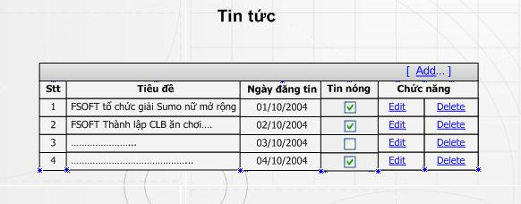
Fig 16: Manage News & Event form.

There are 3 functions to manage news & events:
- Add new news & events (refer to 3.9.4 Add news & Events)
- Edit news & events (refer to 3.9.5 Edit News & Events)
- Delete news & events (refer to 3.9.6 Delete News & Event)

Add new news & events
The screen is displayed follow.
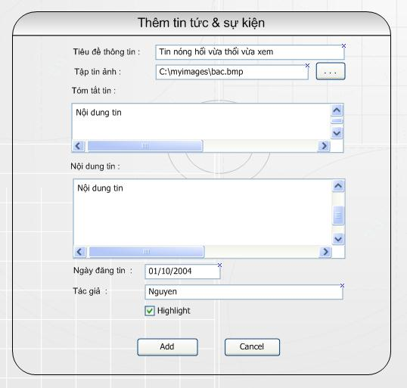
Fig 17: Add new Event form.

- Input”Tiêu đề thông tin” of news & events (mandatory)
- Input “Tập tin ảnh” and file name of image if you want (optional)
- Input “Tóm tắt tin” of news & events (mandatory)
- Input “Nội dung tin” of news & events (mandatory)
- Input “Ngày dăng tin” (Default current date)
- Input “Tác giả” (optional)
- Click highlight checkbox, if you want to make this news is highlight (Default checked).
Click on "Add" button to post this news. After posting successful, this screen will appear again, it is allow you post another else click on "Cancel" button to go back manage job posting page as Fig 16

Edit news & events
The screen is displayed follow:
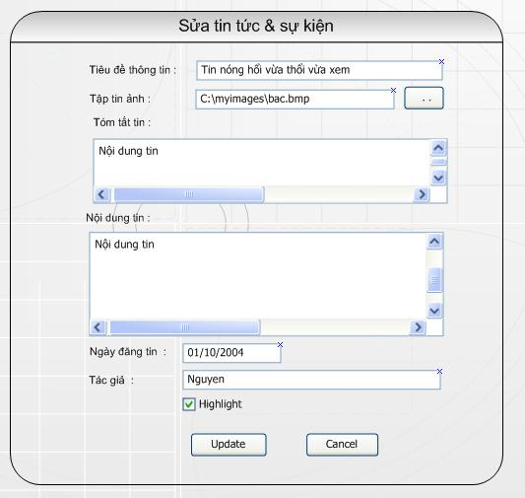
Fig 18: Edit Event form.

This functional allow you update previous news. After changed, if you want to update this one, click on "Update" button to save it, else click on "Cancel" button. After click on on "Update" or "Cancel" button, the screen will go back "manage news & events" page as Fig 16

Delete news & events
The screen is displayed follow:
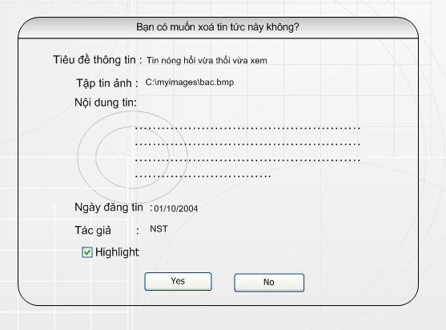
Fig 19: Delete Event form.

- If you want delete this news, click on "Yes" button to delete this news, else click on "No" button to cancel this function. After click on Yes" or "No" button, the screen will go back "manage news & events" page as Fig 16

Post-condition
N/A

Manage user

Description
This function allows Super-Admin manage all system’s user. So Admin (FIST) could be (Add-new, Edit, Delete) user But only “sysAdmin” user is not permit Delete, Default “SysAdmin” user is created when system start that is system user, However “sysAdmin” user can add more user that have the same level or another level).

Pre-condition
N/A

Primary and Alternate Flow of Event

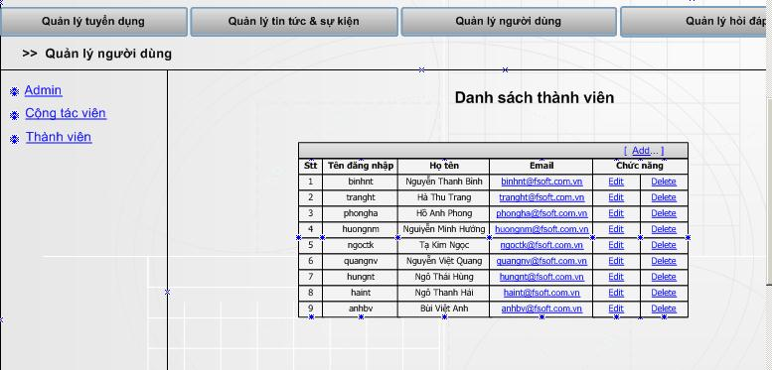
Fig 20: User list table.

There are 3 functions to manage user:
- Add new user (refer to 3.10.4 Add new user)
- Edit user (refer to 3.10.5 Edit user)
- Delete user (refer to 3.10.6 Delete user)

Add new user
The screen is displayed follow.
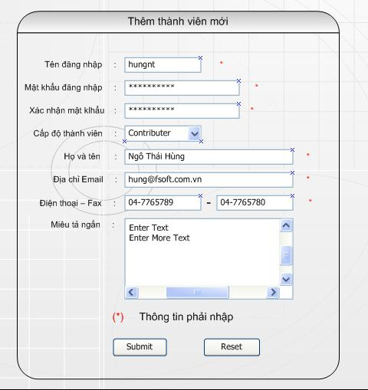
Fig 21: Add new user form.

- Super-Admin must Input “Tên đăng nhật” textbox.
- Super-Admin must Input “Mật khẩu” textbox.
- Super-Admin must input “Xách nhận mật khẩu” textbox that is the same “Mật khẩu” textboxpassword.
- Choose one of user level from “Cấp độ thành viên” combo box.
- Other input-box is option
- Click “Submit” button, User was added to list of user (Fig 18). After add new, The Add new User Screen is displayed again, Super-Admin can add new user another.
- Click “Reset” button to reset all information.

Edit user
The screen is displayed follow.
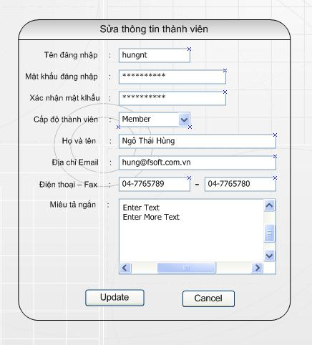
Figure 22 – Edit User form.
- The same “Add new user” function, but Super-Admin could not change user name.

Delete user
The screen is displayed follow.
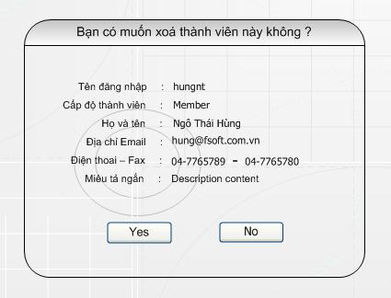
Fig 23: Delete user form.

- Click on “Yes” button to delete this user. After delete user, the Manage User screen is displayed as Fig 20
- Click on “No” button to cancel this function, the Manage User screen is displayed as Fig 20

Post-condition
N/A

Other Specific Requirements

Usability
- The interface should be friendly and easy to use.
- Easy to register via Internet.
- Language supported: Vietnamese.

Reliability
N/A

Performance
- The average response time (time from request page to view that page) should not exceed 10 seconds for line 56 KB, and 5 seconds for lease line 2 MB.
- The number of concurrent access is less than 10 users.

Supportability
- Analysis and design document are available.
- Follow FSOFT coding standards.
- The software will be developed and deployed on Visual Studio .NET.

Design Constraints
N/A

On-line User Documentation and Help System Requirements
N/A

Purchased Components
- Domain name
- Web hosting

Interfaces

User Interfaces
- Web based interface in Vietnamese.
- Support Unicode UTF.
- Support IE 5 (or higher) with screen resolution 800 x 600.

Hardware Interfaces
N/A

Software Interfaces
N/A

Communications Interfaces
N/A

Licensing Requirements
N/A

Legal, Copyright, and Other Notices
2004 Copyright by Fsoft – FPT

Applicable Standards
N/A

Supporting Information
N/A

