**Chapter 1. Software Requirements (SR)**

**1.1 Introduction**

1. **Purpose**
   * 1. **Decrease monthly company expenses by having an automated bookstore instead of hiring more employees to do the same task. Provide convenience for the customers and as well show and manage the company’s inventory. Reduce monthly support cost from $x to $y with Z months.**
     2. **Group Name: Phoenix**
     3. **Group Members:**

**Ian Michael Jesu Alvarez**

**Xiaomei Ji**

**Chloe Ho**

1. **Scope of the Problem**
   * 1. **Software Name: PhoenixBookStore**

**Will do:**

* + - * 1. **In this bookstore software, people could search for a book,**
        2. **order items,**
        3. **pay for the items by using a credit/debit card and other payment methods,**
        4. **and check all of their orders out by providing tracking numbers and a confirmation.**
        5. **The software will also provide the special discount or give-away for the users.**
      1. **Will not do:**
         1. **At this current version, the software will not be able to do book rentals.**
         2. **Also, the software will not be able to contact banking company to confirm users' credit/debit card, etc. information. All payments will be assume viable in this simulation. This version is just a simulate UI used in the terminal.**

1. **Definitions, Acronyms, or Abbreviations**

**UI = User Interface**

1. **References: None**
2. **Overview: None**

**1.2 Use-Case Modeling**

1. **Use-Case Diagram**

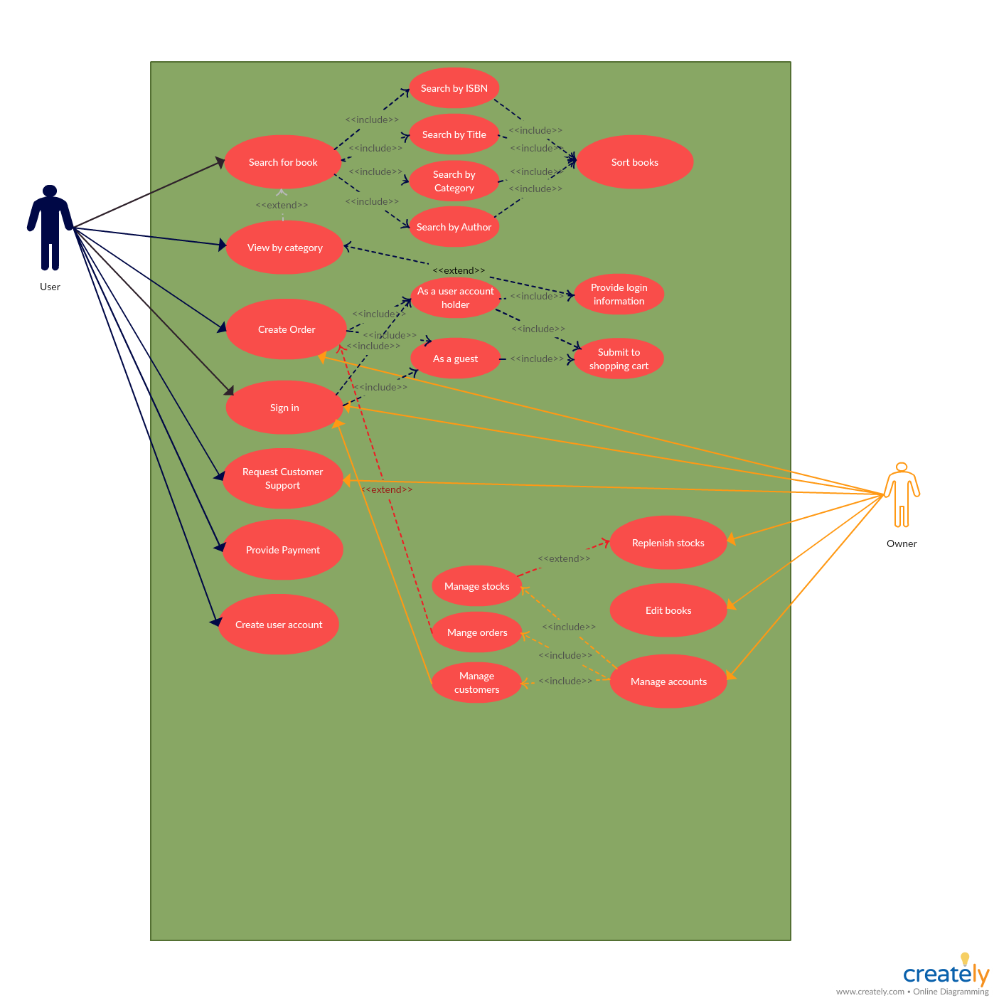

1. **Use-Case Description**

|  |  |  |  |  |
| --- | --- | --- | --- | --- |
| **Use Case ID:** | **UC-1** | | | |
| **Use Case Name:** | **Search for a book** | | | |
| **Created By:** | **Ian Michael Jesu Alvarez** | | **Last Updated By:** | **Ian Michael Jesu Alvarez** |
| **Date Created:** | **07-11-2018** | | **Last Revision Date:** | **07-11-2018** |
| **Actors:** | | **User** | | |
| **Description:** | | **Allows the user to search for a book they want to see.** | | |
| **Trigger:** | | **N/A** | | |
| **Preconditions:** | | **·         Customer has decided to either continue as a guest or as a returning account holder** | | |
| **Postconditions:** | | * **The user can will then be provided the option to search by ISBN, title, category, or by author.** | | |
| **Normal Flow:** | | 1. **User signs in** 2. **Customer selects how they want to search** 3. **Customer enters the book they want based on their previous choice** 4. **Customer selects the book** 5. **Customer decides to either order this book by adding it to their shopping cart or view a different book.** | | |
| **Alternative Flows:**  **[Alternative Flow 1 – Not in Network]** | | **1.     User continue as guest**  **2.     Resume normal flow on step 2** | | |
| **Exceptions:** | | **Exceptions to the Search for a book use case**  **In step 1 of the normal flow, if the customer enters and invalid user name or pin**  **1.      Sign in is disapproved**  **2.      Message to customer to re-enter valid account information**  **3.      Customer enters correct account information**  **4.      Use Case resumes on step 2 of normal flow]** | | |
| **Includes:** | | * **Search by ISBN** * **Search by title** * **Search by category** * **Search by author** | | |
| **Frequency of Use:** | | **On demand** | | |
| **Special Requirements:** | | **N/A** | | |
| **Assumptions:** | | **It is assumed that the all the titles of the book are written in English alphabet** | | |
| **Notes and Issues:** | | **1.     Need to implement word association in the future/later version to search for a title close to what the user typed.** | | |
|  |  |  |  |  |

|  |  |  |  |  |
| --- | --- | --- | --- | --- |
| **Use Case ID:** | **UC-2** | | | |
| **Use Case Name:** | **View by category** | | | |
| **Created By:** | **Ian Michael Jesu Alvarez** | | **Last Updated By:** | **Ian Michael Jesu Alvarez** |
| **Date Created:** | **07-11-2018** | | **Last Revision Date:** | **07-11-2018** |
| **Actors:** | | **User** | | |
| **Description:** | | **The user can choose to view books by selecting a category** | | |
| **Trigger:** | | **N/A** | | |
| **Preconditions:** | | **1.     User must select from the categories available** | | |
| **Postconditions:** | | **1.      Customer is shown the amount of books in that category and list the books.** | | |
| **Normal Flow:** | | **1.      Customer is show the categories available**  **2.      Customer selects from the categories**  **3.      Customer evaluates the list**  **4.      Customer selects a book**  **5.      Customer views the book**  **6.      Customer is prompted to order or view another book** | | |
| **Alternative Flows:**  **[Alternative Flow 1 – Not in Network]** | | **Alternative flows in View by category**  **2.a) If user enters outside category they will need to enter new valid information**  **2.b) User will be informed about it** | | |
| **Exceptions:** | | **Exceptions to the View by category**  **2.a) If user enters outside category they will need to enter new valid information**  **2.b) User enters valid information**  **2.c) Resumes to normal flow on step 3** | | |
| **Includes:** | | **N/A** | | |
| **Frequency of Use:** | | **On demand** | | |
| **Special Requirements:** | | **N/A** | | |
| **Assumptions:** | | **This is assuming that they enter an integer that represents the category they have chosen.** | | |
| **Notes and Issues:** | | **None** | | |

|  |  |  |  |  |
| --- | --- | --- | --- | --- |
| **Use Case ID:** | **UC-3** | | | |
| **Use Case Name:** | **Create order** | | | |
| **Created By:** | **Ian Michael Jesu Alvarez** | | **Last Updated By:** | **Ian Michael Jesu Alvarez** |
| **Date Created:** | **07-12-2018** | | **Last Revision Date:** | **07-12-2018** |
| **Actors:** | | **User** | | |
| **Description:** | | **The user can order a book as an account user or as a guest.** | | |
| **Trigger:** | | **N/A** | | |
| **Preconditions:** | | **1.     Book must be in stock** | | |
| **Postconditions:** | | 1. **Customer adds this to the shopping cart** 2. **Customer pays** 3. **Customer receives tracking number** | | |
| **Normal Flow:** | | 1. **Customer searches for a book** 2. **Customer orders the book** 3. **Customer receives tracking number** 4. **Ask user to find another book** | | |
| **Alternative Flows:**  **[Alternative Flow 1 – Not in Network]** | | **2.a If book is not in stock, notify customer and prompt if they want to view a different book.** | | |
| **Exceptions:** | | **2.b If no book is found resume normal flow step 4 to start step 2 of normal flow** | | |
| **Includes:** | | **Order:**   * **As a user** * **As a guest** | | |
| **Frequency of Use:** | | **On demand** | | |
| **Special Requirements:** | | **N/A** | | |
| **Assumptions:** | | **Assume that the book the customer is ordering is in stock** | | |
| **Notes and Issues:** | | * **In version 1 of the software, all customers shall be assumed as guests no user accounts shall be implemented on version 1** | | |
|  |  |  |  |  |

|  |  |  |  |  |
| --- | --- | --- | --- | --- |
| **Use Case ID:** | **UC-4** | | | |
| **Use Case Name:** | **Sign In** | | | |
| **Created By:** | **Chloe Ho** | | **Last Updated By:** | **Chloe Ho** |
| **Date Created:** | **07-12-2018** | | **Last Revision Date:** | **07-12-2018** |
| **Actors:** | | **User/Owner** | | |
| **Description:** | | **Allows the user and the owner to sign in to view their accounts** | | |
| **Trigger:** | | **N/A** | | |
| **Preconditions:** | | **1.     Customer has decided to either continue as a guest or as a returning account holder**  **2.     Owner logs in to manage the account** | | |
| **Postconditions:** | | **The customer can will be provided the option to sign in as a user account holder or as a guest** | | |
| **Normal Flow:** | | **Owner:**   1. **Owner signs in**   **Customer:**   1. **Customer signs in** 2. **Customer selects to log in if they have an account** 3. **To login, customer needs to provide their username and password** 4. **If not, customer can sign in as a guest by providing their information to continue** 5. **After deciding which books customer wants to buy, then adding their books to the shopping carts** 6. **As a guest check out, the system will not save their books for later check out until they have their own accounts** | | |
| **Alternative Flows:**  **[Alternative Flow 1 – Not in Network]** | | **1.     User wants to create a new account**  **2.     Resume normal flow on step 5** | | |
| **Exceptions:** | | **In step 2 and 3 of the normal flow, if the customer enters an invalid username and password:**   1. **Sign in is disapproved** 2. **Message to customer to re-enter a valid account information** 3. **Customer enters correct account information** 4. **Use case resumes on step 5 of normal flow** | | |
| **Includes:** | | 1. **Sign in as a user account holder** 2. **Sign in as a guest** 3. **Provide login information** | | |
| **Frequency of Use:** | | **On demand** | | |
| **Special Requirements:** | | **N/A** | | |
| **Assumptions:** | | **It is assumed that the language is written in English alphabet** | | |
| **Notes and Issues:** | | **N/A** | | |
|  |  |  |  |  |

|  |  |  |  |  |
| --- | --- | --- | --- | --- |
| **Use Case ID:** | **UC-5** | | | |
| **Use Case Name:** | **Provide payment** | | | |
| **Created By:** | **Chloe Ho** | | **Last Updated By:** | **Chloe Ho** |
| **Date Created:** | **07-12-2018** | | **Last Revision Date:** | **07-12-2018** |
| **Actors:** | | **User** | | |
| **Description:** | | **Allows the user complete their transaction by providing their payment information** | | |
| **Trigger:** | | **N/A** | | |
| **Preconditions:** | | **1.     User must add items to the shopping cart to check out**  **2.     The customer will be provided the option to sign in as a user account holder or as a guest to complete the transaction** | | |
| **Postconditions:** | | **Different payment methods and shipping detail is shown that helps user choose easily** | | |
| **Normal Flow:** | | 1. **User can update their shopping cart by editing the quantity, removing, or adding the new book.** 2. **User can check out as a guest or sign in for faster check out** 3. **Enter shipping address** 4. **Provide payment methods: Credit card or debit card** 5. **Provide 14 digit number of the account** 6. **Provide expiration date** 7. **Provide name of the account holder** 8. **Provide 3 security code in the back of the card** 9. **Enter billing address** 10. **Submit the payment** | | |
| **Alternative Flows:**  **[Alternative Flow 1 – Not in Network]** | | **1.     If the user has their own account, they don’t need to input shipping address and the credit card information to check out unless they want to change it** | | |
| **Exceptions:** | | **In step 2 and 3 of the normal flow, if the customer enters an invalid credit card**   1. **Transaction is not completed** 2. **Message to customer to re-enter a valid account information** 3. **Customer enters correct account information** | | |
| **Includes:** | | 1. **N/A** | | |
| **Frequency of Use:** | | **On demand** | | |
| **Special Requirements:** | | **N/A** | | |
| **Assumptions:** | | **It is assumed that the language is written in English alphabet** | | |
| **Notes and Issues:** | | **1.     N/A** | | |
|  |  |  |  |  |

|  |  |  |  |  |
| --- | --- | --- | --- | --- |
| **Use Case ID:** | **UC-6** | | | |
| **Use Case Name:** | **Request customer support** | | | |
| **Created By:** | **Chloe Ho** | | **Last Updated By:** | **Chloe Ho** |
| **Date Created:** | **07-12-2018** | | **Last Revision Date:** | **07-12-2018** |
| **Actors:** | | **User/Owner** | | |
| **Description:** | | **Allows user can contact to customer services and the owner can support their customers** | | |
| **Trigger:** | | **N/A** | | |
| **Preconditions:** | | **1.     User can provide their phone number or email so owner can contact to them** | | |
| **Postconditions:** | | **Owner will provide the phone number to help user can contact easily** | | |
| **Normal Flow:** | | **1.     Phone number is listed in the “contact us”**  **2.     User can contact to customer service by phone or email**  **3.     Owner check user’s email or phone call to help**  **4.     Owner will reply user’s email within 24 hours** | | |
| **Alternative Flows:**  **[Alternative Flow 1 – Not in Network]** | | **1.     If the user’s problem is not solved, owner will find the best solution to help them within 3-5 days.**  **2.     Confirmation email will be sent to user to make sure they will get help** | | |
| **Exceptions:** | | **1. if the user input the wrong email address or phone number, owner cannot contact to them** | | |
| **Includes:** | | 1. **N/A** | | |
| **Frequency of Use:** | | **On demand** | | |
| **Special Requirements:** | | **N/A** | | |
| **Assumptions:** | | **It is assumed that the language is written in English alphabet** | | |
| **Notes and Issues:** | | **1.     N/A** | | |
|  |  |  |  |  |

|  |  |  |  |  |
| --- | --- | --- | --- | --- |
| **Use Case ID:** | **UC-7** | | | |
| **Use Case Name:** | **Add new book** | | | |
| **Created By:** | **Xiaomei Ji** | | **Last Updated By:** | **Xiaomei Ji** |
| **Date Created:** | **07-12-2018** | | **Last Revision Date:** | **07-12-2018** |
| **Actors:** | | **Admin** | | |
| **Description:** | | **Allows the admin to add a new book info to the stock** | | |
| **Trigger:** | | **N/A** | | |
| **Preconditions:** | | **Admin add the book info to stock** | | |
| **Postconditions:** | | **The new book’s info is added to the stock** | | |
| **Normal Flow:** | | 1. **Admin can add a new book’s info to the stock** | | |
| **Alternative Flows:**  **[Alternative Flow 1 – Not in Network]** | | **N/A** | | |
| **Exceptions:** | | **N/A** | | |
| **Includes:** | | 1. **N/A** | | |
| **Frequency of Use:** | | **On demand** | | |
| **Special Requirements:** | | **N/A** | | |
| **Assumptions:** | | **N/A** | | |
| **Notes and Issues:** | | **1.     N/A** | | |
|  |  |  |  |  |

|  |  |  |  |  |
| --- | --- | --- | --- | --- |
| **Use Case ID:** | **UC-8** | | | |
| **Use Case Name:** | **edit existing book** | | | |
| **Created By:** | **Xiaomei Ji** | | **Last Updated By:** | **Xiaomei Ji** |
| **Date Created:** | **07-12-2018** | | **Last Revision Date:** | **07-12-2018** |
| **Actors:** | | **Admin** | | |
| **Description:** | | **Allows the admin to update the book info, especially update the quantity** | | |
| **Trigger:** | | **N/A** | | |
| **Preconditions:** | | **Admin updates the book info to stock** | | |
| **Postconditions:** | | **The updated book’s info is stored to the stock** | | |
| **Normal Flow:** | | 1. **Admin can updated a new book’s info to the stock** | | |
| **Alternative Flows:**  **[Alternative Flow 1 – Not in Network]** | | **N/A** | | |
| **Exceptions:** | | **N/A** | | |
| **Includes:** | | 1. **N/A** | | |
| **Frequency of Use:** | | **On demand** | | |
| **Special Requirements:** | | **N/A** | | |
| **Assumptions:** | | **N/A** | | |
| **Notes and Issues:** | | **1.     N/A** | | |
|  |  |  |  |  |

|  |  |  |  |  |
| --- | --- | --- | --- | --- |
| **Use Case ID:** | **UC-9** | | | |
| **Use Case Name:** | **Confirm order** | | | |
| **Created By:** | **Xiaomei Ji** | | **Last Updated By:** | **Xiaomei Ji** |
| **Date Created:** | **07-12-2018** | | **Last Revision Date:** | **07-12-2018** |
| **Actors:** | | **Admin** | | |
| **Description:** | | **Allows the admin to confirm a customer’s order, if the payment has received and the quantity != 0, return true; otherwise, return false;**  **If confirm_order() == true, then call function deliver_order** | | |
| **Trigger:** | | **N/A** | | |
| **Preconditions:** | | **the quantity’s value and the payment received or not** | | |
| **Postconditions:** | | **Generated a tracking number, and**  **Update customer’s account (add the tracking number to the account)** | | |
| **Normal Flow:** | | **1)     Admin check the quantity of the ordered book, and the payment**  **2)     Generate a tracking number**  **3)     Update customer account** | | |
| **Alternative Flows:**  **[Alternative Flow 1 – Not in Network]** | | **N/A** | | |
| **Exceptions:** | | **N/A** | | |
| **Includes:** | | 1. **N/A** | | |
| **Frequency of Use:** | | **On demand** | | |
| **Special Requirements:** | | **N/A** | | |
| **Assumptions:** | | **N/A** | | |
| **Notes and Issues:** | | **1.     N/A** | | |
|  |  |  |  |  |

**1.3 Functional Requirements**

**<Functional Requirement 1>**

**<Search for a book>**

**a)    Functionality**

**i) User can search for a book depending on the way they want to search for it.**

**b)    Inputs/Outputs**

**i) User will input the information for the book they want to search for**

**ii) The software would output this book for the customer to see**

**c)    Constraints in Functions and Data**

**i) Information must be spelled correctly**

**d)    Error Handling**

**i) If user enters the wrong information, then notify the user with a message and have them re-enter the right information**

**<Functional Requirement 2>**

**<View by category>**

**a)    Functionality**

**i) User can pick a category and browse the books in there**

**b)    Inputs/Outputs**

**i) User inputs an integer that represents the category they choose**

**ii) The software would output how many books are in that category and as well as the list of books in it**

**c)    Constraints in Functions and Data**

**i) The input must be an integer**

**d)    Error Handling**

**i) If the user inputs out of range, then notify the user with a message and have them re-enter the right integer**

**<Functional Requirement 3>**

**<Create Order>**

**a)    Functionality**

**i) Allows the user or guest to order a book from the store**

**b)    Inputs/Outputs**

**i) User or guest inputs an integer that represents their chosen book**

**c)    Constraints in Functions and Data**

**i) The input must match to the information that the customer was provided**

**d)    Error Handling**

**i) If the user or guest provides an invalid order, the system automatically send a message to ask people to re-enter a valid order**

**<Functional Requirement 4>**

**<Sign in>**

**a)    Functionality**

**i) Allows the user and the owner to sign in to view their accounts**

**b)    Inputs/Outputs**

**i) User and owner input their username and password to log in to the account**

**ii) The software will check if the login information corrects to allow user/owner access to the system**

**c)    Constraints in Functions and Data**

**i) The input must match to the information that user/owner provided**

**d)    Error Handling**

**i) If the user/owner provides the wrong username or password, the system automatically send a message to ask people to re-enter the right account**

**<Functional Requirement 5>**

**<Payment>**

**a)    Functionality**

**i) Allows the user complete their transaction**

**b)    Inputs/Outputs**

**i) User inputs the account number and other information that the system requires**

**ii) The software will check if the account number will match to the account number user provided before**

**c)    Constraints in Functions and Data**

**i) The input must match to the information that user/owner provided**

**d)    Error Handling**

**i) If the user/owner provides the wrong account number, the system automatically send a message to ask people to re-enter the right account**

**<Functional Requirement 6>**

**<Customer support>**

**a)    Functionality**

**i) Allows user can contact to customer services and the owner can support their customers**

**b)    Inputs/Outputs**

**i) User inputs the phone number or email address so customer service can contact to them. User can also call directly to the customer services to save time**

**ii) Receive email from the customer and reply within 24 hours. Contact to customer if there is any problem about their cards or account information**

**c)    Constraints in Functions and Data**

**i) The input must match to the information that user/owner provided**

**d)    Error Handling**

**i) If the user/owner provides the wrong email address, customer service needs to call or contact to user to ask another valid email**

**<Functional Requirement 7>**

**<add new book>**

**a)    Functionality**

**i) Allows the admin to add a new book info to the stock**

**b)    Inputs/Outputs**

**i) Inputs: the books info**

**ii) Outputs: return void type**

**c)    Constraints in Functions and Data**

**i) the input book info must match the required format**

**d)    Error Handling**

**i) check the input info format**

**<Functional Requirement 8>**

**<edit exiting book>**

**a)    Functionality**

**i) Allows the admin to update the book info, especially update the quantity**

**b)    Inputs/Outputs**

**i) Inputs: the books info**

**ii) Outputs: return void type**

**c)    Constraints in Functions and Data**

**i) the input book info must match the required format**

**d)    Error Handling**

**i) check the input info format**

**<Functional Requirement 9>**

**<confirm order>**

**a)    Functionality**

**i) Allows the admin to confirm a customer’s order, if the payment has received and the quantity != 0, return true; otherwise, return false;**

**ii) If confirm_order() == true, then call function deliver_order**

**b)    Inputs/Outputs**

**i) Inputs: customer’s order**

**ii) Outputs: return true or false**

**c)    Constraints in Functions and Data**

**i)                None**

**d)    Error Handling**

**i)                None**

**<Functional Requirement 10>**

**<deliver order>**

**a)    Functionality**

**i)                Allows the admin to generate a track number and update the customer’s account which add the track number.**

**Allows the admin to update the quantity of the book.**

**b)    Inputs/Outputs**

**i) Inputs: none**

**ii) Outputs: return track number**

**c)    Constraints in Functions and Data**

**i) None**

**d)    Error Handling**

**i) None**

**Chapter 2. Specification/Analysis Modeling**

**2.1    Introduction**

**a)      Purpose**

**i) Purpose: is used to graphically represent the flow of data in a bookstore system. Data Flow Diagram describes the processes that are involved in a system to transfer data from the input to the file storage and reports generation.**

**ii) Class name: CPSC 362**

**iii) Semester: Summer 2018**

**iv) Group name: Phoenix**

**v) Member:**

* + 1. **Ian Michael Jesu Alvarez**
    2. **Xiaomei Ji**
    3. **Chloe Ho**

**b)     Definitions, Acronyms, or Abbreviations**

**DFD = Data Flow Diagram**

**BC = Boundary Class**

**CC = Control Class**

**EC = Entity Class**

**c)      References**

***N/A***

**d)      Overview**

***N/A***

**2.2  Data Flow Diagrams**

**a)      Level 0 (Context Diagram)**

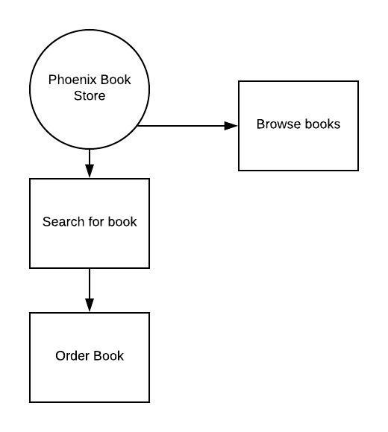

**b)     Level 1 diagrams**

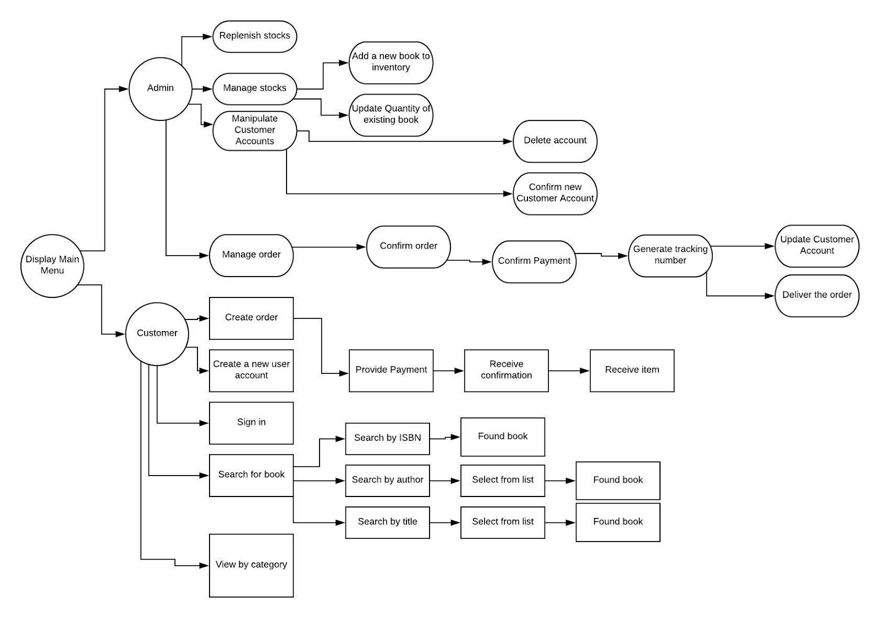

**2.3  Class Modeling**

**a)  Initial Class Diagram**

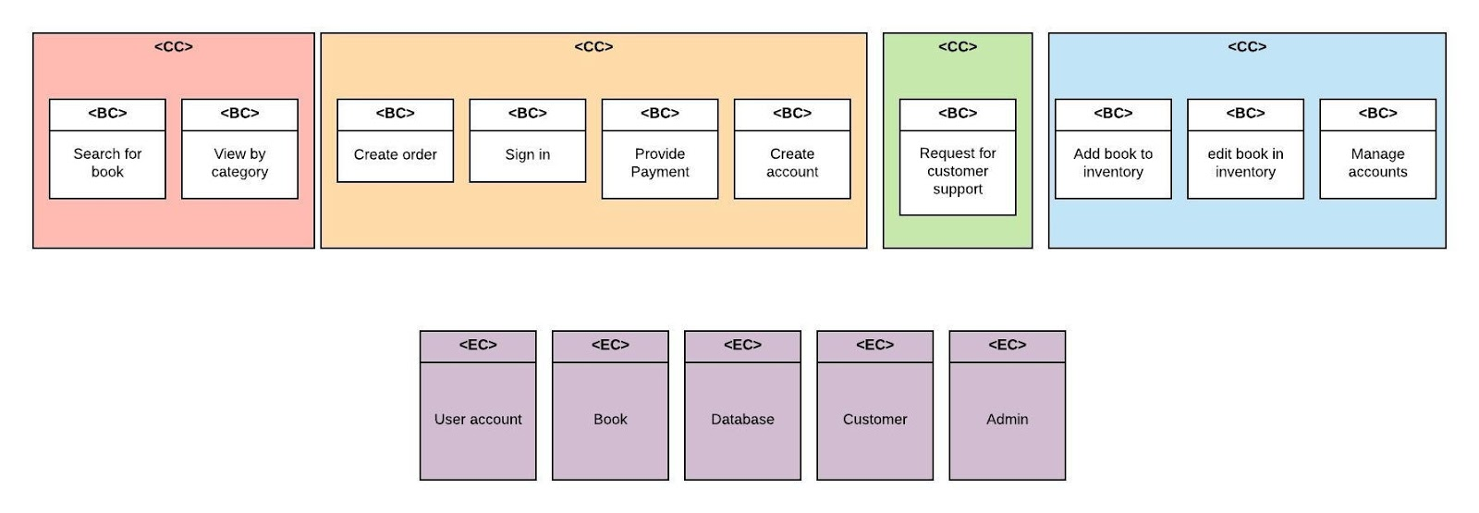

**b) simplified/modified Class Diagram**

***class searchForBook***

***class userMenu***

***class contactSupport***

***class adminMenu***