HW2_2

1_A:

projection matrix =

[[ 0.10324201 -0.01852856 -0.02920487 0.24432505]

[-0.00502912 0.0196838 -0.12314396 0.80625995]

[ 0.00001827 -0.00015889 -0.00014579 0.00267524]]

1_B:

K =

[[464.14857662 -6.47987459 194.05429 ]

[ 0. 483.35687002 314.59901327]

[ 0. 0. 1. ]]

R =

[[-0.99108743 -0.13179146 0.01940934]

[ 0.10303464 -0.66603126 0.73877346]

[-0.08443681 0.73418892 0.67367429]]

T =

[[ 2.74065896]

[ 0.33810642]

[-12.36184469]]

1_C:

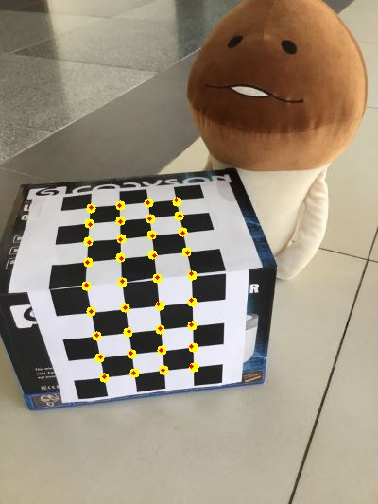

root-mean-squared errors =

0.5655096737344247

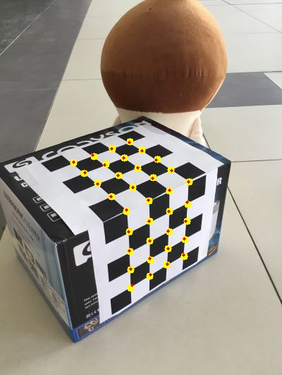

root-mean-squared errors =

0.7429265148241441

1_D:

沒做

2_A:



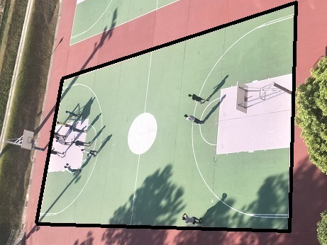



2_B:

Forward:



Backward:



2_C:

Forward1:

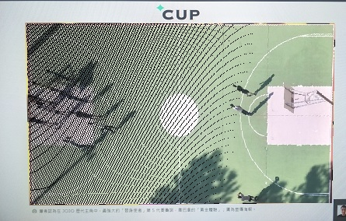  
forward1:

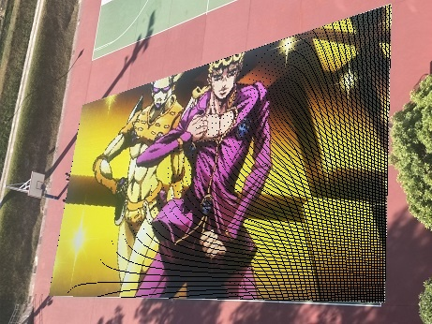

Backward1:

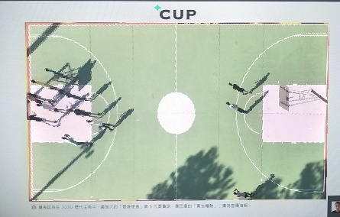

Backward2:



2_D:

可以看到，forward有些點換mapping不到，因此造成黑(白)線，而backward則沒有此問題