Computer Graphics and Multimedia – Work Package 3
Master's Degree in Engineering – 2026/2027
Students: Oriol Ferrer and Cesc Sierra
This report shows the Unity 3D project (URP) built for WP3: a randomly generated 3D maze, a physics-driven Remy character that collects food, a bouncy ball throwing mechanic, destructible blocking walls, the new Input System and particle effects.
Task 1. Move the map to 3D graphics
A new 3D (URP) project was created. The random maze is generated with a depth-first backtracker (MazeGenerator) and built in 3D with wall and floor prefabs (Maze3DBuilder).
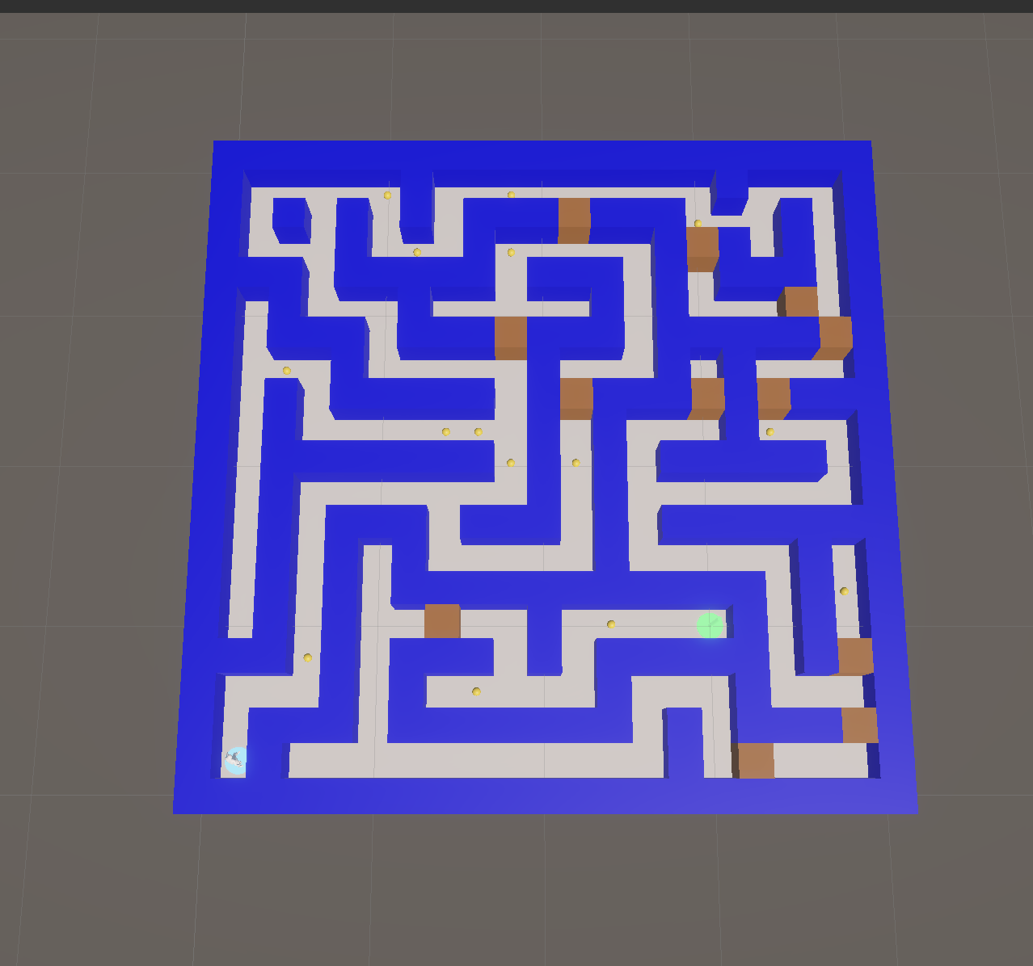
Figure 1. Randomly generated maze represented in 3D. The blue pad marks the start.

Task 2. 3D character and 3D food
Food items are spawned in random corridor cells. Remy moves with a Rigidbody (free, physics-enabled movement relative to the camera) and the walls prevent him from leaving the map.
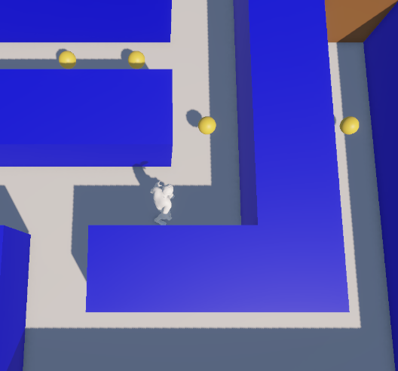
Figure 2. Remy moving along a corridor towards a food element.
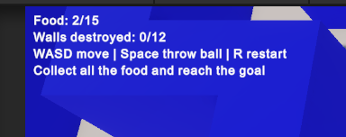
Figure 3. Food counter updated after collecting an item.

Task 3. "Throw ball" mechanic
The bouncy ball is a small black sphere with a Rigidbody and a Physics Material with bounciness 1 assigned to its collider, saved as a prefab asset. Pressing the space bar plays the throw animation and launches the ball forward.
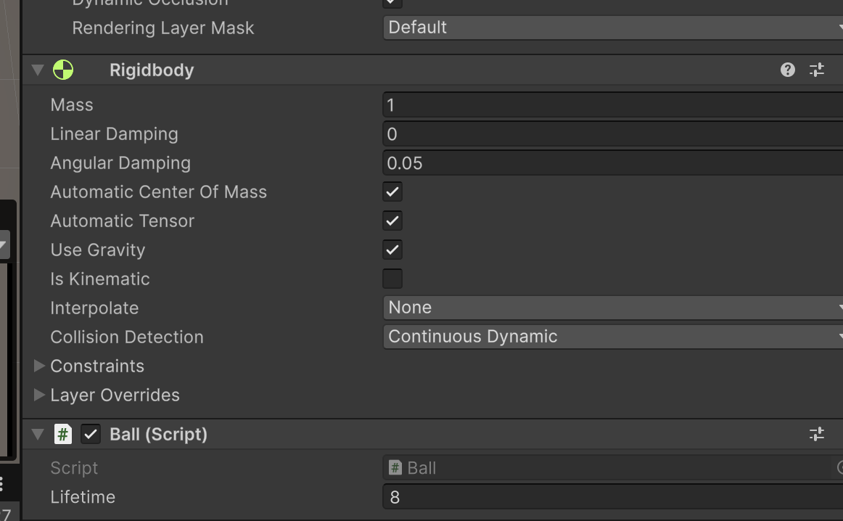Figure 4. Ball prefab: Rigidbody and sphere collider using the BouncyBall physics material.

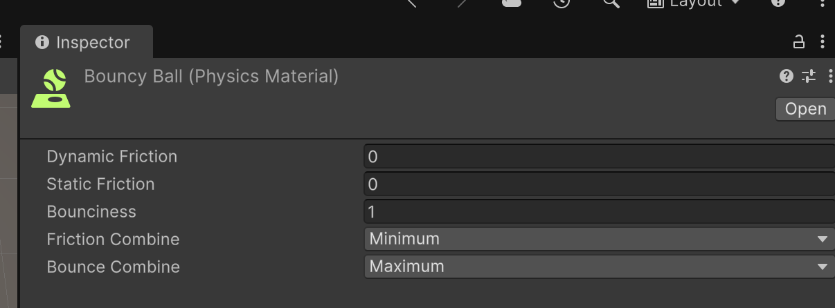
Figure 5. Physics Material with bounciness set to 1.
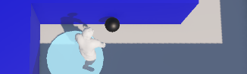
Figure 6. Remy plays the throw animation and the ball is launched in the forward direction.
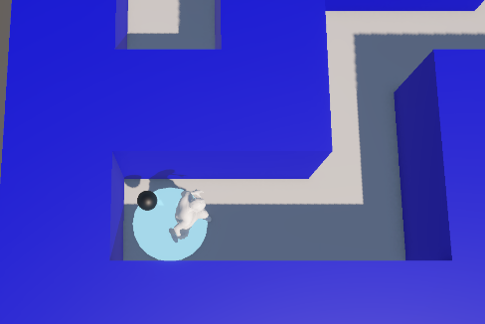
Figure 7. The ball bounces off the normal walls.

Task 4. Destructible blocking walls
Destructible walls (brown) are spawned randomly in straight corridor cells and block the path. They can only be removed by hitting them with a ball.
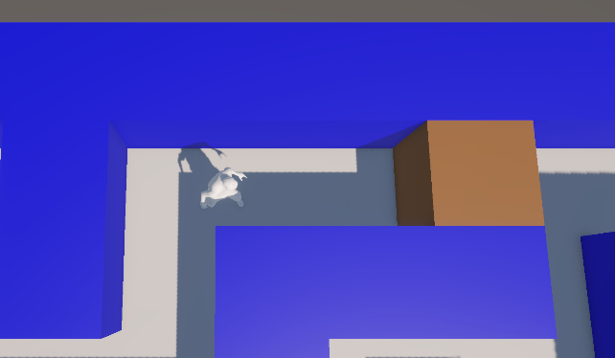
Figure 8. A destructible wall blocking the corridor.
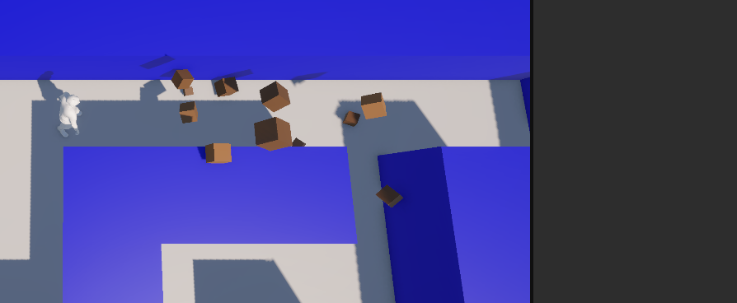
Figure 9. The wall is destroyed by a ball, with particles and physical debris.

Task 5. Additional requirements
New Input System: movement (WASD / arrows / gamepad stick), throwing (space / gamepad button) and restart (R) use InputActions; the project is configured to use only the new Input System.
Particle system: bursts are created at runtime (Effects.cs) when food is collected, when a wall breaks and when the goal is reached.
Additional contributions
• Start pad and goal pad (the goal is the farthest reachable cell and only counts once all the food is collected).
• HUD with food and wall counters, hints and win message.
• Elevated follow camera, so it never goes through the walls.
• Physical debris when a wall is destroyed; smooth acceleration and wall sliding for the player.

