Maryland Labour Stike Analysis
Michael V Cumbo
2025-08-04

Introductions

data updated on Monday, 7th July 2025
This report details the strike activity that has taken place in Maryland,and the number of the strikes and the labor unions involved. Thanks to Cornell university and the research team providing the data.
The chart below indicates the number of Labor Strikes that have occurred in region over the past year, it does this by counting the number of strikes associated with a given region. Data is updated on a month to month basis, the current month will not be represented within the data.
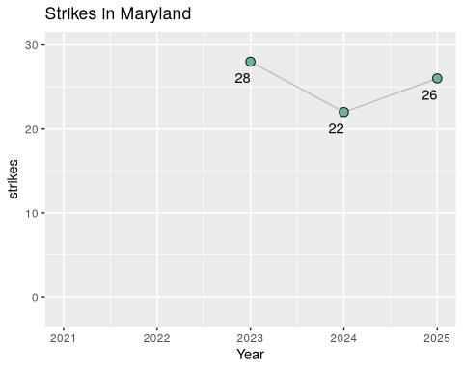

Strikes from formalized labor unions
Below is a list of labor organization who have gone on strike within the state, along with their reasons for striking. Please note that there are additional records in the charts not included here, which could be strikes conducted without a formalized labor organization. Data is updated on a month to month basis, the current month will not be represented within the data.
41 records
Labor Organization | Worker Demands | Year
Workers United | First contract;Cancel Dress Code Change | 2025
The American Federation of State, County, and Municipal Employees (AFSCME) | Health and safety;Against funding cuts;Passing of labor-friendly legislation | 2025
Teamsters (IBT) | Pay;Healthcare;Reinstate terminated worker | 2025
Teachers and Researchers United (TRU-UE) | Academic freedom;Protection of international workers | 2025
Teachers Association of Baltimore County (TABCO) â€“ NEA | Pay;End to budget cuts | 2025
Service Employees International Union (SEIU) | Health and safety;Healthcare;Pay | 2025
National Nurses United (NNU) | Staffing;Health and safety;Job Security;First contract | 2025
Graduate Labor Union (GLU) - UAW | First contract;Union recognition;Right to collectively bargain | 2025
American Federation of State, County, and Municipal Employees (AFSCME) | Health and safety;Enact the Davis Martinez Public Employee Safety and Health Act | 2025
American Federation of State, County and Municipal Employees (AFSCME) | Protect private Social Security information | 2025
American Federation of Labor and Congress of Industrial Organizations (AFL-CIO), American Federation of Government Employees (AFGE), American Federation of State, County and Municipal Employees (AFSCME) | Against Mass Layoffs;Anti Corruption;Against Federal Funding Cuts;Protections for workers | 2025
Amalgamated Transit Union (ATU) | Pay | 2025
ZeniMax Workers United - Communication Workers of America (CWA) | Job Security;Remote Work Protections | 2024
UNITE HERE | Pay;Staffing;Restore Guest Services | 2024
National Nurses Organizing Committee/National Nurses United (NNOC/NNU) | Pay;Health and safety;Staffing;Job Security;Maintenance of of all facilities and services in the community for the duration of the contract; Patient financial protections | 2024
Maryland/DC AFL-CIO | Expand the right to collectively bargain; End wage theft | 2024
International Longshoreman’s Association (ILA) | Pay;Job Security | 2024
International Association of Machinists (IAM) | Pay;Seniority | 2024
United Food and Commercial Workers (UFCW) | Pay;Union recognition | 2023
United Food & Commercial Workers (UFCW) | Pay;Health and safety;End anti-union retaliation; paid time off; increase sick leave | 2023
United Auto Workers (UAW) | Pay;Healthcare;Health and safety;Job Security;Retirement benefits;Scheduling | 2023
Teachers Association of Baltimore County (TABCO) - NEA | Pay;Fair workload; Include specialized instructors and support personnel | 2023
Southwest Airlines Pilots Association (SWAPA) | Pay;Staffing | 2023
One Fair Wage; Service Employees International Union (SEIU); UNITE HERE | Pay | 2023
Graduate Labor Union (GLU); American Association of University Professors (AAUP) | Pay;Union recognition | 2023
Association of State, County, and Municipal Employees (ASCME) | Pay;Health and safety;Job Security;Scheduling;end worker harassment | 2023
Teamsters | Pay | 2022
Teachers Association of Anne Arundel County - NEA - | Staffing;Do not hire contract employees to fill the gaps in special education and ESOL vacancies | 2022
Teachers & Researchers United (TRU) | Pay;Union recognition | 2022
Montgomery County Education Association (MCEA) | Union recognition;End to unlawful delay tactics | 2022
Laborersâ€™ International Union of North America (LIUNA) | Honor existing project labor agreement | 2022
American Postal Workers Union (APWU) | Standardize vote-by-mail rules | 2022
American Federation of Government Employees (AFGE) | Pay;reduction of workload | 2022
Amazonians United | Pay;Longer breaks | 2022
Unemployed Workers’ Union | Pandemic Relief | 2021
Unemployed Workers Union; Peoples Power Assembly | Pandemic Relief | 2021
The Washington-Baltimore News Guild - CWA | Nonprofit ownership | 2021
The NewsGuild - CWA | Prevent sale of Tribune Publishing to Alden Global Capital | 2021
Peopleâ€™s Power Assembly | Pandemic Relief | 2021
National Education Association | COVID-19 protocols;Health and safety | 2021
Maryland State Education Association - NEA | Fully fund school budget | 2021

Charts of Number of Strikes per each year
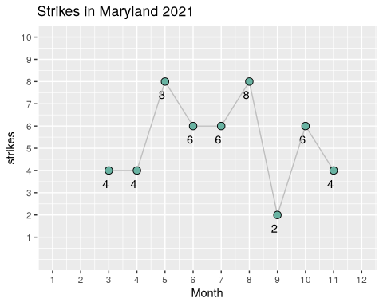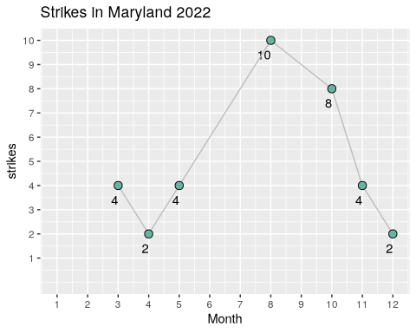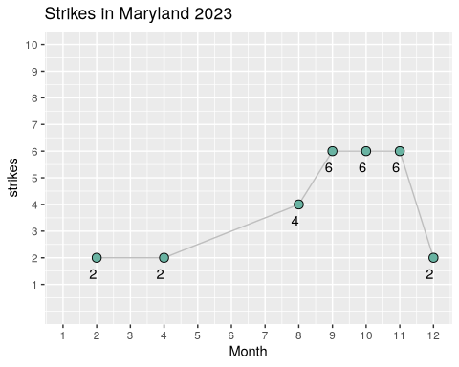
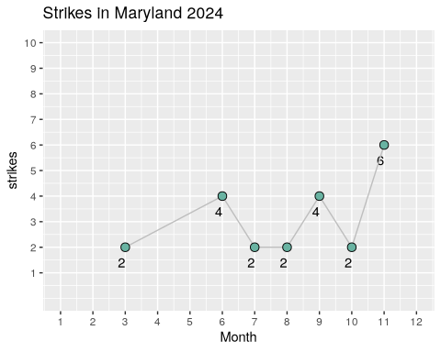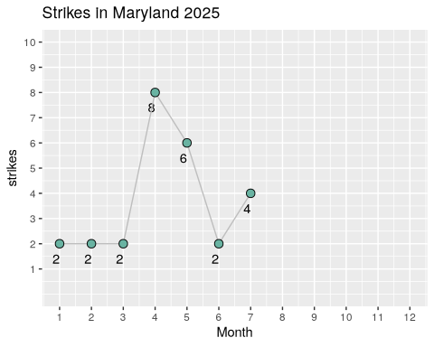

Citation
Kallas, J., Iyer, D. K., & Friedman, E. (2025). “Labor Action Tracker” Cornell University ILR School & University of Illinois LER School. Addison Wesley, Massachusetts, 2nd Edition, 1994.

