Maryland Labour Stike Analysis

Michael V Cumbo

2025-08-04

### Introductions

##### data updated on **Monday, 7th July 2025**

This report details the strike activity that has taken place in Maryland,and the number of the strikes and the labor unions involved. Thanks to Cornell university and the research team providing the data.

The chart below indicates the number of Labor Strikes that have occurred in region over the past year, it does this by counting the number of strikes associated with a given region. Data is updated on a month to month basis, the current month will not be represented within the data.

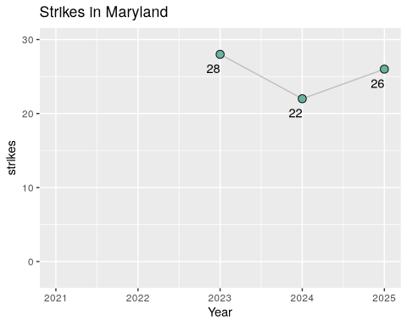

#### Strikes from formalized labor unions

Below is a list of labor organization who have gone on strike within the state, along with their reasons for striking. Please note that there are additional records in the charts not included here, which could be strikes conducted without a formalized labor organization. Data is updated on a month to month basis, the current month will not be represented within the data.

41 records

| Labor Organization | Worker Demands | Year |
| --- | --- | --- |
| Workers United | First contract;Cancel Dress Code Change | 2025 |
| The American Federation of State, County, and Municipal Employees (AFSCME) | Health and safety;Against funding cuts;Passing of labor-friendly legislation | 2025 |
| Teamsters (IBT) | Pay;Healthcare;Reinstate terminated worker | 2025 |
| Teachers and Researchers United (TRU-UE) | Academic freedom;Protection of international workers | 2025 |
| Teachers Association of Baltimore County (TABCO) â€“ NEA | Pay;End to budget cuts | 2025 |
| Service Employees International Union (SEIU) | Health and safety;Healthcare;Pay | 2025 |
| National Nurses United (NNU) | Staffing;Health and safety;Job Security;First contract | 2025 |
| Graduate Labor Union (GLU) - UAW | First contract;Union recognition;Right to collectively bargain | 2025 |
| American Federation of State, County, and Municipal Employees (AFSCME) | Health and safety;Enact the Davis Martinez Public Employee Safety and Health Act | 2025 |
| American Federation of State, County and Municipal Employees (AFSCME) | Protect private Social Security information | 2025 |
| American Federation of Labor and Congress of Industrial Organizations (AFL-CIO), American Federation of Government Employees (AFGE), American Federation of State, County and Municipal Employees (AFSCME) | Against Mass Layoffs;Anti Corruption;Against Federal Funding Cuts;Protections for workers | 2025 |
| Amalgamated Transit Union (ATU) | Pay | 2025 |
| ZeniMax Workers United - Communication Workers of America (CWA) | Job Security;Remote Work Protections | 2024 |
| UNITE HERE | Pay;Staffing;Restore Guest Services | 2024 |
| National Nurses Organizing Committee/National Nurses United (NNOC/NNU) | Pay;Health and safety;Staffing;Job Security;Maintenance of of all facilities and services in the community for the duration of the contract; Patient financial protections | 2024 |
| Maryland/DC AFL-CIO | Expand the right to collectively bargain; End wage theft | 2024 |
| International Longshoreman’s Association (ILA) | Pay;Job Security | 2024 |
| International Association of Machinists (IAM) | Pay;Seniority | 2024 |
| United Food and Commercial Workers (UFCW) | Pay;Union recognition | 2023 |
| United Food & Commercial Workers (UFCW) | Pay;Health and safety;End anti-union retaliation; paid time off; increase sick leave | 2023 |
| United Auto Workers (UAW) | Pay;Healthcare;Health and safety;Job Security;Retirement benefits;Scheduling | 2023 |
| Teachers Association of Baltimore County (TABCO) - NEA | Pay;Fair workload; Include specialized instructors and support personnel | 2023 |
| Southwest Airlines Pilots Association (SWAPA) | Pay;Staffing | 2023 |
| One Fair Wage; Service Employees International Union (SEIU); UNITE HERE | Pay | 2023 |
| Graduate Labor Union (GLU); American Association of University Professors (AAUP) | Pay;Union recognition | 2023 |
| Association of State, County, and Municipal Employees (ASCME) | Pay;Health and safety;Job Security;Scheduling;end worker harassment | 2023 |
| Teamsters | Pay | 2022 |
| Teachers Association of Anne Arundel County - NEA - | Staffing;Do not hire contract employees to fill the gaps in special education and ESOL vacancies | 2022 |
| Teachers & Researchers United (TRU) | Pay;Union recognition | 2022 |
| Montgomery County Education Association (MCEA) | Union recognition;End to unlawful delay tactics | 2022 |
| Laborersâ€™ International Union of North America (LIUNA) | Honor existing project labor agreement | 2022 |
| American Postal Workers Union (APWU) | Standardize vote-by-mail rules | 2022 |
| American Federation of Government Employees (AFGE) | Pay;reduction of workload | 2022 |
| Amazonians United | Pay;Longer breaks | 2022 |
| Unemployed Workers’ Union | Pandemic Relief | 2021 |
| Unemployed Workers Union; Peoples Power Assembly | Pandemic Relief | 2021 |
| The Washington-Baltimore News Guild - CWA | Nonprofit ownership | 2021 |
| The NewsGuild - CWA | Prevent sale of Tribune Publishing to Alden Global Capital | 2021 |
| Peopleâ€™s Power Assembly | Pandemic Relief | 2021 |
| National Education Association | COVID-19 protocols;Health and safety | 2021 |
| Maryland State Education Association - NEA | Fully fund school budget | 2021 |

### Charts of Number of Strikes per each year

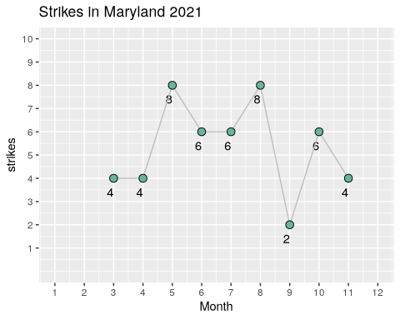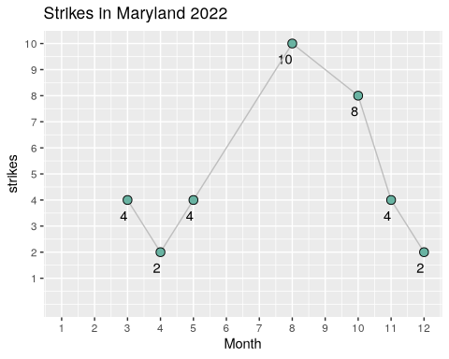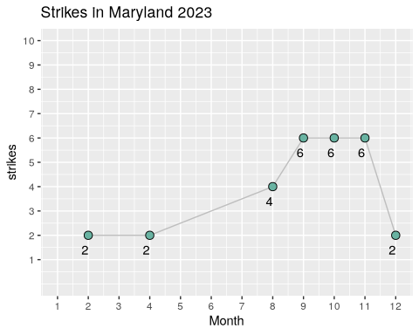

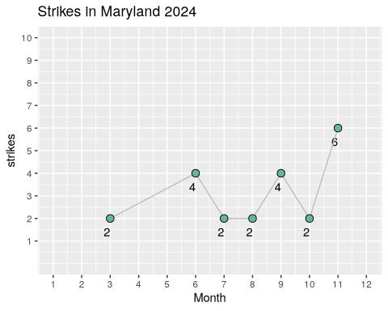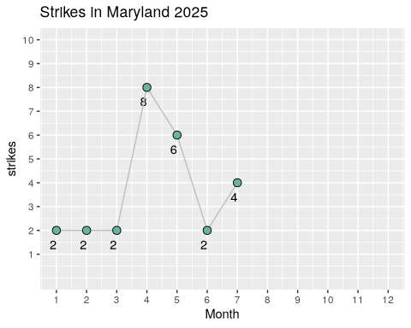

##### Citation

Kallas, J., Iyer, D. K., & Friedman, E. (2025). “Labor Action Tracker” Cornell University ILR School & University of Illinois LER School. Addison Wesley, Massachusetts, 2nd Edition, 1994.