Top Hits
Software Documentation
DB Scheme Structure
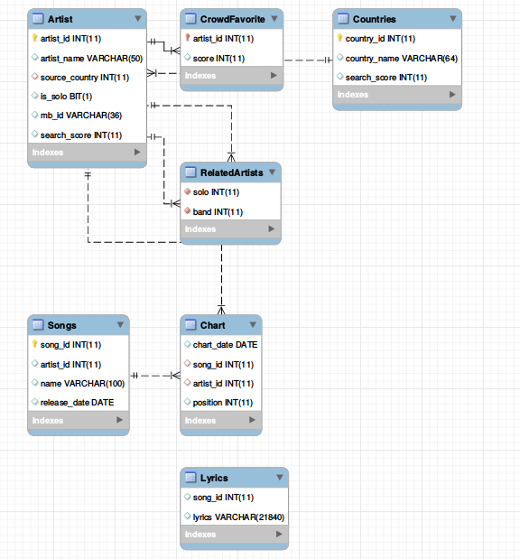

The design is pretty straightforward, we constructed the tables with the information required for our application: songs, lyrics, countries of origin and artists. The Chart table contains songs/artists IDs listed in accordance with their appearance at the top charts tables of billboard.com. We’ll go over the nontrivial information stored in our DB.
We store, and later use, connections between individual artists and their bands in the RelatedArtists table. This is done by processing the information received from musicbrainz.com, one of our sources, which provides artists membership in a band or a group. We later use this information in artists based searches.
Additionally, we store the value of mb_id, which is the ID used by musicbrainz.com, since artists are commonly referred to by different aliases, yet their ID remains the same.
Optimizations
We tried avoiding superfluous information by linking the tables using only IDs, which are merely integers.
We use indexes on the information searched the most, mainly Ids in the Chart and RelatedArtists tables. We use additional indexes for our full search query on the Lyrics table, and the MyISAM engine which is required for this index.
We also chose to index mb_id, since it is queried extensively during the construction of our DB.

Queries
1.
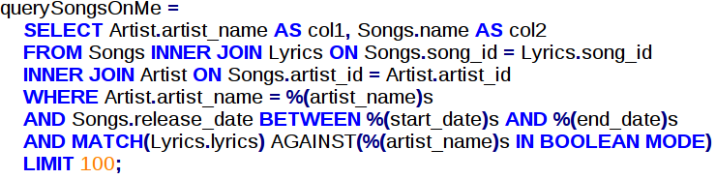
Returns songs in which the artist name appears in their lyrics. The indexing on songs and artists IDs helps optimize this query.

2.
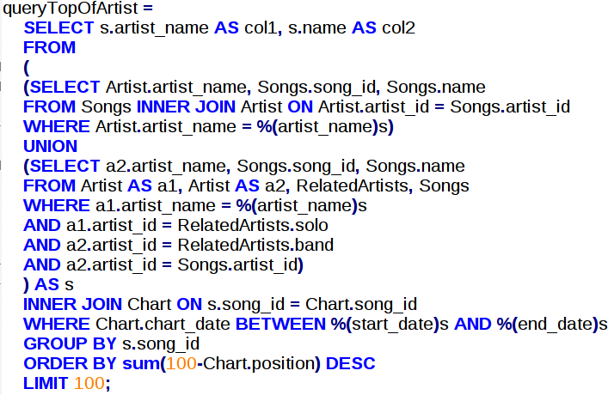

Returns the top charted songs in a specific timeframe based on its artist/band. Indexing on artist, song and chart tables IDs optimizes the query.

3.
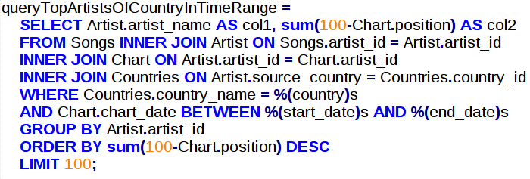
Returns the artists whose songs are top charted during the timeframe in a specific country. Same optimization considerations as in the previous queries.

4.
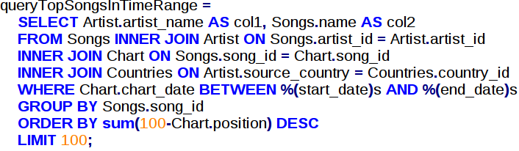
Returns the top charted songs in a certain timeframe.
5.
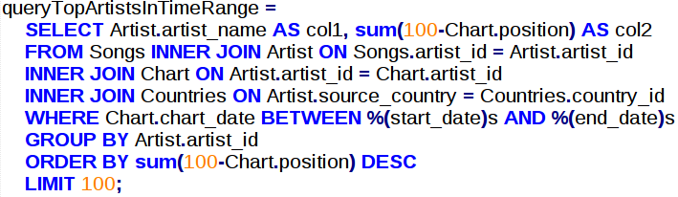
Same as 4, but based on artists.

6.
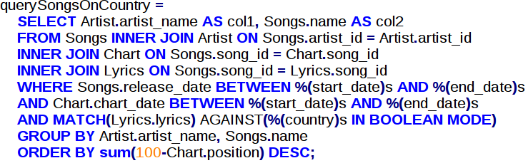
Returns songs that contain the given country. The fulltext index on the lyrics at the Lyrics table helps optimize this query (along with the indexing on IDs as in the previous queries).
7.
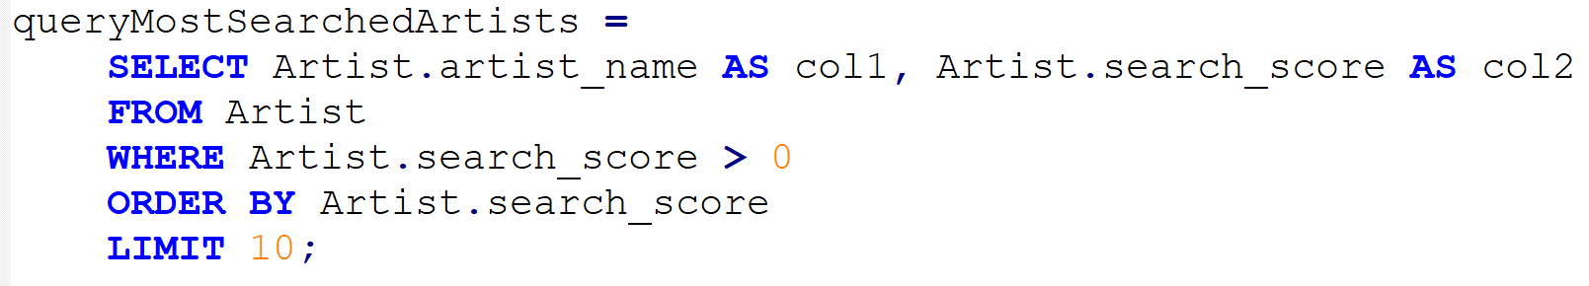
Returns the 10 (or less) most searched artists by the users of the web API.

8.
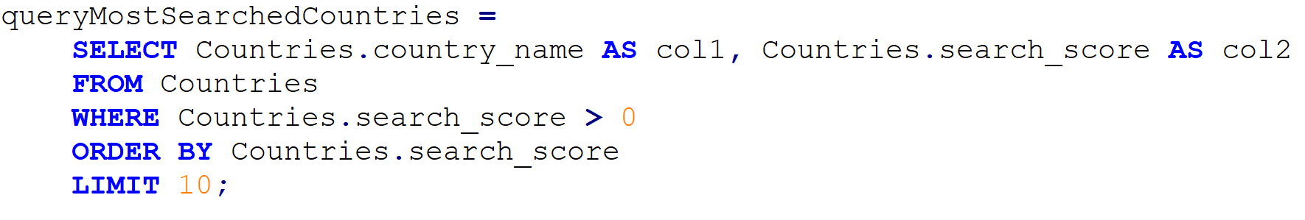
Returns the 10 (or less) most searched countries by the users of the web API.

9.
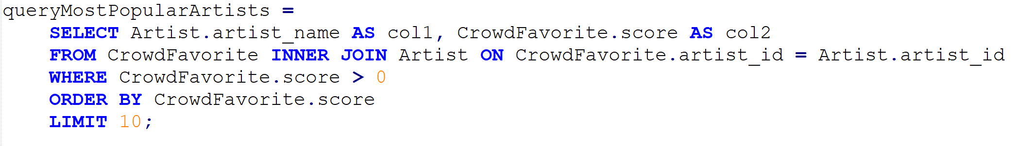
Returns the 10 (or less) searched artists with the highest scores (> 0), as voted by the users of the web API.

Code Structure
filler.py – Main python code used to populate the initial database. It pulls data from the various APIs, performs necessary parsing and analysis, and injects it to the DB. Full documentation of each method used is within the file itself.
fix_lyrics.py – After discovering that the lyrics provided by lyrics.ovh are inserted with a fixed erroneous prefix (sometimes containing the name of the artist, or just padded with superfluous chars), we wrote this script to clean the DB from this unnecessary additions.
server.py – The server side code.
queries.py – Queries used by the server side code. Partly documented in this file above, fully documented within the code itself.
Client side code - ?

APIs
billboard.com - keeps record of all the top charted songs since 1970. Its API allows the extraction of the artists and song names who appeared in those charts, returned from a search based on charts’ dates. We parsed this information, injected it to our website and expanded on it.

musicbrainz.com – collects information about songs/artists, including their membership in a band, and various aliases.

lyrics.ovh – provided the lyrics for the songs.

External Packages/Libraries
The billboard.com and musicbrainz.com APIs come in the form of external python packages. We imported them into our filler.py file, and used them to extract the required data. An additional external package required for the use of billboard.com API is BeautifulSoup, which is used to parse web pages.
client side libraries/packages?

General Flow
The database is populated with data by filler.py. This is a one-time process, which injects the top charts information of the last 50 years.
Afterwards the website itself is accessible via http://delta-tomcat-vm.cs.tau.ac.il:40663, the description of its use is fully detailed in the user manual.
Some information in the database, mainly search and user rank statistics, can be updated by the user post the population described above.

