Top Hits
Software Documentation
DB Scheme Structure
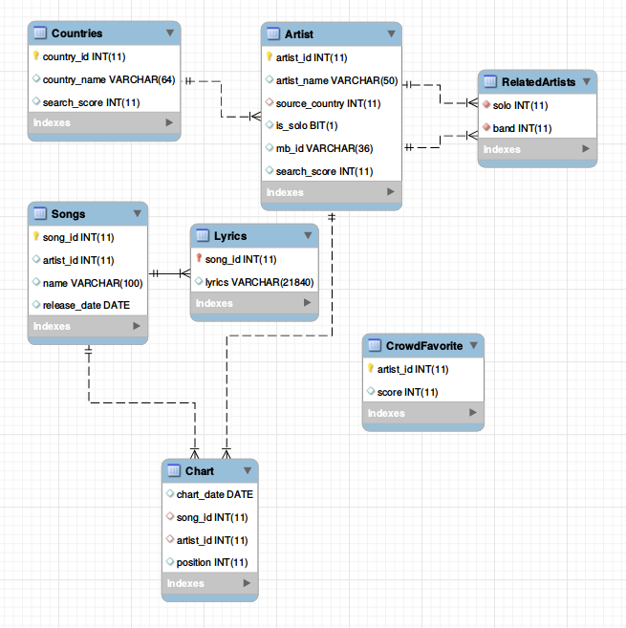

The design is pretty straightforward, we constructed the tables with the information required for our application: songs, lyrics, countries of origin and artists. The Chart table contains songs/artists IDs listed in accordance with their appearance at the top charts tables of billboard.com. We’ll go over the nontrivial information stored in our DB.
We store, and later use, connections between individual artists and their bands in the ‘RelatedArtists’ table. This is done by processing the information received from musicbrainz.com, one of our sources, which provides artists membership in a band or a group. We later use this information in artist-based searches.
Additionally, we store the value of mb_id, which is the ID used by musicbrainz.com, since artists are commonly referred to by different aliases, yet their ID remains the same.
We use ‘CrowdFavorite’ table to keep track on the users aggregated scores for each artist. Since most artist in ‘Artist’ table will probably not be voted, we decided to initialize an empty table and add rows to it according to the users votes.

Optimizations
We tried avoiding superfluous information by linking the tables using only IDs, which are merely integers.
We use indexes on the information searched the most, mainly Ids in the Chart and RelatedArtists tables. We use additional indexes for our full search query on the Lyrics table, and the MyISAM engine which is required for this index.
We also chose to index mb_id, since it is queried extensively during the construction of our DB.

Queries
1. For a given artist, returns all the song where his name appears that were sung by him or by any band he was in.
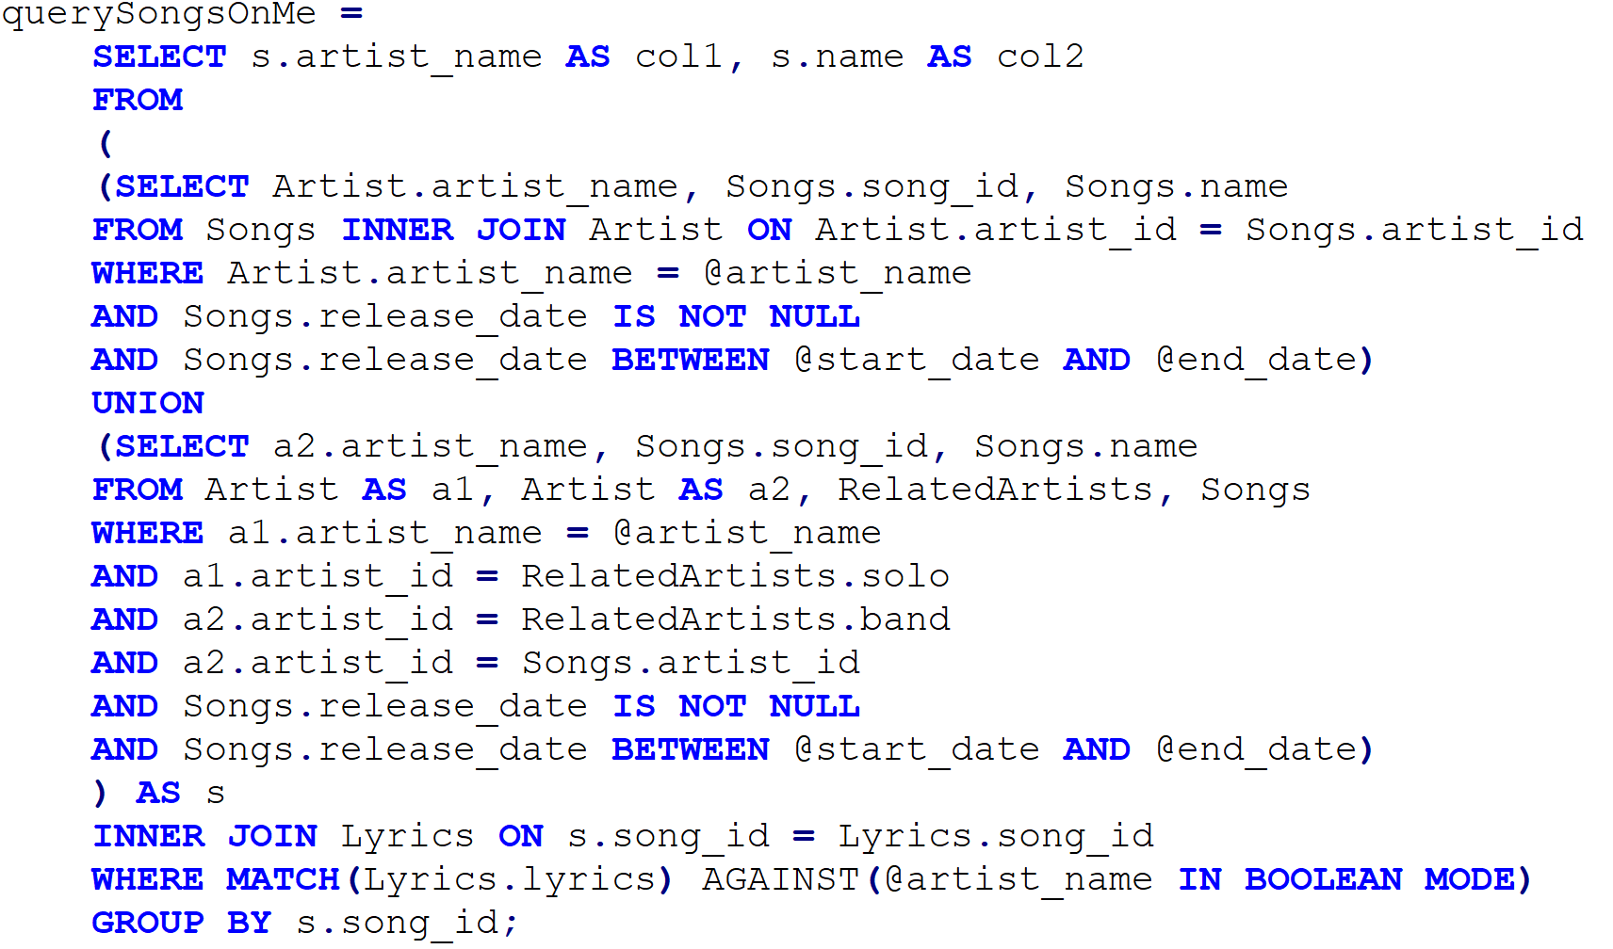
Both ‘Artist’ and ‘Songs’ tables are indexed by ‘artist_id’, to make the queries faster.
Also, ‘Lyrics’ table has FullText index to allow full-text search.
Since the ‘Match Against’ takes the most time, we do it only after filtering by all the other conditions.

2. Returns the top charted songs in a specific timeframe based on its artist/band.
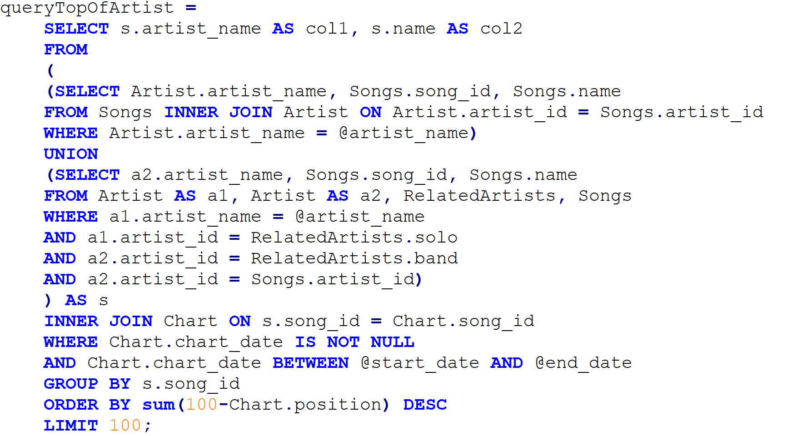
Just like in previous query, ‘Artist’ table is indexed by ‘Artist.artist_name’, ‘Songs’ is indexed by ‘Songs.artist_id’, which optimizes the JOIN between those two tables.
‘RelatedArtist’ is indexes by ‘RelatedArtist.solo’ to optimize the WHERE clause in the second part of the UNION.
Also, ‘Chart’ is indexed by ‘Chart.chart_date’ to filter faster based on dates.

3. Top 10 best years of artist, including as part of a band.
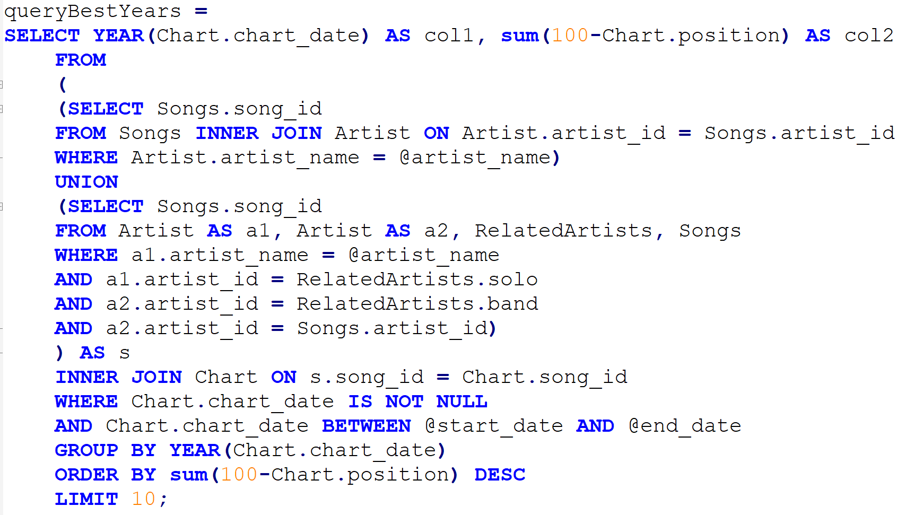
In contrast to the previous queries, in this one the UNION returns only the relevant song_ids of an artist, since the end result is a table with the year and the artist total score.
The same optimizations are applied here.

4. Returns the artists whose songs are top charted during the timeframe in a specific country.
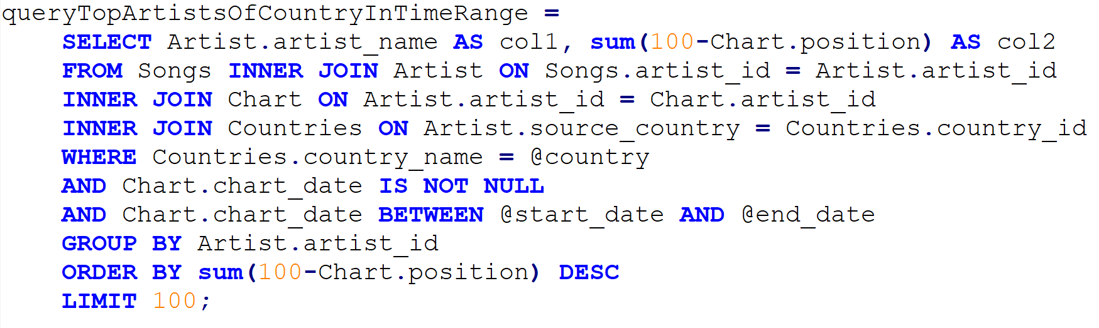 Same optimization considerations as in the previous queries.
Also, ‘Countries’ is indexed by ‘Countries.country_name’ to find the relevant country_id faster.

5. Returns the top charted songs in a certain timeframe.
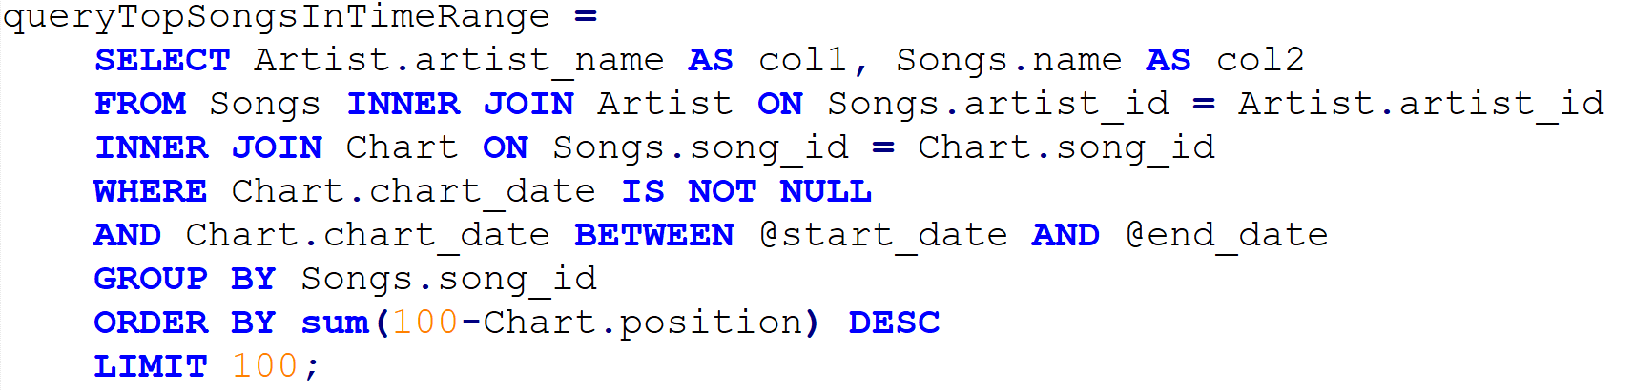
Same optimization considerations as in the previous queries.

6. Returns the top artists in a certain timeframe.
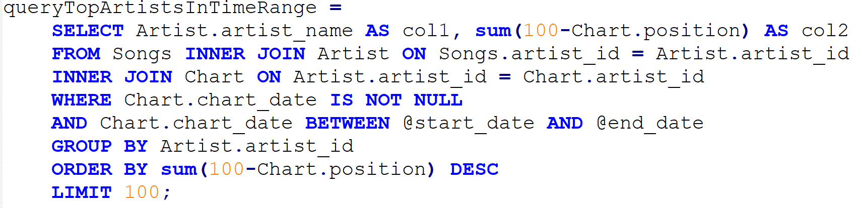
Same as the previous query, only based on artists.

7. Returns songs that contain the given country in the lyrics.
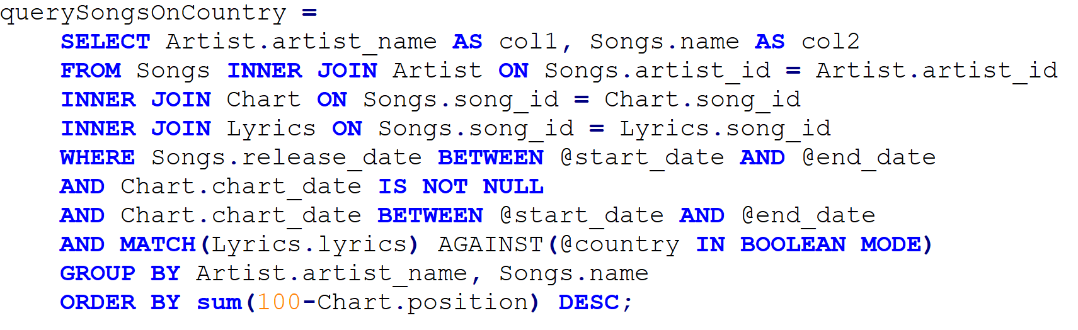
The fulltext index on the lyrics at the ‘Lyrics’ table helps optimize this query (along with the indexing on IDs as in the previous queries).
The results are ordered by their score, since as in other queries, we wish to present the top songs first.

8. Returns the 10 (or less) most searched artists by the users of the web API.
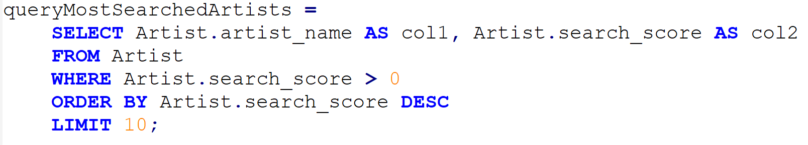

Since the search-score is changeable, and the query depends on a single table, we decided there was no need for optimization.

9. Returns the 10 (or less) most searched countries by the users of the web API.
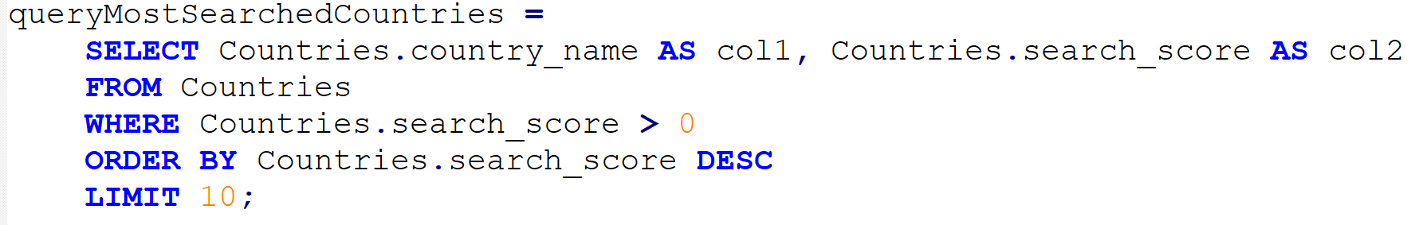
Since the search-score is changeable, and the query depends on a single table, we decided there was no need for optimization.

10. Returns the 10 (or less) searched artists with the highest scores (> 0), as voted by the users of the web API.
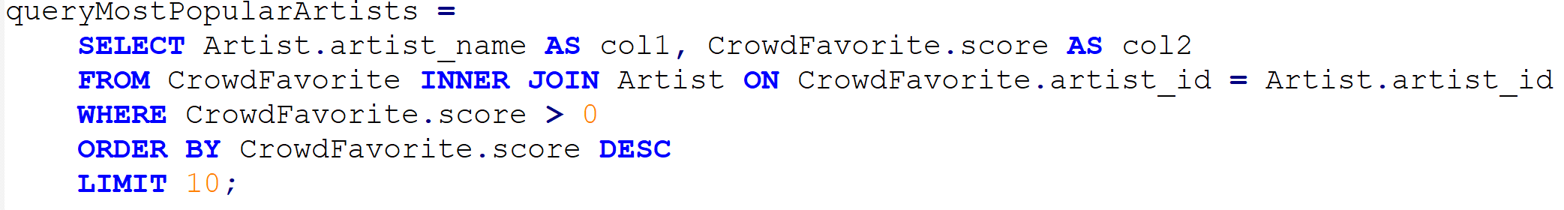
The index on ‘Artist.artist_id’ helps make the JOIN faster.

11. Update the number of searches for an artist.
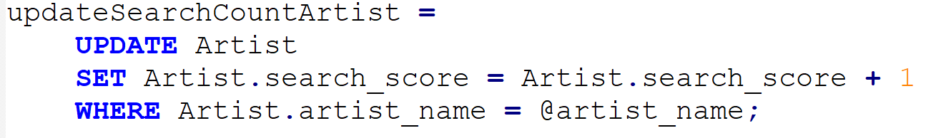
Each time the user searches for a specific artist, we increment his search_count by one.

12. Update the number of searches for a country.
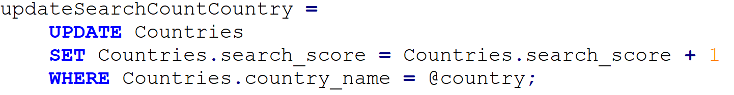
Each time the user searches for a specific country, we increment its search_count by one.

13. Update the score of an artist based on users votes.
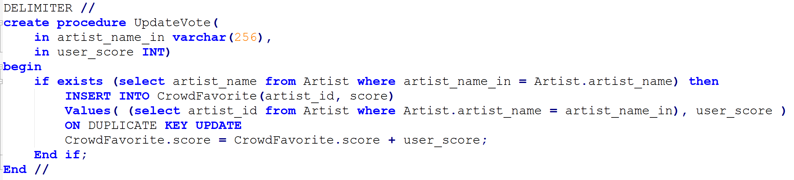
Since ‘CrowdFavorite’ table in empty at the beginning and we populate it according to users votes, we use INSERT … ON DUPLICATE KEY UPDATE to easily insert new rows for artist who got voted for the first time, or update their score if they already exist in the table.

Code Structure
create_schema.sql – Contains the code for creating the DB.
filler.py – Main python code used to populate the initial database. It pulls data from the various APIs, performs necessary parsing and analysis, and injects it to the DB. Full documentation of each method used is within the file itself.
fix_lyrics.py – After discovering that the lyrics provided by lyrics.ovh are inserted with a fixed erroneous prefix (sometimes containing the name of the artist, or just padded with superfluous chars), we wrote this script to clean the DB from those unnecessary additions.
server.py – The server side code. It uses flask with gevent.wsgi
to handle multiple requests from users.
Each time a user submits a request, the server connects to the DB to handle it, and redirects the result to the appropriate url.
queries.py – Queries used by the server side code. Partly documented in this file above, fully documented within the code itself.
Client side code – The web API was written in HTML with the use of Bootstrap and Javascript.

APIs
billboard.com - keeps record of all the top charted songs since 1970. Its API allows the extraction of the artists and song names who appeared in those charts, returned from a search based on charts’ dates. We parsed this information, injected it to our website and expanded on it.

musicbrainz.com – collects information about songs/artists, including their membership in a band, and various aliases.

lyrics.ovh – provided the lyrics for the songs.

External Packages/Libraries
The billboard.com and musicbrainz.com APIs come in the form of external python packages. We imported them into our filler.py file and used them to extract the required data. An additional external package required for the use of billboard.com API is BeautifulSoup, which is used to parse web pages.

General Flow
The database is populated with data by filler.py. This is a one-time process, which injects the top charts information of the last 50 years.
Afterwards the website itself is accessible via http://delta-tomcat-vm.cs.tau.ac.il:40663, the description of its use is fully detailed in the user manual.
Some information in the database, mainly search and user rank statistics, can be updated by the user post the population described above.
The server reacts to each request made by the user. If the user searched by a country or an artist, it first updates the appropriate search_score before handling the actual request made by the user. The server queries the DB and then sends the result along other data needed by the API, to the client-side.

