Top Hits
User Manual
Overview
The Top Hits application gathers information on the top charted songs of the last 50 years (as collected by billboard.com, based on radio airplay, sales and streaming data). It allows the search and retrieval of top songs by timeframe, artist, country of origin and additional filters. In addition, the user can add personal score to its favorite songs. Finally, the application displays site statistics, based on the most searched artists and countries of origin, and on the highest user upvoted songs.
Application Screens
Please note: In addition to this manual, each page contains a fully detailed description of its use.
Home Page: A simple introduction to the site, with a navigation bar at its top. All pages are accessible via this navigation menu.
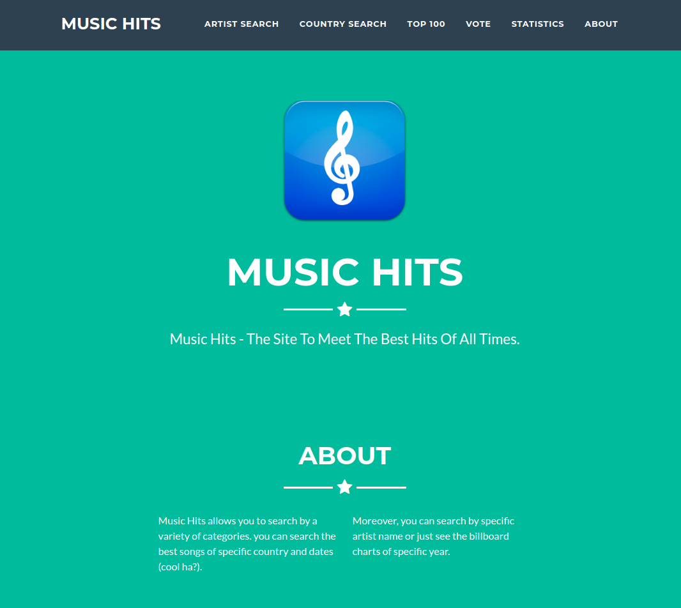
Search By Artist: Here the user can search top songs by filtering on dates combined with the artist’s name. Additional filters are songs of the best year in this frame, and Self Adored Songs, which contains songs in which the name of the artist himself appears.
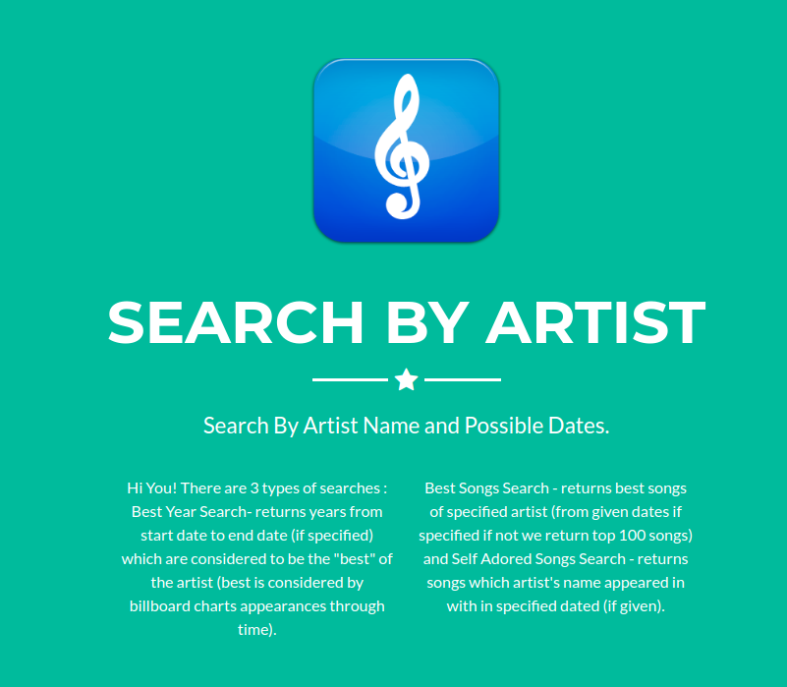
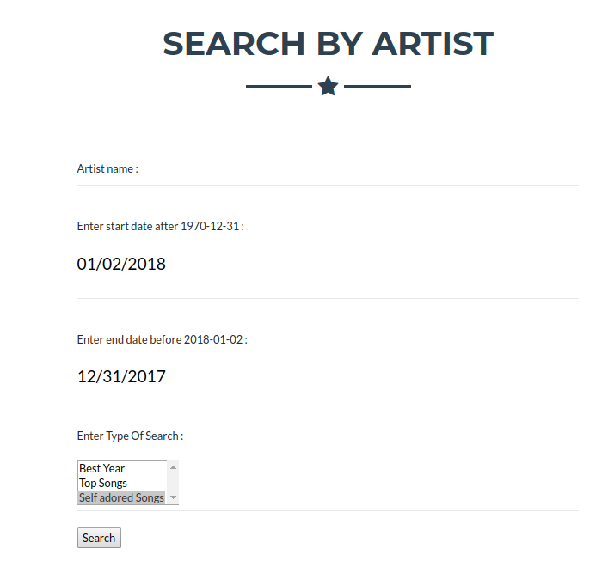

Search By Country: Search top artists by filtering on a combination of dates and countries of origin. Top singers are those who appeared most at the top charts at the searched timeframe and were born at the chosen country.
Also, search Patriotic Songs – songs in which the name of the chosen country appeared at their lyrics.
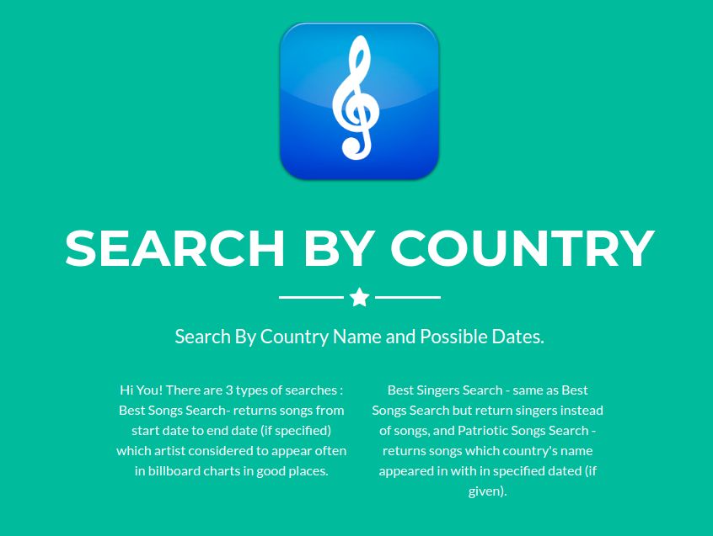

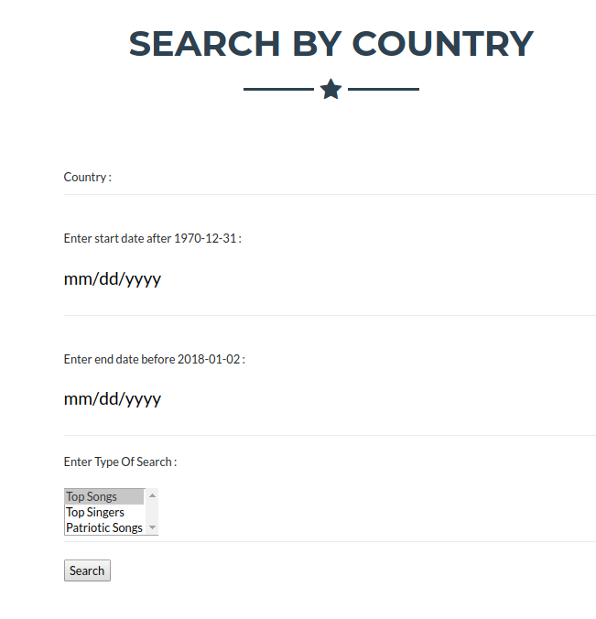

Top 100: Simply retrieve the top chart at a given timeframe, filtering on songs at those charts or their artists.
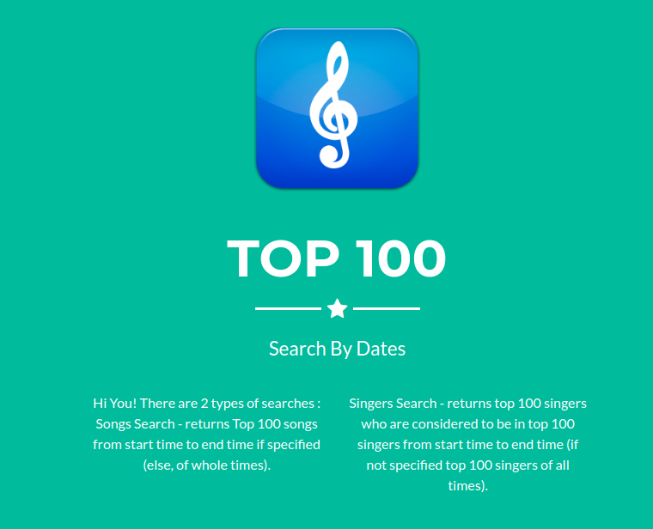

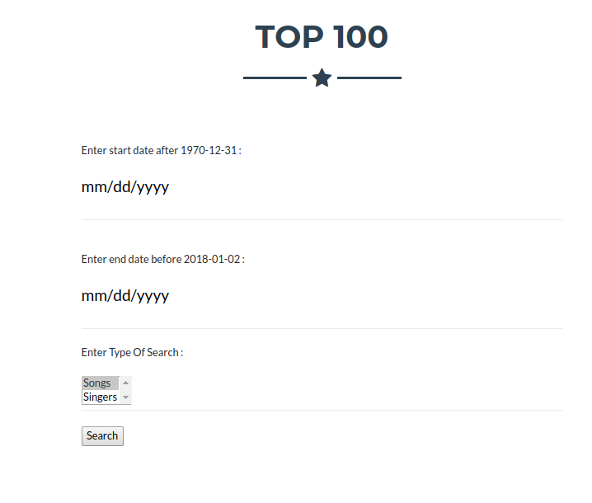

Statistics: In the statistics page, one can look for the most searched artists/countries, and the most popular songs by users’ votes.
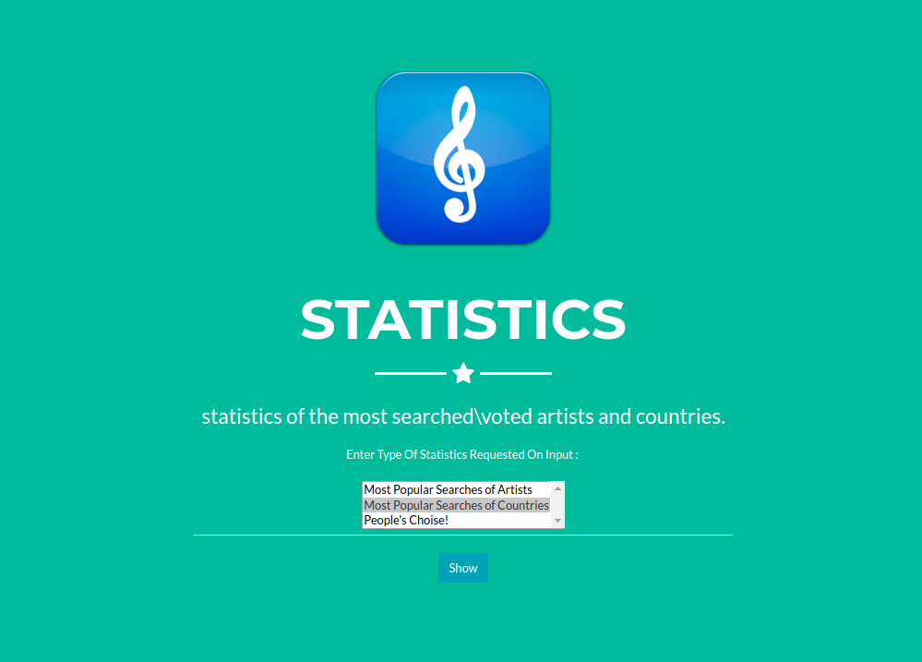

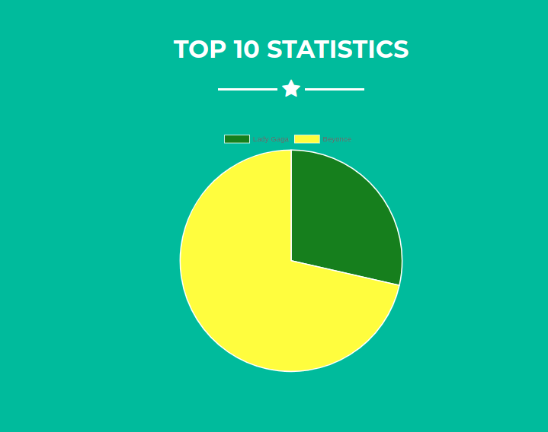

Updating DB via the Web UI:
There are two ways the user can update the database:
1. Rate its favorite song – user’s rating is updated in the CrowdFavorite table, and is used in the statistical analysis displayed at the Statistics page.
2. Perform searches – by performing searches the user is passively updating the search_score columns at the Countries and Artist tables.

Vote page:
