CURRICULUM VITAE

JOHN CHRISTIAN P. ORAA
Blk 36 Lot 05 Phase 02 Lakesidenest Subd., Brgy.
Banay Banay, City of Cabuyao, Laguna
johnoraa24@gmail.com
09077551198

PERSONAL DATA
Birthday : June 26, 1999
Sex : Male
Birthplace : Iriga City, Cam Sur
Mother’s Name : Neonita Oraa
Occupation : N/A
Father’s Name : Alfredo Oraa
Occupation : Decease
Religion : Roman Catholic
Civil Status : Single

WORK EXPERIENCE
Katecs Philippines Inc
On the job training
(January 2017 – March 2017)

Cabuyao Youth Development Affairs Office
On the job training
(November 2019– March 2020)

CHARACTER REFERENCES

Mr. John Patrick M. Ogalesco
09322038984
Former school dean
Pamantasan ng Cabuyao

TRAININGS AND SEMINARS ATTENDED

Globally We Need I.T.
July 25, 2015
Pamantasan ng Cabuyao

I hereby certify that the aforementioned information is true and correct to the best of my knowledge and belief.

JOHN CHRISTIAN P. ORAA
Applicant

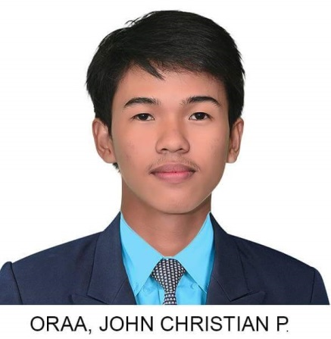

PROFILE

I am a diligent and highly motivated individual. I exhibit flexibility and able to learn quickly with a strong commitment to succeed in my career. I am optimistic, have the ability to communicate in an appropriate manner.

TECHNICAL SKILLS

Software Microsoft Office Applications (word, excel, access, publisher)

Programming C#, PHP, HTML5, CSS

EDUCATIONAL BACKGROUND

TERTIARY:
Bachelor of Science in Information Technology
Pamantasan ng Cabuyao
2015 up to 2020

Associate in Computer Technology
Pamantasan ng Cabuyao
2015 to 2017

SECONDARY:

Pulo National Highschool (PNHS)
Brgy. Pulo National Highway
2011 to 2015

PRIMARY:

Banay Banay Elementary School
Brgy. Banay Banay City of Cabuyao
2011 to 2015

