Instructions for use

Seed box (Light Sensor) Control with STM32
http://
Last updated .

Table of Contents
Summary 2
1. Introduction 2
1.1 LDR- Light Sensor 2
1.2 Moisture Sensor 2
1.3 BMP280- Temperature and Pressure Sensor 2
1.4 LCD 16x02 (4pin) 2
1.5 PUMP 3
1.6 Software and Hardware 3
1.7 LDR Data sheet 4
1.8 LCD pins functions 5
1.9 PUMP components 5
2. Commissioning of the system 6
2.1 The wiring of the system: 6
2.2 LDR connect with MCU 7
2.3 LCD 16x02 Interfacing 7
2.4 Pump wiring system 8
2.5 STM32 CubeMX set up 9
2.6 Visual Studio Code and Platformio setup: 9
2.7 Communication Using RS485 10
3. Functions 14
3.1 LDR functions 14
3.2 Moisture Functions 15
3.3 BMP280 functions 15
3.4 LCD functions 16
3.5 PUMP functions 20
4. Problem situations 21
4.1 Moisture Sensor data: 21
4.2 BMP280 21
4.3 LCD 16x02 21
5. Maintenance 21
6. Appendices 22
7. References 22
8. Glossary 22
ADC: Analog to Digital Converter 22
GPIO: General Purpose Input and Output 22
USART3: Universal Synchronous and Asynchronous Receiver-Transmitter 3 22
LCD: Liquid Crystal Display 22
I2C: Inter-Integrated Circuit 22
9. Index 22

Summary
A practical embedded systems project called Seed Box, which could be use as automatic seed growing systems. With the use of Seed Box, the plant could be provided the best growing environment and the owner can track the growing level as well as the measurements which is directly impact to the growth of the plants. Light sensor will detect light level from the sun and perform in form of LUX index
For the Seed Box to function correctly, it needs to be able to determine the humidity of the soil in which a plant is trying to grow. This way, the box can monitor and manage the moisture levels that the plant is exposed to and enhance its growth. The pressure measurement is an additional function of the BMP280.
The measurements are shown with basic 16x02 LCD for transparent view.
A part of this environment is an automated watering system that ensures the plant always has the optimal moisture level.

1. Introduction

1.1 LDR- Light Sensor
LDR: The most common light sensor type that’s used in a light sensor circuit are photoresistors, also known as a light-dependent resistor (LDR). Photoresistors are used to simply detect whether a light is on or off and compare relative light levels throughout a day.
A typical light dependent resistor has a resistance in the darkness of 1MΩ, and in the brightness a resistance of a couple of KΩ
This resistor works on the principle of photo conductivity. It is nothing but, when the light falls on its surface, then the material conductivity reduces and also the electrons in the valence band of the device are excited to the conduction band. These photons in the incident light must have energy greater than the band gap of the semiconductor material. This makes the electrons to jump from the valence band to conduction.
  - Moisture Sensor
The Moisture Sensor is used only in order to determine the moisture levels within the Seed Box and has no other functionality whatsoever.

1.3 BMP280- Temperature and Pressure Sensor
The BMP280 is used in order to determine the environment temperature and pressure around the Seed Box.
To control the BMP280 Sensor in the same way we did, one has to wire it up to a STM32 Nucleo board, and use the driver written by the manufacturer (Bosch Sensor Tec).

1.4 LCD 16x02 (4pin)
The 16x02 LCD is mainly used in several embedded systems projects, which enhance the user experience and UI of the project. In Seed Box project, we use 16x02 LCD to display the: temperature, soil moisture, lux and air pressure.
To control and make use of the LCD, we need basic C programming for microcontroller, basic knowledge of reading data sheet and wiring components on breadboard.
The Seed Box system is constructed by four main sensors to collect measurements from air temperature and pressure, the light density (lux), soil moisture. Additionally, the system can take care the plants automatically thanks to the bump (motor) that is controlled by the moisture sensor and keep the plants hydrated.
The LCD acts as the monitor which allows the plants owner to keep track of their plant’s environment

1.5 PUMP
A DC motor is used in a wide variety of projects. In this Seed Box project, we use the DC motor as a pump that will pump the water from a water source to the Seedbox.
To control and make use of the DC motor, we need basic C programming for microcontroller, basic knowledge of reading data sheet and 3D modelling to print the parts which we need to conver the DC motor to a pump.

1.6 Software and Hardware
Visual Studio Code with Platformio extension and realterm, fusion 360 and ultimaker cura
Basic hardware for study: STM32 board, breadboard, pull-up resister (10 KΩ), LCD 16x02, 10k potentiometer, DC pump, L293D, 3D printer

1.7 LDR Data sheet
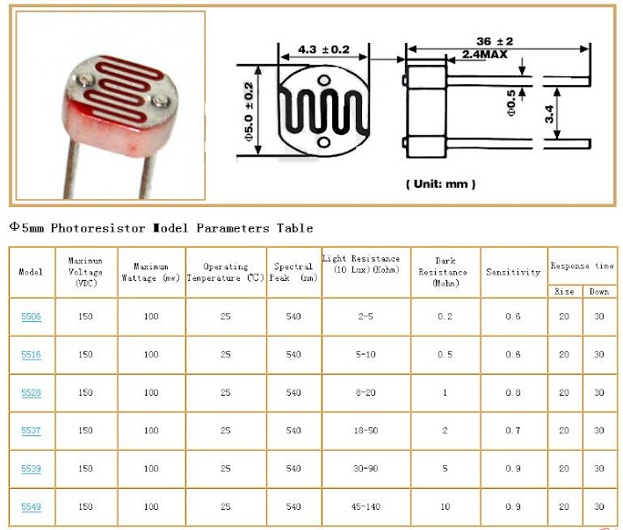

1.8 LCD pins functions
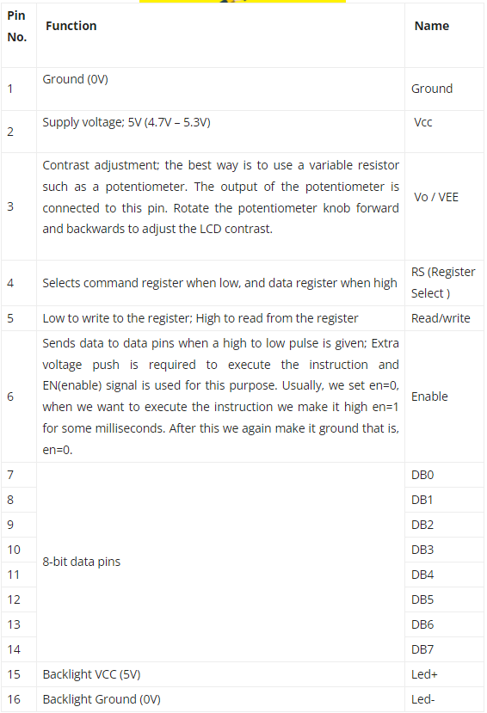

1.9 PUMP components
L293D
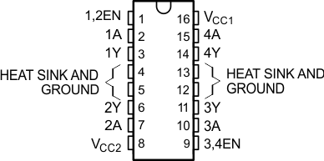

2. Commissioning of the system

2.1 The wiring of the system:
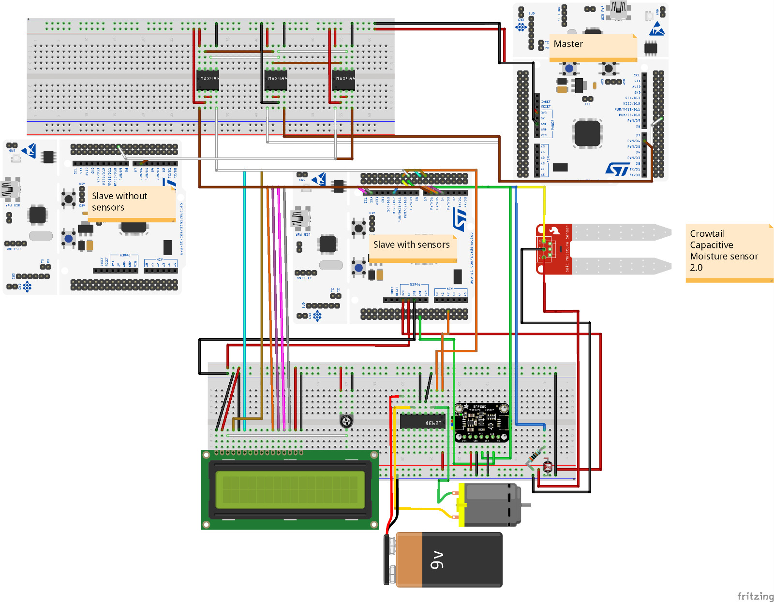

2.2 LDR connect with MCU
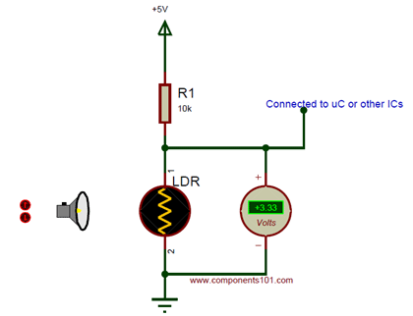

2.3 LCD 16x02 Interfacing
In the scope of this project, we will port the LCD in 4-Bit mode to make it easily configurable and portable.
The interfacing method is parallel connection which requires 6 GPIO pins.
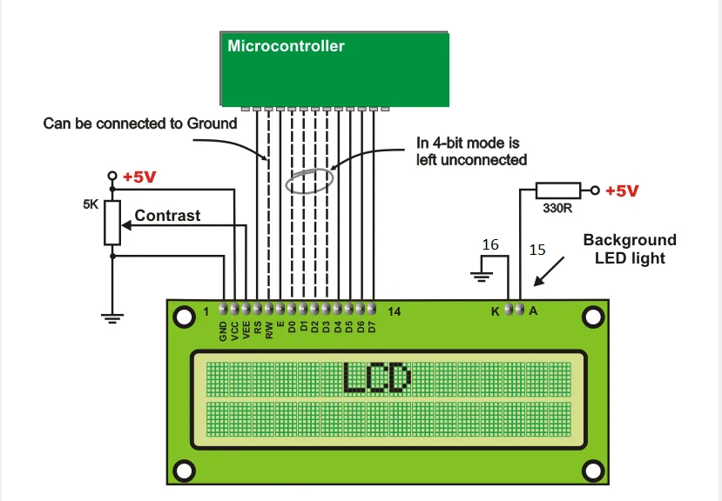

2.4 Pump wiring system
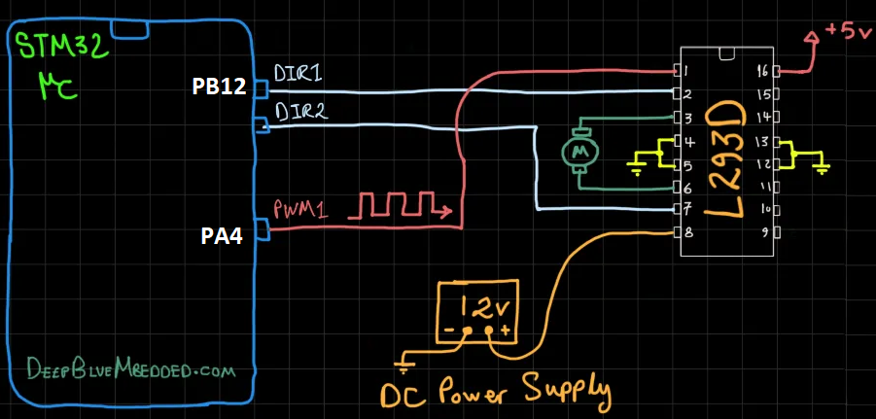
- Converting the motor to a pump: To convert the motor to a pump we have designed 2 parts to put on the motor in fusion 360. The first part goes on the motor shaft and the second part goes on top of the motor .
- Once the motor starts spinning it will create a vacuum in the middle. The vacuum will take in water which will be pushed to the tube on the side by the blades.
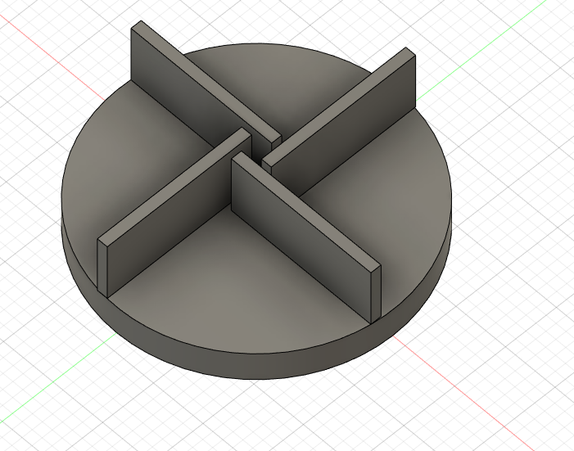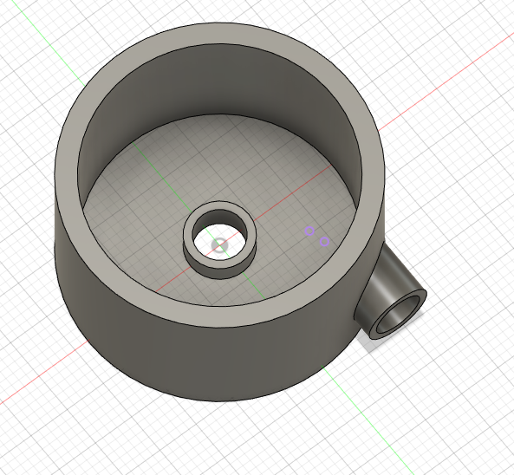

2.5 STM32 CubeMX set up
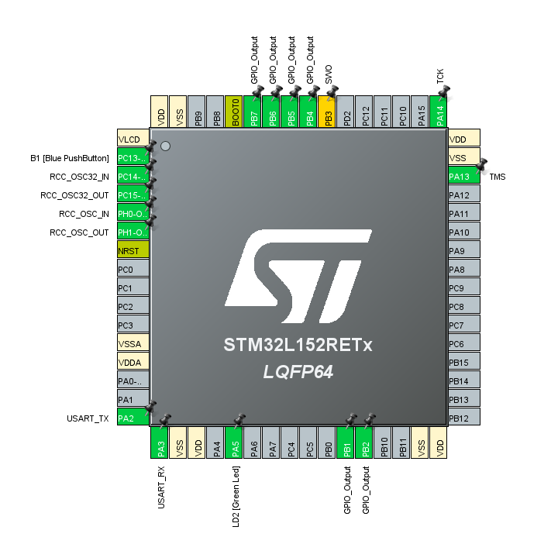

2.6 Visual Studio Code and Platformio setup:
- Include the platformio.ini into the project folder generated by CubeMX
- Open the project with Platformio.
- LDR sensor file included: ldr.c and ldr.h
- BMP280 files: we created a folder named “bsp” to store all the files needed to read the data from BMP280 sensor. The files below are from Bosch SensorTec
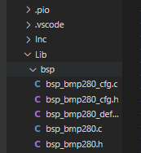
- LCD files: DWT_Delay.h and DWT_Delay.c, LCD16x2_cfg.h and LCD16x2_cfg.c, LCD16x2.h and LCD16x2.c
- PUMP files: You can find the source code of the motor driver in DC_MOTOR.c and to use it you need to include the header DC_MOTOR.h. In the DC_MOTOR.h and DC_MOTOR_cfg.c you can find the config structure that is used to assign the DIR and GPIO pins, timer , PWM_Timer channel, Clock, PWM frequency and the PWM resolution

2.7 Communication Using RS485
In this project, we are using a STM32L152RE as a master device that will receive information from slave devices (also STM32L152RE) and then send that information to PC (displaying by Real term).
We are using the MAX3485 to transfer data from slave devices to master device by USART3.
For successful running communication: one master device connects to two slave devices. One slave device includes LCD display, sensors and motor, the other slave device is much simpler which is programmed to send some “testing” message to the master (showing that the communication between master and slave devices are going through).

2.7.1 MAX3485 information
The MAX3485 are 3.3V, low-power transceivers for RS-485 and RS-422 communication. Each part contains one driver and one receiver. The MAX3485 transmit at up to 10Mbps. Drivers are short-circuiting current limited and are protected against excessive power dissipation by thermal shutdown circuitry that places the driver outputs into a high-impedance state. The receiver input has a fail-safe feature that guarantees a logic-high output if both inputs are open circuit. The MAX3485 are designed for half-duplex communication.
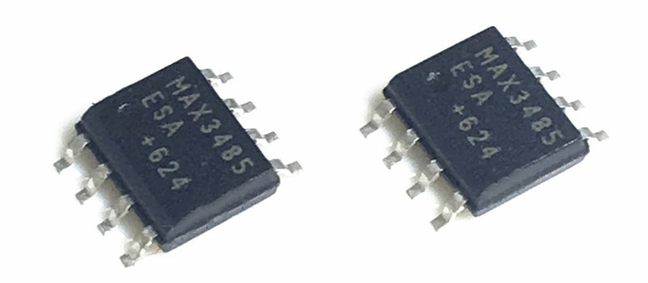
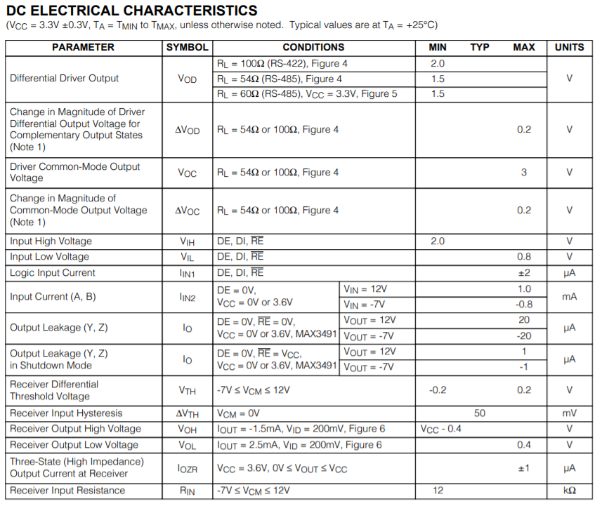
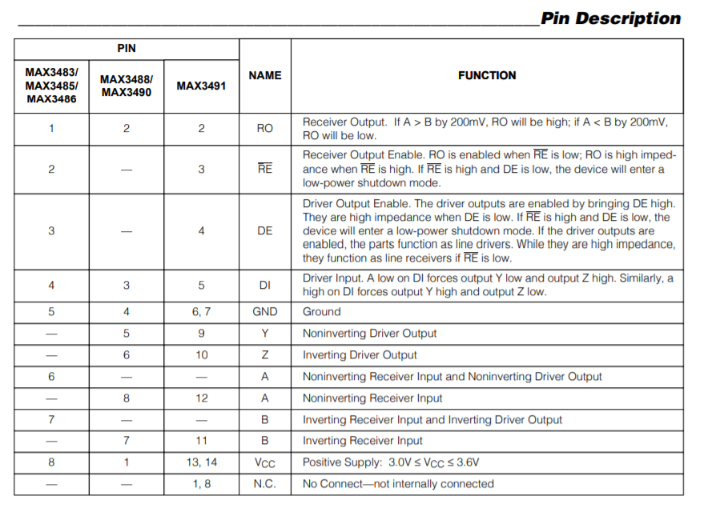

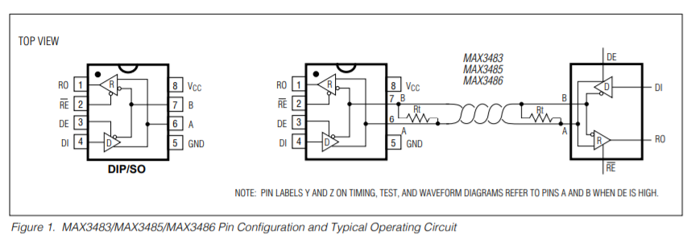

2.7.2 Debugging Method
To debug the data that being transferred by MAX3485, we use RS485 USB cable.
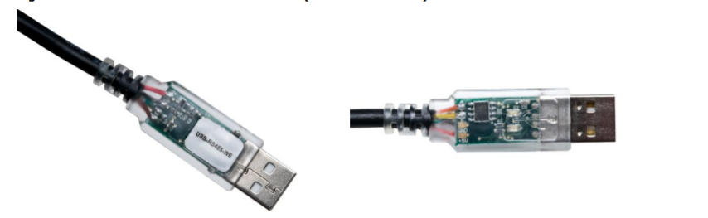
Information

The USB-RS485 cable is a USB to RS485 levels serial UART converter cable incorporating FTDI‟s FT232RQ USB to serial UART interface IC device which handles all the USB signalling and protocols. The cable provides a fast, simple way to connect devices with a RS485 interface to USB. Each USB-RS485 cable contains a small internal electronic circuit board, utilising the FT232R, which is encapsulated into the USB connector end of the cable. The FT232R datasheet, DS_FT232R, is available at http://www.ftdichip.com. The integrated electronics also include the RS485 transceiver plus Tx and Rx LEDs which give a visual indication of traffic on the cable (if transparent USB connector specified). The other end of the cable is bare, tinned wire ended connections by default, but can be customised using different connectors to support various applications. The USB-RS485 cable is designed for use at the end of an RS485 network up to approximately 10m. For longer networks or placement of the USB-RS485 cable in the middle of an RS485 network it is recommended that the attached wire is cut to 20cm or less to ensure signal integrity.

Connection
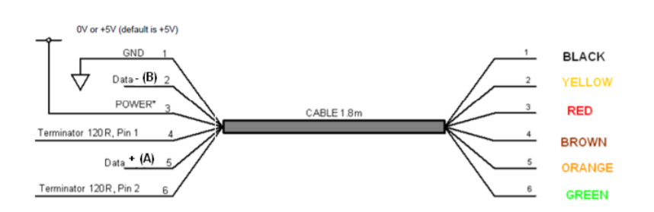
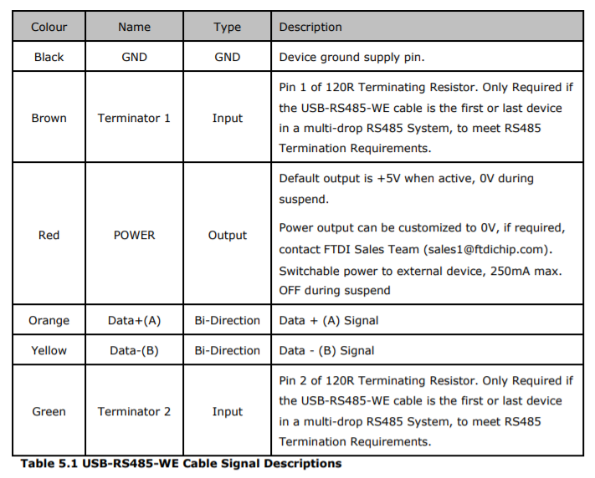

In this project, we only need to use orange and yellow cables to connect to Data+(A) and Data-(B) to the respective A, B pin of MAX3485 then connect the USB to PC and read the data through Real term.

Result of Debugging
The data transferred through the MAX3485 is as expected. We can no longer receive any data through the RS485 cable after connecting more than one slave to the master. But for one master – one slave connection, the debugger is collecting the correct data and as the same as the data received by the master (which is sent from the slave device).

3. Functions

3.1 LDR functions
The first function use to read voltage level then ADC converting. This function load into slave nucleo
void read_ldr_sensor(void)
{
uint16_t raw_value;
double temp,lux;
HAL_ADC_PollForConversion(&hadc, HAL_MAX_DELAY);

raw_value = HAL_ADC_GetValue(&hadc);
temp = ((double)raw_value);
lux = 3.0 * 1000000.0 * pow(temp, -1.367);
int l_decimal=(int)(round(lux));
sprintf(MSG, "Lux: %d\r\n", l_decimal);
HAL_UART_Transmit(&huart2, MSG, sizeof(MSG), 100);
HAL_UART_Transmit(&huart3, MSG, sizeof(MSG), 100);
}
This function will first start the ADC convertion with polling method and store in raw_value
With formula: lux = 3.0 * 1000000.0 * pow(temp, -1.367) in order to convert raw_value to LUX value.
A global message call MSG use to hold the Lux value then transmit to USART2 and USART3
(using USART3 to transmit Lux data to master nucleo)
The second function will load into the master nucleo
void ldr_print(UART_HandleTypeDef *uart)
{
OS_ERR os_err;

HAL_UART_Receive(&huart3, MSG, sizeof(MSG), 100);
HAL_UART_Transmit(&huart2, MSG, sizeof(MSG), 100);
OSTimeDlyHMSM(0, 0, 0, 1, OS_OPT_TIME_HMSM_STRICT, &os_err);
}
This function will receive the MSG was transmit from the slave nucleo

3.2 Moisture Functions
There are no specific functions just for the Moisture Sensor, though its usage has been implemented within the MoisturePercentageTask task. This task takes no user input, but does measure the moisture using the Moisture Sensor. The measured amount of voltage is converted into a percentage, 100% being pure water, 0% being dry air, and then sent through USART3.
Using the measured moisture-levels, the pump is controlled. When the amount of moisture within the soil drops beneath the desired level, in this case 50%, the pump activates for a short moment.

3.3 BMP280 functions
There are two importants and mainly used to read the data, which are defined in the ”bsp_bmp280_cfg.c”
- BMP280_Setup()
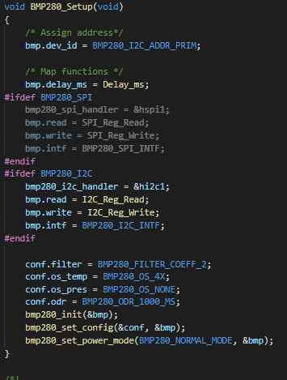
The function is to set up the sensor. The I2C protocol used to read the data according to the wiring of the systems, 4 indexes are set based on the information from Bosch and 3 functions from “bsp_bmp280.c” are called to configure the sensor before use.
- BMP280_Read()
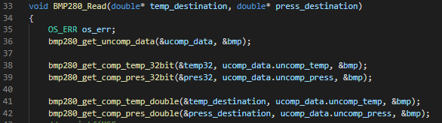
This functions is to read the environment temperature and pressure by receiving 2 parameters which are declared as global variables and used later on to store the data of the sensor.
The two last functions on the line 41 and 42 are to calculate the real environmental data we need to track every time.

3.4 LCD functions
- LCD_DATA():
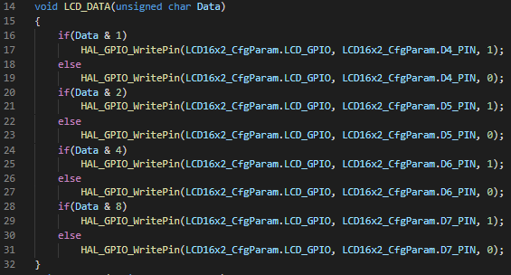
We need a routine to parse out the data and send these bits to the corresponding pins of the GPIO pins connected to LCD data pins.
- LCD_CMD():
We need to select the command register and transfer the corresponding bits. The steps to follow:
- Move the data to the output port (LCD pins)
- Select the command register
- Select write operatiion
- Send enable signal
- Wait for LCD to process the command
The function takes 1 parameter for command data.
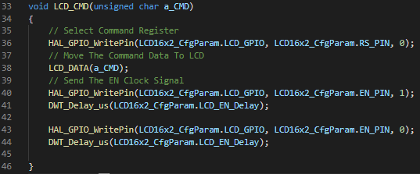
It will pull the RS pin LOW to select the command register. Then, move the command data to LCD by calling the LCD_Data(). After that we need to perform the enable pin strobe (send enable signal pulse) to update this data to the respective pins, it means that first pull the pin HIGH and then pull it LOW.
- LCD_Init():
This functions is defined in LCD16x2.c
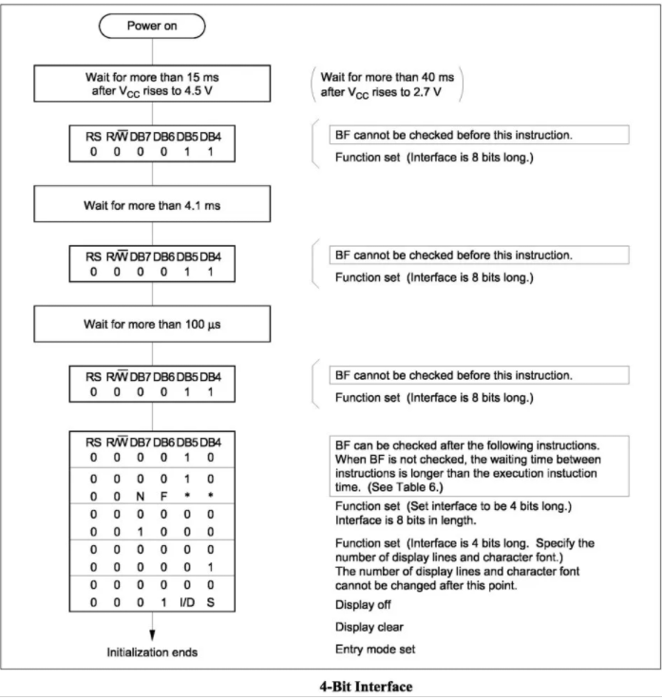
The routine above is what we need to do to make the LCD operate in 4-Bit mode.
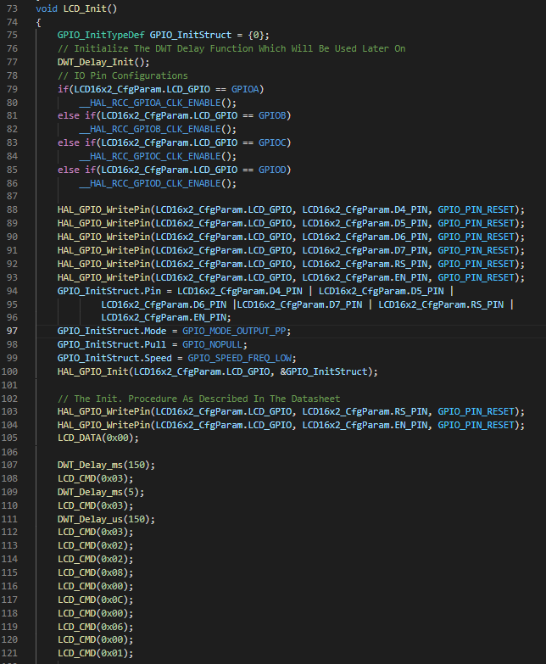
This function is used to initialize the LCD. It checks for which GPIO pins are used by LCD and configure the pins according to the modes which the pins should be. (from line 79 to line 104)
At the beginning, we should do some initialization steps for the LCD display before it can be used. These steps are followed by the manufacturer of the LCD Driver IC in the datasheet. After these steps the LCD knowed how to opererate next. (from line 105 to line 121)
- LCD_Set_Cursor():
This function is defined in LCD16x2.c
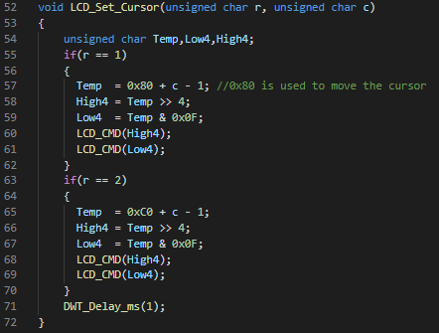
Input: r and c stands for row and column. And the cursor position offset is calculated from the base 0x80.
If r = 1 and c = 1, the text will be shown at the first column and the first row of LCD.

- LCD_Clear():
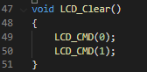
The function will clear the current display using command.

3.5 PUMP functions
- The pump has only 1 function, which is using the measured moisture-levels, the pump is controlled. When the amount of moisture within the soil drops beneath the desired level, in this case 50%, the pump activates for a short moment.
- All the functions of the motor
- DC_MOTOR_Init: initializes the required GPIO pins for direction control logic (DIR1 & DIR2), the associated Timer with the selected PWM channel. And sets the PWM resolution and frequency as configured by the user in the config file.
- DC_MOTOR_Start: Sets the motor direction and speed to start the motor
- DC_MOTOR_Set_Speed: Sets the speed of the motor by adjusting the PWM duty cycle
- DC_MOTOR_Set_Dir: Sets the direction of rotation for the motor (CW or CCW)
- DC_MOTOR_Stop: Stops the motor
- DC_MOTOR_GET_MaxFreq: Returns the maximum operating frequency (in Hz) for the PWM channel at the selected PWM resolution in the config structure for that specific motor

4. Problem situations

4.1 Moisture Sensor data:
- When receiving nonsensical data that do not match up with the environment that the sensor finds itself in.
  - Solution: Check all wiring connections and try swapping out some cables with new ones. Alternatively, check whether the sensor is still functional by connecting it to a voltage meter.

4.2 BMP280
- When receiving nonsensical data that do not match up with the environment that the sensor finds itself in.
  - Solution: Solder the jumper to the sensor first. Check all wiring connections and try swapping out some cables with new ones.

4.3 LCD 16x02
Some errors may occur and solutions:
- Showing weird characters or showing nothing: The LCD shows the strange characters and not what the user wants to display. It could happen in the initialization step because of not enough delay time between two commands or the routine to set up the LCD is not suitable for the purpose.
  - Solution: Put enough delay time according to the data sheet. Make sure all the connected pins are correct and the program send the right command to the LCD.
- The text is too dim or bold: This is the contrast issue. The LCD has 1 pin for the contrast adjustment (Vo/VEE). If the user doesn’t set for it a reasonable value it will lead to very hard to read the text.
- Solution: The best way is to use a 10k potentionmeter connected to the pin and adjust the LCD contrast by rotating the knob to get the best view.

5. Maintenance
Software functionality can be changed in a multitude of ways. If one wants to change the pins to which the sensor is connected, it can be done by generating a different pinout using Cube MX. If one wants to change the actual functionality of the code, this can be done by changing the selected tasks in main.c.
Because of the DC_MOTOR.h and DC_MOTOR_cfg.c files you can easily change the pins which makes the system very flexible. We also use a L293D motor driver which makes it very easy to change the motor to your need.

6. Appendices

7. References

8. Glossary

ADC: Analog to Digital Converter

GPIO: General Purpose Input and Output

USART3: Universal Synchronous and Asynchronous Receiver-Transmitter 3

LCD: Liquid Crystal Display

I2C: Inter-Integrated Circuit

9. Index

