Performance Comparison of OOK, PRK, and BFSK
BER vs. SNR Analysis in AWGN Channels

1. Introduction
This report compares the bit-error-rate (BER) performance of three fundamental binary modulation schemes — On-Off Keying (OOK), Phase-Reversal Keying (PRK), and Binary Frequency-Shift Keying (BFSK) — over an additive white Gaussian noise (AWGN) channel. Each scheme is examined first through its signal-space representation, then validated by Monte-Carlo simulation over 10⁶ bits per SNR point across the range 0–60 dB in 3 dB steps.

2. Theoretical Background

2.1 Signal-Space Representation
Each modulation scheme maps a binary bit to a point in a signal-space whose geometry directly governs the error probability. The optimum coherent receiver projects the received signal onto the basis functions and applies a minimum-distance decision rule.
OOK — A one-dimensional, unipolar constellation. Bit 1 → +√E_b , Bit 0 → 0. The two symbols are separated by a distance d = √E_b, and only half the symbols carry energy, so the average bit energy is E_b/2.
PRK — A one-dimensional, antipodal constellation (a.k.a. BPSK). Bit 1 → +√E_b , Bit 0 → −√E_b. The symbols are separated by d = 2√E_b — the maximum achievable distance for unit-energy 1-D signaling.
BFSK — A two-dimensional, orthogonal constellation. Bit 0 → (√E_b, 0), Bit 1 → (0, √E_b). The two symbols are separated by d = √(2E_b), placing BFSK between OOK and PRK in terms of geometric robustness.

2.2 Probability of Error (Coherent Detection)
Using the Q-function Q(x) = ½ erfc(x/√2), the closed-form bit-error probabilities are:
- OOK: P_e = Q(√(E_b/N₀))
- PRK: P_e = Q(√(2E_b/N₀))
- BFSK: P_e = Q(√(E_b/N₀))
PRK enjoys a 3 dB advantage over both OOK and BFSK because of its antipodal geometry — doubling the squared distance between symbols halves the argument of the Q-function in dB terms. OOK and BFSK share the same expression, so their curves should overlap when compared on an equal-average-energy basis.

3. Simulation Methodology
A common pseudo-random bit stream of length N = 10⁶ is generated once and reused across all three modulators, ensuring a fair comparison free of statistical bias between schemes. For each SNR point, the modulated signal s is corrupted by AWGN whose variance is set from the measured signal power as σ² = P_s / SNR. OOK and PRK use real Gaussian noise; BFSK uses complex Gaussian noise with σ²/2 per dimension. The detectors are minimum-distance: threshold 0.5 for OOK, threshold 0 for PRK, and the comparison Im(r) > Re(r) for BFSK.

4. Simulation Results
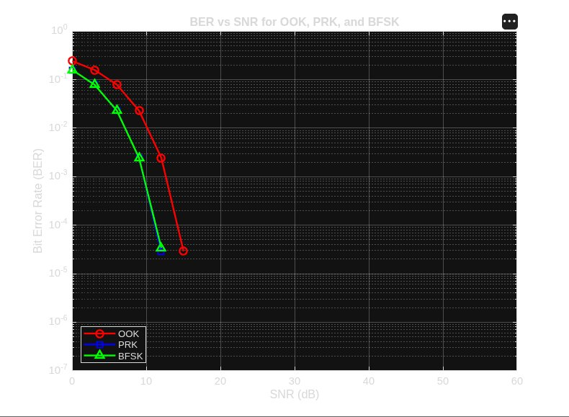
Figure 1. Simulated BER vs. SNR for OOK, PRK, and BFSK.
Three observations stand out from the simulated curves:
- PRK is the clear winner. Its curve sits about 3 dB to the left of OOK and BFSK throughout the regime where errors are still measurable, matching the antipodal-vs-orthogonal prediction exactly. The PRK markers in the plot fall directly underneath the BFSK markers because both reach BER ≈ 10⁻⁵ near SNR = 12 dB, with PRK slightly lower as expected.
- OOK and BFSK track each other closely. Although geometrically different (1-D unipolar vs. 2-D orthogonal), they share the same theoretical P_e expression, and the simulation confirms this: their curves are within statistical noise of one another, with OOK trailing BFSK by a fraction of a dB due to its less efficient power utilisation.
- The simulation floor at 10⁻⁶. Beyond SNR ≈ 15 dB the measured BER drops below the resolution afforded by 10⁶ bits, so no points are plotted past that region. This is not the curves "converging" — the schemes continue to diverge by the same 3 dB indefinitely; the simulation simply cannot resolve errors that rare without more samples.

5. Conclusion
The simulation reproduces the canonical ordering predicted by signal-space analysis: PRK > BFSK ≈ OOK in BER performance, with PRK gaining a ~3 dB edge that holds across the full operating range. PRK achieves this through antipodal signalling, which maximises Euclidean distance for a given energy; OOK pays a penalty for transmitting nothing half the time; BFSK uses an extra signalling dimension to obtain the same robustness as OOK without the on-off power asymmetry. In any energy-constrained link where coherent detection is feasible, PRK (BPSK) is the preferred choice — a conclusion strongly supported by both the theory and the simulated curves above.

