SCREENSHOTS(RESULT) OF THE CLI, JSON, JUNIT, PROGRESS, EMOJITRAIN
RUNNER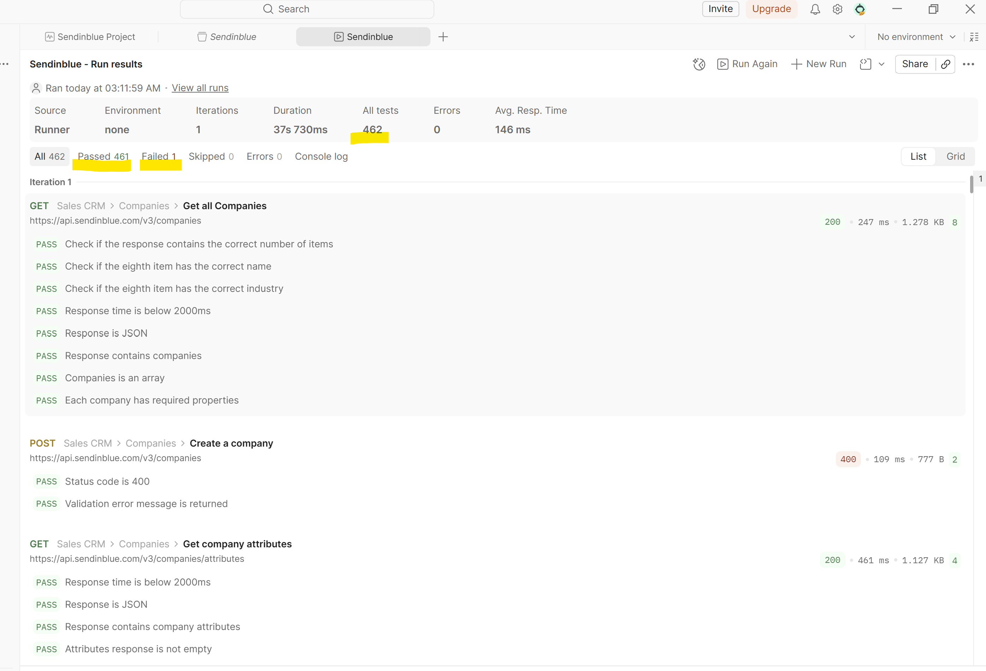
CLI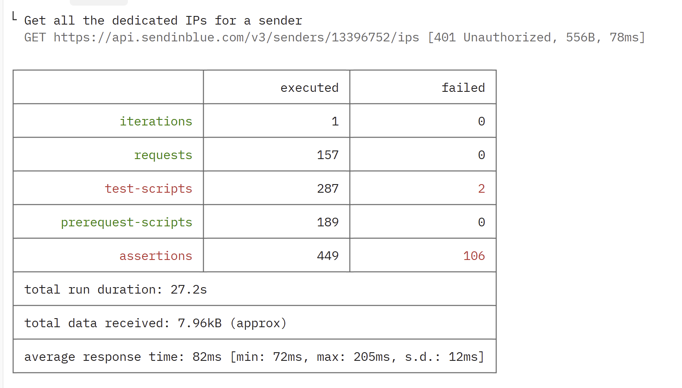

PROGRESS
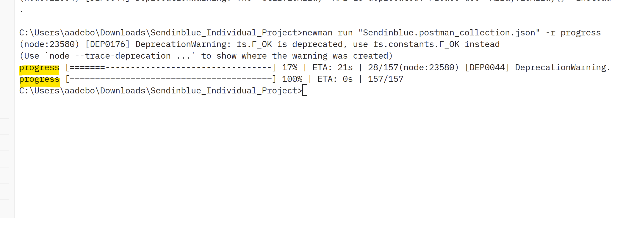

EMOJITRAIN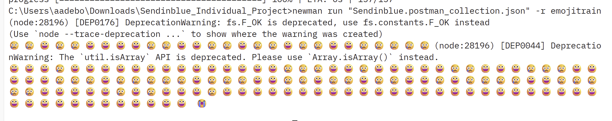

ALLURE REPORT
