Assignment 2:

Installing Your Monitoring Service

Student Information

Student Name: Oluwafemi Adeyemi

Date (dd/mm/yy): 13/9/2024

**Step 1 Initial Configuration:**

Complete this section AFTER finishing step 1 of the assignment.

Nagios Installation and Configuration

Linux Distribution Used: **Ubuntu**

System IP Address: 192.168.56.1

Current IP Address: **10.0.2.15** (Before change)

Static IP Address Based on first name initial from Appendix A (e.g., A = .200, B = .201, etc.)

Static IP Address:**10.0.2.214** (After change)

Web Browser Access:

URL: http://10.0.2.214/nagios

Login Credentials Setup: Username: admin and password: 6680102

Tactical Overview Screenshot:

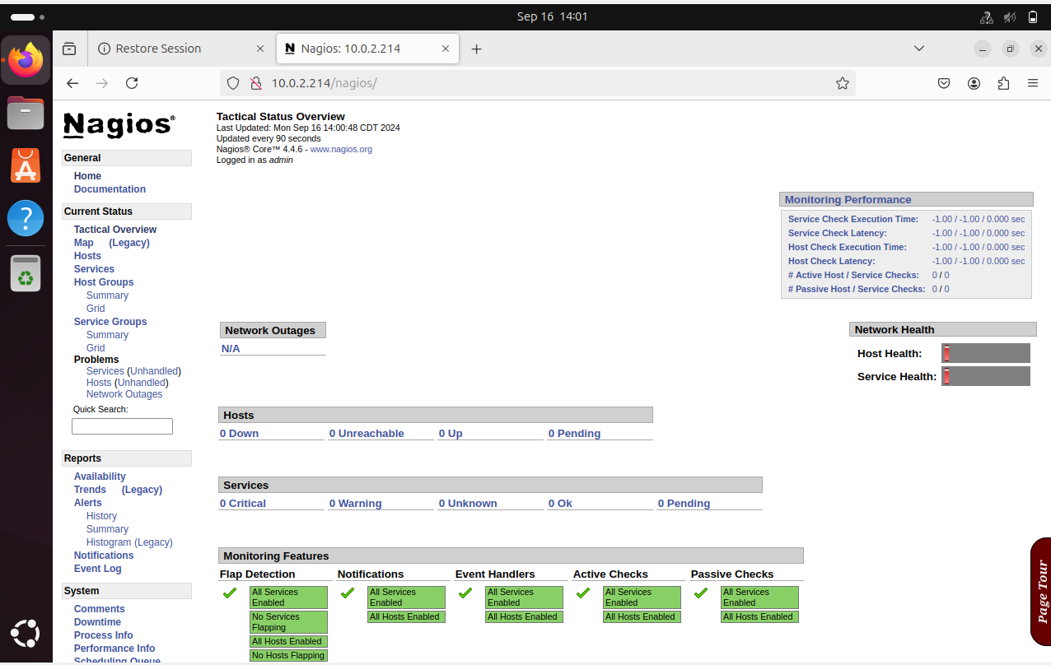.

**Part 2: Script and Command Descriptions**

Step 2: Command Interpretation

Script Commands:

**Command:** sudo apt install wget unzip curl openssl build-essential libgd-dev libssl-dev libapache2-mod-php php-gd php apache2 -y  
**Description:** This installs the necessary dependencies for Nagios, including development tools (build-essential), SSL libraries (libssl-dev), Apache server (apache2), and PHP components (php-gd, libapache2-mod-php) required for Nagios to run.

**Command:** wget https://assets.nagios.com/downloads/nagioscore/releases/nagios-4.4.6.tar.gz  
**Description:** This uses wget to download the Nagios Core source tarball (version 4.4.6) from the Nagios official website.

**Command:** sudo tar -zxvf nagios-4.4.6.tar.gz  
**Description:** Extracts the contents of the nagios-4.4.6.tar.gz archive using the tar command. The flags -zxvf mean:

* z: uncompress a .tar.gz file,
* x: extract the files,
* v: verbose output,
* f: file to extract.

**Command:** cd nagios-4.4.6  
**Description:** Changes the current directory to the nagios-4.4.6 folder, which contains the extracted Nagios source code.

**Command:** sudo ./configure  
**Description:** Configures the Nagios build environment, checking if all required dependencies are installed and setting up necessary paths and settings for compiling the software.

**Command:** sudo make all  
**Description:** Compiles the Nagios Core program and its CGI scripts (web interface). The make command processes the Makefile generated by the ./configure script to build the source code.

**Command:** sudo make install-groups-users  
**Description:** Creates the nagios user and group on the system, which will be used to run Nagios. This isolates Nagios from other system processes for better security.

**Command:** sudo usermod -a -G nagios www-data  
**Description:** Adds the Apache web server user (www-data) to the nagios group. This ensures Apache can access Nagios files.

**Command:** sudo make install  
**Description:** Installs Nagios Core on the system by copying the compiled files and necessary configurations to their respective directories.

**Command:** sudo make install-init  
**Description:** Installs the Nagios Core init script, allowing you to start and stop the Nagios service using standard service management commands (systemctl, etc.).

**Command:** sudo make install-commandmode  
**Description:** Sets proper permissions for Nagios command files and directories, enabling other system users (like the web server user) to interact with Nagios commands securely.

**Command:** sudo make install-config  
**Description:** Installs example configuration files to help you get started with Nagios monitoring.

**Command:** sudo make install-webconf  
**Description:** Installs the Nagios web interface configuration for Apache, setting up the necessary files for running Nagios via a web browser.

**Command:** sudo a2enmod rewrite  
**Description:** Enables the Apache rewrite module, which is often required for URL redirection and other HTTP requests that Nagios may need.

**Command:** sudo a2enmod cgi  
**Description:** Enables the CGI module in Apache, allowing Nagios to run CGI scripts, which is necessary for the web interface.

**Command:** sudo systemctl restart apache2  
**Description:** Restarts the Apache web server to apply the changes made by enabling modules and installing Nagios web configuration.

**Command:** sudo htpasswd -c /usr/local/nagios/etc/htpasswd.users admin  
**Description:** Creates a new user (admin) for the Nagios web interface using htpasswd and sets a password. This user will be prompted for authentication when accessing Nagios via the browser.

**Command:** cd ~/  
wget https://nagios-plugins.org/download/nagios-plugins-2.3.3.tar.gz  
**Description:** This navigates to the home directory and downloads the Nagios plugins package (version 2.3.3) needed for monitoring various services and resources.

**Command:** sudo tar -zxvf nagios-plugins-2.3.3.tar.gz  
**Description:** Extracts the contents of the plugin tarball.

**Command:** cd nagios-plugins-2.3.3/  
**Description:** Changes to the directory containing the extracted Nagios plugin files.

**Command:** sudo ./configure --with-nagios-user=nagios --with-nagios-group=nagios  
**Description:** Configures the plugin build environment, specifying that the Nagios user and group should be nagios to ensure correct permissions.

**Command:** sudo make  
**Description:** Compiles the Nagios plugins.

**Command:** sudo make install  
**Description:** Installs the compiled Nagios plugins into the system.

**Command:** sudo /usr/local/nagios/bin/nagios -v /usr/local/nagios/etc/nagios.cfg  
**Description:** Validates the Nagios configuration file to check for syntax errors or misconfigurations before starting the service.

**Command:** sudo systemctl start nagios  
**Description:** Starts the Nagios service, making the monitoring tool operational.

**Command:** sudo systemctl enable nagios  
**Description:** Configures Nagios to start automatically when the system boots.