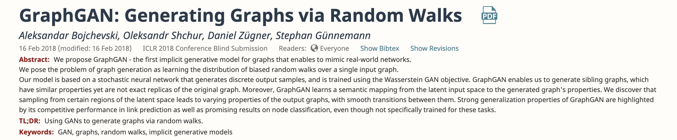

Summary

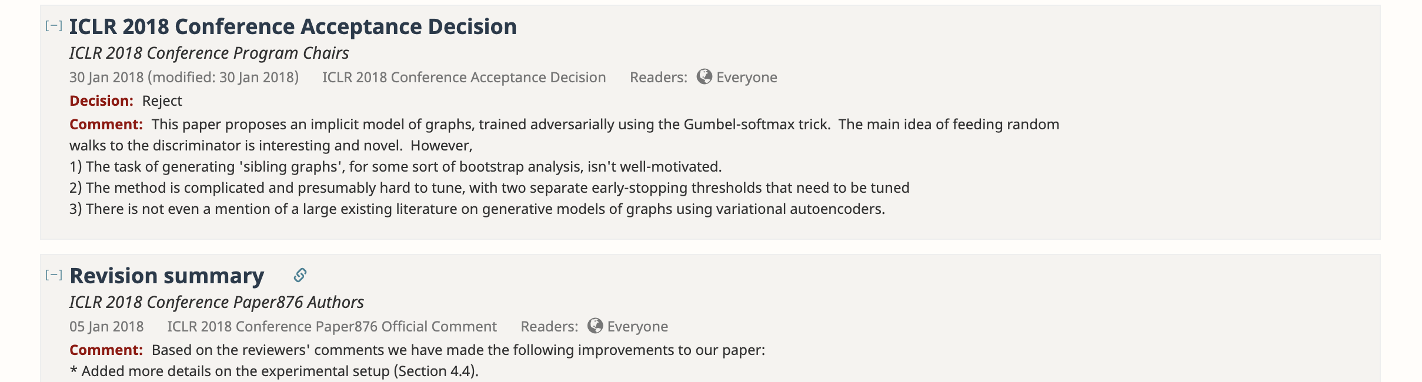

Response



Review

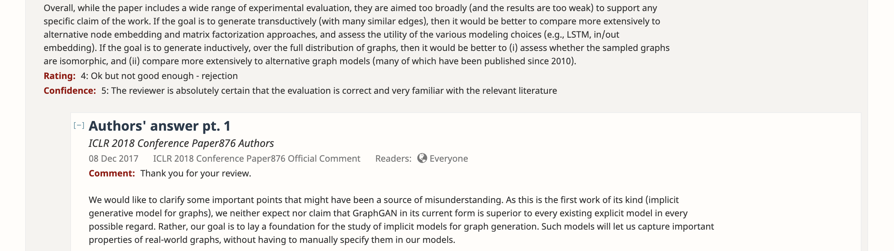

Response

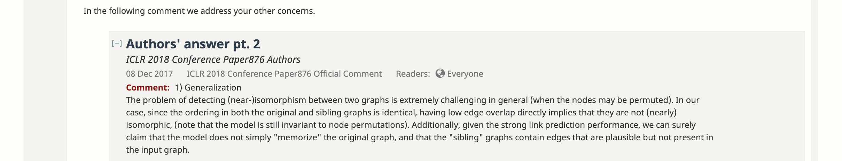

Response





Comment

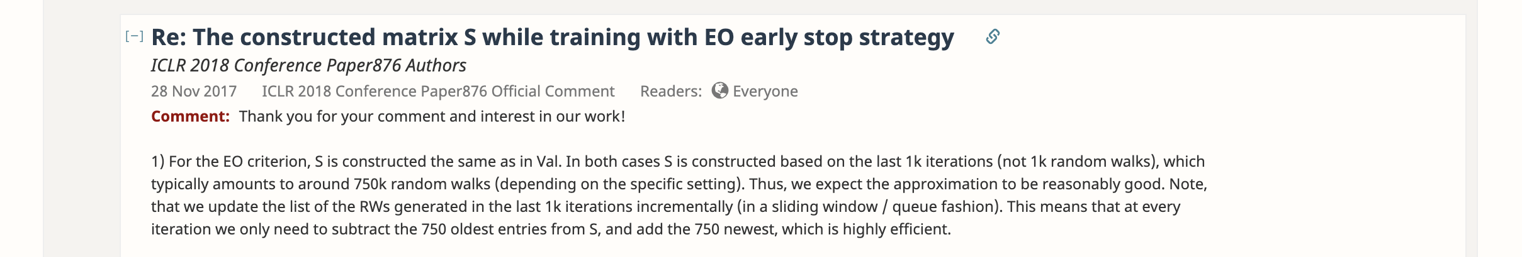

Response

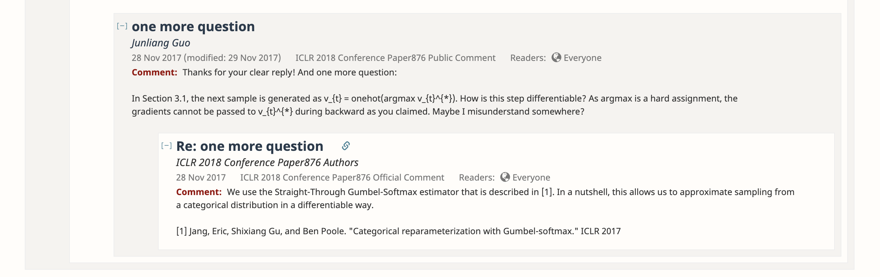

Response

Response