

GRADUATION PROJECT LITERATURE SURVEY

Name: Osman Alperen

Surname: Kayasaroğlu

Number: 16050511011

Date: 15.11.2021

A new microwave photonic triangular waveform generator has been presented. It has a very simpleand low-cost structure. It is capable of realising a triangular waveform with a high repetition rate of>20 GHz as MZMs [17] and 90°hybrid couplers [18] with an operating frequency of >60 GHz arecommercially available. Tuning the waveform repetition rate can be done by simply controlling theRF signal frequency into the modulator. A technique has been proposed to overcome the effect ofphase imbalance in the 90°hybrid coupler used in the structure. The proposed triangular waveformgenerator has been analysed and the setting of the system parameters required to obtain a triangularwaveform has been presented. Experimental results demonstrated the waveform generated bythe proposed triangular waveform generator has a tunable microwave-frequency repetition rate, asmall RMSE value of <0.049 when comparing with the ideal triangular waveform, and a stableperformance.

ournal Simple Technique for Triangular Waveform

Fig. 1. Dual-polarisation modu

<https://www.researchgate.net/publication/325638592_A_Simple_Technique_for_Triangular_Waveform_Generation_Based_on_a_Dual-Polarization_Modulator>

optical, GHZ level

We have theoretically and experimentally demonstrated a novel approach to generating a full-duty-cycle triangular waveform based on a MPF with negative coefficient. The undesired harmonics are removed by the MPF with periodic transmission response, while the desired ones are well kept. A triangular waveform at fundamental frequency is generated by setting the bias of the MZM at quadrature point. However, a broadband 90° microwave phase shifter has to be used after the BPD to adjust the phases of odd-order harmonics. On the other hand, a frequency doubling triangular waveform can be generated if the MZM is biased at the maximum or minimum transmission point. In this case, the broadband microwave phase shifter is no longer needed but it is more power consuming. We have experimentally generated triangular waveform at 5 GHz using a sinusoidal microwave signal at 5 or 2.5 GHz, respectively. Moreover, the frequency tunability of the proposed scheme have also been verified. A triangular waveform at 6 GHz has been successfully generated using a 3-GHz microwave signal. The frequency tunable range of the triangular waveform is mainly restricted by the bandwidth of the devices used in our experiment. In addition, the performance of the triangular waveform generator can be further improved by using a multi-tap MPF with negative coefficient.

It is worth noting that the proposed method is designed to generate waveforms consisting of only odd-order harmonics, e.g. triangular waveforms or square waveforms [11,12]. Unfortunately, it is not possible to generate waveforms which have both odd-order and even-order harmonics, e.g. sawtooth even arbitrary waveforms.

<https://www.osapublishing.org/oe/fulltext.cfm?uri=oe-22-12-14993&id=290542>

optical, ghz level

5Vpp at 38MHz triangle /\/\/\/ is 10V/38M = slew rate = 0.28V/us = 360ns/V ( not V/ns )

The bandwidth depends on your tolerance to signal error.

Can you define that in measurable terms? Linearity error? Peak rounding error? RMS error?

What load are you planning? 50R?

5% linearity is easy. <1% linearity is hard. What's this for?

Until then...

I would consider up to the 9th harmonic or a 3dB BW of ~360MHz BW as a starting point.

Bandwidth of triangle waves has the same odd harmonics as a square wave except attenuated by 6 dB per octave from integration.

So an ideal square wave and integrator with a lower capacitance load.

To stay well below current limit of Op Amp such as 30mA the maximum capacitive load at this slew rate from Ic=C\*dv/dt

or C <=30mA \* 360 ns/V = 0.01uF max ok.

Small signal is easy. But 5Vpp 1% linearity is hard. So specs on MUST HAVEs need to be defined.

Perhaps with suitable RF layout, one can generate this with 1.5GHz GBW will give one a gain of 5 at 300MHz

- limited to samples in USA only unless you want to buy 98 pcs at $1.83 budgetary price

AD8000

1.5 GHz, Ultra-High Speed Op Amp with Power-Down

<https://www.electro-tech-online.com/threads/high-frequency-triangle-wave-generator.144977/>

this opamp can be usable for mhz level triangular wave generators

<https://www.planetanalog.com/function-generator-circuit-concepts-part-3-additional-function-generator-fg-capabilities/>

TRANSISTOR, TUNABLE, MHZ LEVEL

<https://www.circuitstoday.com/triangular-wave-generator>

FIXED, OPAMP, KHZ LEVEL

This paper presents a new design of a square/triangular wave generator. The proposed circuit features a compact circuitry and can control the operating frequency, output amplitude, and duty-cycle by tuning diverse circuit parameters. This paper first reviews several previous designs used to produce square/triangular wave generators followed by circuit principles, governing formulas, non ideality problems, and design procedures. For conducting the experiments, a prototype circuit is implemented using commercially available AD844 and LM13700 integrated circuits (ICs) and discrete passive components on a breadboard. The PSpice simulations and experimental results demonstrate the feasibility of the circuit and verify the theoretical analyses.

<http://jase.tku.edu.tw/articles/jase-201909-22-3-0020.pdf>

IC, TUNABLE, KHZ LEVEL

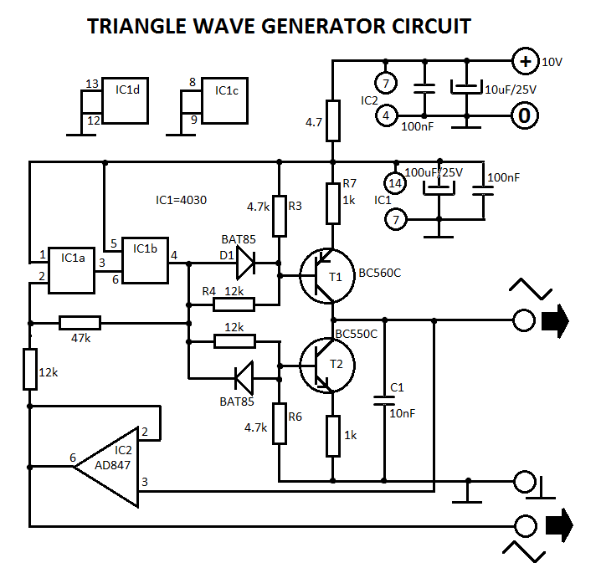

This triangle wave generator is made with a trigger Schmitt that converts a triangle wave into a rectangular one used to charge and discharge a capacitor through current sources. The positive current source T1 provide the charging and T2 the discharging. The trigger Schmitt is made from OR-EXCL gates IC1a and IC1b.

The rectangular signal amplitude must not be higher than the T1 and T2 base voltage. Assuming a 10 V power supply, results that the amplitude will be 2.5V. IC2 is a good quality operational amplifier (200 V/us) that acts like a buffer between Schmitt input and output.

<https://www.electroschematics.com/triangle-wave-generator/>

TRANSISTOR FIXED KHZ LEVEL