

GRADUATION PROJECT-1

TRIANGULAR WAVE GENERATION METHODS

Name: Osman Alperen Kayasaroğlu

ID: 16050511011

Contents

1. RC Network Square to Triangular Wave Converter 2

2. Op-Amp Triangular Wave Generator 4

3. Transistor Based Triangular Wave Generator 5

4. 555 Timer Triangular Wave Generator 6

5. COMPARISON TABLE 7

6. What is Miller Effect? 7

References 8

# RC Network Square to Triangular Wave Converter

Now we will see how to convert a square wave to a triangle wave using RC networks, you only need resistors and capacitor to build this circuit.

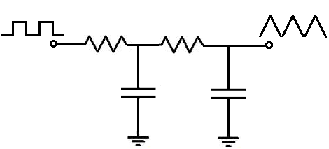

Figure 1 RC Network TWG Circuit

To build this circuit, we only need 2 RC networks. Each RC network is comprised of 1 resistor and 1 capacitor. While this circuit is simple in setup, it is somewhat complex in determining the values of resistors and capacitors in relation to the frequency of the input signal.

The first resistor and capacitor creates the classic capacitor charging and discharging waveform. Being that the voltage across the capacitor, Vc= Vin(1 – exp(-t/RC)), the voltage across the capacitor charges up exponentially and discharges exponentially. Therefore, the waveform, upon charging is a parabolic-shaped exponential waveform upside down. The same way the capacitor charges up exponentially, it discharges exponentially. Therefore, when the capacitor is discharging, you see a parabolic-shaped exponential waveform right side up. So this is the waveform that you will see after the first RC network.

Figure 2 Bad Shaped Triangle Wave after 1st RC Network

After the first RC network, we then have our second RC network. This RC network takes the exponential waveform and converts it into a triangle waveform. It straightens out the parabolic exponential waveforms so that they appear as a straight ascending slope on the charging side and straight descending slope on the discharging side. The result is a triangle. Just like with the first capacitor, the second capacitor charges and discharges, charges and discharges, over and over again. The result is continous never-ending oscillations of triangle waveforms.

Figure 3 RC Network Triangular Wave Oscilloscope Display

Depending on what frequency you use, the values of the capacitors needed to be carefully chosen. If the correct values are not chosen and are way out of the frequency range, the output waveform will be the same exact square wave, as is input into the circuit, except attenuated a bit due to the resistors. The waveform will be unchanged because the capacitors have no reactance to the voltage due to the frequency level. If the capacitor still has some on the signal due to frequency but is still out of range, you may get a very poorly formed triangle waveform.

Use the same value for both capacitors. If you use different values for capacitors you may get a mixed, poorly defined waveform.

For high frequencies, lower value capacitors are needed. So for really high frequencies, you may use capacitors in the order of picofarads. This may require some trial and error and testing with building the circuit and checking the waveform on an oscilloscope.

As far as adjusting the amplitude, this just requires feeding a larger square wave into the circuit to increase the amplitude. Or feeding a smaller square wave into the circuit to decrease the amplitude.

And this is about all that can be done for building and adjusting this square-to-triangle wave converter circuit.

# Op-Amp Triangular Wave Generator

This circuit is very crisp, producing a beautiful triangle wave signal at the output.

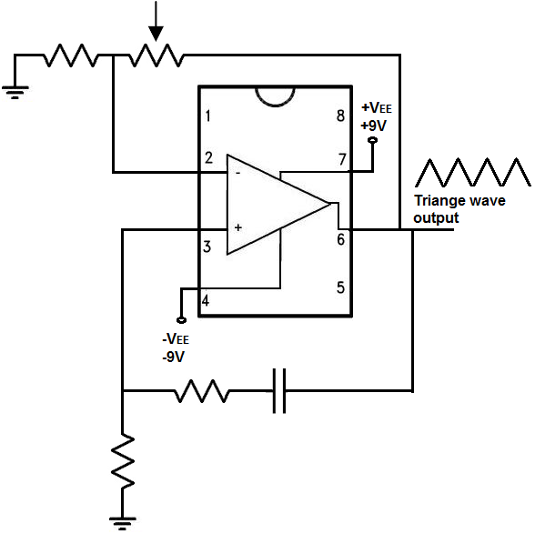

Figure 4 Op-Amp Triangular Wave Generator Circuit

This circuit is made up of several different components, all of which are composed of either resistors, capacitors, or potentiometers. There are several formulas that we follow in order to get the frequency and gain that we desire for the circuit:

The frequency, f= 1/2πRC, where π= 3.14, R is equal to the resistance value, and C is equal to the capacitance values

The RC network at the bottom of the circuit diagram determines the frequency of the output triangle wave signal.

Now we can focus on the gain, amplitude of the signal, which is how tall or loud the signal is. We can adjust the gain of the circuit by adjusting the DC voltage powering the circuit.

This circuit is very precise and sensitive. The potentiometer must be tuned to the exact right value in order for a good triangle wave to be shown at the output. If the resistance of the potentiometer is too low, you will not get a triangle wave at all at the output. If the gain is too high, the peaks of triangle waves will be clipped and, thus, distorted. The potentiometer has to be adjusted so that there is an undistorted, unclipped triangle wave at the output.

The resistor-capacitor determines the time constant of the signal because they control the charge-discharge cycle time of the capacitor. The smaller the resistor and capacitor are, the shorter the time constant and, thus, the greater the frequency. This is because with less resistance, there is less impedement to the flow of current. Thus, a greater amount of current can flow more easily through the circuit. The smaller the capacitor, the less charge it can store, so it takes a shorter period of time for the capacitor to charge up. All this equates into a shorter time cycle for the capacitor, which means a greater frequency.

# Transistor Based Triangular Wave Generator

You can see the transistor based triangle wave generator circuit below.

Figure 5 Transistor Based Triangular Wave Generator Circuit

The operational amplifier and the resistors R1 and R2 form a comparator with hystresis, that is a Schmitt trigger, with output voltages either Vsat+ or Vsat- and threshold voltages VTH=ßVsat+ and VTL=ßVsat- where ß=(R2/(R1+R2)). When the output voltage of the Schmitt trigger is Vsat+, the upper current mirror formed by transistors Q1–Q4 produces a constant current I1 = (((Vsat+) - 2VBE)/R3). This current charges the capacitor C linearly with time at a rate of I1/C. When the voltage across the capacitor reaches VTH the output of the Schmitt trigger switches to Vsat-, the lower current-mirror formed by transistors Q5– Q8 produces a constant current I2 = ((|Vsat-| - 2VBE)/R4). This current discharges the capacitor C linearly with time at a rate of I2/C. When the voltage across the capacitor reaches VTL, the output voltage of the Schmitt trigger switches to Vsat+ and the cycle is repeated.

The slope of the positive-going edge of the capacitor voltage and the charging time of the capacitor will be given by:

Similarly, the slope of the negative-going edge of the triangular wave and the discharging time will be given by:

The frequency of oscillation can be expressed as:

We can see that is possible to control the frequency of oscillation by adjusting the resistors R1 and/or R2 without disturbing the slopes of the positive- and negative-going edges of the triangular waveform obtained across the capacitor C.

# 555 Timer Triangular Wave Generator

In this circuit, first creating a square wave with the 555 timer chip, then take that square wave and convert it into a triangle wave via RC networks, also called pole filters.

Figure 6 555 Timer Triangular Wave Circuit

The 555 timer can operate from a supply voltage between 4.5 volts and 18 volts, with its output voltage approximately 2 volts lower than its supply voltage VCC. 555 timer works in astable mode for this circuit.

The R1 resistor and C1 capacitor determine the frequency of the square wave signal output. By adjusting these values, we can adjust the frequency of the output signal from the circuit.

The next part of our circuit, which converts the square wave to a triangle wave. This is done through RC networks. The RC networks reshape the waveform to a triangular shape.

The first capacitor creates the classic capacitor charging waveform, waveform changes to parabolic triangular wave. Then exponentially shaped function gets converted into a clean triangle waveform after 2nd RC network. You will have to adjust the capacitors C3 and C4 when there are changes to the input frequency signal.

# COMPARISON TABLE

|  |  |  |  |  |
| --- | --- | --- | --- | --- |
| Technique | Frequency | Amplitude | Active/Passive | Disadvantage |
| RC Network | Little Adjustable | Adjustable | Passive | Amplitude Loss |
| Op-Amp | Adjustable | Adjustable | Active | Miller Effect  (due to opamp) |
| Transistor | Adjustable | Adjustable | Active | Sensitive Adjustment |
| 555 Timer | Up to 2 MHz | Up to 18V | Active | Amplitude Loss |

# A picture containing text Description automatically generatedWhat is Miller Effect?

Figure 7 Miller Effect on Oscilloscope

Miller effect accounts for the increase in the equivalent input capacitance of an inverting voltage amplifier due to amplification of the effect of capacitance between the input and output terminals. The virtually increased input capacitance due to the Miller effect is given by;



where is -Av is the voltage gain of the inverting amplifier and C is the feedback capacitance.

# References

1. <http://www.learningaboutelectronics.com/Articles/Square-to-triangle-wave-converter-circuit.php>
2. <http://www.learningaboutelectronics.com/Articles/Triangle-wave-generator-circuit-with-an-LM741-op-amp.php>
3. <https://www.electronics-tutorials.ws/rc/rc_3.html>
4. <http://citeseerx.ist.psu.edu/viewdoc/download;jsessionid=41BEDE8290D7C00BF3E1533ECC33D9B6?doi=10.1.1.615.9396&rep=rep1&type=pdf>
5. <http://www.learningaboutelectronics.com/Articles/Triangle-wave-generator-circuit.php>
6. <https://www.electronics-tutorials.ws/waveforms/555-circuits-part-1.html>
7. <https://en.wikipedia.org/wiki/Miller_effect>
8. <https://scholarship.rice.edu/bitstream/handle/1911/89656/RICE0687.pdf?sequence=1&isAllowed=y>