Jacob Oakes

Image Rec.

Lab 1

**Why will dealing with 3D arrays be important in this class?**

We will be dealing with pixels in an image a lot. These pixels can be represented as a 3D array. In color it will be x, y, color, and in greyscale it will be x, y, intensity. The color itself will be another array representing the RGB value.

**Write a MATLAB expression to refer to the first column of a 2D-array.**

A(:, 1)

**Write a MATLAB expression to refer to the upper-right-hand pixel of a 7 x 10 array. Note we always give dimensions of 2D arrays as (#rows) x (#cols).**

A(1, cols)

**Write a MATLAB expression to replace all values in a matrix A between 10 and 20 with the value -1.**

A(find(A > 10 & A < 20)) = -1

**In your own words, summarize these MATLAB concepts: find, zeros, slicing, flexible subscripting.**

Find – returns indices of a matrix where the given condition is true for the value at an indice

Zeros – creates a matrix of all zeroes with a given row and column size

Slicing – extracting part of a matrix or array

Flexible subscripting – you can give it a number of things depending on what you would like to get back, a single subscript for a single value, colons for entire rows, columns or ranges, an array of the elements to get [1 3 4] or the first, third, and fourth.

Image Source: <http://wallimgs.com/landscape-photography-trees.html/landscape-photography-trees>

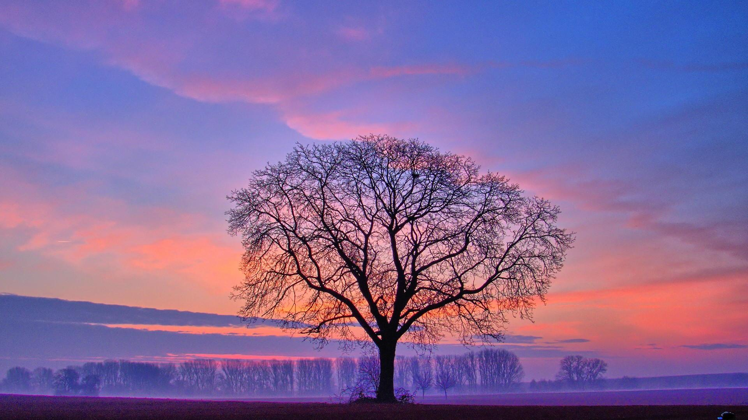

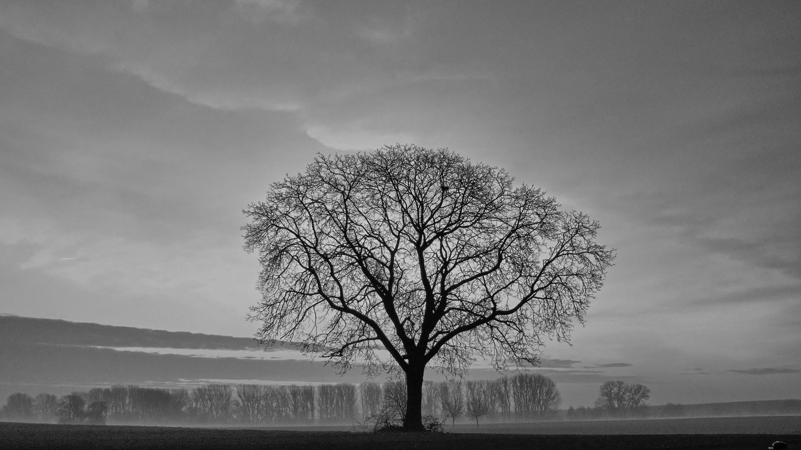

**Summarize what you have learned about converting color to grayscale images.**

I learned that a picture can be broken into a red, green, and blue bands. The averaging of these three bands seems to be a good approximation of converting to gray scale. However a more realistic approximation is gray = 0.3R + 0.59G + 0.11B.

Quick Reference Guide:

creating a 3D array:

>> A(:,:,1) = [1 2; 3 4]

>> A(:,:,2) = [5 6; 7 8]

>> A(:,:,3) = [9 10; 11 12]

if statement:

if true

do something

else

do else

end

for loop:

for j = 1: 10

count = count + 1;

end

images:

img = imread('image.jpg')

imtool(img)

imshow(img)

imwrite(img, 'image.png')

red = img(:,:,1)

gray = rgb2gray(img)