CYCLIC EXECUTIVE DUAL LED EMBEDDED SYSTEM
Document name: Cyclic Executive Dual LED Embedded System
Document reference: cmpe310.fall25.project5
Revision: 1.0 — ECN revision of cmpe310.fall25.project4
Date of publication: [Your Date Here]
LEAD ENGINEER: Oluwadamilola Kuforiji, University of Maryland Baltimore County
STAKEHOLDERS:
Prof Kidd, Instructor, University of Maryland Baltimore County, Baltimore, Maryland, USA
MD Safwan Zaman, TA, University of Maryland Baltimore County, Baltimore, Maryland, USA

DESCRIPTION
The system performs identically to PROJECT-ASYNC: it controls two LEDs on Digital Pins 2 and 3 of an Arduino Uno R3, allowing a user to independently set each LED’s blink interval in milliseconds via the Arduino IDE serial monitor. The design change mandated by ECR 0.1 replaces the ad-hoc cooperative multitasking structure of PROJECT-ASYNC with a formal round-robin Cyclic Executive task manager. Tasks are registered in a function pointer array and dispatched in sequence on each pass of the main loop. This architecture improves reliability and makes it straightforward to add future tasks without restructuring the scheduler.

ENGINEERING CHANGE REQUEST
ECR Number: ECR 0.1
Date: January 1, 2030
Requestor: Prof. Kidd
Originating Document: cmpe310.fall25.project4
Description of Change: Modify the design resulting from the high-level requirements defined in the project 2 assignment to use a round-robin cyclic executive task manager. There is no change to the Customer Requirements or the High-Level Technical Requirements defined in the project 2 guidelines.
Reason for Change: Results in a more reliable design. The new design will reduce labor and design costs for implementing future extensions.

ENGINEERING CHANGE NOTE (ECN)
The following document has been revised in response to ECR 0.1:
Previous document: Project 1 ASYNC
This document: Kuforiji.Oluwadamilola.cmpe310.fall25.project5

Summary of Changes
- SOFTWARE ARCHITECTURE (Design section): Replaced ad-hoc cooperative multitasking with a formal round-robin Cyclic Executive task manager dispatched via a function pointer array.
- SOURCE CODE (Design section): Rewritten to implement the Cyclic Executive. All task logic (serial input, LED 1 blink, LED 2 blink) are in dedicated functions registered in the task array using the declaration: void (*tasks[])() = {getSerialInput, blinkPin2, blinkPin3};
- TESTING AND VALIDATION REQUIREMENTS: Added T.9 and T.10 to verify correct cyclic executive dispatch behavior. All prior tests T.1–T.8 are retained unchanged.
- DEFINITIONS AND ABBREVIATIONS: Added definitions for Cyclic Executive, ECR, ECN, Function Pointer, Round-Robin, and Task.
No change to: Customer Requirements, High-Level Technical Requirements, Educational Constraints, Hardware Design, or Conventions.

REFERENCES
1. cmpe310.fall25.project4 — Asynchronous Dual LED Embedded System (PROJECT-ASYNC baseline document)
2. Arduino Reference – millis(): https://www.arduino.cc/reference/en/language/functions/time/millis/
3. ATmega328P Datasheet – Microchip Technology
4. Arduino IDE 2.3.3 Documentation: https://docs.arduino.cc/

DEFINITIONS AND ABBREVIATIONS
ATmega328P – 8-bit AVR microcontroller used on the Arduino Uno R3
Cyclic Executive – A simple scheduler that repeatedly calls a fixed set of tasks in round-robin order
ECR – Engineering Change Request
ECN – Engineering Change Note; documents the changes made in response to an ECR
Function Pointer – A variable that stores the address of a function, enabling it to be called indirectly
IDE – Integrated Development Environment
LED – Light Emitting Diode
millis() – Arduino function returning elapsed time in milliseconds since program start
Non-blocking – Code that does not halt program execution while waiting
PROJECT-ASYNC – The previous project upon which this project is based; Ref: Kuforiji.Oluwadamilola.cmpe310.fall25.project4
Round-Robin – A scheduling scheme in which tasks are dispatched in a fixed cyclic order
Serial Monitor – Terminal interface in the Arduino IDE for serial communication
Task – A discrete unit of work (function) registered in the cyclic executive task array

CONVENTIONS
Must, shall, or will – The design must satisfy the requirement.
May – The design may satisfy the requirement but does not have to.
Informative – The intent of the following description is to make the requirement more understandable.
All customer requirements are prefixed with C.#
All high-level requirements are prefixed with HL.#
All testing/validation requirements are prefixed with T.#
All educational constraints are prefixed with E.#

CUSTOMER REQUIREMENTS
The customer requirements C.1 through C.3 (including C.1.1 and C.2.1) are identical to those of PROJECT-ASYNC.
Ref: cmpe310.fall25.project4, CUSTOMER REQUIREMENTS section.

HIGH-LEVEL TECHNICAL REQUIREMENTS
The high-level technical requirements HL.1 through HL.6 are identical to those of PROJECT-ASYNC.
Ref cmpe310.fall25.project4, HIGH-LEVEL TECHNICAL REQUIREMENTS section.
The Educational Constraints E.1 through E.4 are identical to those of PROJECT-ASYNC.
Ref: cmpe310.fall25.project4, HIGH-LEVEL TECHNICAL REQUIREMENTS section (Educational Constraints).

TESTING AND VALIDATION REQUIREMENTS
The testing and validation requirements T.1 through T.8 are identical to those of PROJECT-ASYNC.
Ref: Kuforiji.Oluwadamilola.cmpe310.fall25.project4, TESTING AND VALIDATION REQUIREMENTS section.
Additional requirements added by this revision (ECR 0.1):
T.9 Verify that all tasks (getSerialInput, blinkPin2, blinkPin3) are registered in the cyclic executive function pointer array.
T.10 Verify that the cyclic executive dispatches all tasks in round-robin order on each iteration of the main loop, with no task skipped or blocking another.

DESIGN

Hardware Design
The hardware design is identical to that of PROJECT-ASYNC.
Ref: Kuforiji.Oluwadamilola.cmpe310.fall25.project4, DESIGN — Hardware Design section.
Components:
- Arduino Uno R3 (ATmega328P)
- 2 LEDs
- 2 x 200Ω resistors
- USB cable for programming and power

Connection Details:
LED1 → Digital Pin 2 → 200Ω resistor → Ground
LED2 → Digital Pin 3 → 200Ω resistor → Ground
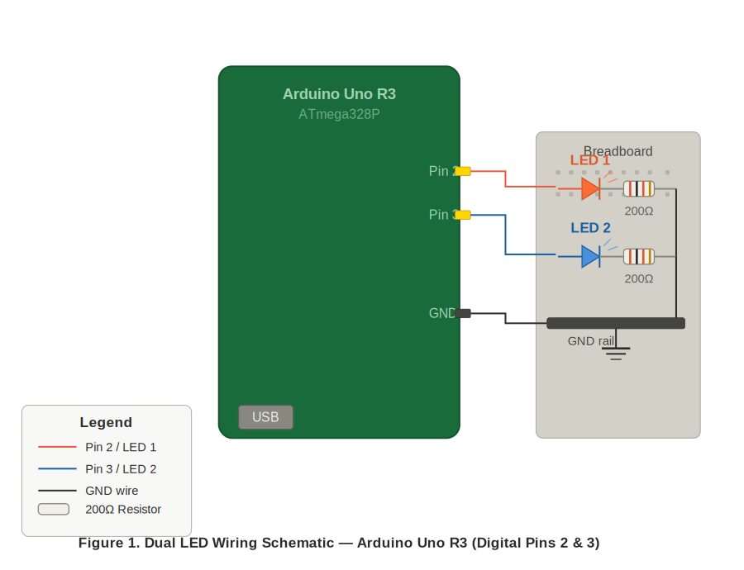
Figure 1. Dual LED Wiring Schematic — Arduino Uno R3 (Digital Pins 2 & 3)

Software Architecture
The system implements a polled, round-robin Cyclic Executive task manager. Three tasks are defined and registered in a function pointer array: getSerialInput, blinkPin2, and blinkPin3. On every iteration of loop(), the Cyclic Executive iterates over the task array and calls each function in sequence. Each task uses millis()-based non-blocking logic and returns immediately if it has no work to do, ensuring no task blocks another.
Task Table:
Index 0: getSerialInput — checks for serial input and updates LED intervals
Index 1: blinkPin2 — checks and updates LED1 (Pin 2) blink state
Index 2: blinkPin3 — checks and updates LED2 (Pin 3) blink state

Timing Operation
Timing operation is identical to PROJECT-ASYNC.
Ref: cmpe310.fall25.project4, DESIGN — Timing Operation section.
For an interval of X milliseconds:
LED ON for X/2 ms
LED OFF for X/2 ms
This cycle repeats continuously.

Serial State Machine
The serial state machine logic is identical to PROJECT-ASYNC, now enclosed in getSerialInput().
Ref: cmpe310.fall25.project4, DESIGN — Serial State Machine section.
State WAIT_LED: Prompt for LED number (1 or 2).
State WAIT_INTERVAL: Prompt for interval in milliseconds.
After updating the selected LED interval, return to WAIT_LED.

Source Code
#include <Arduino.h>

#define LED1_PIN 2
#define LED2_PIN 3

// LED Control Structure
struct LEDControl {
int pin;
unsigned long interval;
unsigned long lastToggleTime;
bool state;
};

LEDControl led1 = {LED1_PIN, 1000, 0, LOW};
LEDControl led2 = {LED2_PIN, 1000, 0, LOW};

// Serial State Machine
enum SerialState { WAIT_LED, WAIT_INTERVAL };
SerialState currentState = WAIT_LED;
int selectedLED = 0;

// Shared LED handler (non-blocking)
void handleLED(LEDControl &led) {
unsigned long now = millis();
if (led.interval > 0) {
if (now - led.lastToggleTime >= led.interval / 2) {
led.state = !led.state;
digitalWrite(led.pin, led.state);
led.lastToggleTime = now;
}
}
}

// Task functions
void blinkPin2() { handleLED(led1); }
void blinkPin3() { handleLED(led2); }

void getSerialInput() {
Serial.setTimeout(10); // prevent blocking
if (Serial.available() > 0) {
int input = Serial.parseInt();
if (currentState == WAIT_LED) {
if (input == 1 || input == 2) {
selectedLED = input;
Serial.println("What interval (in msec)?");
currentState = WAIT_INTERVAL;
}
} else if (currentState == WAIT_INTERVAL) {
if (input > 0) {
if (selectedLED == 1) led1.interval = input;
else led2.interval = input;
Serial.println("What LED? (1 or 2)");
currentState = WAIT_LED;
}
}
}
}

// Cyclic executive task table
// create list of function ptrs
void (*tasks[])() = {getSerialInput, blinkPin2, blinkPin3};

const int NUM_TASKS = sizeof(tasks) / sizeof(tasks[0]);

void setup() {
pinMode(LED1_PIN, OUTPUT);
pinMode(LED2_PIN, OUTPUT);
Serial.begin(9600);
Serial.setTimeout(10);
while (!Serial);
Serial.println("What LED? (1 or 2)");
}

// Round-robin cyclic executive
void loop() {
for (int i = 0; i < NUM_TASKS; i++) {
tasks[i]();
}
}

TESTING

Retained Test Cases from PROJECT-ASYNC
Ref: cmpe310.fall25.project4, TESTING section.
Input: LED 2 → 600 ms
Expected: LED2 blinks 300ms ON / 300ms OFF
Input: LED 1 → 1600 ms
Expected: LED1 blinks 800ms ON / 800ms OFF. Verify other LED remains unaffected.

Additional Test Cases (ECR 0.1)
T.9 — Cyclic Executive Registration:
Inspect source code to confirm that getSerialInput, blinkPin2, and blinkPin3 are all present in the tasks[] function pointer array.
T.10 — Round-Robin Dispatch:
Confirm that loop() iterates over all entries in tasks[] on every cycle with no task skipped or called out of order. Verify by code inspection and by observing that both LEDs blink and serial input is accepted simultaneously without interruption.

Test Results
T.1 – Two LEDs verified connected and functional.
T.2 – Each LED independently configurable via serial input.
T.3 – Asynchronous operation confirmed; no LED pause during serial input.
T.4 – ON/OFF timing verified to equal interval/2.
T.5 – Blink rate stable over 30-second observation period.
T.6 – LED connections to Pins 2 and 3 confirmed.
T.7 – Required serial dialog sequence executes correctly.
T.8 – Successful compilation confirmed with Arduino IDE 2.3.3.
T.9 – All three tasks confirmed registered in the function pointer array.
T.10 – Round-robin dispatch confirmed by code inspection and live operation.
END OF DOCUMENT

