Exercise 3.1 (May 8, 2020)

-B9TB1707

# Question:

Suppose we have three points in 3D space and their coordinates are (x,y,z)=(0.2+rx1 , -0.1+ry1 , 1.0+rz1 ), (3.0+rx2 , 0.1+ry2 , -1.0+rz2), and (1.0+rx3 , -2.0+ry3 , -0.5+rz3 ), respectively. r is a random number between -0.1 and 0.1. Find a plane passing through these three points. Note that the equation of a plane that does not pass through the origin (0,0,0) is given by *ax + by + cz = 1*

# Solution:

There are two ways to solve this problem: namely either, using an inverse or using the Gaussian elimination method. In this report, I am going to use the inverse to find the solution.

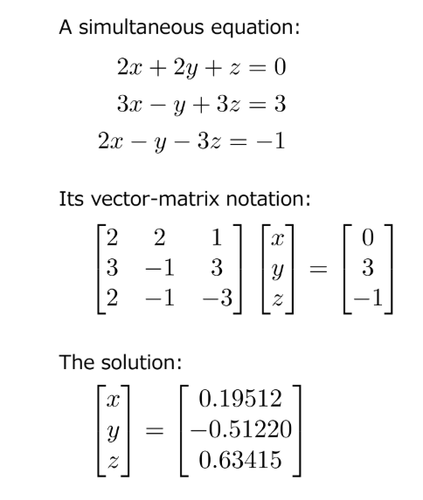

This is the hint we got.

My code for the solution is below.

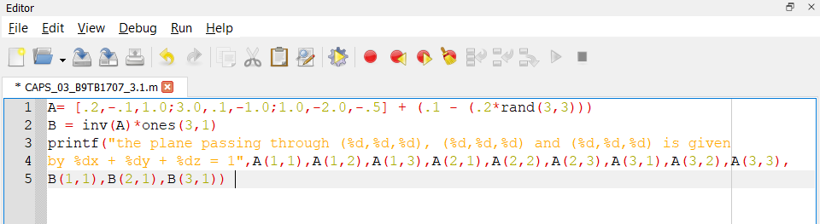

The output is as follows. The randomly generated points are the stored in matrix A the points are displayed below.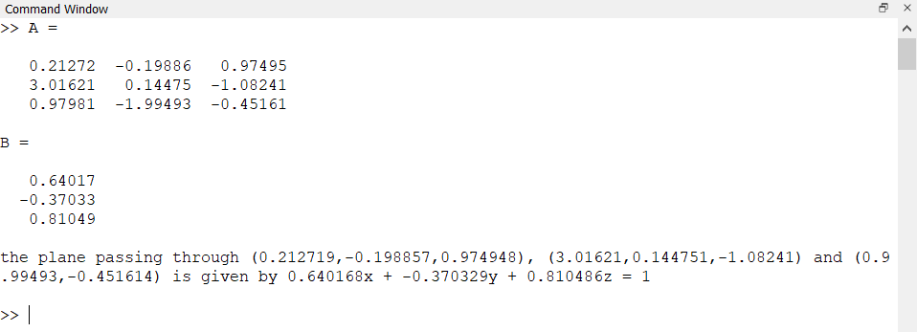

##### How it works:

1. Line 1 initializes a matrix with the each point as a row on the matrix. It also uses the A + (B-A)*rand() algorithm, where A and B are the upper and lower limit of the set within which a random number must be chosen (0.1 and -.1 in this case).
2. Line 2 gets the solution and stores it in the array B. It gets the answer by inverting A and multiplying it with a matrix with all elements with 1.
3. Lines 3,4,5 deals with standard printing functionalities.

# Conclusion:

Hence I solved the problem by using an inverse matrix. The Gaussian elimination method is more efficient and is better method overall, but this is only a three-dimensional problem, I feel that the inverse method sufficient since it simplifies the code by a lot. This is the reason I used the inverse method.