Exercise 4.1 (May 11, 2020)

-B9TB1707

# Question:

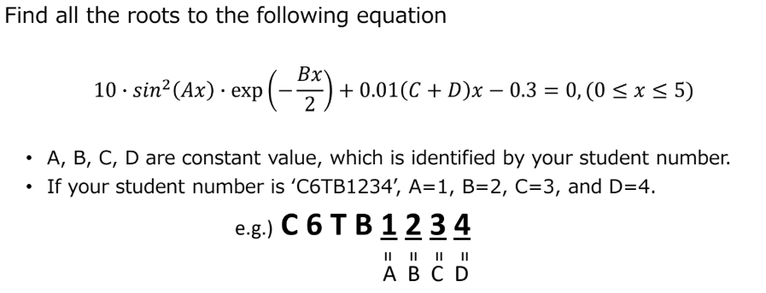

# Solution:

The roots of the equation are: **0.22798** & **0.96635**

My code for the solution is as follows:

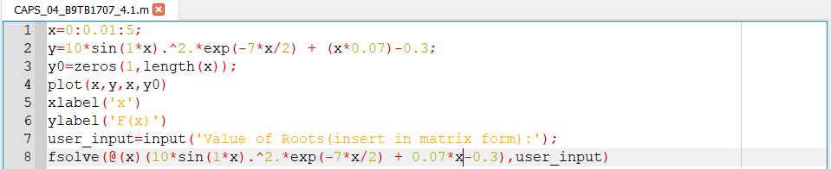

Where A = 1,

B = 7,

C = 0,

D = 7.

The output is as follows:

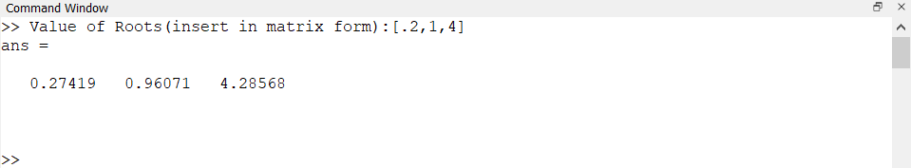

And the plot of the function is depicted below:

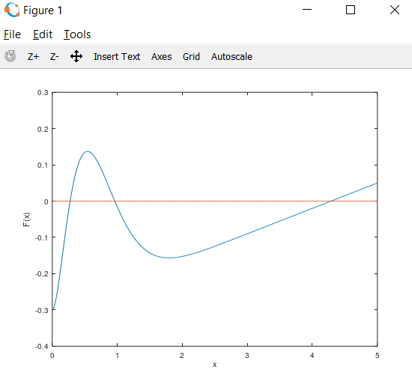

##### How it works:

1. Line 1 initializes x with a domain of 0 to 5 with an interval increment of 0.01
2. Line 2 initializes the y with the problem expression
3. Line 3 intializes a matrix y0 with filled with zeroes. This matrix is used to store the values of every F(x) value corresponding to every x value.
4. Line 4 plots the graph.
5. Line 5 and 6 labels the graph
6. Line 7 gets the input from the user for secondary inputs for fsolve function.
7. Line 8 uses the fsolve function to display the output. It uses a value from the user and checks the neighbourhood around it for a solution.

# Conclusion:

This code uses both the computational power of the computer and the guesses of the user to arrive at the solution. The guesses must be such that the roots of the equation are in proximity to the guessed value. I feel that this is not a good way to solve for equation as one could skip the root by guessing a value that is not in the neighbourhood of the solution.