Exercise 6.1 (May 18, 2020)

-B9TB1707

# Question:

Consider a mass m, to which a spring with spring constant k and a damper with damping constant c are attached as shown in the diagram. Assume that the mass can move only in the x. The equation of motion is given by

When setting c to ((your birth month) modulo 3) +1) and k to ((your birthday) modulo 7) +1), plot x (t) with m=1, x (0) =1 and dx/dt (0) =0. E.g., If your birth month and date is 13th August, then c=3 and k=7

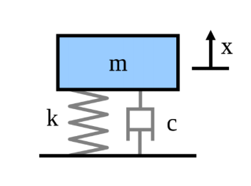

# Solution:

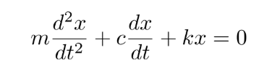Taking c to be 1 and k to be 2.

My code for the solution is as follows:

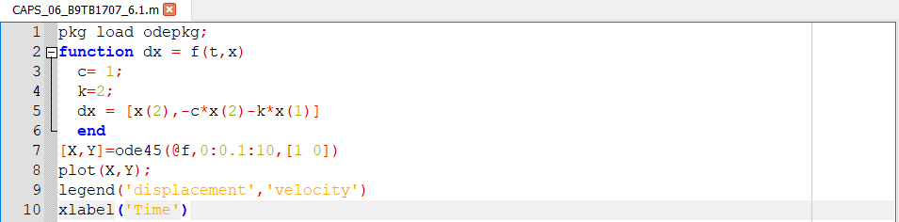

And the output is as follows:

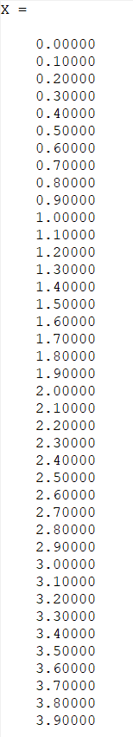 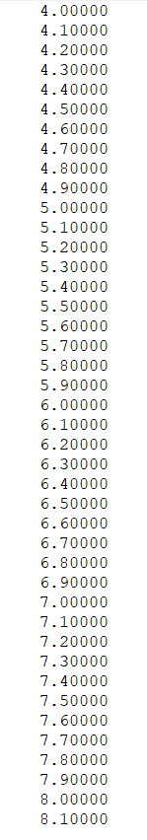 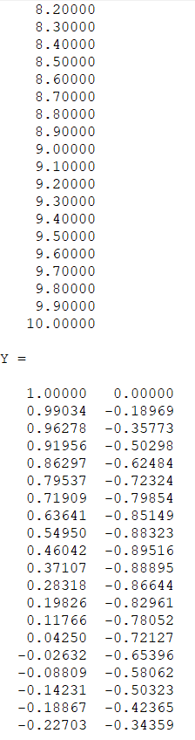 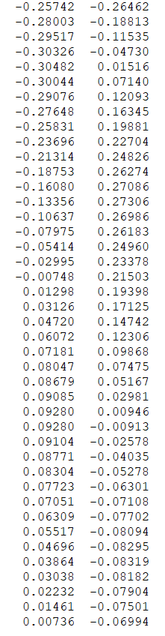 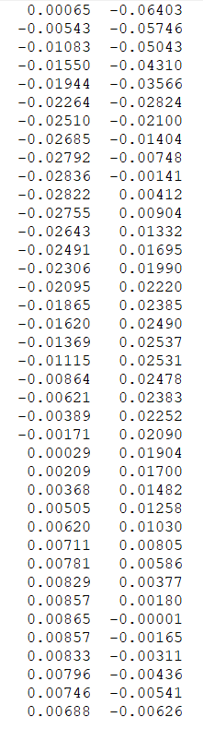 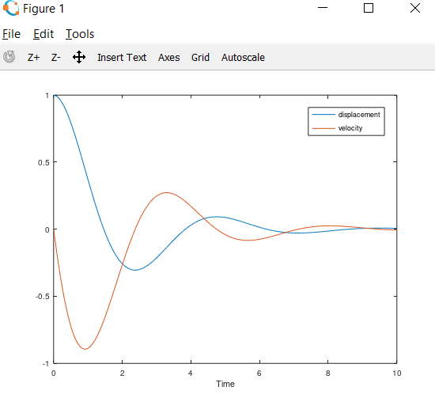

Where the blue curve stands for displacement and orange for velocity as given by the legend.

##### How it works:

1. Line 1 imports the odepkg to use the ode45 function.
2. Line 2 is the function header which sets up the differential function for ode45 to solve.
3. Line 3 and 4 initialize the variables c and to the required values.
4. Line 5 initializes dx to a matrix with first element being the initial value of x’ and the second value being the differential equation along with the initial values of the arguments.
5. Line 6 terminates the function block with the command end.
6. Line 7 calls the function ode45 with its parameters being the differential equation as function f, the time domain of interval increment of 0.1, and the initial values for the equation. The result is stored in an array.
7. Line 8 plots the solution using the plot function and the solution array as an argument.
8. Line 9 specifies the legend to differentiate the displacement and velocity curves.
9. Line 10 labels the x-axis.

# Conclusion:

Hence I have solved and plotted the given differential equation. There are many ways to solve this problem, for example by using ode23, ode15, and symbolic. I chose to use ode45 because even though symbolic is more efficient, I couldn’t get symbolic running on my computer and so I chose the ode45 because I felt it was easy to use and easily found reference material easier to find online