Exercise 8.1 (May 25, 2020)

-B9TB1707

# Question:

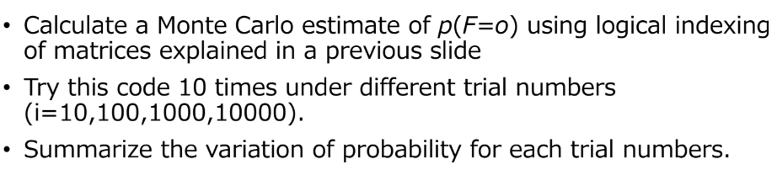

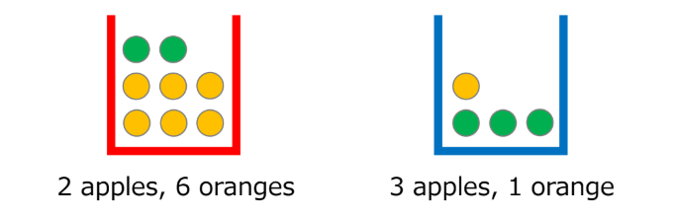

# Solution:

My code for the solution is as follows:

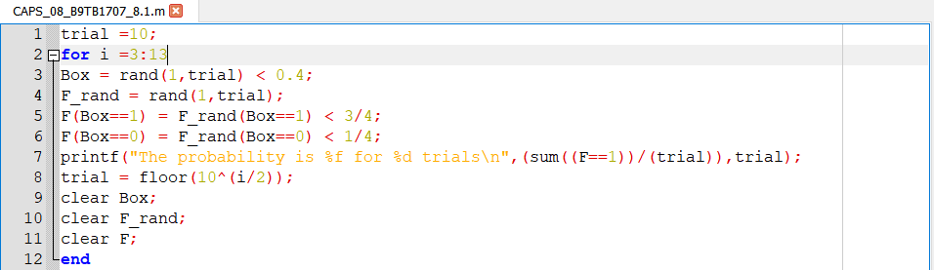

And the output is as follows:

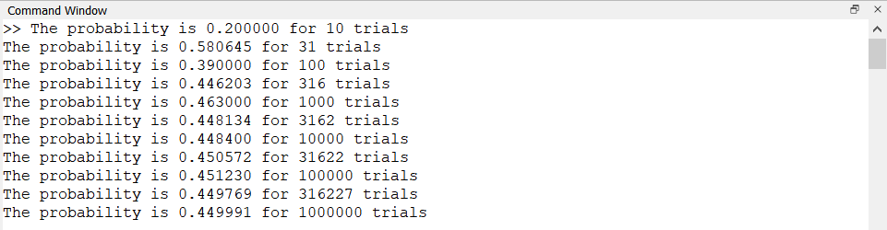

##### How it works:

1. Line 1 initializes the variable for number of trials.
2. Line 2 sets up the for loop to iterate through multiple trials.
3. Line 3 creates an array to store the outcome of the choice of box. A random number between 1 and 0 is generated and if this number is below 0.4 it is assigned 1 to denote a red box and zero to denote a blue box by using a simple less than logical operator.
4. Line 4 creates an array of random numbers between 0 and 1.
5. Line 5 and 6 stores the fruit choice as 1 for oranges and 0 for apples by using the same method described in step 3 but this time there is an extra input of the state of B. The probability to be check in the logical operation is changed according to the value of B.
6. Line 7 displays the results.
7. Line 8 updates the number of trials. I have chosen to increase by powers of 0.5 because otherwise the numbers will become too large.
8. Line 9 to 11 clears the data stored in the variables for a fresh set of values.
9. Line 12 closes the for loop.

# Conclusion:

And thus I have calculated the Monte Carlo estimate of probabilities by using the logical indexing method, a method that uses binary arrays to process a large amount of data. In my opinion logical indexing is far superior to the regular iterative method. I have also calculated probabilities for various number of trials, and as expected, the larger the number of trials the closer the calculated probability got to the actual theoretical value of 0.45.