Exercise 9.1 (May 29, 2020)

-B9TB1707

# Question:

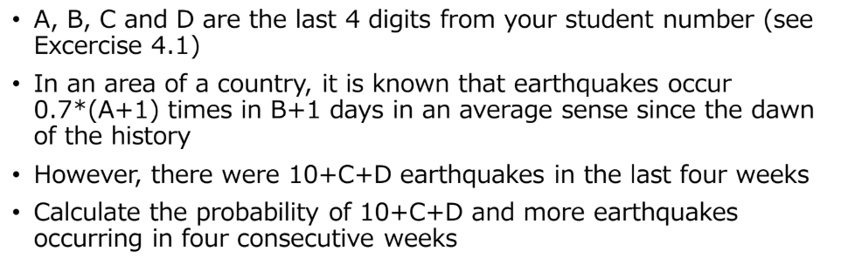

# Solution:

My code for the solution is as follows: 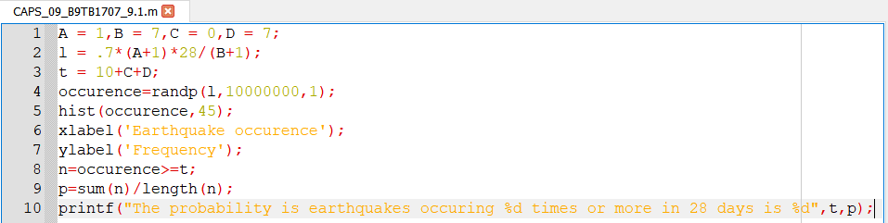

The output is as follows: 

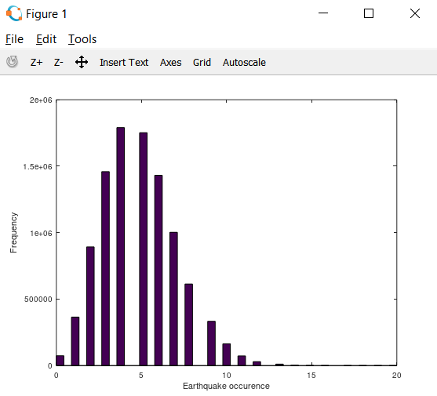

Where A = 1, B = 7, C = 0, D = 7.

The probability that the event happened $k$ times in this specified interval is given by;

$$P\left(X=k\right)=\frac{{}^{k}e^{-}}{k!}$$

And the expected value of the event defined $E\left[X\right]$ is equal to $.$

This is the Poisson distribution equation, and I will use this equation to solve this problem.

##### How it works:

1. Line 1 declares the variables A, B, C, D.
2. Line 2 declares the variable to hold the value of lambda for the Poisson equation.
3. Line 3 declares the variable to hold the unusual occurrences of earthquakes, the threshold value.
4. A Poisson distribution is generated by randp function of length 10000000
5. Line 5 generates a histogram based on the Poisson distribution.
6. Line 6 and 7 labels the histogram.
7. Line 8 filters the data in the distribution and keeps only the values equal to or greater than the threshold, by using a simple relational operatorLin.
8. Line 9 calculates the probability
9. Line 10 displays the results.

# Conclusion:

The program above uses the randp() function to generate the passion distribution. One could use an iterative approach to solve this problem, but I feel that this way is too inefficient and cumbersome to code, so I stuck with the randp() function.