Exercise 10.1 (June 5, 2020)

-B9TB1707

# Question:

 

# Solution:

My code for the solution is as follows: 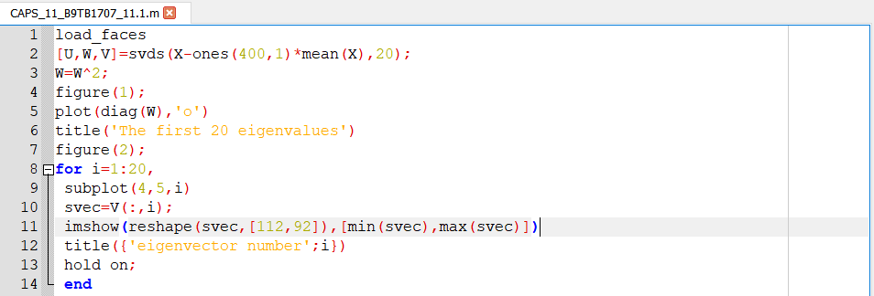

And the output is as follows: 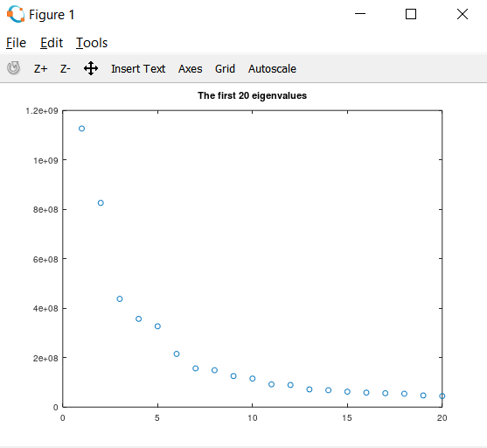 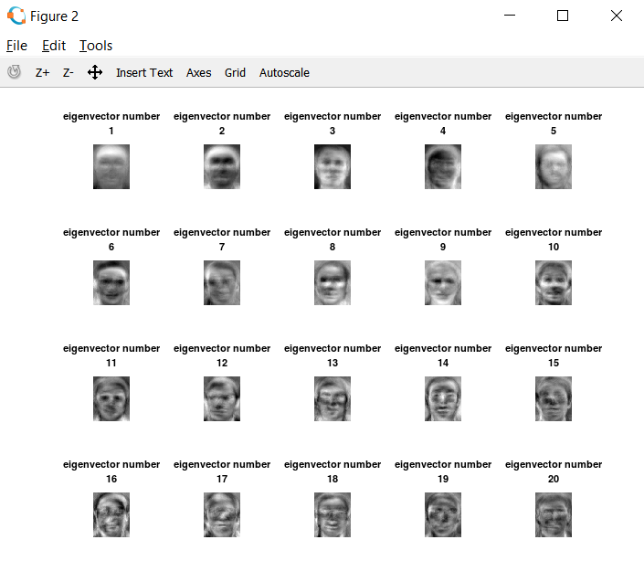

##### How it works:

1. Line 1 runs the scripts given in class to load the images and to initialize matrix X.
2. Line 2 performs singular value decomposition on the covariance matrix of X. the covariance matrix of X is calculated by subtracting the mean of X from every term of X. The svds() function calculates a specified number of the largest singular values for a given matrix. That is why we give it an extra parameter, 20.
3. From the definition of singular value decomposition we get the values of the eigenvalues by squaring the W in Line 3 (The values stored inside the diagonal elements of W after SVD is the square root of the eigenvalues.)
4. Line 4 creates a new plot window.
5. Line 5 plots the eigenvalues.
6. Line 6 titles the graph.
7. Line 7 creates a new plot for the images created using the eigenvectors.
8. Line 8 creates a for loop construct.
9. Line 9 divides the plot into twenty spaces using the subplot function.
10. Line 10 retrieves the eigenvector stored in the ith column and stores it in variable svec.
11. Line 11 reconstructs the image from the eigenvector along a normalized scale for brightness and specifies the dimensions using the reshape() and imshow() functions.
12. Line 12 titles the image.
13. Line 13 is a hold on command to hold on to the data in the plot.
14. Line 14 ends the for block.

# Conclusion:

And thus rather than to find the eigenvalues and eigenvectors directly using the command eig(), I used singular value decomposition to more efficiently solve the problem. Though eig() is a perfectly valid option for problems involving a small amount of data, it becomes too intensive on the system when a large set of data is involved (especially for images, where each pixel is a data point). Using SVD we decompose the matrix into 3 matrices, out which 1 is the eigenvectors and one contains the square root of the eigenvalues in its diagonals. It is then very easy to extract this data and reconstruct the images from the data.