Name : Oakar Kyaw
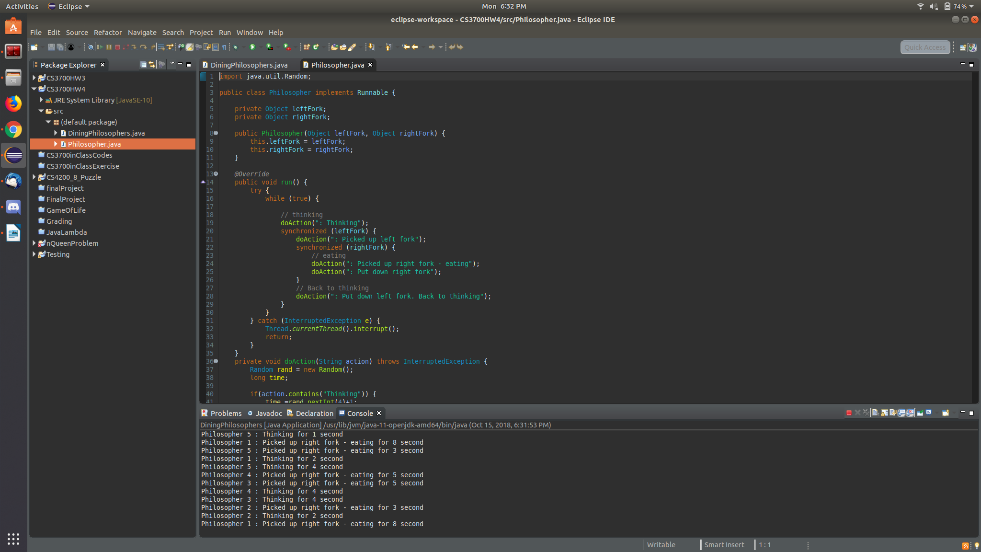
Github : https://github.com/oakkar8

1) The class file for philosopher

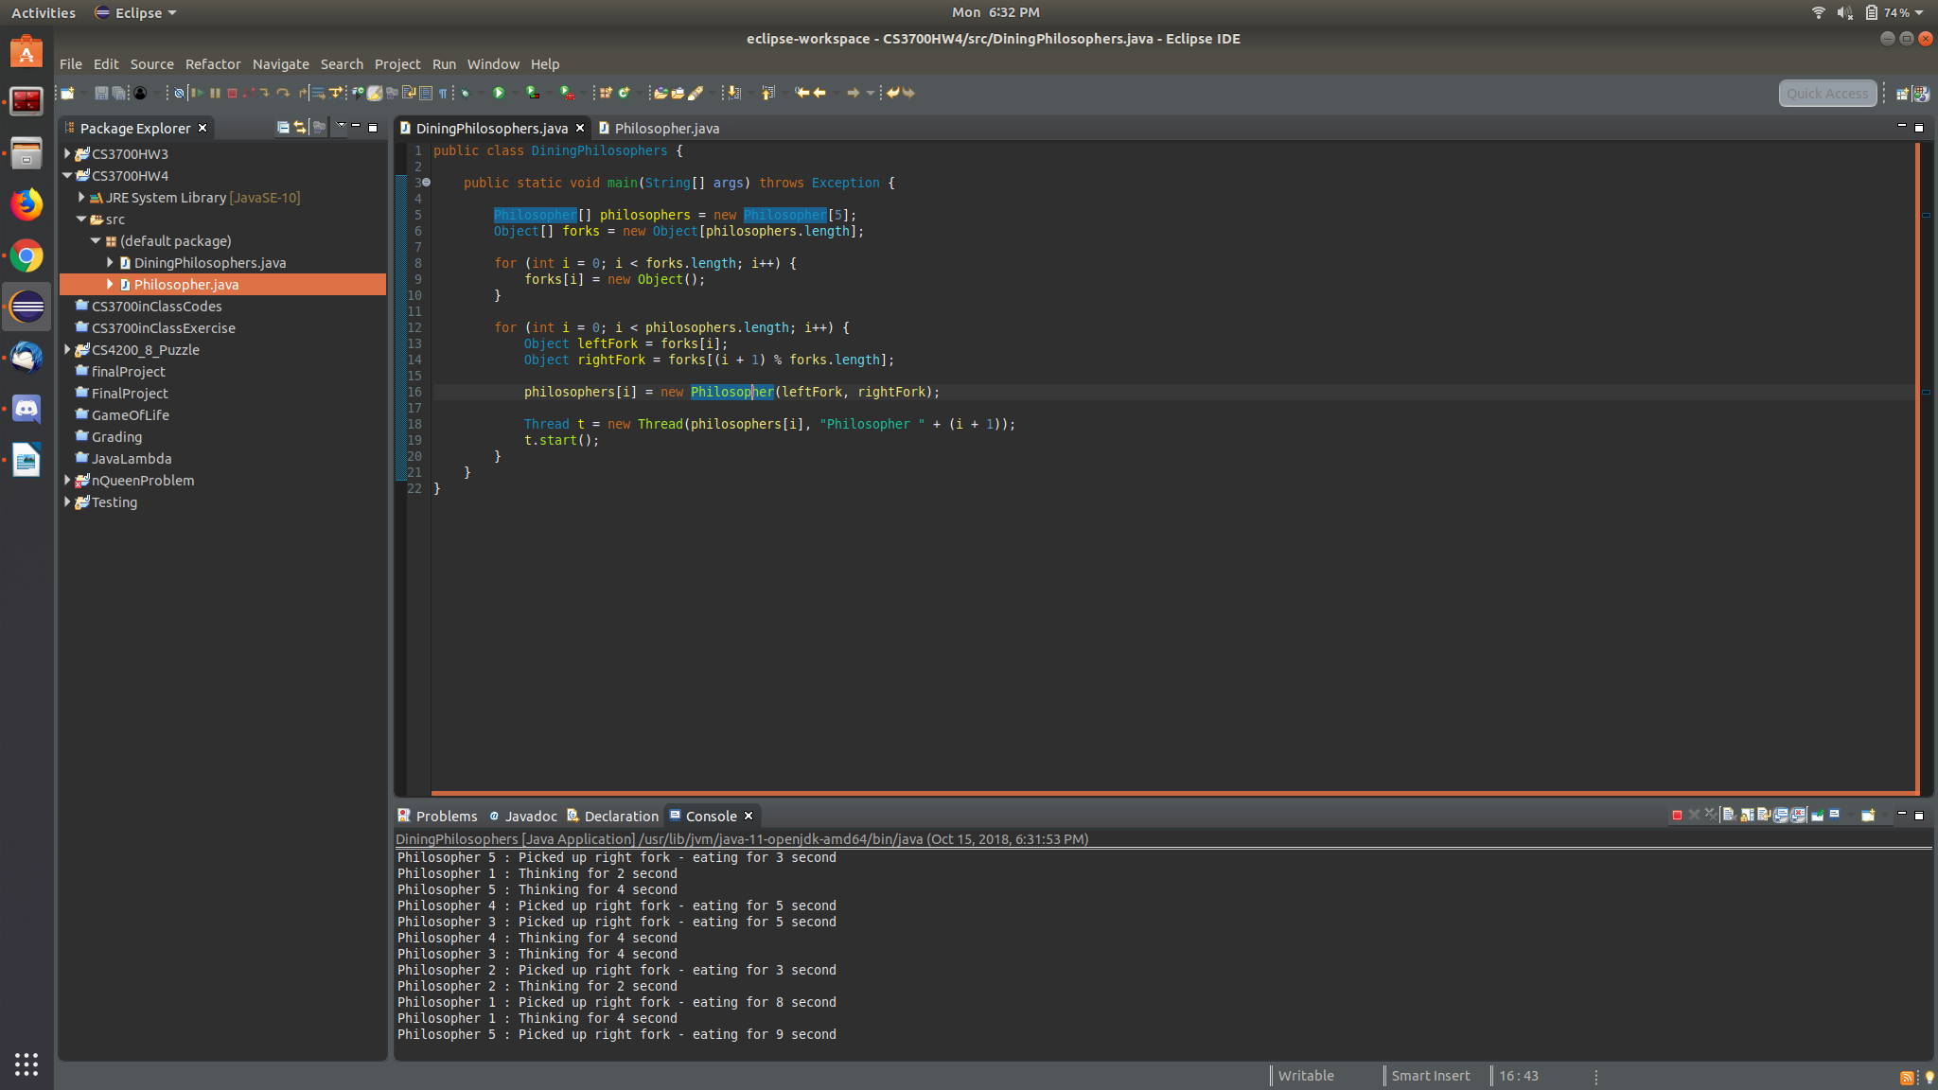

2) main thread for running the threads.

There will be time. The program will in deadlock when all philosopher take their left fork and waiting for the right fork.

