Kaleem Hamid-Butt

[Company name]  [Company address]

front-end development

github

<https://kh1704040.github.io/front-end-development-/home.html>

Contents

Introduction 2

Advantages and disadvantages of form surveys 2

[branding 3](https://ua92-my.sharepoint.com/personal/l39219321_student_ua92_ac_uk/Documents/uni/assiasgment/assisagmen.docx#_Toc149316875)

Logo 4

Responsive page 5

Multipage 5

Form validation 6

HTML 6

CSS 7

Javascript 7

Bootstrap 7

Accessibility 7

Documenting website(reflective) 8

8

9

10

12

14

testing 15

Reference 16

HTML validator 16

overall 21

title

my website is called football town and the product I will be selling will be vintage football shirts.

# Introduction

i work for a software company called TNK technologies LTD and I have tasked with the job of developing a website application for a new start-up client named Football Town. They specialise in selling football shirts which are typically vintage. They have asked me to create an e-commerce website for their business where they can sell their products to their customers. They would like 4-5 pages for their website and would like it not to be so text-filled. Using Microsoft Form as my elicitation I found out the user requirements that my client want as I created questions and my client answered them.

# Advantages and disadvantages of form surveys

One advantage of form surveys is that you can get quick and efficient answers because the survey is sent straight to the client and they are telling you exactly what they want for their brand. Another advantage of form survey is that it is very cost efficient because through using Microsoft forms and emailing the client it cost nothing whatsoever as these are free service providers.

# branding

For the branding, I created a form survey for my client to answer so I could get simple but straightforward answers about what he would like for his branding. As you can see below my first question was if the client already had a company logo and as you can see they answered the second question they answered that they wanted me to create a new one for their brand.

Then my third question that I asked is what would the client like their logo to be called and they said football town then I asked for the logo what colours would you like and the client have told me that they would like the logo to be white with a dark blue background. Then an important question I asked is what their target audience was which is needed as it is very important to know and they told me that their target audience is going to be males who aged 14-35 yr old. The last question I asked is if the client would like a slogan and they answered no.

# Logo

Taking everything into consideration from the client answers I then used adobe logo maker to create this logo which is the final one, as you can see it is white with a blue background and has the brand name on it as well. I tried and create this while keeping the client target audience in mind.

# Responsive page

A responsive design allows software developers to build a Web page that can dynamically adapt to the size of the devices. This development philosophy enables the rendering of Web pages in a fast and optimized way, ensuring a good user experience on mobile devices, tablet and desktop. And the benefits of this is that software developers emphasize the guarantee of a good user experience and the increase of accessibility as the two most important advantages of responsive design. Additionally, there is greater disagreement in considering time and maintenance costs as an advantage of responsive design. Regarding the limitations, they emphasize the compatibility with older versions of a Web browser, the higher loading time and the difficulties in optimizing user experience.

-Lindqvist, Josefine. "The transition to a responsive website: A user study." (2016).[1]

I did this In different ways for examples using the code “<meta name="viewport" content="width=device-width, initial-scale=1.0">” which what it does is makes the website comptabile on multiple devices like tablet/phones/computer. This is a positive because It is makes my website professional looking on every device. Another thing that I did was that using “max-width” makes images on my website more compatible and more responsive because the imager will go smaller if it is needed but never bigger. This is a positive things for smaller devices

# Multipage

Having multiple pages is a beneficial things as it allows users to navigate their way around the website content through navigation and are allow to find certain content which they wish to require. there is multiple advantages to using multipage for example having great marketing. This is becauseA multi-page website is ideal for spreading brand awareness and advertising. Blog posts, different URLs, categories, etc. can be advertised through social media posts. Different segments of the audience can be targeted for advertising different parts of your website. Or that is great for SEO because  By delivering different types of content through blogging and providing in-depth information through siloing (creating different categories and sections), you can easily target more volumes of keywords. This keeps your website SEO-centric, leading to a higher rank on SERPs.

* Communications crafts. “Single Page VS Multi Page Websites: What attracts users more?”[2][3][4]

I have done this by simply creating 6 pages which all have different content focus and by creating an easy yet professional-looking navigation bar so users can use my website and find their content without having to scroll down for ages. This beneficial for the client because it makes their website more professional.

# Form validation

When processing user input in forms and in a more general context, the input data must be validated to ensure that the data is correct and does not cause security issues. This validation can and should be performed both on the client and on the application server. Despite the similarity of the validation rules in both environments, the implementations of these validation phases are almost always separated due to differing technologies used on both sides as well as the differing access to the databases used by the service. This leads to the validation logic being duplicated on the client and the server, which in turn leads to the need to maintain validation implementations separately on both sides.

- Nurminen, Valtteri. "Unification of form validation implementations in web clients and servers." (2023).[5]

How I used this was by creating a signup form for users to come and use the website. And if they filled in information wrong or not fill it at all it would inform them that they need to fill out the field .A screenshot of a computer

# HTML

HTML is just the standard markup language for documents designed that will be shown in a web browser. It is typically used with CSS and JavaScript. I used visual studio code as my text editor. HTML is a easy way for beginner’s to program and HTML allows users to utilise templates which then makes designing a webpage very easy. Perhaps the greatest benefit of using HTML as the basis for CR-ROMs is that the same set of text, graphics, and sound files can serve both Macintosh and Windows platforms; only the user-provided browser program needs to differ. Hence no file-conversion or -duplication is necessary. This can represent a substantial saving of time an J effort to the would-be CD-ROM produc.er.

Misanchuk, E.R. and Schwier, R.A., 1996. Benefits and Pitfalls of Using HTML as a CD-ROM Development Tool.[6]

How I used HTML is by using a text editor to create a website which includes 6 pages and I used HTML to create the whole thing

# CSS

This I a style sheet language which is typically used for styling the presentation of a coded document write using HTML or XML. There is multiple benefits of CSS for example you can have faster speed of your page, It can link to better user experiences because CSS is not only used to make the web page look more eye-catching and it also allows to make website more user-friendly too all type of people. CSS is used to define styles for your web pages, including the design, layout and variations in display for different devices and screen sizes.- <https://www.w3schools.com/css/css_intro.asp>[7]

# Javascript

This is a programming Language which is used along HTML and CSS. Javascript is a lanauge that allows a user to create a dynamical content,control multimedia,animate images and a lot of other things. There is multiple benefits of using javascript that it can be used to easily add things like animation,interactive maps,and scrolling videos. users can benefit from flexible syntax, loose type systems, powerful reflection mechanisms, and shorter build cycles. Scripting languages have proven their usefulness in various application areas

H. M. Kienle, "It's About Time to Take JavaScript (More) Seriously," in IEEE Software, vol. 27, no. 3, pp. 60-62, May-June 2010, doi: 10.1109/MS.2010.76.[8]

# Bootstrap

Bootstrap is just a free open source CSS framework which is directed at being responsive,mobile-first front-end web development. Bootstrap includes HTML.CSS and javascript-based design templates for typography,forms buttons,navigation and other interface componets. Benefits of using bootstrap is that it is easy to prevent repetitons it can help designs to adapt to different screen sizes. Bootstrap is compatible with all modern browsers (Chrome, Firefox, Internet Explorer, Edge, Safari, and Opera)

w3schools.com[9]

# Accessibility

|  |  |
| --- | --- |
| Accessibility | Yes/no |
| HTML tags indicate heading,lists etc | yes |
| Body text at least 16px | yes |
| Line spacing | Yes |
| Anchor text is clear | Yes |
| Text can be enlarged or made smaller | Yes |
| Images have alt text | Yes |
| Can pause,mute,exit autopplay | Yes |
| Audios and video have subtitles or transcripts | No |
| Can navigate with only keyboard | No |
| Page titles | Yes |
| Menu order is same throughout site | Yes |
| No time limits is imposed on users | Yes |
| Can scroll only with keyboard | yes |

The increasing provision of Web-based information resources has moved from a simple text interface to dynamic and interactive designs. While this move has provided people with a more creative and flexible experience, there are dangers that some people will be excluded because they cannot use standard methods of access. Research has shown that people with disabilities are most at risk of being excluded from access, and in particular people who are blind or visually impaired and who use assistive technologies such as screen readers. In a library environment, ensuring access for all is important because the method of delivery is predominantly Web-based and the development of e-book provision will provide increased opportunities to access library services remotely.- Brophy, Peter, and Jenny Craven. "Web accessibility." Library trends 55.4 (2007): 950-972.[10]

This shows that having a website that is accessible is good because then does it not only wider your target audience and the amount people that can use your website but it also it is critical to have functions in your website that can cater to audiences that have disadvantages

# Documenting website(reflective)

Function

Logo

Screenshot with explantation

The reason I created and used the logo is because first my client told me that they wanted a logo in their website and because having a logo makes the business easier to remember and spot so its beneficial for them. I used adobe logo maker to create this logo then used css to make it seem more professional by making it into a circle.

User view

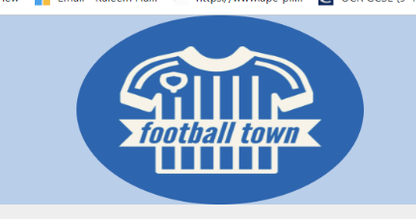

codeview

img class="logo"src="images/logo.jpeg" alt="logo" width="100px" height="150px" >

css

logo{ border-radius: 50%; display: block;

        margin-left: auto;

        margin-right: auto;

    max-width: 40%;

    max-height: 15%;

    }

function

title

screenshot with explain



the reason I created a title is because it helps massively to show users what the page will be full of. So for example the shirts page will include shirts and content will be full of the shirts. It then allows each page to have its own identity and ID

Userview



HTML

<h1>Shirts</h1>

CSS

 h1{text-align: center; text-decoration: underline;}

function-nav

screenshot with explanation

The reason I created a navigation is because without that users can not go onto the next page whatsoever to take in the rest of your content and if you have a nav but not a navbar that clearly shows your navigation then it makes unprofessional and unclear to the user so they might struggle to navigate themselves around the website.

I used w3s school with help with the code and css so I could understand it.

User view

Code view

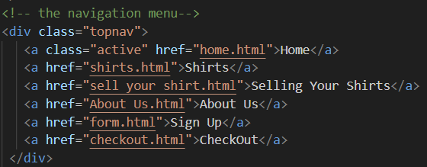

css

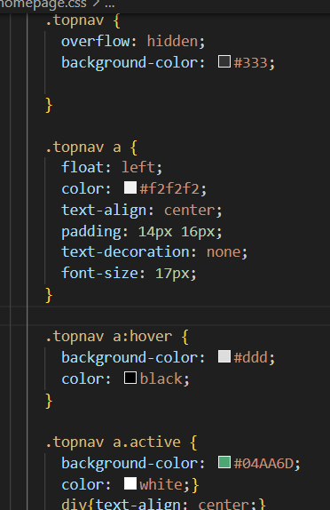

Fuction-footer

Screenshot with explantation



creating a footer is just essential for website creation because users can use it to find information like contact information, details about the company, social media posts or links, or even to discover new or related content on the site. A footer doesn’t need to include all of these things and can include bare minimum but it just important to include at least somethin

user view



Code view

Fuction-img

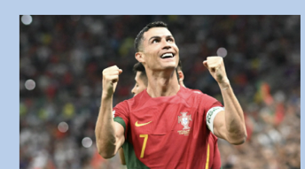Screenshot with explanation

including a image in your website is crucial because it is important from usability point of view, a website that is good would contain images which are relevant to the website or the customers need. Because they are useful for conveying concepts and information and also images can attract and engages a user attentation.

I used google images to find a picture of Ronaldo then used a converter to convert change it from webp to jgp

User view

Code view



css

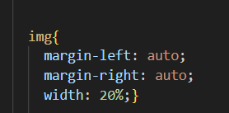

Function-form

Screenshot with explanatation

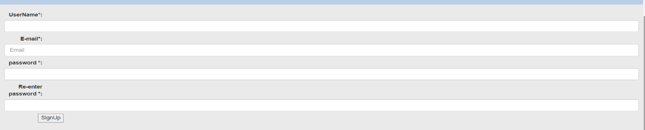

Having validation and a form in your website is pretty important because having a sign up form with validation allows users to make and have a account that they can use to save their data with. It is also important to validate form for security measures and to make sure data entered is correct and in the correct form. I used bootstrap to create the style and the validation within the form.

User view

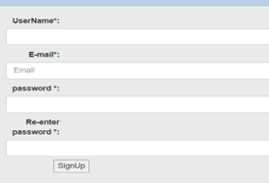

Code

    <form action="https://webdevbasics.net/scripts/demo.php"

        name="SignUp" onsubmit="return myFunction()">

<label for="inputname">UserName*:</label>

<input type="name" class="form-control" id="inputname placeholder="name" required>

<label class="form-label" for="inputPassword"> E-mail*:</label>

<input type="email" class="form-control" id="inputEmail" placeholder="Email" required>

<label for="inputname">password *:</label>

<input type="password" class="form-control" id="inputpassword placeholder="Password" Required>

<label for="inputname">Re-enter password *:</label>

<input type="password" class="form-control" id="inputpassword placeholder="password" Must Match>

<br>

<input id="mySubmit" onclick="clicked" type="submit" value="SignUp" class="middle">

       </form>

Bootsrap/css

<script src="javascript.js"></script>

    <link href="https://cdn.jsdelivr.net/npm/bootstrap@5.0.2/dist/css/bootstrap.min.css" rel="stylesheet">

<script src="https://cdn.jsdelivr.net/npm/bootstrap@5.0.2/dist/js/bootstrap.bundle.min.js"></script>

<link rel="stylesheet" href="https://maxcdn.bootstrapcdn.com/bootstrap/3.4.1/css/bootstrap.min.css">

    <body style="background-color : #B4CFEC ;">

<style>

 body{background-image: ur

Function-shopping basket

Screenshot with explanation

In my client website it is important to have a shopping basket ability because his website is made to sell football shirt so it is crucial that it has that customers can put items into their basket and then buy it.

userview

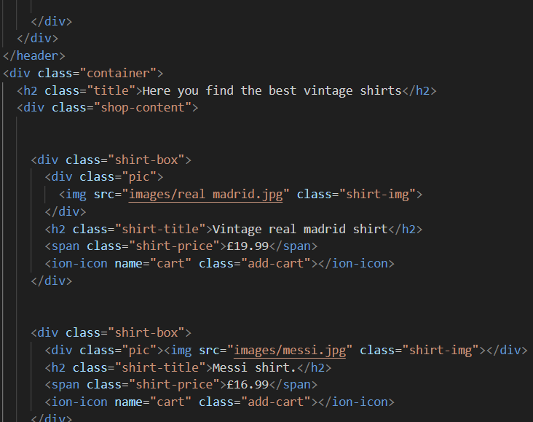codeview

# 

# 

# testing

|  |  |  |  |  |
| --- | --- | --- | --- | --- |
| Testing number | fuction | prediction | screenshot | Worked y/n |
| 1 | img | Should show a image |  | Y |
| 2 | Homepage link | Should show the correct page |  | Y |
| 3 | Shirts link | Should show the correct page |  | Y |
| 4 | Sell your shirts link | Should show the correct page |  | Y |
| 5 | About us link | Should show the correct page |  | Y |
| 6 | Sign up link | Should show the correct page |  | Y |
| 7 | Shopping link | Should show the correct page |  | y |

# Reference

For my navigation bar I used https[://www.w3schools.com/css/css_navbar.asp](https://www.w3schools.com/css/css_navbar.asp) for reference so I can understand how to do it.

For my form I didn’t use a certain reference because I just used the form we created in class but I attached bootstrap to it that I took off the internet.

For my shopping basket I used reference from <https://www.tutorjoes.in/JS_tutorial/food_shopping_cart_in_js>

To help with me the JavaScript. I will say that I did not succeed very much with a lot of the JavaScript.

For the shirts page I used https:[//www.w3schools.com/howto/howto_css_product_card.asp](https://www.w3schools.com/howto/howto_css_product_card.asp) to give me information on how to create the base of it then I did the rest myself.

# HTML validator

Using a HTML coder my findings were that in my first page I had multiple mistakes that I needed to fix. All of these mistakes are simply but unfortunate mistakes.

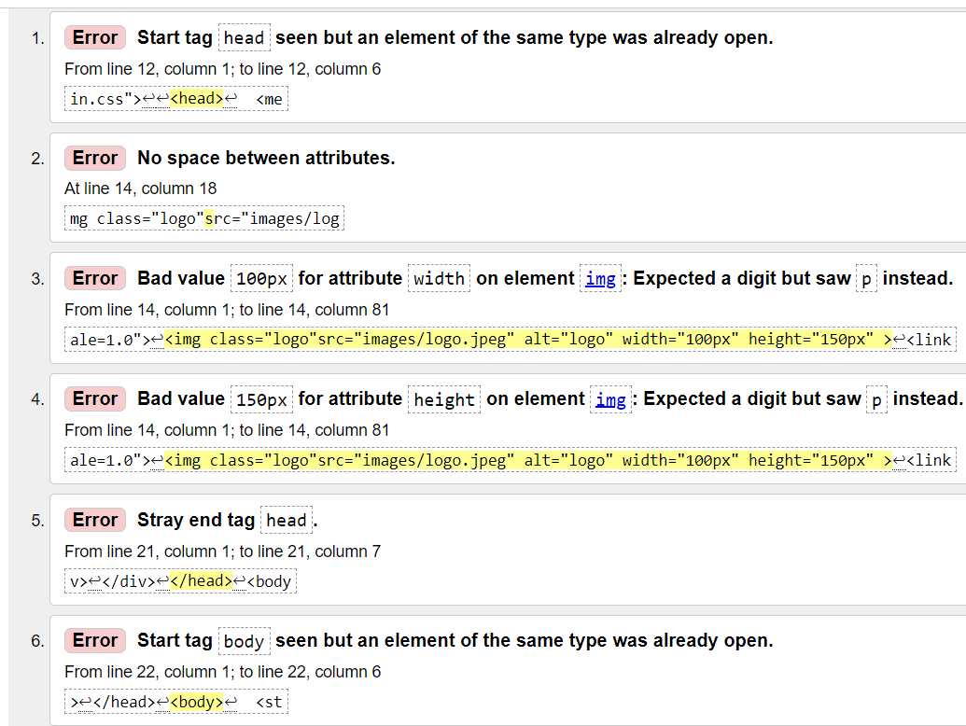 This is my second Shirt page and it does seem like maybe the mistakes all might be the same things that I need to fix.

This is my third page named selling shirts and yet again it is all just the same errors that I need to fix which isn’t too bad because at least I know how to fix it.

on my fourth page it is just simple mistakes yet again like needing spacing or a end tag or needing bigger px attributes.

on my fifth page which is the form I had same again problems with just some style problems that I need to fix so it can be perfect.

for my last page which is the shopping basket and I just had a problem with the head then spacing in the logo then some problems with the pictures that I can fix

for my css I put it into a validator and it came out with four errors within the whole website which is quite well so I only need to fix four errors and then my css is fine

# overall

to sum up using the html/css validator my code doesn’t have too many problems and doesn’t have any problems that aren’t fixable so would say it is more than good enough to meet my clients needs and expectations.

1.
2.
3.
4.
5. # Deploying the website

   Step 1:

   had to create a user profile to give me ability to begin deployment. I did this on the GitHub website

   A screenshot of a black screen

   Description automatically generated

   Step 2/3:

   Once the account was created then had to create a new respiratory and then insert my website files which is HTML,CSS,JAVAacript and images and then once the files were added clicked commit changes so the GitHub can process creating my website.

   A screenshot of a black screen

   Description automatically generated
6.
7.
8.
9.
10. Step 4

    then had to click on settings and then select pages and had to changed the source option to main and save it.

    A screenshot of a computer

    Description automatically generated

    Step 5:

    Once it was done now the GitHub should now return my website URL which now can be used to access my websiteA screen shot of a computer

    Description automatically generated

    # Conclusion

    Through this creation of the website I have learnt how to make a website that includes HTML,CSS, bootstrap and JavaScript and how to make my website fulfil its purpose.have learnt how to create a form and use validation and bootstrap.