Fall 2021 - 1st Semester

Project Report

CPCS-433

**MACHINE LEARNING PROJECT With R Language**

Artificial Intelligence Topics

|  |  |  |
| --- | --- | --- |
| Student Name | ID | Section |
| Omar Abdulaziz Alqurashi (Leader) | 1742589 | A |
| Mohammed Alzahrani | 1740166 |
| Mohammed Saleh Alharbi | 1740373 |

**Supervisor:** Dr. Turki T. Turki

December 8, 2020

List of Contents

List of Illustrations 3

1 Selection 4

2 Preprocessing 5

3 Transformation 5

4 Data Mining 5

5 Interpretation/Evaluation 5

5.1 ROC Curves Plots 5

5.2 Performance Measures 9

5.3 Statistical Tests 11

Appendix 14

# List of Illustrations

**Figures**

Figure 1: ROC Curves Plot for glass0 dataset 6

Figure 2: ROC Curves Plot for spambase dataset 7

Figure 3: ROC Curves Plot for twonorm dataset 8

Figure 4: ROC Curves Plot for vehicle0 dataset 9

**Tables**

Table 1: Performance Measures and Standard Deviation for XGBoost 10

Table 2: Performance Measures and Standard Deviation for SVM 10

Table 3: Performance Measures and Standard Deviation for Random Forests 11

Table 4: Performance Measures and Standard Deviation for AdaBoost 11

Table 5: Statistical Comparison for MACC 12

Table 6: Statistical Comparison for MBAC 12

Table 7: Statistical Comparison for MF1 13

# 1 Selection

The selected features of each dataset are the following:

* **Standard Datasets:**
  + Spambase: The number of the selected features is **57**: Word_freq_make, Word_freq_address, Word_freq_all, Word_freq_3d, Word_freq_our, Word_freq_over, Word_freq_remove, Word_freq_internet, Word_freq_order, Word_freq_mail, Word_freq_receive, Word_freq_will, Word_freq_people, Word_freq_report, Word_freq_addresses, Word_freq_free, Word_freq_business, Word_freq_email, Word_freq_you, Word_freq_credit, Word_freq_your, Word_freq_font, Word_freq_000, Word_freq_money, Word_freq_hp, Word_freq_hpl, Word_freq_george, Word_freq_650, Word_freq_lab, Word_freq_labs, Word_freq_telnet, Word_freq_857, Word_freq_data, Word_freq_415, Word_freq_85, Word_freq_technology, Word_freq_1999, Word_freq_parts, Word_freq_pm, Word_freq_direct, Word_freq_meeting, Word_freq_original, Word_freq_project, Word_freq_re, Word_freq_edu, Word_freq_table, Word_freq_conference, Char_freq1, Char_freq2, Char_freq3, Char_freq4, Char_freq5, Char_freq6, Capital_run_length_average, Capital_run_length_longest, and Capital_run_length_total.
  + Twonorm: The number of the selected features is **20**: A1, A2, A3, A4, A5, A6, A7, A8, A9, A10, A11, A12, A13, A14, A15, A16, A17, A18, A19, and A20.
* **Imbalanced Datasets:**
  + Glass Identification: The number of the selected features is **9**: RI, Na, Mg, Al, Si, K, Ca, Ba, and Fe.
  + Vehicle: The number of the selected features is **18**: Compactness, Circularity, Distance_circularity, Radius_ratio, Praxis_aspect_ratio, Max_length_aspect_ratio, Scatter_ratio, Elongatedness, Praxis_rectangular, Length_rectangular, Major_variance, Minor_variance, Gyration_radius, Major_skewness, Minor_skewness, Minor_kurtosis, Major_kurtosis, and Hollows_ratio.

# 2 Preprocessing

There are stages of preprocessing has been done on the datasets. First, the extension of each file of the four datasets has been changed from "dat" into "txt", and their headers has been deleted and the remaining is the data itself. Second, The Oversampling has been applied to the Imbalanced datasets (Glass Identification and Vehicle). (The uploaded dataset files are the edited ones)

# 3 Transformation

In SVM, and AdaBoost classifiers, the labels for the Glass Identification and Vehicle datasets (positive, negative) are transformed into (+1, -1). For the two other datasets (Spambase and Twonorm), the labels (1, 0) are transformed into (+1, -1).

For the XGBoost classifier, the labels for the Glass Identification and Vehicle datasets (positive, negative) are transformed into (+1, 0). For the two other datasets (Spambase and Twonorm), the labels (1, 0) are transformed into (+1, 0), although that there is no need for the last one, it is good for safety purposes.

# 4 Data Mining

16 classifiers are the combinations of 4 algorithms (XGBoost, SVM, Random Forests, and AdaBoost), and 4 datasets (Glass Identification, Vehicle, Spambase, and Twonorm).

For the parameters of XGBoost, the number of rounds is 5, and the objective is "binary:hinge". For the SVM, the used kernel is the default in the R language (radial basis kernel).

# 5 Interpretation/Evaluation

## 5.1 ROC Curves Plots

Each of the following four **Figures (1,2,3,4)** represents the performance (AUC) of all classifiers on the specified dataset through ROC Curves.

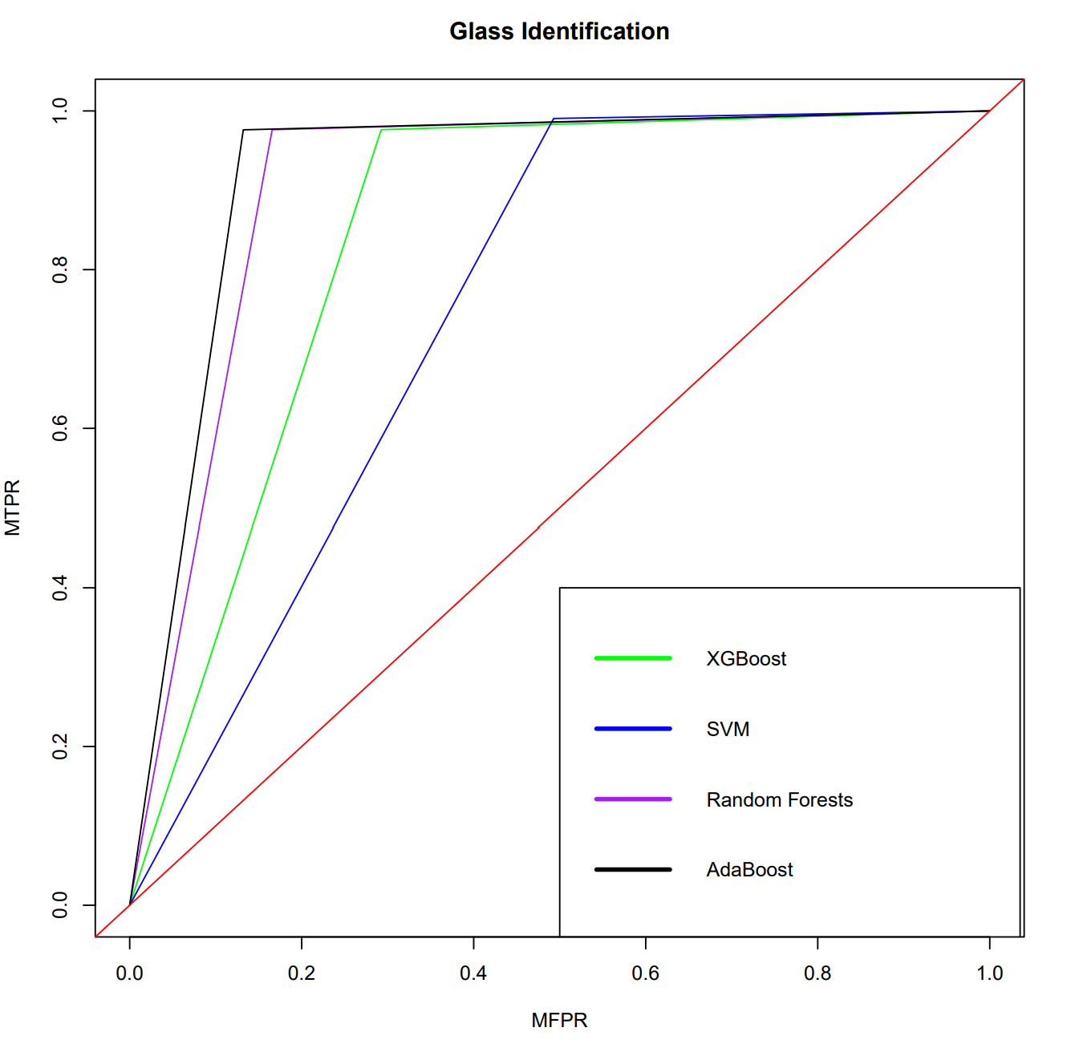

Figure 1: ROC Curves Plot for glass0 dataset

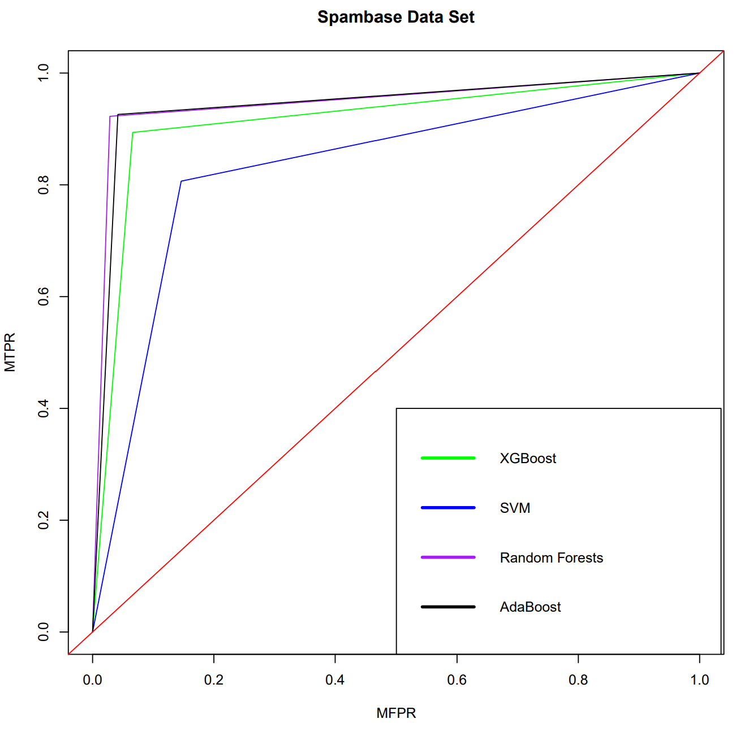

Figure 2: ROC Curves Plot for spambase dataset

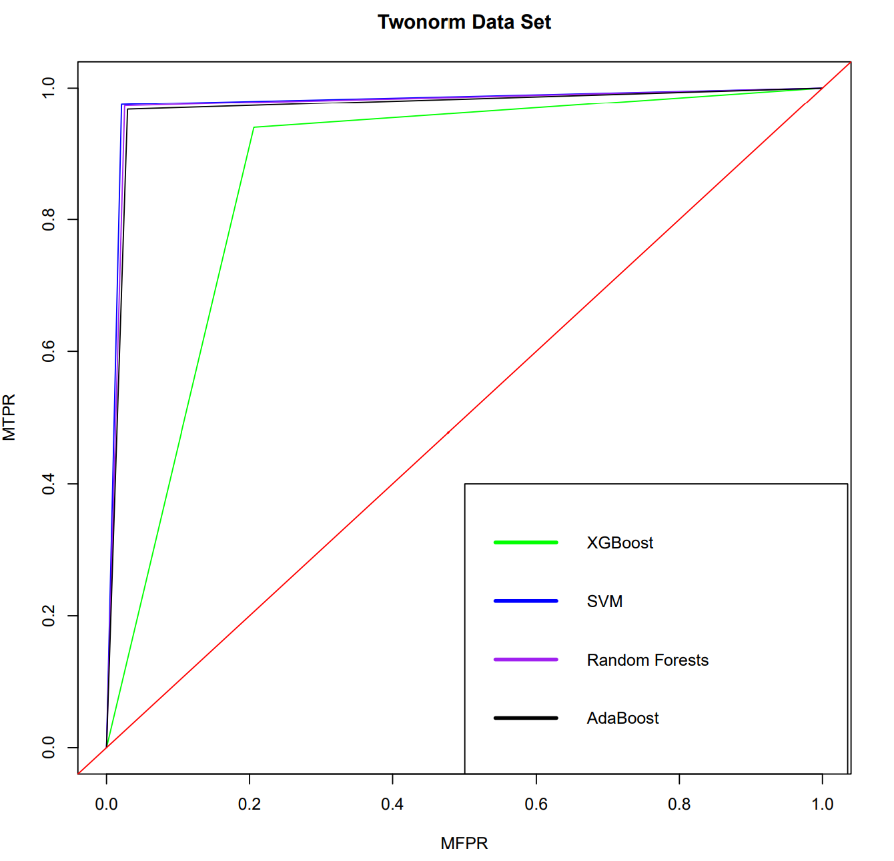

Figure 3: ROC Curves Plot for twonorm dataset

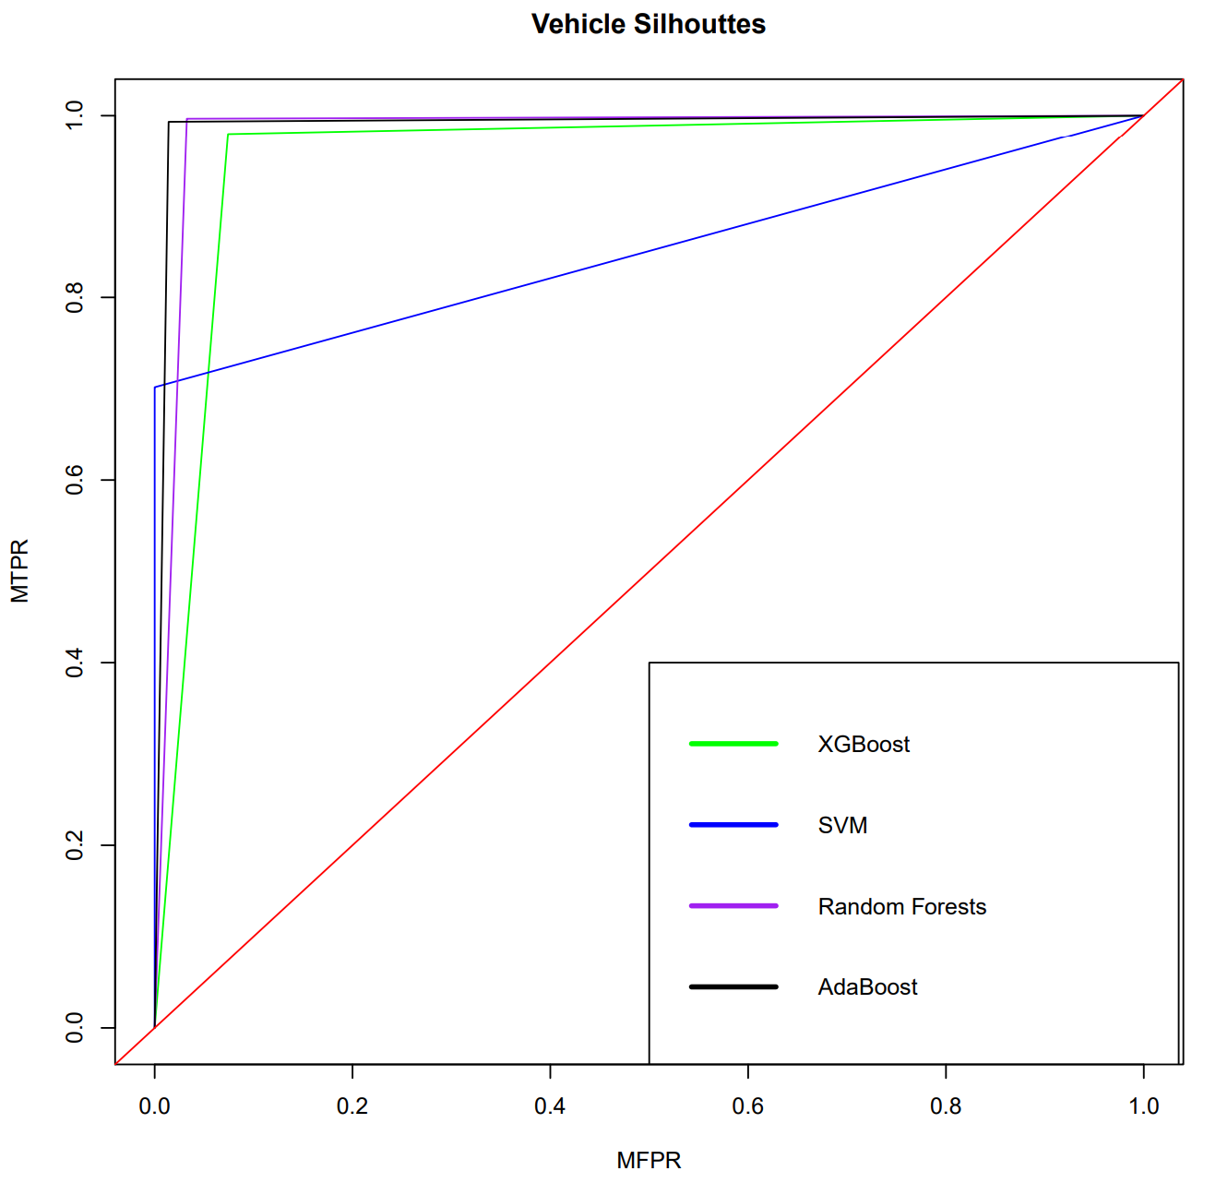

Figure 4: ROC Curves Plot for vehicle0 dataset

## 5.2 Performance Measures

The performance (MACC, MBAC, MF1, and Standard Deviation) of each classifier on the four datasets is illustrated through the following four tables: **Table (1,2,3,4)**

Table 1: Performance Measures and Standard Deviation for XGBoost

|  |  |  |
| --- | --- | --- |
| XGBoost | | |
| Dataset\Measure Types | **Performance Measures** | **Standard Deviation** |
| glass0 | MACC = 0.867510 | 0.037816 |
| MBAC = 0.841975 | 0.043177 |
| MF1 = 0.897450 | 0.027898 |
| spambase | MACC = 0.917986 | 0.009063 |
| MBAC = 0.913859 | 0.010678 |
| MF1 = 0.895769 | 0.010239 |
| twonorm | MACC = 0.866892 | 0.012559 |
| MBAC = 0.866909 | 0.013746 |
| MF1 = 0.875943 | 0.009554 |
| vehicle0 | MACC = 0.951772 | 0.012034 |
| MBAC = 0.952784 | 0.011698 |
| MF1 = 0.950967 | 0.013170 |

Table 2: Performance Measures and Standard Deviation for SVM

|  |  |  |
| --- | --- | --- |
| SVM | | |
| Dataset\Measure Types | **Performance Measures** | **Standard Deviation** |
| glass0 | MACC = 0.793985 | 0.025447 |
| MBAC = 0.748751 | 0.029246 |
| MF1 = 0.850736 | 0.018178 |
| spambase | MACC = 0.835097 | 0.017753 |
| MBAC = 0.830275 | 0.016858 |
| MF1 = 0.794183 | 0.019549 |
| twonorm | MACC = 0.976892 | 0.002210 |
| MBAC = 0.976899 | 0.002309 |
| MF1 = 0.976774 | 0.002732 |
| vehicle0 | MACC = 0.856866 | 0.033181 |
| MBAC = 0.850798 | 0.034293 |
| MF1 = 0.823020 | 0.050052 |

Table 3: Performance Measures and Standard Deviation for Random Forests

|  |  |  |
| --- | --- | --- |
| Random Forests | | |
| Dataset\Measure Types | **Performance Measures** | **Standard Deviation** |
| glass0 | MACC = 0.918262 | 0.024626 |
| MBAC = 0.905366 | 0.025299 |
| MF1 = 0.933773 | 0.020438 |
| spambase | MACC = 0.952355 | 0.010442 |
| MBAC = 0.947042 | 0.011490 |
| MF1 = 0.938572 | 0.013464 |
| twonorm | MACC = 0.973784 | 0.004835 |
| MBAC = 0.973791 | 0.004873 |
| MF1 = 0.973652 | 0.005422 |
| vehicle0 | MACC = 0.981503 | 0.008361 |
| MBAC = 0.982065 | 0.008377 |
| MF1 = 0.981011 | 0.008505 |

Table 4: Performance Measures and Standard Deviation for AdaBoost

|  |  |  |
| --- | --- | --- |
| AdaBoost | | |
| Dataset\Measure Types | **Performance Measures** | **Standard Deviation** |
| glass0 | MACC = 0.932349 | 0.024870 |
| MBAC = 0.922052 | 0.024854 |
| MF1 = 0.944633 | 0.020770 |
| spambase | MACC = 0.945616 | 0.010235 |
| MBAC = 0.942116 | 0.011332 |
| MF1 = 0.930588 | 0.013297 |
| twonorm | MACC = 0.969054 | 0.003651 |
| MBAC = 0.969028 | 0.003775 |
| MF1 = 0.968890 | 0.004484 |
| vehicle0 | MACC = 0.989539 | 0.009706 |
| MBAC = 0.989593 | 0.009928 |
| MF1 = 0.989195 | 0.010036 |

## 5.3 Statistical Tests

This section shows the statistical comparison between each classifier on the four datasets using the performance measures (MACC, MBAC, and MF1); including the rank of each classifier (Using Friedman ranking test), raw p-value, and the corrected p-value (Using correction by BH). These things are illustrated through the following tables: **Table (5,6,7)**

(Note that no classifier is statistically significant from the others)

Table 5: Statistical Comparison for MACC

|  |  |  |  |  |
| --- | --- | --- | --- | --- |
| MACC | | | | |
| Summary | | | | |
|  | **XGBoost** | **SVM** | **RandomForests** | **AdaBoost** |
|  | 0.9010398 | 0.8657101 | 0.9564761 | 0.9591393 |
| raw.pval | | | | |
| Classifier | **XGBoost** | **SVM** | **RandomForests** | **AdaBoost** |
| XGBoost | NA | 1.0000000 | 0.1003482 | 0.1003482 |
| SVM | 1.0000000 | NA | 0.1003482 | 0.1003482 |
| RandomForests | 0.1003482 | 0.1003482 | NA | 1.0000000 |
| AdaBoost | 0.1003482 | 0.1003482 | 1.0000000 | NA |
| corrected.pval | | | | |
| Classifier | **XGBoost** | **SVM** | **RandomForests** | **AdaBoost** |
| XGBoost | NA | 1.0000000 | 0.6020895 | 0.6020895 |
| SVM | 1.0000000 | NA | 0.6020895 | 0.6020895 |
| RandomForests | 0.6020895 | 0.6020895 | NA | 1.0000000 |
| AdaBoost | 0.6020895 | 0.6020895 | 1.0000000 | NA |

Table 6: Statistical Comparison for MBAC

|  |  |  |  |  |
| --- | --- | --- | --- | --- |
| MBAC | | | | |
| Summary | | | | |
|  | **XGBoost** | **SVM** | **RandomForests** | **AdaBoost** |
|  | 0.8938818 | 0.8516807 | 0.9520658 | 0.9556972 |
| raw.pval | | | | |
| Classifier | **XGBoost** | **SVM** | **RandomForests** | **AdaBoost** |
| XGBoost | NA | 1.0000000 | 0.1003482 | 0.1003482 |
| SVM | 1.0000000 | NA | 0.1003482 | 0.1003482 |
| RandomForests | 0.1003482 | 0.1003482 | NA | 1.0000000 |
| AdaBoost | 0.1003482 | 0.1003482 | 1.0000000 | NA |
| corrected.pval | | | | |
| Classifier | **XGBoost** | **SVM** | **RandomForests** | **AdaBoost** |
| XGBoost | NA | 1.0000000 | 0.6020895 | 0.6020895 |
| SVM | 1.0000000 | NA | 0.6020895 | 0.6020895 |
| RandomForests | 0.6020895 | 0.6020895 | NA | 1.0000000 |
| AdaBoost | 0.6020895 | 0.6020895 | 1.0000000 | NA |

Table 7: Statistical Comparison for MF1

|  |  |  |  |  |
| --- | --- | --- | --- | --- |
| MF1 | | | | |
| Summary | | | | |
|  | **XGBoost** | **SVM** | **RandomForests** | **AdaBoost** |
|  | 0.9050322 | 0.8611782 | 0.9567521 | 0.9583262 |
| raw.pval | | | | |
| Classifier | **XGBoost** | **SVM** | **RandomForests** | **AdaBoost** |
| XGBoost | NA | 1.0000000 | 0.1003482 | 0.1003482 |
| SVM | 1.0000000 | NA | 0.1003482 | 0.1003482 |
| RandomForests | 0.1003482 | 0.1003482 | NA | 1.0000000 |
| AdaBoost | 0.1003482 | 0.1003482 | 1.0000000 | NA |
| corrected.pval | | | | |
| Classifier | **XGBoost** | **SVM** | **RandomForests** | **AdaBoost** |
| XGBoost | NA | 1.0000000 | 0.6020895 | 0.6020895 |
| SVM | 1.0000000 | NA | 0.6020895 | 0.6020895 |
| RandomForests | 0.6020895 | 0.6020895 | NA | 1.0000000 |
| AdaBoost | 0.6020895 | 0.6020895 | 1.0000000 | NA |

# Appendix

|  |
| --- |
| > source("source_code.txt")  [1] "-----------------= Students' Info =--------------------"  [1] "Names:"  [1] "- Omar Alqurashi , ID: 1742589"  [1] "- Mohammed Alzahrani, ID: 1740166"  [1] "- Mohammed Alharbi , ID: 1740373"  [1] "2020-12-08 18:35:57 +03"  [1] "2020-12-08"  [1] "========================Start=========================="  [1] "---------------------Preparation-----------------------"  [1] "Glass Dimensions:"  [1] 214 10  [1] "Spambase Dimensions:"  [1] 4597 58  [1] "Twonorm Dimensions:"  [1] 7400 21  [1] "Vehicle Dimensions:"  [1] 846 19  [1] "================Oversampling==============="  [1] "-------------------before------------------"  [1] "Num. Records in Glass Dataset Labeled as 'positive':"  [1] 70  [1] "Num. Records in Glass Dataset Labeled as 'negative':"  [1] 144  [1] "Num. Records in Vehicle Dataset Labeled as 'positive':"  [1] 199  [1] "Num. Records in Vehicle Dataset Labeled as 'negative':"  [1] 647  [1] "-------------------after-------------------"  [1] "Num. Records in Glass Dataset Labeled as 'positive':"  [1] 210  [1] "Num. Records in Glass Dataset Labeled as 'negative':"  [1] 144  [1] "Num. Records in Vehicle Dataset Labeled as 'positive':"  [1] 597  [1] "Num. Records in Vehicle Dataset Labeled as 'negative':"  [1] 647  [1] "=============Oversampling End============"  [1] "" |
| [1] "==== Start 5-Folds Cross-Validation ===="  [1] ""  [1] "_______________ i = 1 ________________"  [1] "============= Training... ============"  [1] train-error:0.397887  [2] train-error:0.084507  [3] train-error:0.038732  [4] train-error:0.038732  [5] train-error:0.038732  [1] train-error:0.601849  [2] train-error:0.087571  [3] train-error:0.081044  [4] train-error:0.064455  [5] train-error:0.057656  [1] train-error:0.501858  [2] train-error:0.208277  [3] train-error:0.103716  [4] train-error:0.075507  [5] train-error:0.057432  [1] train-error:0.523618  [2] train-error:0.052261  [3] train-error:0.033166  [4] train-error:0.033166  [5] train-error:0.017085  [1] "---------- XGBoost Trained -----------"  [1] "------------ SVM Trained -------------"  [1] "------ Random Forests Trained --------"  [1] "--------- AdaBoost Trained -----------"  [1] "============= Testing... ============="  [1] "---------- XGBoost Tested ------------"  [1] "------------- SVM Tested -------------"  [1] "----- Random Forests Tested ----------"  [1] "--------- AdaBoost Tested ------------"  [1] "" |

|  |
| --- |
| [1] "_______________ i = 2 ________________"  [1] "============= Training... ============"  [1] train-error:0.407801  [2] train-error:0.078014  [3] train-error:0.056738  [4] train-error:0.056738  [5] train-error:0.056738  [1] train-error:0.607017  [2] train-error:0.164264  [3] train-error:0.069350  [4] train-error:0.048409  [5] train-error:0.046777  [1] train-error:0.494595  [2] train-error:0.226689  [3] train-error:0.110135  [4] train-error:0.081926  [5] train-error:0.055405  [1] train-error:0.520080  [2] train-error:0.040161  [3] train-error:0.017068  [4] train-error:0.017068  [5] train-error:0.016064  [1] "---------- XGBoost Trained -----------"  [1] "------------ SVM Trained -------------"  [1] "------ Random Forests Trained --------"  [1] "--------- AdaBoost Trained -----------"  [1] "============= Testing... ============="  [1] "---------- XGBoost Tested ------------"  [1] "------------- SVM Tested -------------"  [1] "----- Random Forests Tested ----------"  [1] "--------- AdaBoost Tested ------------"  [1] "" |
| [1] "_______________ i = 3 ________________"  [1] "============= Training... ============"  [1] train-error:0.415493  [2] train-error:0.080986  [3] train-error:0.042254  [4] train-error:0.042254  [5] train-error:0.035211  [1] train-error:0.610114  [2] train-error:0.107667  [3] train-error:0.065797  [4] train-error:0.053834  [5] train-error:0.052202  [1] train-error:0.504054  [2] train-error:0.226858  [3] train-error:0.120101  [4] train-error:0.084459  [5] train-error:0.056588  [1] train-error:0.526633  [2] train-error:0.040201  [3] train-error:0.032161  [4] train-error:0.026131  [5] train-error:0.026131  [1] "---------- XGBoost Trained -----------"  [1] "------------ SVM Trained -------------"  [1] "------ Random Forests Trained --------"  [1] "--------- AdaBoost Trained -----------"  [1] "============= Testing... ============="  [1] "---------- XGBoost Tested ------------"  [1] "------------- SVM Tested -------------"  [1] "----- Random Forests Tested ----------"  [1] "--------- AdaBoost Tested ------------"  [1] "" |

|  |
| --- |
| [1] "_______________ i = 4 ________________"  [1] "============= Training... ============"  [1] train-error:0.406360  [2] train-error:0.084806  [3] train-error:0.028269  [4] train-error:0.028269  [5] train-error:0.028269  [1] train-error:0.606745  [2] train-error:0.122926  [3] train-error:0.061463  [4] train-error:0.062823  [5] train-error:0.049497  [1] train-error:0.501351  [2] train-error:0.181081  [3] train-error:0.109797  [4] train-error:0.076351  [5] train-error:0.051182  [1] train-error:0.511558  [2] train-error:0.038191  [3] train-error:0.029146  [4] train-error:0.027136  [5] train-error:0.024121  [1] "---------- XGBoost Trained -----------"  [1] "------------ SVM Trained -------------"  [1] "------ Random Forests Trained --------"  [1] "--------- AdaBoost Trained -----------"  [1] "============= Testing... ============="  [1] "---------- XGBoost Tested ------------"  [1] "------------- SVM Tested -------------"  [1] "----- Random Forests Tested ----------"  [1] "--------- AdaBoost Tested ------------"  [1] "" |
| [1] "_______________ i = 5 ________________"  [1] "============= Training... ============"  [1] train-error:0.406360  [2] train-error:0.063604  [3] train-error:0.045936  [4] train-error:0.045936  [5] train-error:0.045936  [1] train-error:0.603425  [2] train-error:0.101386  [3] train-error:0.063876  [4] train-error:0.060342  [5] train-error:0.050829  [1] train-error:0.500169  [2] train-error:0.196115  [3] train-error:0.106250  [4] train-error:0.081419  [5] train-error:0.055574  [1] train-error:0.518593  [2] train-error:0.039196  [3] train-error:0.028141  [4] train-error:0.028141  [5] train-error:0.025126  [1] "---------- XGBoost Trained -----------"  [1] "------------ SVM Trained -------------"  [1] "------ Random Forests Trained --------"  [1] "--------- AdaBoost Trained -----------"  [1] "============= Testing... ============="  [1] "---------- XGBoost Tested ------------"  [1] "------------- SVM Tested -------------"  [1] "----- Random Forests Tested ----------"  [1] "--------- AdaBoost Tested ------------"  [1] "" |

|  |
| --- |
| [1] "---------Calculations of Performance Measures----------"  [1] "------------------------XGBoost------------------------"  [1] "glass0:"  [1] "MACC = 0.867510, SD = 0.037816"  [1] "MBAC = 0.841975, SD = 0.043177"  [1] "MF1 = 0.897450, SD = 0.027898"  [1] "spambase:"  [1] "MACC = 0.917986, SD = 0.009063"  [1] "MBAC = 0.913859, SD = 0.010678"  [1] "MF1 = 0.895769, SD = 0.010239"  [1] "twonorm:"  [1] "MACC = 0.866892, SD = 0.012559"  [1] "MBAC = 0.866909, SD = 0.013746"  [1] "MF1 = 0.875943, SD = 0.009554"  [1] "vehicle0:"  [1] "MACC = 0.951772, SD = 0.012034"  [1] "MBAC = 0.952784, SD = 0.011698"  [1] "MF1 = 0.950967, SD = 0.013170"  [1] "--------------------------SVM--------------------------"  [1] "glass0:"  [1] "MACC = 0.793985, SD = 0.025447"  [1] "MBAC = 0.748751, SD = 0.029246"  [1] "MF1 = 0.850736, SD = 0.018178"  [1] "spambase:"  [1] "MACC = 0.835097, SD = 0.017753"  [1] "MBAC = 0.830275, SD = 0.016858"  [1] "MF1 = 0.794183, SD = 0.019549"  [1] "twonorm:"  [1] "MACC = 0.976892, SD = 0.002210"  [1] "MBAC = 0.976899, SD = 0.002309"  [1] "MF1 = 0.976774, SD = 0.002732"  [1] "vehicle0:"  [1] "MACC = 0.856866, SD = 0.033181"  [1] "MBAC = 0.850798, SD = 0.034293"  [1] "MF1 = 0.823020, SD = 0.050052" |
| [1] "-------------------Random Forests----------------------"  [1] "glass0:"  [1] "MACC = 0.918262, SD = 0.024626"  [1] "MBAC = 0.905366, SD = 0.025299"  [1] "MF1 = 0.933773, SD = 0.020438"  [1] "spambase:"  [1] "MACC = 0.952355, SD = 0.010442"  [1] "MBAC = 0.947042, SD = 0.011490"  [1] "MF1 = 0.938572, SD = 0.013464"  [1] "twonorm:"  [1] "MACC = 0.973784, SD = 0.004835"  [1] "MBAC = 0.973791, SD = 0.004873"  [1] "MF1 = 0.973652, SD = 0.005422"  [1] "vehicle0:"  [1] "MACC = 0.981503, SD = 0.008361"  [1] "MBAC = 0.982065, SD = 0.008377"  [1] "MF1 = 0.981011, SD = 0.008505"  [1] "-----------------------AdaBoost------------------------"  [1] "glass0:"  [1] "MACC = 0.932349, SD = 0.024870"  [1] "MBAC = 0.922052, SD = 0.024854"  [1] "MF1 = 0.944633, SD = 0.020770"  [1] "spambase:"  [1] "MACC = 0.945616, SD = 0.010235"  [1] "MBAC = 0.942116, SD = 0.011332"  [1] "MF1 = 0.930588, SD = 0.013297"  [1] "twonorm:"  [1] "MACC = 0.969054, SD = 0.003651"  [1] "MBAC = 0.969028, SD = 0.003775"  [1] "MF1 = 0.968890, SD = 0.004484"  [1] "vehicle0:"  [1] "MACC = 0.989539, SD = 0.009706"  [1] "MBAC = 0.989593, SD = 0.009928"  [1] "MF1 = 0.989195, SD = 0.010036"  [1] "============= Cross-Validation Finished ==============="  [1] "" |

|  |
| --- |
| [1] "================= Statistical Tests ==================="  [1] "------------------------MACC---------------------------"  $summary  XGBoost SVM RandomForests AdaBoost  [1,] 0.9010398 0.8657101 0.9564761 0.9591393  $raw.pval  XGBoost SVM RandomForests AdaBoost  XGBoost NA 1.0000000 0.1003482 0.1003482  SVM 1.0000000 NA 0.1003482 0.1003482  RandomForests 0.1003482 0.1003482 NA 1.0000000  AdaBoost 0.1003482 0.1003482 1.0000000 NA  $corrected.pval  XGBoost SVM RandomForests AdaBoost  XGBoost NA 1.0000000 0.6020895 0.6020895  SVM 1.0000000 NA 0.6020895 0.6020895  RandomForests 0.6020895 0.6020895 NA 1.0000000  AdaBoost 0.6020895 0.6020895 1.0000000 NA  [1] "------------------------MBAC---------------------------"  $summary  XGBoost SVM RandomForests AdaBoost  [1,] 0.8938818 0.8516807 0.9520658 0.9556972  $raw.pval  XGBoost SVM RandomForests AdaBoost  XGBoost NA 1.0000000 0.1003482 0.1003482  SVM 1.0000000 NA 0.1003482 0.1003482  RandomForests 0.1003482 0.1003482 NA 1.0000000  AdaBoost 0.1003482 0.1003482 1.0000000 NA  $corrected.pval  XGBoost SVM RandomForests AdaBoost  XGBoost NA 1.0000000 0.6020895 0.6020895  SVM 1.0000000 NA 0.6020895 0.6020895  RandomForests 0.6020895 0.6020895 NA 1.0000000  AdaBoost 0.6020895 0.6020895 1.0000000 NA |
| [1] "-------------------------MF1---------------------------"  $summary  XGBoost SVM RandomForests AdaBoost  [1,] 0.9050322 0.8611782 0.9567521 0.9583262  $raw.pval  XGBoost SVM RandomForests AdaBoost  XGBoost NA 1.0000000 0.1003482 0.1003482  SVM 1.0000000 NA 0.1003482 0.1003482  RandomForests 0.1003482 0.1003482 NA 1.0000000  AdaBoost 0.1003482 0.1003482 1.0000000 NA  $corrected.pval  XGBoost SVM RandomForests AdaBoost  XGBoost NA 1.0000000 0.6020895 0.6020895  SVM 1.0000000 NA 0.6020895 0.6020895  RandomForests 0.6020895 0.6020895 NA 1.0000000  AdaBoost 0.6020895 0.6020895 1.0000000 NA  [1] "=========================END==========================="  [1] "-----------------= Students' Info =--------------------"  [1] "Names:"  [1] "- Omar Alqurashi , ID: 1742589"  [1] "- Mohammed Alzahrani, ID: 1740166"  [1] "- Mohammed Alharbi , ID: 1740373"  [1] "2020-12-08 18:38:14 +03"  [1] "2020-12-08"  > |