Command Name: WTF GUI

At startup it will show output of “wtf status” command in MAIN Window with a radio button to all row output of the command. It will allow to select a module and then click command no. 3,4,5

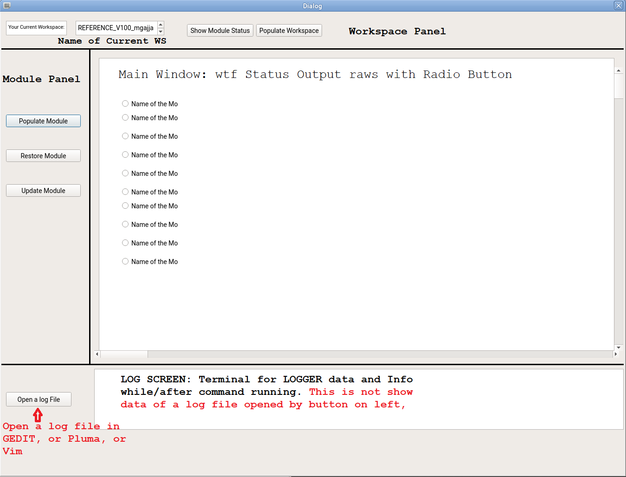

1.Wtf Status: It will list the status of the module same as terminal but with a radio button. That radio button will be used

2. Populate Workspace : After completion of populates the workspace, gui will provide a message that says “workspace populated successfully”, If can not populate workspace, it provides a message in a progess bar below.

select the radio button which selects a MODULE name from MAIN Window and then click respective button.

3. Populate Module: wtf pop_module [Radio Button Selected]:

Whatever choice been selected in the MAIN_Window, that module name is being passed to run the “wtf pop_modules [Module Name]” command

4. Update Module : “wtf update [MODULE]

5. Restore Module ; “wtf restore [Module]

Log button: You can open the recent log for the command you ran.

Log Screen: The screen will be used for showing the terminal data.