**Rsync** is a Linux tool used for **backup** and file recovery. It transfers and synchronizes files between a machine and an external hard drive, or across a network. **Rsync** makes the process more efficient by comparing the modification dates and sizes of files, and only **backing up** when needed

**How to Clone a CentOS Server with Rsync**

Cloning is the practice of cloning an exact copy of an existing Live Linux server using the [rsync command-line tool](https://www.tecmint.com/rsync-local-remote-file-synchronization-commands/" \o "Rsync Command Examples" \t "_blank). Cloning requires 2 instances of servers – the server to be cloned and the destination server where the cloning process will occur. The rsync command-line tool [synchronizes all the files and directories](https://www.tecmint.com/sync-two-apache-websites-using-rsync/) from the server being cloned to the destination server.

In this guide, you will learn how to hot clone a CentOS server with Rsync file synchronization tool.

**Lab Setup**

Here’s the lab setup that we are using for this guide.

* Source Server – CentOS 7 – 192.168.2.103
* Destination Server – CentOS 7 – 192.168.2.110

The source server is the one we are going to clone onto the destination server.

**Setup and Requirements**

Before proceeding, ensure that you have met the prerequisites below:

* Both servers need to be running the same release of the operating system i.e **CentOS 7.x**, **CentOS 8.x**, etc.
* Additionally, the servers should have identical file systems and the same hard disk configuration i.e whether single-disks or in RAID configuration.

**NOTE**: Before hot cloning, ensure you disable all the services that involve shipping or writing data e.g databases, mail service, etc.

**Step 1: Installing the Rsync Tool in CentOS**

For cloning to be successful the **rsync** command-line tool needs to be present on both servers. This will be used for mirroring the source server to the destination server and syncing all the differences between the two systems. Thankfully, modern systems come with **rsync** already pre-installed.

To check the version of **rsync** installed run:

$ rsync --version

If you want to view additional information about rsync, execute the following [rpm command](https://www.tecmint.com/20-practical-examples-of-rpm-commands-in-linux/):

$ rpm -qi rsync

[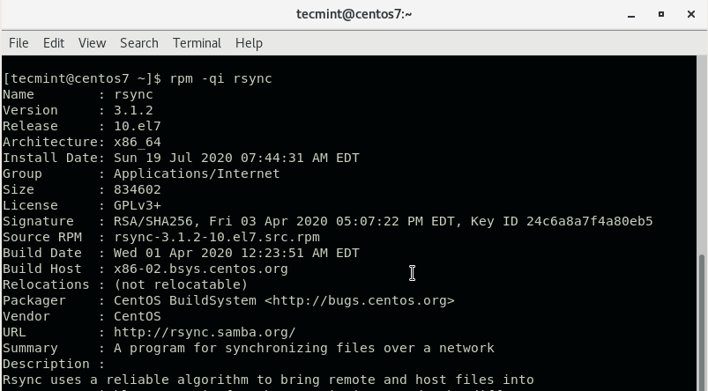](https://www.tecmint.com/wp-content/uploads/2020/07/Check-Rsync-Version-in-CentOS.png)

Check Rsync Version in CentOS

If **rsync** is missing, run the following command to install it in **RHEL** / **CentOS** / **Fedora** systems.

$ sudo yum install rsync

**Step 2: Configure the Source Server**

There are directories and files that you may want to exclude from cloning because they are either already available in the destination server or are autogenerated. These include the /boot, /tmp and /dev directories.

Therefore, create an exclusion file /root/exclude-files.txt and add the following entries:

/boot

/dev

/tmp

/sys

/proc

/backup

/etc/fstab

/etc/mtab

/etc/mdadm.conf

/etc/sysconfig/network\*

Save and exit the configuration file.

**Step 3: Clone the CentOS Server**

With everything set, proceed and **rsync** your server to the remote or destination server using the command:

$ sudo rsync -vPa -e 'ssh -o StrictHostKeyChecking=no' --exclude-from=/root/exclude-files.txt / **REMOTE-IP:/**

[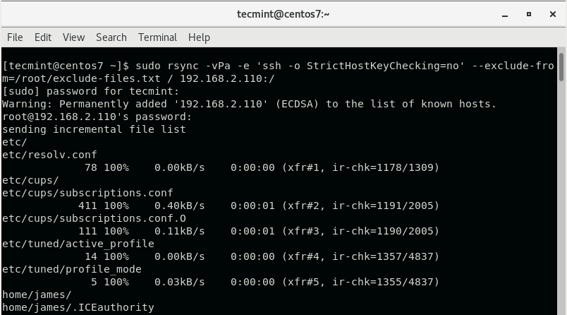](https://www.tecmint.com/wp-content/uploads/2020/07/Clone-CentOS-Server.png)

Clone CentOS Server

The command will rsync everything from the source server to the destination server while excluding the files and directories you defined earlier on. Be sure to replace the REMOTE-IP: option with your destination server’s IP address.

After the synching is done, **reboot** the destination system to reload the changes and thereafter, boot into the server using the source server’s credentials. Feel free to decommission the old server since you now have a mirror copy of it.

**fwbackups – A Feature-rich Backup Program for Linux**

[**Ravi Saive**](https://www.tecmint.com/author/admin/)**November 6, 2019 Categories**[**Backups**](https://www.tecmint.com/category/backups/)[**4 Comments**](https://www.tecmint.com/fwbackups-backup-program-for-linux/#comments)

**fwbackups** is a free and open-source feature-rich user backup application that allows you to backup your important documents anytime, anywhere using a simple powerful interface with the support for scheduled backups and backing up to remote systems.

**fwbackups – Features**

**fwbackups** offers a rich interface that is both powerful and easy to use with the following features:

* **Simple interface**: Creating new backups or restoring from a previous backup is an easy task.
* **Flexible backup configuration**: Select between a number of backup formats and modes, which includes the archive format and clone copy mode for recovering data from corrupted or damaged disks.
* **Backup your files to any computer**: It can backup files to a remote backup server or a connected media like USB device, making it perfect for all users.
* **Backup the entire computer**: Create archives images of your entire system so that your files are safe.
* **Scheduled and one-time backups**: Select to run a backup once (on demand) or periodically so that you never have to panic about losing your data again.
* **Faster backups**: Create your backup quicker by taking only the changes from the last backup with the incremental backup modes.
* **Exclude files or folders**: Don’t waste disk space on your system by backing up files you don’t require.
* **Organized and clean**: It takes care of the organization of backups, including the deletion of expired ones so you don’t have to bother about organizing the backups. It also allows you to choose a backup to restore from with a list of dates.

**Install fwbackups on Linux Systems**

**fwbackups** is not included in most Linux distribution’s repositories, so the only way to install **fwbackups** using the source tarball as explained below.

**Install fwbackups on Debian and Ubuntu/Mint Linux**

First, install these following dependencies on your system.

$ sudo apt-get install gettext autotools-dev intltool python-crypto python-paramiko python-gtk2 python-glade2 python-notify cron

Then [download fwbackups](http://www.diffingo.com/oss/fwbackups/download) to your home directory using [wget command](https://www.tecmint.com/10-wget-command-examples-in-linux/" \t "_blank) and install it from source using the following commands.

$ wget http://downloads.diffingo.com/fwbackups/fwbackups-1.43.7.tar.bz2

$ tar xfj fwbackups-1.43.7.tar.bz2

$ cd fwbackups-1.43.7/

$ ./configure --prefix=/usr

$ make && sudo make install

**Install fwbackups on CentOS and RHEL**

Similarly, you need to install these following dependencies on **CentOS** and **RHEL** system as well.

$ sudo yum install gettext autotools-dev intltool python-crypto python-paramiko python-gtk2 python-glade2 python-notify cron

Next, download fwbackups and install it from source using the following commands.

$ wget http://downloads.diffingo.com/fwbackups/fwbackups-1.43.7.tar.bz2

$ tar xfj fwbackups-1.43.7.tar.bz2

$ cd fwbackups-1.43.7/

$ ./configure --prefix=/usr

$ make && sudo make install

**Install fwbackups on Fedora Linux**

**fwbackups** is included in the **Fedora Linux** repositories and can be installed using the following [dnf command](https://www.tecmint.com/dnf-commands-for-fedora-rpm-package-management/" \t "_blank).

$ sudo dnf install fwbackups

Once installed, you can start the **fwbackups** using a Graphical and Command-line way.

Select **Applications** → **System Tools** → **fwbackups** from the menu or simply type **fwbackups** on the terminal to start it.

$ fwbackups

[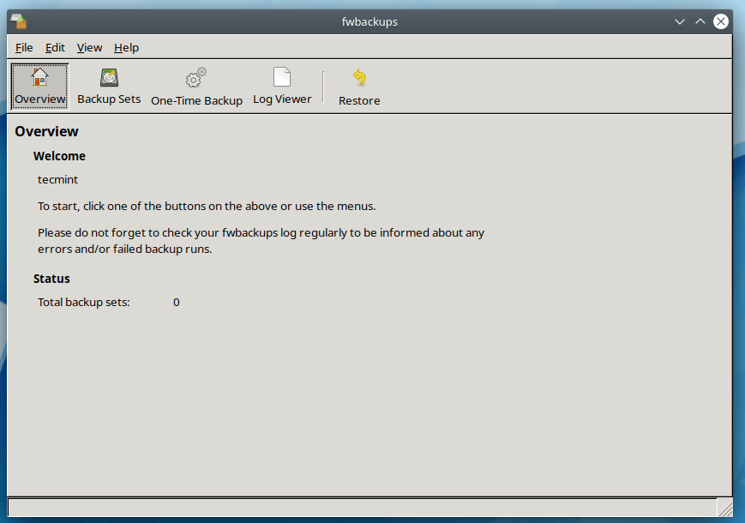](https://www.tecmint.com/wp-content/uploads/2019/11/fwbackups.png)fwbackups Overview

From the **fwbackups** Overview page, you can simply click on any one of the toolbar buttons to begin.

* **⁠Backup Sets** – To create, edit or delete backup sets as well as manually create a backup set.
* ⁠**One-Time Backup** – Create “one-time” backups.
* **⁠Log Viewer** – Shows the information about fwbackups’s activities.
* **⁠Restore** – Allows you to restore any backup from previously made backup.

To know more about creating backup sets, I request you to [read the user guide](http://www.diffingo.com/downloads/fwbackups/docs/html/) that will help you on how to use and configure fwbackups. As it provides instructions for creating and configuring backups with various configuration options.

# How to Install s3cmd in Linux and Manage Amazon s3 Buckets

**s3cmd** is a command line utility used for creating s3 buckets, uploading, retrieving and managing data to Amazon s3 storage. This article will help you to how to use install **s3cmd** on CentOS, RHEL, OpenSUSE, Ubuntu, Debian & LinuxMint systems and manage s3 buckets via command line in easy steps. To install s3cmd on windows servers read article [install s3cmd in Windows](https://tecadmin.net/setup-s3cmd-in-windows/).

We can also mount s3 bucket as local drive in our system using S3FS with FUSE. To configure it read next article [mount s3 bucket on Linux](https://tecadmin.net/mount-s3-bucket-centosrhel-ubuntu-using-s3fs/).

##### Install s3cmd on Linux

s3cmd is available in default rpm repositories for CentOS, RHEL and Ubuntu systems, You can install it using simply executing following commands on your system.

##### On CentOS/RHEL:

yum install s3cmd

##### On Ubuntu/Debian:

sudo apt-get install s3cmd

##### On SUSE Linux Enterprise Server 11:

zypper addrepo http://s3tools.org/repo/SLE\_11/s3tools.repo

zypper install s3cmd

##### Install Latest s3cmd using Source

If you are not getting the latest version of s3cmd using package managers, You can install last s3cmd version on your system using the source code. Visit [this url](https://sourceforge.net/projects/s3tools/files/s3cmd/) or use below command to download latest version of s3cmd.

wget https://sourceforge.net/projects/s3tools/files/s3cmd/2.0.1/s3cmd-2.0.1.tar.gz

tar xzf s3cmd-2.0.1.tar.gz

Now install it using below command with source files.

cd s3cmd-2.0.1

sudo python setup.py install

##### Configure s3cmd Environment

In order to configure s3cmd we would require Access Key and Secret Key of your S3 Amazon account. Get these security keys from [aws securityCredentials page](https://console.aws.amazon.com/iam/home?" \l "security_credential" \t "_blank). If will prompt to login to your amazon account.

After getting key files, use below command to configure s3cmd.

# s3cmd --configure

Enter new values or accept defaults in brackets with Enter.

Refer to user manual for detailed description of all options.

Access key and Secret key are your identifiers for Amazon S3

Access Key: xxxxxxxxxxxxxxxxxxxxxx

Secret Key: xxxxxxxxxxxxxxxxxxxxxxxxxxxxxxxxxxxx

Encryption password is used to protect your files from reading

by unauthorized persons while in transfer to S3

Encryption password: xxxxxxxxxx

Path to GPG program [/usr/bin/gpg]:

When using secure HTTPS protocol all communication with Amazon S3

servers is protected from 3rd party eavesdropping. This method is

slower than plain HTTP and can't be used if you're behind a proxy

Use HTTPS protocol [No]: Yes

New settings:

Access Key: xxxxxxxxxxxxxxxxxxxxxx

Secret Key: xxxxxxxxxxxxxxxxxxxxxxxxxxxxxxxxxxxx

Encryption password: xxxxxxxxxx

Path to GPG program: /usr/bin/gpg

Use HTTPS protocol: True

HTTP Proxy server name:

HTTP Proxy server port: 0

Test access with supplied credentials? [Y/n] Y

Please wait, attempting to list all buckets...

Success. Your access key and secret key worked fine :-)

Now verifying that encryption works...

Success. Encryption and decryption worked fine :-)

Save settings? [y/N] y

Configuration saved to '/root/.s3cfg'

##### Uses of s3cmd Command Line

Once the configuration is successfully completed. Now find below command details to how to manage s3 buckets using commands.

##### 1. List All S3 Bucket

Use the following command to list all s3 buckets in your aws account.

# **s3cmd ls**

##### 2. Creating New Bucket

To create a new bucket in Amazon s3 use below command. It will create bucket named **tecadmin** in S3 account.

# **s3cmd mb s3://tecadmin**

Bucket 's3://tecadmin/' created

##### 3. Uploading file in Bucket

Below command will upload file **file.txt** to s3 bucket using s3cmd command.

# **s3cmd put file.txt s3://tecadmin/**

file.txt -> s3://tecadmin/file.txt [1 of 1]

190216 of 190216 100% in 0s 1668.35 kB/s done

##### 4. Uploading Directory in Bucket

If we need to upload entire directory use **-r** to upload it recursively as below.

# **s3cmd put -r backup s3://tecadmin/**

backup/file1.txt -> s3://tecadmin/backup/file1.txt [1 of 2]

9984 of 9984 100% in 0s 18.78 kB/s done

backup/file2.txt -> s3://tecadmin/backup/file2.txt [2 of 2]

0 of 0 0% in 0s 0.00 B/s done

Make sure you are not adding trailing slash in upload directory named backup (eg: backup/), else it will upload only content to backup directory only.

# **s3cmd put -r backup/ s3://tecadmin/**

backup/file1.txt -> s3://tecadmin/file1.txt [1 of 2]

9984 of 9984 100% in 0s 21.78 kB/s done

backup/file2.txt -> s3://tecadmin/file2.txt [2 of 2]

0 of 0 0% in 0s 0.00 B/s done

##### 5. List Data of S3 Bucket

List the objects of s3 bucket using **ls** switch with s3cmd.

# **s3cmd ls s3://tecadmin/**

DIR s3://tecadmin/backup/

2013-09-03 10:58 190216 s3://tecadmin/file.txt

##### 6. Download Files from Bucket

Sometimes if we need to download files from the s3 bucket, Use following commands to download it.

# **s3cmd get s3://tecadmin/file.txt**

s3://tecadmin/file.txt -> ./file.txt [1 of 1]

4 of 4 100% in 0s 10.84 B/s done

##### 7. Remove Data of S3 Bucket

To remove files are folder from s3 bucket use following commands.

**Removing file from s3 bucket**

# **s3cmd del s3://tecadmin/file.txt**

File s3://tecadmin/file.txt deleted

**Removing directory from s3 bucket**

# **s3cmd del s3://tecadmin/backup**

File s3://tecadmin/backup deleted

##### 8. Remove S3 Bucket

If we don’t need s3 bucket anymore, we can simply delete it using the following command. Before removing bucket make sure its empty.

# **s3cmd rb s3://tecadmin**

ERROR: S3 error: 409 (BucketNotEmpty): The bucket you tried to delete is not empty

**Above command failed because of s3 bucket was not empty**

To remove bucket first remove all objects inside bucket and then use the command again.

# **s3cmd rb s3://tecadmin**

Bucket 's3://tecadmin/' removed

**To backup Files on s3**

s3cmd sync /home/itech/s3backup/ s3://linuxbackup-tech

**To Restore Loss File**

1017 s3cmd sync s3://linuxbackup-tech /home/itech/s3backup/