**RHEL 8 / CentOS 8 recover root password**

This article provides step by step instructions on how to recover/reset lost or forgotten [RHEL 8](https://linuxconfig.org/how-to-install-rhel-8) / CentOS 8 Linux root administrative password. To recover the root password you will first boot to the GRUB menu and perform a break at early stage of the boot process. Afterwards, you will remount the sysroot directory with read & write access and change the root password on RHEL 8 / CentOS 8 by using the passwd command to set the new root password.  
  
**In this tutorial you will learn:**

* How to perform a break at an early stage of the boot process.
* How to remount root partition with read/write access.
* How to change root password.
* How to force filesystem relabeling.

[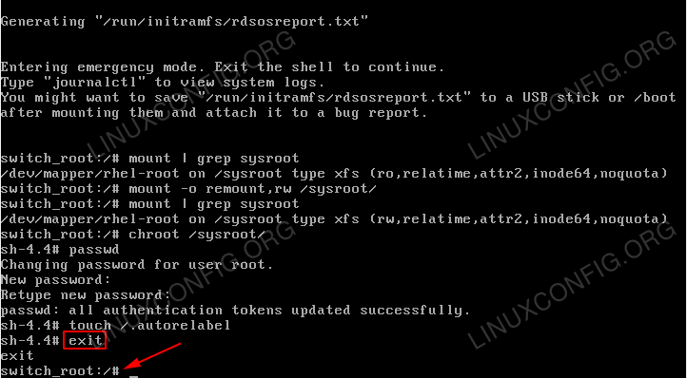](https://linuxconfig.org/images/08-redhat-8-recover-root-password.png)

Successfully recovered lost root administrative password on RHEL 8 Linux Server/Desktop.

**Software Requirements and Conventions Used**

| **Category** | **Requirements, Conventions or Software Version Used** |
| --- | --- |
| System | RHEL 8 / CentOS 8 |
| Software | N/A |
| Other | Privileged access to your Linux system as root or via the sudo command. |
| Conventions | **#** - requires given [linux commands](https://linuxconfig.org/linux-commands" \t "_blank) to be executed with root privileges either directly as a root user or by use of sudo command **$** - requires given [linux commands](https://linuxconfig.org/linux-commands" \t "_blank) to be executed as a regular non-privileged user |

**How to recover RHEL 8 / CentOS 8 root password step by step instructions**

1. Boot to the GRUB menu and enter the edit mode. Use your arrows to navigate to the the menu item you would normally boot your RHEL 8 Linux system from. Press e to start editing the selected menu item.

[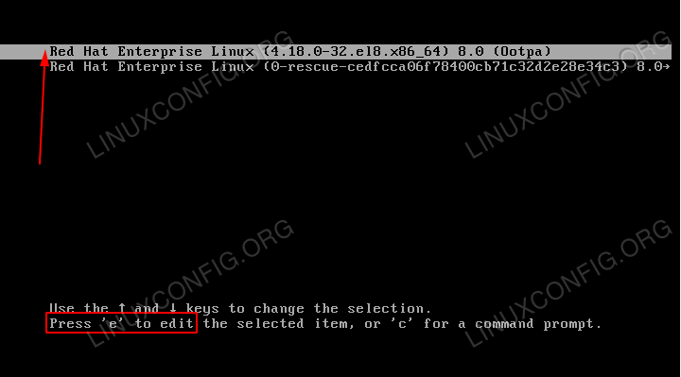](https://linuxconfig.org/images/01-redhat-8-recover-root-password.png)

GRUB boot menu on RHEL 8 Linux.

1. Perform a break at an early stage of the boot process by typing rd.break at the end of the line starting with kernel=. Once ready press CTRL+X to start the RHEL 8 boot process.

[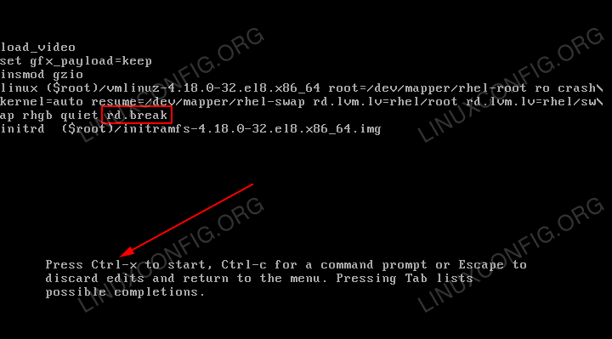](https://linuxconfig.org/images/02-redhat-8-recover-root-password.png)

Editing GRUB boot menu to interrupt the boot process.

1. Check write access on the /sysroot mount point. By default this mount point is mounted only with the read-only (ro) access. Execute:
2. switch\_root:/# mount | grep sysroot

[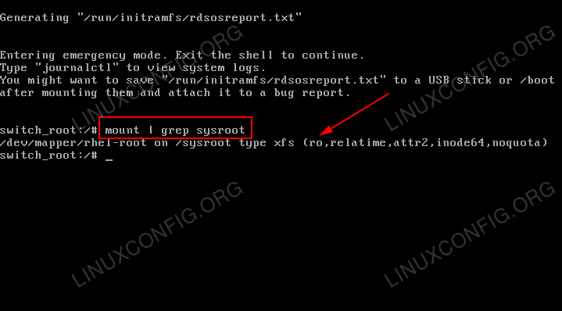](https://linuxconfig.org/images/03-redhat-8-recover-root-password.png)

/sysroot/ is mounted as read only. Note the ro string as per the mount command output.

1. Remount the sysroot directory with read & write access. To do so execute:
2. switch\_root:/# mount -o remount,rw /sysroot/
3. switch\_root:/# mount | grep sysroot

[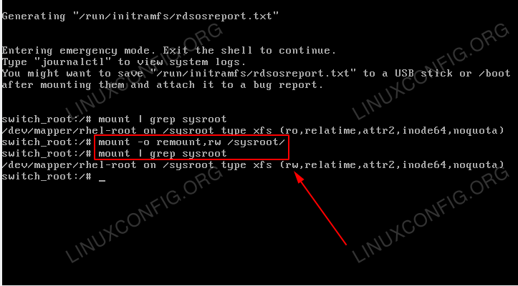](https://linuxconfig.org/images/04-redhat-8-recover-root-password.png)

/sysroot/ is now mounted with read and write access. Note the rw string as per the mount command output.

1. Enter chroot system by executing:
2. switch\_root:/# chroot /sysroot

[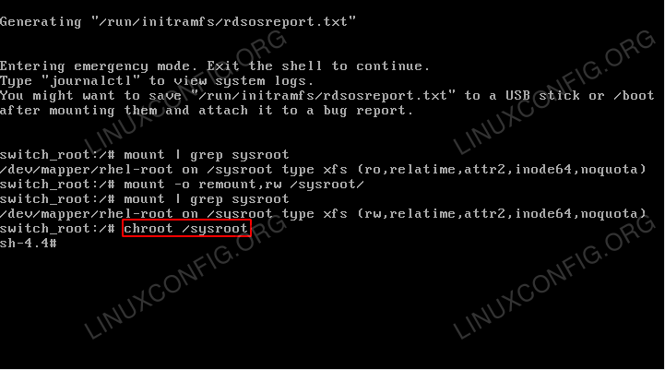](https://linuxconfig.org/images/05-redhat-8-recover-root-password.png)

Enter chroot on RHEL 8 Linux system. This will provide you with a regular shell.

1. Use the passwd command to set a new root password. Please note that when typing a new password the characters you type will not be visible. Simply keep typing.

[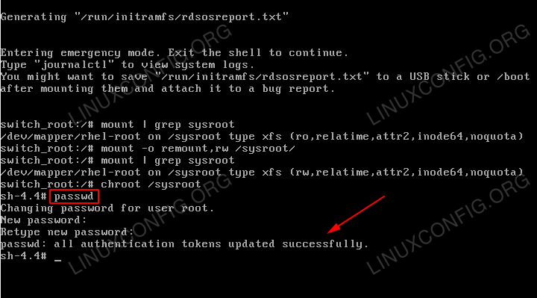](https://linuxconfig.org/images/06-redhat-8-recover-root-password.png)

Set new root password using the passwd command.

1. Force file-system relabeling by executing the following command:
2. # touch /.autorelabel

[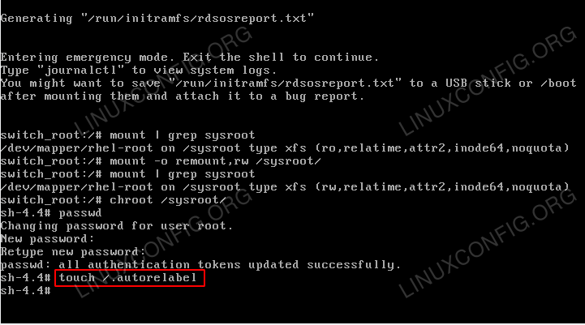](https://linuxconfig.org/images/07-redhat-8-recover-root-password.png)

Force file-system relabeling on RHEL 8 Linux system.

1. Exit the chroot system by executing the exit command:
2. # exit

[](https://linuxconfig.org/images/08-redhat-8-recover-root-password.png)

Exit the chroot system.

1. Logout to continue the normal boot:
2. switch\_root:/# logout

[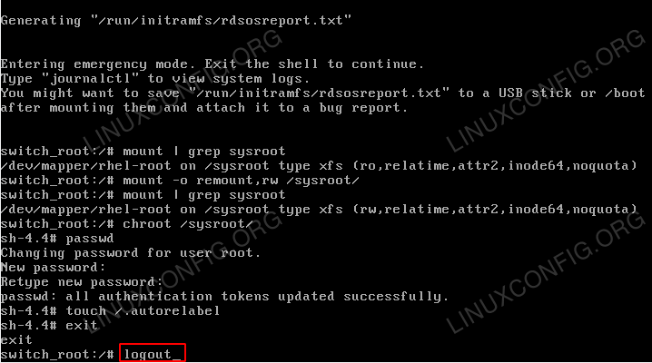](https://linuxconfig.org/images/09-redhat-8-recover-root-password.png)

Logout to continue with the regular boot process.

1. Wait for the file-system relabeling to complete. Depending on your system speed and number of files this might take some time. Be patient.

[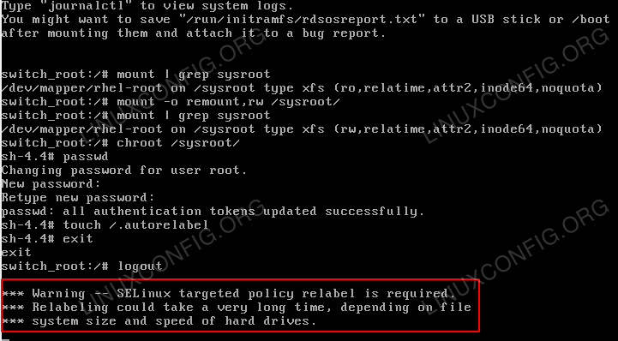](https://linuxconfig.org/images/10-redhat-8-recover-root-password.png)

File-system relabeling in progress.

1. Login with your new root password.

[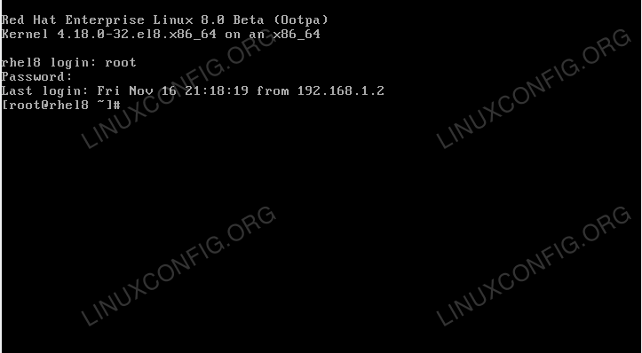](https://linuxconfig.org/images/11-redhat-8-recover-root-password.png)

RHEL 8 / CentOS 8 login TTY console screen.