# How to Create and Manage Cron Jobs on Linux

[Cron](https://www.tecmint.com/11-cron-scheduling-task-examples-in-linux/) is one of [Linux’s most useful tools](https://www.tecmint.com/category/top-tools/) and a developer favorite because it allows you to run [automated commands at specific periods](https://www.tecmint.com/run-repeat-linux-command-every-x-seconds/), dates, and intervals using both general-purpose and task-specific scripts. Given that description, you can imagine how system admins use it to [automate backup tasks](https://www.tecmint.com/linux-system-backup-tools/), directory cleaning, notifications, etc.

[Cron jobs](https://www.tecmint.com/online-cron-job-generator-and-tester-for-linux/) run in the background and constantly check the **/etc/crontab** file, and the **/etc/cron.*/** and **/var/spool/cron/** directories. The cron files are not supposed to be edited directly and each user has a unique crontab.

How then are you supposed to create and edit cron jobs? With [crontab commands](https://www.tecmint.com/11-cron-scheduling-task-examples-in-linux/). The crontab is the method you use to create, edit, install, uninstall, and list cron jobs.

The command for creating and editing cron jobs is the same and simple. And what’s even cooler is that you don’t need to restart cron after creating new files or editing existing ones.

$ crontab -e

## **Linux Crontab Syntax**

The crontab is used for running specific tasks on a regular interval. Linux crontab is like windows task schedules. Crontab is very useful for routine tasks like scheduling system scanning, daily backups, etc.

Linux crontab has six fields. 1-5 fields define the date and time of execution. The 6th fields are used for command or script to be executed. The Linux crontab syntax are as following:

**[Minute] [Hour] [Day_of_the_Month] [Month_of_the_Year] [Day_of_the_Week] [command]**

[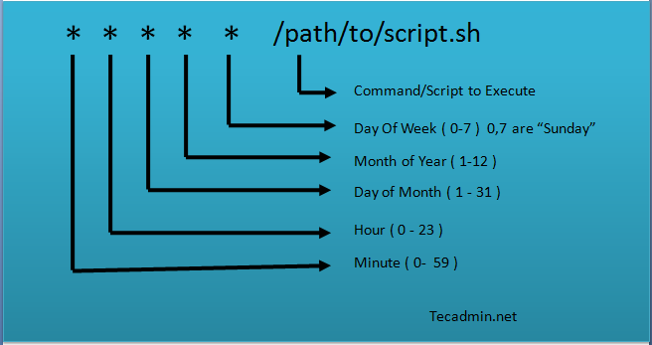](https://tecadmin.net/wp-content/uploads/2013/03/crontab-2.png)

* **Minute** – A minute value can be between 0-59
* **Hour** – A hour value can be between 0-23
* **Day_of_the_month** – This value can between 1-31. For the months having less days will ignore remaining part
* **Month_of_the_year** – This can be between 1-12. You can also define this value with first three alphebts of month like jan, feb, mar, apr etc.
* **Day_of_the_Week** – This can be the value between 0-7. Where 0 and 7 for Sunday, 1 for Monday, 2 for Tuestday etc. You can also use first three alphabets of days like, sun, mon, tue, wed, etc.

Now, below statements will describe you to how to define multiple values or ranges. Read below and understand.

* **Astrics (*)** – Matches anything
* **Multiple values**– Use command (,) to define multiple values like 2,4,8 or sun,fri or jan,oct,dec etc.
* **Define range**– You can define range using the hyphen like: 1-10 or 20-30 or sun-fri or feb-apr
* **Define multiple range**– You can define multiple ranges with command separated like: jan-mar, jul-sep

## **How to Add/Edit Crontab**

To add or update jobs in crontab, use the below command. It will open a crontab file in the editor where a job can be added/updated.

crontab -e

By default, it will edit crontab entries of current logged in user. To edit other user crontab use command as below

crontab -u username -e

Change the **EDITOR** environment variable to change your default editor.

## **How to List Crontab**

To view crontab entries of current users use the following command.

crontab -l

Use -u followed by the username to view crontab entries of the specified user.

crontab -u username -l

## **20 Useful Crontab Examples**

Here is the list of examples for scheduling cron jobs in a Linux system using crontab.

##### **1. Schedule a cron to execute at 2am daily.**

This will be useful for scheduling database backup on a daily basis.

0 2 * * * /bin/sh backup.sh

* Asterisk (*) is used for matching all the records.

##### **2. Schedule a cron to execute twice a day.**

Below example command will execute at 5 AM and 5 PM daily. You can specify multiple time stamps by comma-separated.

0 5,17 * * * /scripts/script.sh

##### **3. Schedule a cron to execute on every minutes.**

Generally, we don’t require any script to execute on every minute but in some cases, you may need to configure it.

* * * * * /scripts/script.sh

##### **4. Schedule a cron to execute on every Sunday at 5 PM.**

This type of cron is useful for doing weekly tasks, like log rotation, etc.

0 17 * * sun /scripts/script.sh

##### **5. Schedule a cron to execute on every 10 minutes.**

If you want to run your script on 10 minutes interval, you can configure like below. These types of crons are useful for monitoring.

*/10 * * * * /scripts/monitor.sh

**\*/10:** means to run every 10 minutes. Same as if you want to execute on every 5 minutes use */5.

##### **6. Schedule a cron to execute on selected months.**

Sometimes we required scheduling a task to be executed for selected months only. Below example script will run in January, May and August months.

* * * jan,may,aug * /script/script.sh

##### **7. Schedule a cron to execute on selected days.**

If you required scheduling a task to be executed for selected days only. The below example will run on each Sunday and Friday at 5 PM.

0 17 * * sun,fri /script/script.sh

##### 8. Schedule a cron to execute on first sunday of every month.

To schedule a script to execute a script on the first Sunday only is not possible by time parameter, But we can use the condition in command fields to do it.

0 2 * * sun [ $(date +%d) -le 07 ] && /script/script.sh

##### **9. Schedule a cron to execute on every four hours.**

If you want to run a script on 4 hours interval. It can be configured like below.

0 */4 * * * /scripts/script.sh

##### **10. Schedule a cron to execute twice on every Sunday and Monday.**

To schedule a task to execute twice on Sunday and Monday only. Use the following settings to do it.

0 4,17 * * sun,mon /scripts/script.sh

##### **11. Schedule a cron to execute on every 30 Seconds.**

To schedule a task to execute every 30 seconds is not possible by time parameters, But it can be done by schedule same cron twice as below.

* * * * * /scripts/script.sh

* * * * * sleep 30; /scripts/script.sh

##### **12. Schedule a multiple tasks in single cron.**

To configure multiple tasks with single cron, Can be done by separating tasks by the semicolon ( ; ).

* * * * * /scripts/script.sh; /scripts/scrit2.sh

##### 13. Schedule tasks to execute on yearly ( @yearly ).

@yearly timestamp is similar to “**0 0 1 1 \***“. It will execute a task on the first minute of every year, It may useful to send new year greetings

@yearly /scripts/script.sh

##### 14. Schedule tasks to execute on monthly ( @monthly ).

@monthly timestamp is similar to “**0 0 1 * \***“. It will execute a task in the first minute of the month. It may useful to do monthly tasks like paying the bills and invoicing to customers.

@monthly /scripts/script.sh

##### 15. Schedule tasks to execute on Weekly ( @weekly ).

@weekly timestamp is similar to “**0 0 * * mon**“. It will execute a task in the first minute of the week. It may useful to do weekly tasks like the cleanup of the system etc.

@weekly /bin/script.sh

##### 16. Schedule tasks to execute on daily ( @daily ).

@daily timestamp is similar to “**0 0 * * \***“. It will execute a task in the first minute of every day, It may useful to do daily tasks.

@daily /scripts/script.sh

##### 17. Schedule tasks to execute on hourly ( @hourly ).

@hourly timestamp is similar to “**0 * * * \***“. It will execute a task in the first minute of every hour, It may useful to do hourly tasks.

@hourly /scripts/script.sh

##### 18. Schedule tasks to execute on system reboot ( @reboot ).

@reboot is useful for those tasks which you want to run on your system startup. It will be the same as system startup scripts. It is useful for starting tasks in the background automatically.

@reboot /scripts/script.sh

##### 19. Redirect Cron Results to specified email account.

By default, cron sends details to the current user where cron is scheduled. If you want to redirect it to your other account, can be done by setup MAIL variable like below

# crontab -l

MAIL=bob

0 2 * * * /script/backup.sh

##### 20. Taking backup of all crons to plain text file.

I recommend keeping a backup of all jobs entry in a file. This will help you to recover crons in case of accidental deletion.

**Check current scheduled cron:**

# crontab -l

MAIL=rahul

0 2 * * * /script/backup.sh

**Backup cron to text file:**

# crontab -l > cron-backup.txt

# cat cron-backup.txt

MAIL=rahul

0 2 * * * /script/backup.sh

**Removing current scheduled cron:**

# crontab -r

# crontab -l

no crontab for root

**Restore crons from text file:**

# crontab cron-backup.txt

# crontab -l

MAIL=rahul

0 2 * * * /script/backup.sh

**‘crontab’ in Linux**

The **crontab** is a list of commands that you want to run on a regular schedule, and also the name of the command used to manage that list. Crontab stands for “cron table” because it uses the job scheduler *cron* to execute tasks; *cron* itself is named after “chronos, ” the Greek word for time. *cron* is the system process which will automatically perform tasks for you according to a set schedule. The schedule is called the crontab, which is also the name of the program used to edit that schedule.

**Linux Crontab Format**

MIN HOUR DOM MON DOW CMD

**Crontab Fields and Allowed Ranges (Linux Crontab Syntax)**

**Field Description Allowed Value**

MIN Minute field 0 to 59

HOUR Hour field 0 to 23

DOM Day of Month 1-31

MON Month of the Year 1-12

DOW Day of Week 0-6

CMD Command Any command to be executed.

**Examples of Cron jobs**

**1. Scheduling a Job for a Specific Time**

The basic usage of cron is to execute a job in a specific time as shown below. This will execute the Full backup shell script (full-backup) on 10th June 08:30 AM.

The time field uses 24 hours format. So, for 8 AM use 8, and for 8 PM use 20.

30 08 10 06 * /home/maverick/full-backup

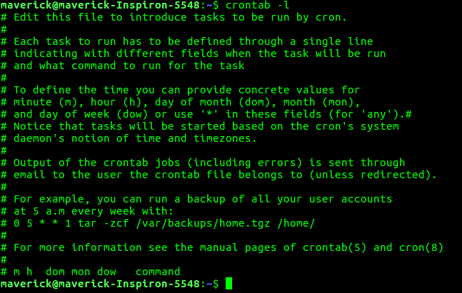30 – 30th Minute  
08 – 08 AM  
10 – 10th Day  
06 – 6th Month (June)  
* – Every day of the week

**2.To view the Crontab entries**

* View Current Logged-In User’s Crontab entries: To view your crontab entries type crontab -l from your unix account.

* 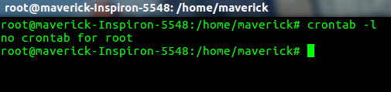View Root Crontab entries : Login as root user (su – root) and do crontab -l.
* To view crontab entries of other Linux users : Login to root and use -u {username} -l.  
  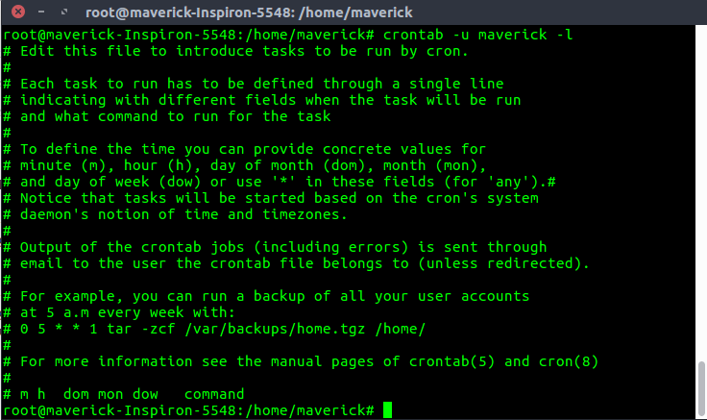

**3. To edit Crontab Entries**  
Edit Current Logged-In User’s Crontab entries. To edit a crontab entries, use crontab -e. By default this will edit the current logged-in users crontab.

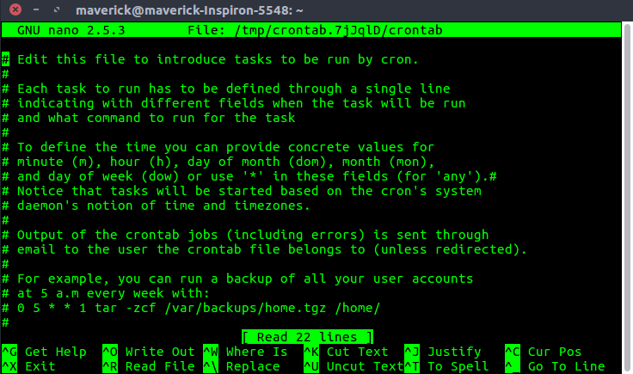

**4. To schedule a job for every minute using Cron.**  
Ideally you may not have a requirement to schedule a job every minute. But understanding this example will will help you understand the other examples.

* * * * * CMD

The * means all the possible unit — i.e every minute of every hour through out the year. More than using this * directly, you will find it very useful in the following cases.

When you specify */5 in minute field means every 5 minutes.  
When you specify 0-10/2 in minute field mean every 2 minutes in the first 10 minute.  
Thus the above convention can be used for all the other 4 fields.

**5. To schedule a job for more than one time (e.g. Twice a Day)**

The following script take a incremental backup twice a day every day.

This example executes the specified incremental backup shell script (incremental-backup) at 11:00 and 16:00 on every day. The comma separated value in a field specifies that the command needs to be executed in all the mentioned time.

00 11, 16 * * * /home/maverick/bin/incremental-backup

00 – 0th Minute (Top of the hour)  
11, 16 – 11 AM and 4 PM  
* – Every day  
* – Every month  
* – Every day of the week

**6.To schedule a job for certain range of time (e.g. Only on Weekdays)**

If you wanted a job to be scheduled for every hour within a specific range of time then use the following.

* Cron Job everyday during working hours:  
  This example checks the status of the database everyday (including weekends) during the working hours 9a.m – 6p.m
* 00 09-18 * * * /home/maverick/bin/check-db-status

00 – 0th Minute (Top of the hour)  
09-18 – 9 am, 10 am, 11 am, 12 am, 1 pm, 2 pm, 3 pm, 4 pm, 5 pm, 6 pm  
* – Every day  
* – Every month  
* – Every day of the week

* Cron Job every weekday during working hours:  
  This example checks the status of the database every weekday (i.e excluding Sat and Sun) during the working hours 9 a.m – 6 p.m.

00 09-18 * * 1-5 /home/maverick/bin/check-db-status

00 – 0th Minute (Top of the hour)  
09-18 – 9 am, 10 am, 11 am, 12 am, 1 pm, 2 pm, 3 pm, 4 pm, 5 pm, 6 pm  
* – Every day  
* – Every month  
1-5 -Mon, Tue, Wed, Thu and Fri (Every Weekday)

**7.To schedule a background Cron job for every 10 minutes.**  
Use the following, if you want to check the disk space every 10 minutes.

*/10 * * * * /home/maverick/check-disk-space

It executes the specified command check-disk-space every 10 minutes throughout the year. But you may have a requirement of executing the command only during certain hours or vice versa. The above examples show how to do those things. Instead of specifying values in the 5 fields, we can specify it using a single keyword as mentioned below.

There are special cases in which instead of the above 5 fields you can use @ followed by a keyword — such as reboot, midnight, yearly, hourly.

**Cron special keywords and its meaning**

Keyword Equivalent

@yearly 0 0 1 1 *

@daily 0 0 * * *

@hourly 0 * * * *

@reboot Run at startup.

**8. To schedule a job for first minute of every year using @yearly**  
If you want a job to be executed on the first minute of every year, then you can use the @yearly cron keyword as shown below.This will execute the system annual maintenance using annual-maintenance shell script at 00:00 on Jan 1st for every year.

@yearly /home/maverick/bin/annual-maintenance

**9. To schedule a Cron job beginning of every month using @monthly**  
It is as similar as the @yearly as above. But executes the command monthly once using @monthly cron keyword. This will execute the shell script tape-backup at 00:00 on 1st of every month.

@monthly /home/maverick/bin/tape-backup

**10. To schedule a background job every day using @daily**  
Using the @daily cron keyword, this will do a daily log file cleanup using cleanup-logs shell script at 00:00 on every day.

@daily /home/maverick/bin/cleanup-logs "day started"

**11. To execute a linux command after every reboot using @reboot**  
Using the @reboot cron keyword, this will execute the specified command once after the machine got booted every time.

@reboot CMD