OpenG2P Connector User Manual

Connector Admin — configure, navigate, and operate

Document control
Document type | User manual
Product | OpenG2P Connector Service + Connector Admin UI
Audience | Integration operators, registry administrators, support staff
Scope | How to access, navigate, configure, and operate integration pipelines
Version | 1.0

How to use this manual
This manual explains how to operate the Connector Admin web application that manages integration pipelines between external data sources and the OpenG2P Registry. Each screen is shown with numbered red markers; the meaning of each number is listed in the caption directly beneath the figure, so you can match what you see on screen to the instructions.
Wherever a host or address is needed, this manual uses a placeholder such as https://<connector-host>/. Replace it with the actual address provided by your administrator. No environment-specific URLs are assumed.

1. Introduction

1.1 What the connector does
The OpenG2P Connector is a multi-transport integration gateway. It ingests data from external platforms and delivers it to the OpenG2P Registry through the Partner API. You use the Connector Admin UI to define pipelines — each pipeline describes one data source, how to authenticate to it, how to transform records, and which registry to deliver them to.

1.2 Transport types
A pipeline’s transport determines how data arrives:
Transport | Pattern | How data arrives
odk_central | Poll | The connector polls ODK Central on a schedule and fetches new submissions incrementally.
webhook | Push | An external system posts JSON to a connector URL.
websub | Push (pub/sub) | A WebSub hub notifies the connector when a subscribed topic publishes an event.
kafka / rabbitmq / sqs | Consumer | A background consumer reads messages from a topic or queue (when enabled).

1.3 Components
Component | Role
Connector Admin UI | The web application described in this manual: create, edit, and monitor pipelines.
Connector Service API | Backend that stores pipeline definitions, runs ingestion, and exposes REST endpoints.
Background workers | Scheduled polls and asynchronous processing of pushed events.
Registry Partner API | The delivery target that receives normalized records and creates registry change requests.

1.4 Key concepts
Term | Meaning
Pipeline | A connector definition: source, transport, authentication, mapping, and registry delivery.
Run | One ingestion attempt for a single source record/event.
Sender (partner mnemonic) | Identifies your integration to the registry; must match a registered partner.
Target register | The registry your records are delivered into (for example an individual or household register).
Mapper (JMESPath) | An expression that reshapes a source record before delivery.
Cursor / checkpoint | Saved poll position so each poll only fetches new records.
Idempotency key | A dedupe key derived from the source event so the same record is not ingested twice.
DLQ | Dead Letter Queue — failed ingestions that you can inspect and replay.

2. Accessing the Connector Admin

2.1 Open the portal
- Open a current browser (Chrome, Edge, or Firefox).
- Go to the connector portal address provided by your administrator: https://<connector-host>/.
- The Integration Pipelines page loads (Figure 1).
The Connector Admin UI does not show its own login screen — access is controlled at the network or gateway layer (VPN, single sign-on, or network policy). If the page does not load, confirm your network access and that the service is running.

2.2 Connection status
A status indicator below the header shows whether the browser can reach the Connector Service API. If it reports an error, verify the portal address, your network/VPN, and with your administrator that the backend is healthy.

3. Navigation overview
The header has three areas. Use them to move between the main parts of the application.
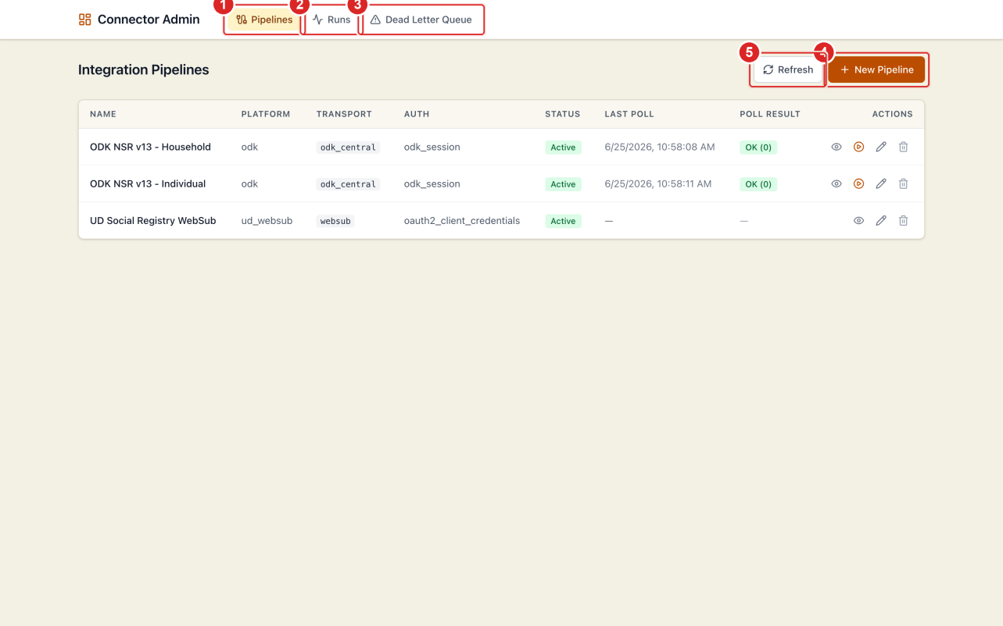
Figure 1 — Pipeline list and primary navigation
Figure 1. Integration Pipelines (home). (1) Pipelines — list and manage all pipelines. (2) Runs — ingestion activity across every pipeline. (3) Dead Letter Queue — failed ingestions, with replay. (4) New Pipeline — create a pipeline. (5) Refresh — reload the list.

3.1 Pipeline list columns
Column | Meaning
Name | Pipeline name; click to open its detail page.
Platform | Source platform label (for example odk).
Transport | Technical transport (odk_central, websub, webhook, …).
Auth | Authentication strategy in use.
Status | Active, Paused, or Disabled.
Last Poll | Time of the most recent poll (poll transports only).
Poll Result | Outcome of the last poll (OK / Partial / Failed) with record count.
Actions | View, Poll now, Edit, Delete.
The Poll now action appears only for poll-based pipelines. Push pipelines (webhook, WebSub) receive events and have no poll action.

4. Viewing a pipeline
Click a pipeline name (or the view icon) to open its detail page.
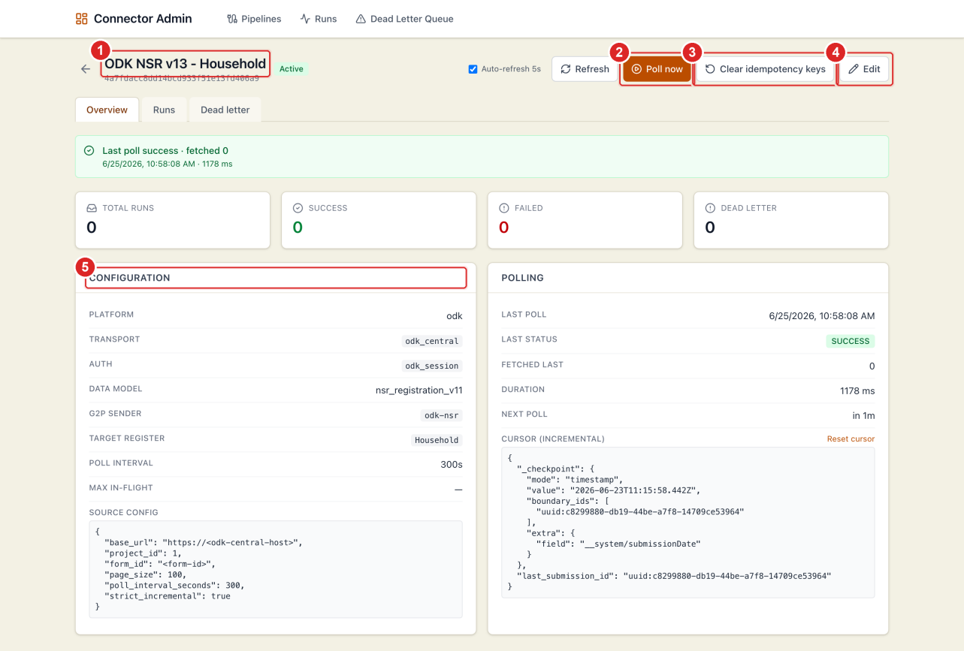
Figure 2 — Pipeline overview
Figure 2. Pipeline overview. (1) Title, connector ID, and status badge. (2) Poll now — trigger an immediate poll (poll transports). (3) Clear idempotency keys — allow previously seen records to be processed again (use with care). (4) Edit — open the configuration form. (5) Configuration panel — transport, auth, sender, target register, and parsed source config.

4.1 What the overview shows
- KPI cards: total runs, successes, failures, and dead-letter count.
- Latest run: the most recent ingestion with its status and registry correlation ID.
- Configuration panel: platform, transport, auth type, data model, sender, target register, poll interval, and source config.
- Polling panel (poll pipelines): last poll time, status, fetched count, duration, next poll, and the incremental cursor (with a Reset cursor control).
- Push pipelines show the inbound URL instead, in the form POST /webhook/by-slug/<your-slug>.

4.2 Action buttons
Button | Use it to
Auto-refresh 5s | Keep the page updating while you watch a poll or replay.
Refresh | Reload stats once.
Poll now | Poll the source immediately (poll transports).
Sync hub subscriptions | WebSub only — register topics and subscribe the callback URL at the hub.
Clear idempotency keys | Re-allow previously processed records (testing/replay; avoid in production).
Edit | Change the pipeline configuration.

5. Monitoring ingestion runs

5.1 Runs for one pipeline
Open a pipeline, then select the Runs tab.
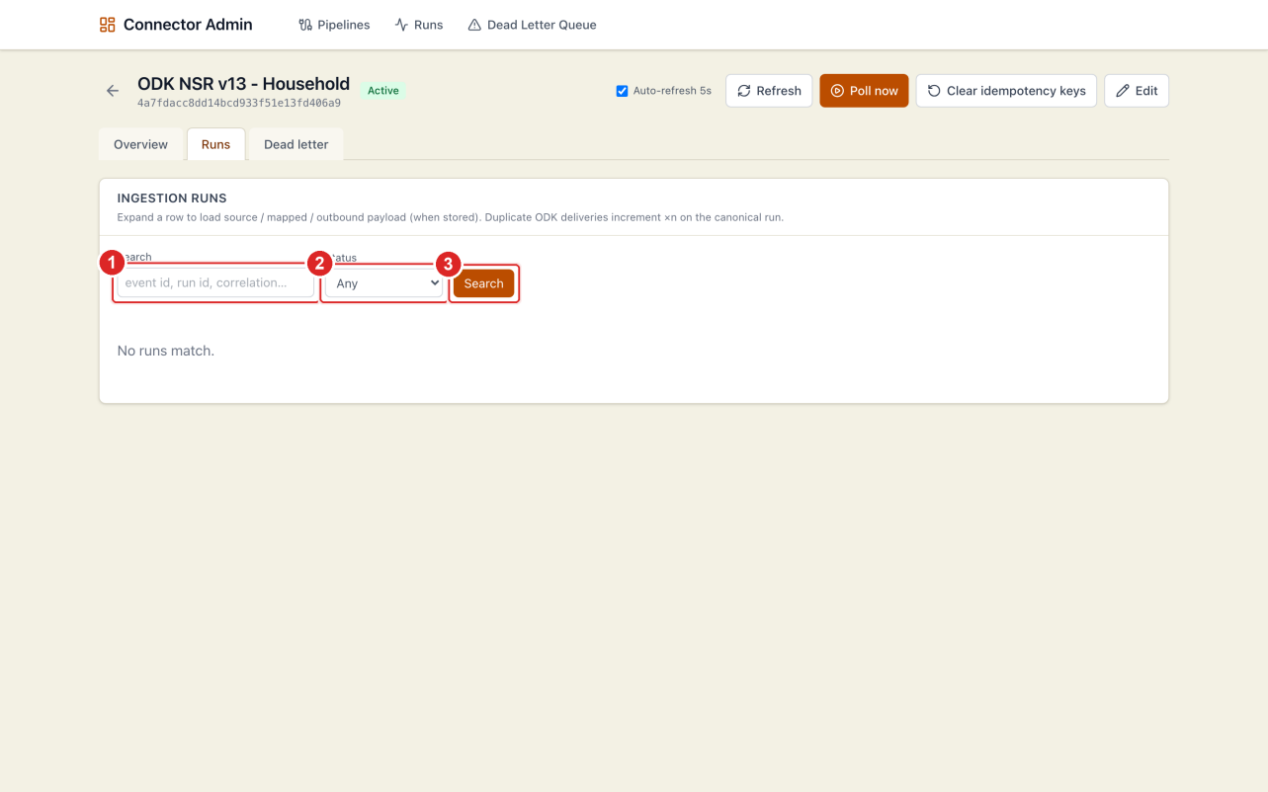
Figure 3 — Runs tab for a pipeline
Figure 3. Pipeline runs. (1) Search by event ID, run ID, or correlation ID. (2) Filter by status. (3) Apply the search.
Each row shows the run ID, source event, status, duplicate count, registry ID, and last activity. Expand a row (chevron at the left) to inspect the stored payload when payload storage is enabled.

5.2 Runs across all pipelines
Select Runs in the header to see activity from every pipeline in one place.
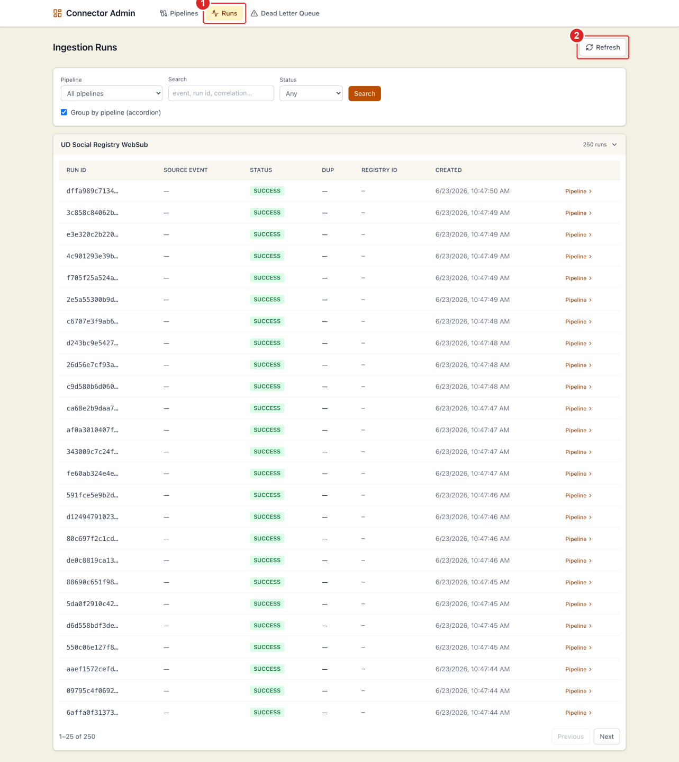
Figure 4 — Global runs
Figure 4. Global runs. (1) The active Runs section. (2) Refresh. Use the filters to choose a pipeline, search, filter by status, or toggle grouping by pipeline. This view answers “did anything fail recently, anywhere?”

6. Dead letter queue (DLQ)
Ingestions that fail and cannot be retried automatically are stored in the Dead Letter Queue so you can inspect and replay them.

6.1 DLQ for one pipeline
Open a pipeline, then select the Dead letter tab.
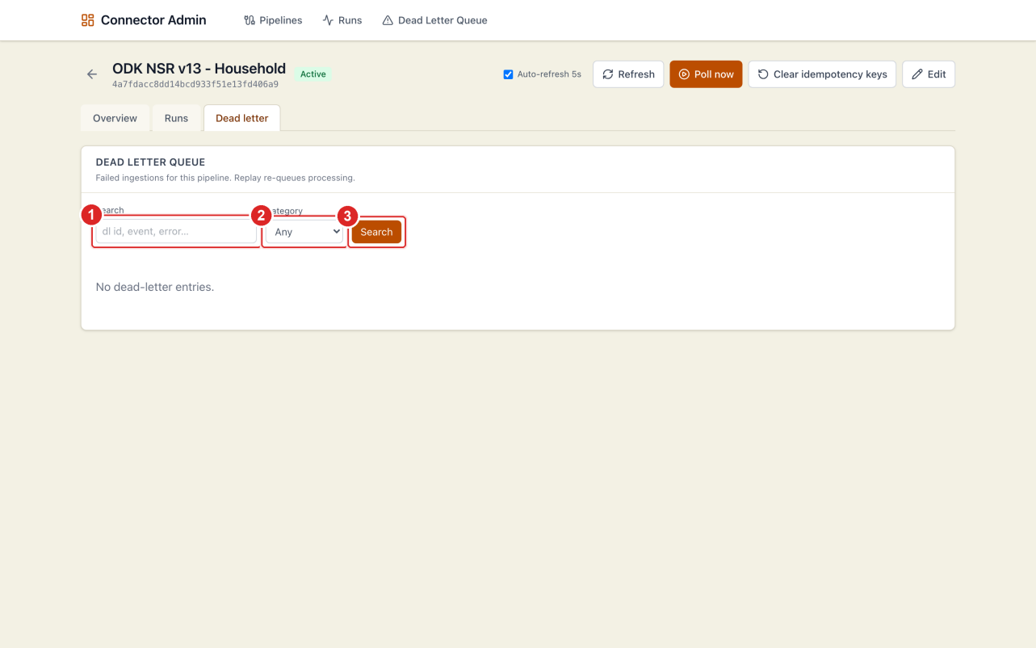
Figure 5 — DLQ tab for a pipeline
Figure 5. Pipeline dead letter queue. (1) Search dead-letter entries. (2) Filter by error category. (3) Apply the search.

6.2 DLQ across all pipelines
Select Dead Letter Queue in the header.
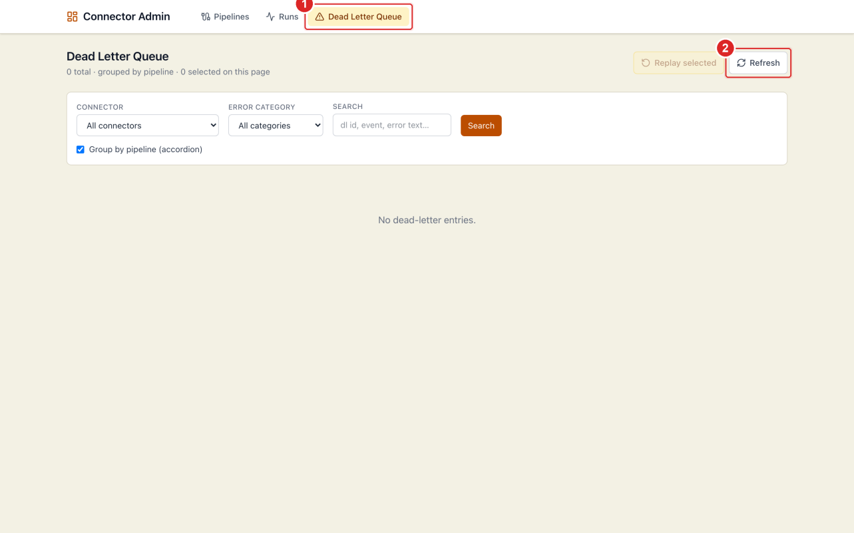
Figure 6 — Global DLQ
Figure 6. Global dead letter queue. (1) The active Dead Letter Queue section. (2) Refresh. Each entry can be replayed; expand it to read the error and payload.

6.3 Error categories
Category | Typical cause | Action
transient | Network timeout / target briefly unavailable | Replay; it often succeeds.
permanent | Unrecoverable source or registry rejection | Fix the data/config, then replay.
validation | Mapped record failed schema validation | Correct the mapping or schema.
config | Missing sender, register, or mapper error | Fix the pipeline configuration.

7. Creating a pipeline
Click New Pipeline on the home page.
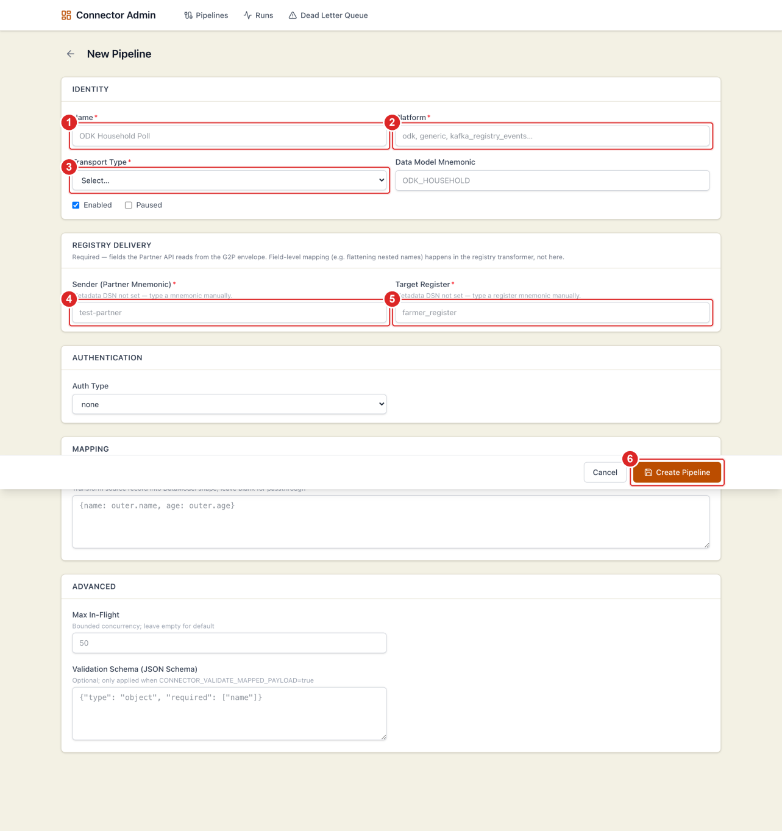
Figure 7 — New pipeline form
Figure 7. New pipeline — required fields. (1) Name. (2) Platform. (3) Transport Type. (4) Sender (partner mnemonic). (5) Target Register. (6) Create Pipeline (sticky footer).
Fill the form section by section.

7.1 Identity
Field | Required | Description
Name | Yes | Display name in the pipeline list.
Platform | Yes | Logical platform key (for example odk, generic).
Transport Type | Yes | How records are received (poll, webhook, consumer, or WebSub).
Data Model Mnemonic | No | Optional semantic label used by registry transformers.
Enabled | — | When off, the pipeline neither polls nor accepts pushes.
Paused | — | Temporarily stop processing without deleting the pipeline.

7.2 Registry delivery
These fields populate the envelope sent to the registry.
Field | Required | Description
Sender (Partner Mnemonic) | Yes | Must match a registered partner in the registry.
Target Register | Yes | The register mnemonic to deliver into.
When the service has registry metadata configured, these appear as dropdowns; otherwise type the mnemonic.

7.3 Source configuration (JSON)
Transport-specific connection details. Replace placeholders with your own values.
ODK Central (poll):
{
"base_url": "https://<odk-central-host>",
"project_id": 1,
"form_id": "<form-id>",
"page_size": 100,
"poll_interval_seconds": 300,
"strict_incremental": true
}
WebSub (push):
{
"hub_url": "https://<websub-hub-host>/hub",
"partner_id": "<partner-id>",
"callback_url": "https://<connector-host>/webhook/by-slug/<your-slug>"
}

7.4 Authentication
Auth type | Use for | Secrets (JSON)
none | Public endpoints | —
odk_session | ODK Central | {"email": "...", "password": "..."}
oauth2_client_credentials | OAuth-protected hubs/APIs | {"token_url": "...", "client_id": "...", "client_secret": "..."}
Secrets are write-only: the UI never displays stored credentials after you save.

7.5 Webhook / WebSub
Shown for webhook and websub transports.
Field | Description
Path Slug | URL alias: /webhook/by-slug/<your-slug>.
Verifier | Signature algorithm used to validate inbound requests.
Webhook Secret | Shared secret for signature verification.

7.6 Mapping and advanced options
Field | Description
Mapper Expression (JMESPath) | Reshape each source record before delivery; leave blank for passthrough.
Max In-Flight | Limit concurrent ingestions for the pipeline.
Validation Schema | Optional JSON Schema enforced when validation is enabled on the service.
Click Create Pipeline to save.

8. Editing a pipeline
From the list or detail page, click Edit.
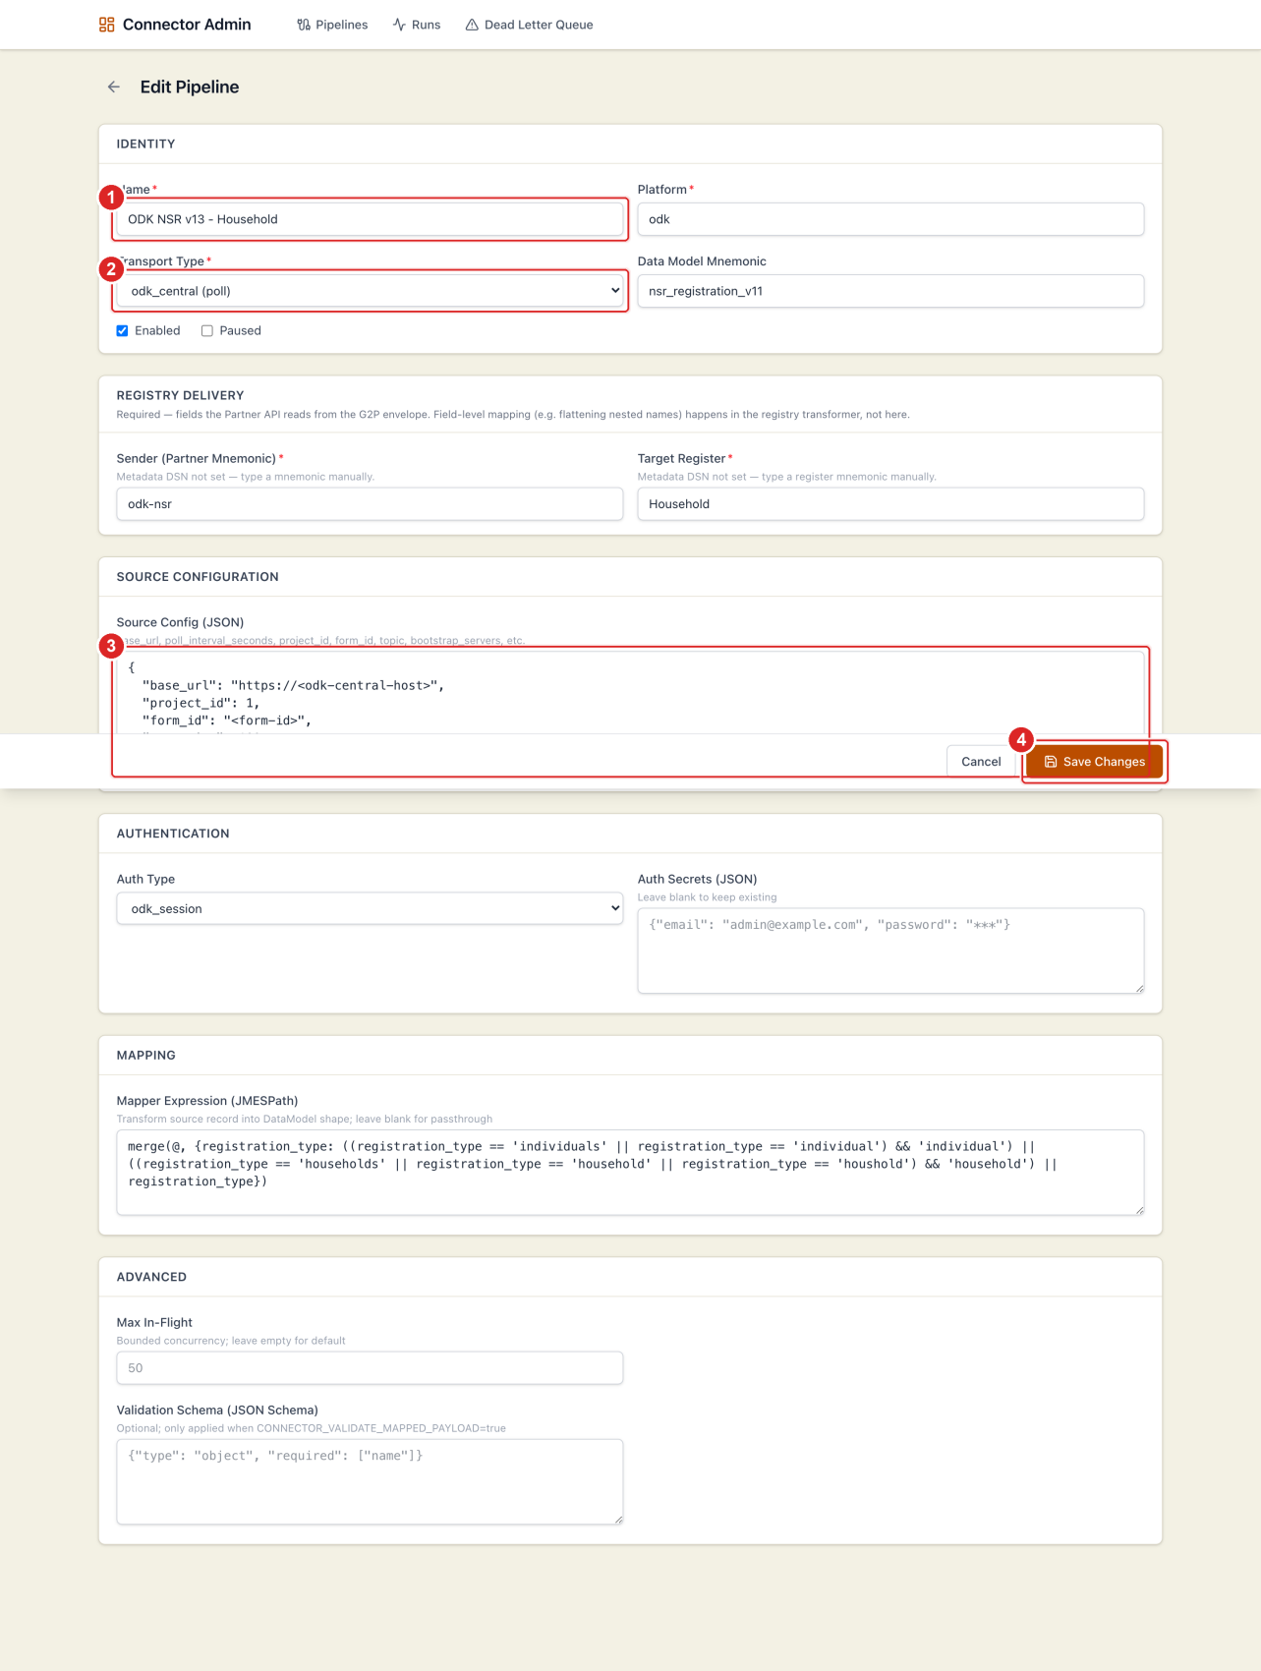
Figure 8 — Editing a poll pipeline
Figure 8. Edit pipeline. (1) Name (identity). (2) Transport Type. (3) Source Config (JSON). (4) Save Changes.
WebSub and webhook pipelines show additional sections for the callback and authentication:
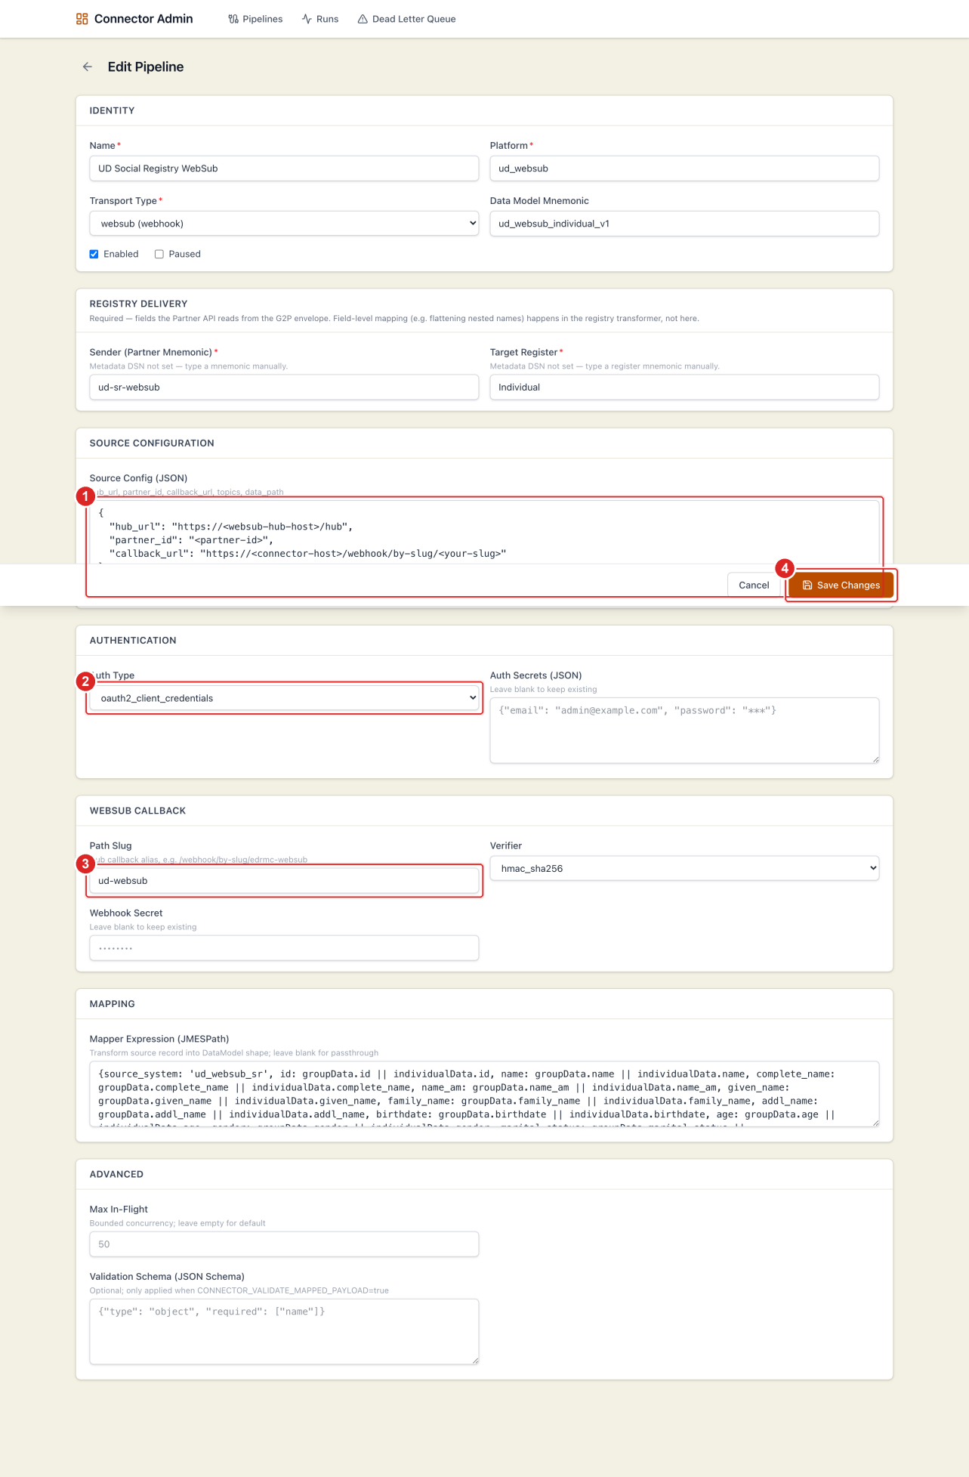
Figure 9 — Editing a WebSub pipeline
Figure 9. Edit a WebSub pipeline. (1) Source Config — hub URL, partner ID, callback URL, topics. (2) Auth Type — for example OAuth2 client credentials. (3) Path Slug — the callback alias. (4) Save Changes.
Important: leave Auth Secrets and Webhook Secret blank when editing unless you intend to replace them — blank means “keep the existing secret.”
After saving, return to the detail page and use Sync hub subscriptions (WebSub) or Poll now (poll transports) to verify the change.

9. Common operator tasks

9.1 Trigger an immediate poll
- Open Pipelines and locate the poll-based pipeline.
- Click the Poll now (play) icon in Actions, or open the pipeline and click Poll now.
- A confirmation shows the background task ID.
- Open the Runs tab or enable Auto-refresh to watch progress.

9.2 Subscribe WebSub topics at the hub
- Open the WebSub pipeline.
- Click Sync hub subscriptions.
- Review the result — each topic shows its register and subscribe status.
- If a subscription fails, verify the hub URL, callback URL, credentials, and that the callback is reachable from the hub.

9.3 Investigate and recover a failure
- In the pipeline Runs tab, look for FAILED runs and expand a row to read the error.
- If the entry is in the DLQ, open the Dead letter tab (or the global queue).
- Fix the root cause (mapping, sender, target register, or source data).
- Click Replay on the entry.

9.4 Re-process historical records
- Open the poll pipeline’s detail page.
- In the Polling panel, click Reset cursor and confirm.
- Click Poll now (or wait for the next scheduled poll). The next poll re-fetches from the start.

9.5 Pause without deleting
- Click Edit.
- Check Paused and save. Processing stops until you clear it.

10. Troubleshooting
Symptom | Likely cause | What to do
Page shows an API connection error | Network / gateway / service down | Verify the portal address, VPN, and service health.
Poll result Failed | Bad credentials, wrong URL, or timeout | Check auth secrets, base_url, and the last poll error on the overview.
Poll OK but 0 fetched | Cursor already up to date | Normal when there are no new records.
WebSub events not arriving | Hub subscription missing or callback unreachable | Run Sync hub subscriptions; confirm the callback URL is reachable.
Registry rejects records | Wrong sender or target register | Confirm the partner exists and the register mnemonic matches the registry.
Duplicate records after replay | Idempotency keys were cleared | Avoid clearing idempotency keys in production unless intentional.
Runs payload empty | Payload storage disabled | Ask an administrator to enable run payload storage.

11. Glossary
Term | Definition
Pipeline | A connector definition: source, transport, mapping, and registry delivery.
Run | A single ingestion attempt for one source event.
Envelope | The wrapper sent to the registry containing sender, register, and payload.
JMESPath | Query language used for mapper expressions.
DLQ | Dead Letter Queue — failed ingestions eligible for replay.
Idempotency key | Dedupe key preventing the same record from being ingested twice.
Cursor / checkpoint | Saved poll position for incremental fetching.
WebSub | Publish/subscribe protocol where a hub pushes notifications to a callback URL.

