# Main page:

## About us button doesn’t do anything



## Uploading a file different than a pdf still leads the user to a result xml.

## Clicking on the “AUTOMATIC MAGAZINES METADATA FILING” button redirects to an error page.

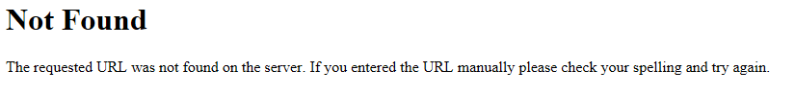

# Presentation page:

1. The title is misspelled.

Instead of “magazines” it says “megazines” and instead of “filling”, it says “filing”



1. Possible improvement in the grammar

Suggested replacement:

This project is about transforming given articles of magazines in text and metadata. To be specific, when the user will upload an article, he will receive information about the author, which heading is the title, the ISBN of the article and also raw text, depending on the type of the magazine.   
  
The point from where this project started is from having a set of training data (images and their metadata), after which we trained a program to recognize the same behaviour in different images.   
  
This program should save a lot of time when it comes to searching for specific information to be used.

## The user can’t return to the upload page from the presentation page.