**Name:** Pop Oana Ruxandra

**Group:** 248/2

**Entity Framework Documentation**

**1. Theoretical aspects**

Entity Framework is an open-source ORM framework for .NET applications supported by Microsoft. It enables developers to work with data using objects of domain specific classes without focusing on the underlying database tables and columns where this data is stored. With the Entity Framework, developers can work at a higher level of abstraction when they deal with data, and can create and maintain data-oriented applications with less code compared with traditional applications.

**2. Practical aspects**

Through this POC I wanted to demonstrate the usefulness and the simplicity of the Entity Framework. First of all, I picked two models, Artist and Song, which can be found in the “Models” folder. Regarding the models, there is a one-to-many relation, an artist can have one or more songs. After that, I created a folder named “Controllers” that contains 2 controllers, one for the Artist and one for the Song. This folder exposes the endpoints that will realize some CRUD operations.

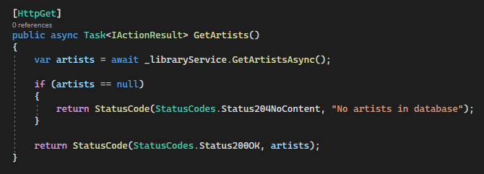

For example, here we have the “GetArtists” controller which calls the service and if the result is not null, it will return a response with status code 200 and with the artists. In the “Data” folder there is the class named “AppDbContext” which overrides the “DbContext” class.

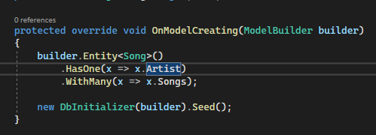

In this function, there are set some constraints, like a song having one artist and an artist being able to have many songs. Also I have created a function called “Seed” which will populate the tables with some random values. One of the most important folder of this project is the “Migrations” one because it contains the creation of the tables based on the models. This procedure is very easy because it consists of creating the desired entities and after running the add migration command the tables will be created.

The last folder would be the one which contains the services. For every entity, there is a service which implements all these CRUD operations.

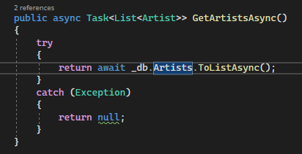 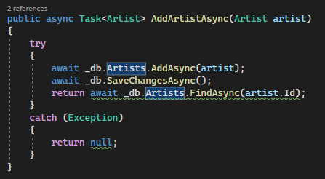

It can be seen how easy it is to work with some functions that are already implemented instead of writing some SQL scripts to manage a database.