C:\Users\OanaAlexandra\Desktop\19-12-13_funapp.jpg

**University:** UNIVERSITY “POLITEHNICA” OF BUCHAREST

**Professor:** DRAGOS-CONSTANTIN STOICA

**Students:** STAN ALEXANDRA-OANA

DRAGUSIN LUIZA-MARIA

NISTOR VLADUT-CRISTIAN

**Group:** 1232E

**Software:** Eclipse + Android SDK

**Coding:** JAVA

**CONTENT**

1. Background
2. Resources used
3. Analysis & Specifications
4. Strategy & Functionalities
5. Installation and user guide
6. Conclusion

**BACKGROUND**

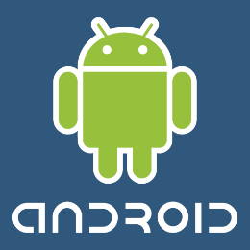

Applications ("[apps](http://en.wikipedia.org/wiki/Mobile_app)"), that extend the functionality of devices, are developed primarily in the [Java](http://en.wikipedia.org/wiki/Java_(programming_language)) programming languageusing the [Android software development](http://en.wikipedia.org/wiki/Android_software_development) kit (SDK). The SDK includes a comprehensive set of development tools,  including a [debugger](http://en.wikipedia.org/wiki/Debugger), [software libraries](http://en.wikipedia.org/wiki/Software_library), a handset [emulator](http://en.wikipedia.org/wiki/Emulator) based on [QEMU](http://en.wikipedia.org/wiki/QEMU), documentation, sample code, and tutorials. The officially supported [integrated development environment](http://en.wikipedia.org/wiki/Integrated_development_environment) (IDE) is [Eclipse](http://en.wikipedia.org/wiki/Eclipse_(software)) using the Android Development Tools (ADT) plug in. Other development tools are available, including a [Native Development Kit](http://en.wikipedia.org/wiki/Native_development_kit) for applications or extensions in C or C++, [Google App Inventor](http://en.wikipedia.org/wiki/Google_App_Inventor), a visual environment for novice programmers, and various [cross platform mobile web applications frameworks](http://en.wikipedia.org/wiki/Multiple_phone_web_based_application_framework). In January 2014, Google unveiled an [Apache Cordova](http://en.wikipedia.org/wiki/Apache_Cordova)–based framework for porting [Chrome](http://en.wikipedia.org/wiki/Google_Chrome) [HTML 5](http://en.wikipedia.org/wiki/HTML_5) [applications](http://en.wikipedia.org/wiki/Web_app) to Android, wrapped in a native application shell.

Android has a growing selection of third-party applications, which can be acquired by users by downloading and installing the application's [APK](http://en.wikipedia.org/wiki/APK_(file_format)) file, or by downloading them using an [application store](http://en.wikipedia.org/wiki/Application_store) program that allows users to [install, update, and remove applications](http://en.wikipedia.org/wiki/Package_manager) from their devices. [Google Play Store](http://en.wikipedia.org/wiki/Google_Play_Store) is the primary application store installed on Android devices that comply with Google's compatibility requirements and license the Google Mobile Services software. Google Play Store allows users to browse, download and update applications published by Google and third-party developers.

Due to the open nature of Android, a number of third-party application marketplace also exist for Android, either to provide a substitute for devices that are not allowed to ship with Google Play Store, provide applications that cannot be offered on Google Play Store due to policy violations, or for other reasons. Examples of these third-party stores have included the [Amazon Appstore](http://en.wikipedia.org/wiki/Amazon_Appstore), [GetJar](http://en.wikipedia.org/wiki/GetJar) and SlideMe. [F-Droid](http://en.wikipedia.org/wiki/F-Droid), another alternative marketplace, seeks to only provide applications that are distributed under [free and open source](http://en.wikipedia.org/wiki/Free_and_open_source) [licenses](http://en.wikipedia.org/wiki/Free_software_license).

### APPLICATIONS BENEFITS

### Benefits for Business – Apps: Build relationships Build loyalty Reinforce your brand Increase your visibility Increase your accessibility Solve the problem of getting stuck in spam folders Increase sell-through Increase exposure across mobile devices Connect you with on-the-go consumers Generate repeat business Give you tools that are driving the "New App Economy" Enhance your social networking strategies

### Benefits for Customers – They'll receive: Easy access to your inventory Notifications of special events, launches, and more One-touch access to your contact information Directions to your location from wherever they are Fast, seamless appointment scheduling Automatic recording of their next appointment Automatic reminder of their next servicing date A record of their mileage and most recent servicing Embedded QR Code Scanner Free one-on-one Chat Extras: parking markers, loan calculators, and local gas prices

### Why is a Mobile App better than browsing the Mobile Web? It's much faster. It takes a second to launch a Mobile App. It can take up to several minutes for a Mobile Web site to load in an area with bad reception.  *Mobile Web Sites are important but they do not replace the need for Mobile Apps for the following reasons:*  Mobile Apps: Function offline Mobile Web Sites: Don't  Mobile Apps: Enable Push Notifications for Direct Contact with Customers Mobile Web Sites: Don't  Mobile Apps: Always visible on your phone's home screen Mobile Web Sites: Not always visible  Mobile Apps: Appear in the Apps Stores Mobile Web Sites: Don't

**RESOURCES USED**

**For the application project we used:**

1. PNG / JPEG images made in Photoscape
2. Android SDK Tools
3. Android platform
4. Eclipse + ADT plugin
5. Genymotion Emulator
6. Oracle Virtual Machine

**ANALYSIS & SPECIFICATIONS**

The design for this project contains:

* the username.
* the password.
* the button that starts the application(login)
* the button register to make an account
* a progress bar that tells when you go in a homepage that can be customized by changing the color of its background (divisions).

**STRATEGY & FUNCTIONALITIES**

We created an Android Application Project and we build on this template.

We have two textfields ( Username and Password ) . They get their values ​​by writing.

The graphic files contain a button(LOGIN) that acted on it and make the homepage appear and a button (REGISTER) which goes to a place where you can make an account.

In the homepage you can change the color of the background by clicking on the button (Change the homepage color) , you can change the picture that is used there and you can also logout.

We created a database using parse.com, with 5 users and their passwords in order to verify their names.

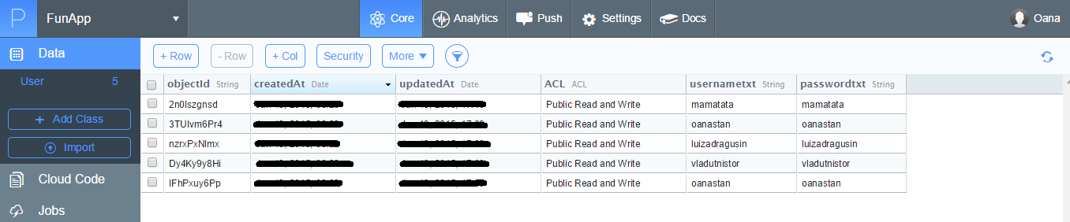

**At runtime:**

We have as an emulator, GenyMotion. We made the configurations and we run everytime with this emulator, instead of the android emulator. We need also an Oracle Virtual Machine to do this.

**INSTALLATION & USER GUIDE**

**The explanation of the steps to run the application**

In order to use the application you need to run **FunApp.**

**You need to run the following steps:**

* **Chose the name of the user by writing it in the “Username” textField.**
* **Choose the password by by writing it in the “Password” textField.**
* **Click “LOGIN” button, and that’s all. The ProgressBar shows the divisions are loading and you go in the homepage. There you can customize the page by changing its background color. You just click on the button “Change the homepage background” and the color is changed from white to red. You can also change the picture by pressing the button (Change the picture).**
* **Click “REGISTER” button to create a new account.**

**It starts the application !**

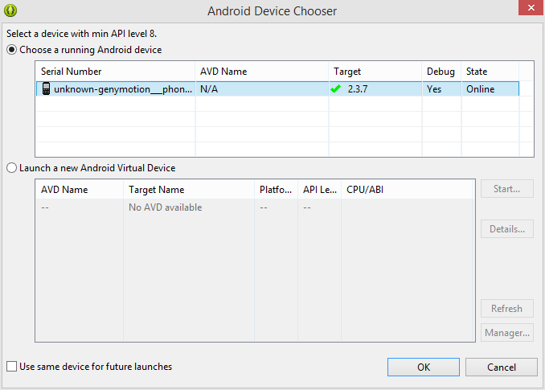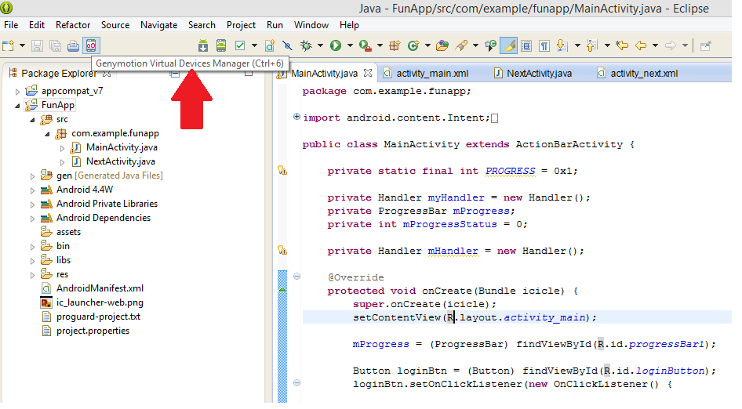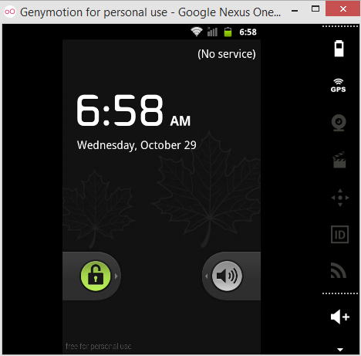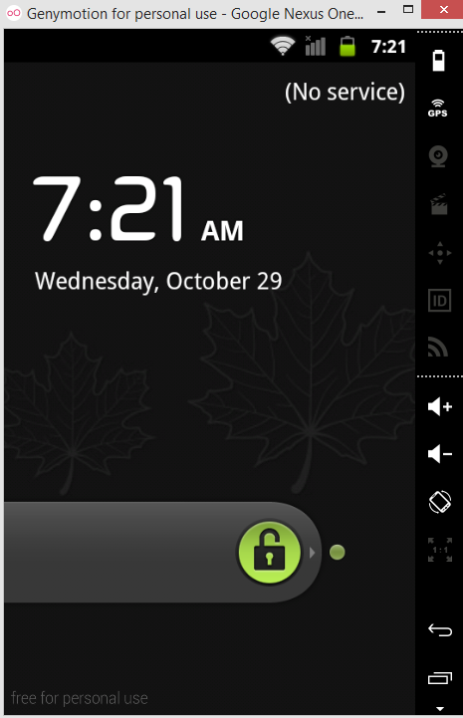

**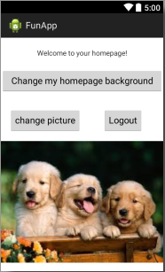**

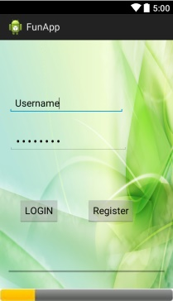

**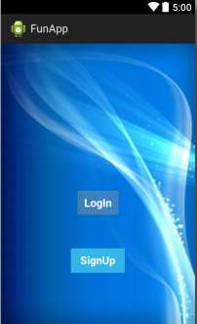**

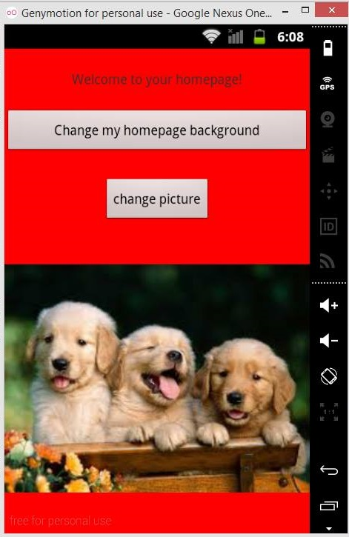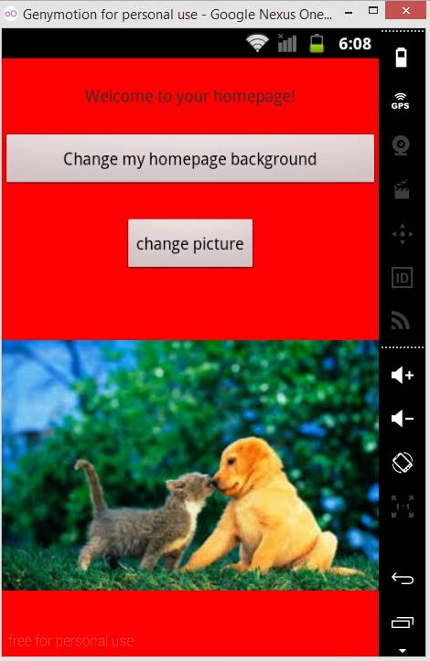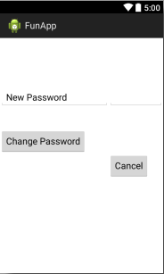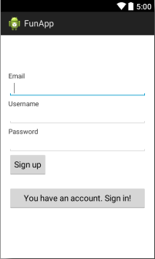

**We have also the complete package for weather, but it doesn’t work!**

**CONCLUSIONS**

**Mobile Applications Development is Must Resource For Nowadays Business**

Mobile database integration has obtained a lot of significance in the recent and the need available that you can buy is continuing to grow like fire in the forest. But this improving need for services could confirm to be a excellent omen for your enterprise as there are great possibilities of developing, broadening and retaining business by serving these requirements.  
  
Mobile app progression is not just a progression process but it's like a switch that functions to increase the efficiency of your cell phone. When you create programs it helps you execute certain features that are necessary for your enterprise enterprise and can help you be linked with your clients and clients.  
  
There are various systems now available on which you can try your hands out. BlackBerry, Symbian, Operating system, Windows and the notorious iPhone all of them are there to be benefit from. In the last several decades the iPhone has really been the reason for developing such an fascinating industry possibilities with its choice of third party program support. This has lead to many developers and developers to come out available that you can buy and create applications to generate income.  
  
Not only this it has also assisted a lot businesses to grow extremely as now one can be in touch with their clients and clients all the time through their cell phone devices. And with the newest technology of iPhone 4 and Windows Phone 7 things are looking even lighter than before. Now the features of these mobile mobile phones have been taken to the next level and thus the customers can expect better and more effective mobile apps development progression and get programs to execute more complicated features in even better ways.  
  
This entire pattern has created a whole new industry of outsourced workers services that has seen a incredible uplift in the last 5 decades. Mobile database integration Indian is one such choice that gives you real achievement at very huge discounts. Outsourcing perform in such nations around the world is a very effective way of getting your perform done without having to spend much. There are certain benefits. The work expenses are smaller, the production is easy and extra, the timeframes and reliability is managed, you can seek the services of devoted developers and developer as per according to your need

**References**

Here are some key references used throughout these notes:

<http://ro.wikipedia.org>

<http://developer.android.com/training/index.html>

<http://www.oracle.com/>

[www.**genymotion**.com/](http://www.genymotion.com/)