LLM_development_roadmap smoke tests

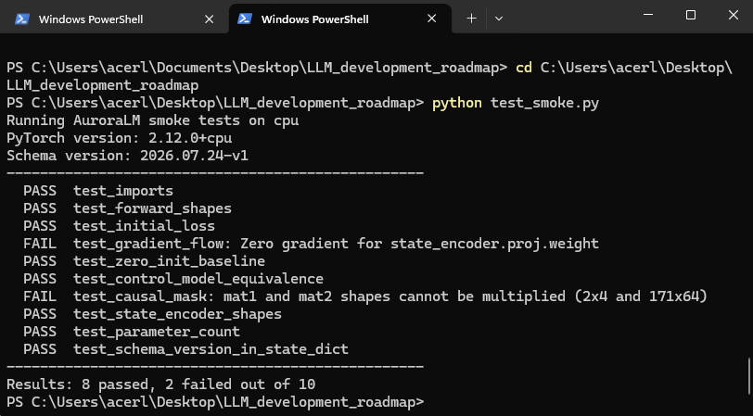
24/07/2026 – 01:55am

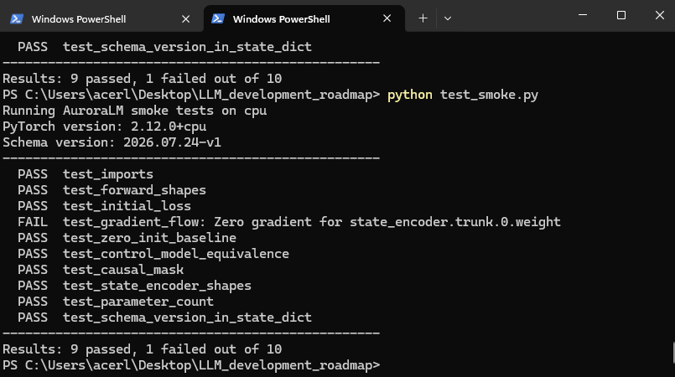
24/07/2026 – 02:16

state_encoder.trunk.0.weight gets zero gradient because of your own zero-init design. Here's the chain:
You deliberately set state_head's weights to zero so the model starts out ignoring the state. Gradients flow backwards through the network by multiplying at each step. When the gradient reaches the trunk, it has to pass through state_head's weights — which are zero. Anything multiplied by zero is zero.
So the trunk gets nothing on step 0. Mathematically guaranteed, not broken.
It unblocks itself: state_head picks up gradient from elsewhere, becomes non-zero after a step or two, and then the trunk starts learning normally. It's a short delay, not a permanent block.
Two things follow:
- Add "state_encoder.trunk" to zero_init_exceptions in the test. But note your test uses a bare assert, so it stops at the first failure — there are likely more zero-grad params hiding behind this one (attn_cond.mlp.0.weight is my bet, same reason).
- The better fix: change that test to run 3 optimiser steps first, then check gradients. That tests what you actually care about — "does the state pathway learn?" — rather than "is it zero at the instant we designed it to be zero."

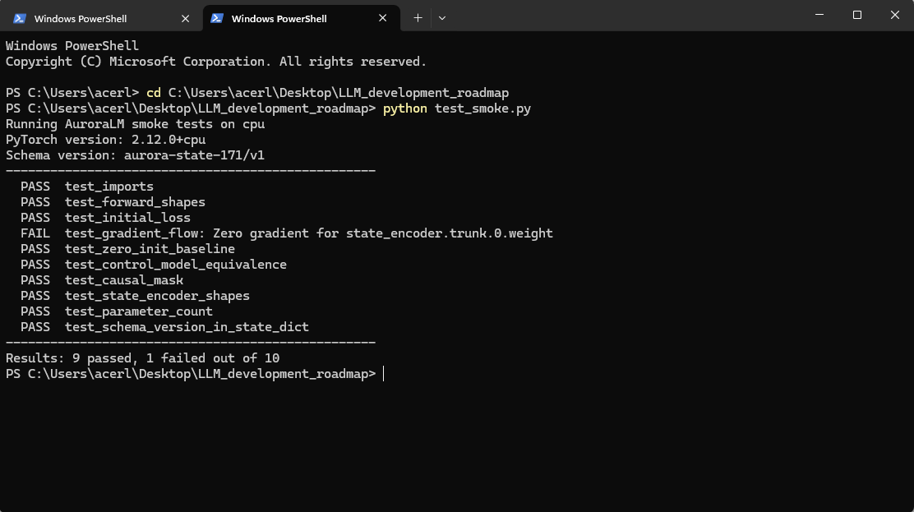
24/07/2026 15:21pm

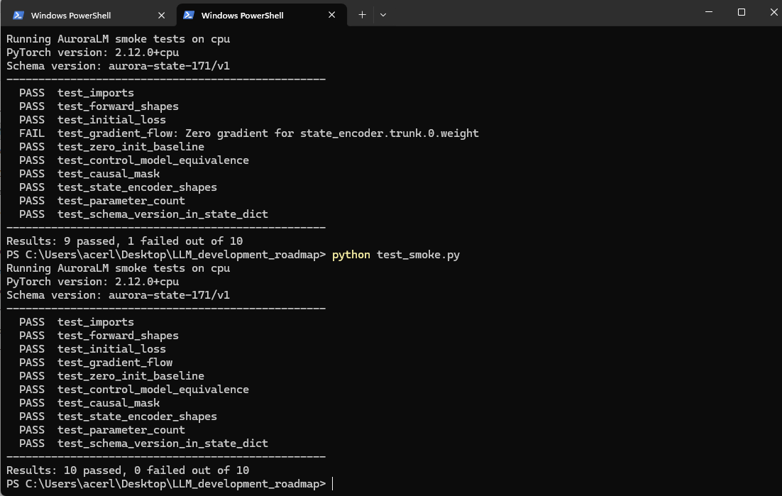
24//07/2026

