Validation of the Small Animal Biospace Gamma Imager Model Using GATE Monte Carlo Simulations on the Grid
Release 3.14

Joe Aoun^{1, 2}, Vincent Breton², Laurent Desbat¹, Bruno Bzeznik³, Mehdi Leabad⁴ and Julien Dimastromatteo⁵

July 18, 2008
¹Grenoble Joseph Fourier University, TIMC-IMAG
²Clermont Ferrand Blaise Pascal University, LPC
³Grenoble Joseph Fourier University, CIMENT
⁴Biospace LAB, Paris
⁵Grenoble Joseph Fourier University, INSERM U877
Abstract

Monte Carlo simulations are nowadays widely used in the field of nuclear medicine. They are valuable for accurately reproducing experimental data, but at the expense of a long computing time. An efficient solution for shorter elapsed time was recently proposed: grid computing. The aim of this work is to validate a Monte Carlo simulation of the Biospace small animal γ Imager and to confirm the usefulness of grid computing for such a study. Simulated data obtained by the validated model of the gamma camera will enable to investigate new algorithms such as scatter and attenuation correction, and reconstruction methods. Good matches between measured and simulated data were achieved and a crunching factor as high as 70 was achieved on a campus grid.

Contents

1 Introduction 1
2 Materials and Methods 2
3 Results and discussions 8
4 Conclusions and perspectives 12

Introduction
Preclinical small animal researches have become a major focus in nuclear medicine [Del Guerra 2007]. New therapeutic and diagnostic studies are first investigated and validated on mice or rats before their application to patients [Constantinesco 2007]. In consequence, we can find many dedicated small field of view scanners for SPECT (Single Photon Emission Tomography) [Smith 1998][Berthot 2001][Garibaldi 2001][Lazaro 2004][Beekman 2004] and PET (Positron Emission Tomography) [Merheb 2007][Vandervoort 2007] which have been designed in the last decade for these purposes. Scanners’ models should incorporate all the physical effects (attenuation, scatter…) in order to improve the quantification and the quality of SPECT images [King 2004]. When imaging with ¹²⁵I (27.5 keV) a concentration of radioactivity placed in the centre of a rat-sized cylinder of water, the scatter-to-primary ratio can reach up to 30% and the photon attenuation can reduce the activity quantitation by up to 50% (25% with ^{99m}Tc - 140 keV) [Hwang 2008]. Such degradations are very difficult to compensate by an experimental or analytical approach [Buvat 2002]. Few researchers tried to assess an analytical and experimental estimation of photon distributions in SPECT projections [Riauka 1996][Wells 1998]. Monte Carlo Simulations (MCS) have greatly contributed to solve these problems thanks to their accuracy and the possibility of modelling all the physical processes independently [Lazaro 2005][El Bitar 2006]. Since the 1960s, Monte Carlo methods became an essential tool in the field of nuclear medicine [Morel 2007]. Unfortunately, the use of MCS has limitations in computing time. Different strategies have been suggested to reduce the computing time such as the acceleration techniques [Buvat 2006]. Another solution to speed up MCS is to combine Monte Carlo and non-Monte Carlo modelling [Buvat 2006]. A third option that has recently been explored is the deployment of computing grids, also known as the parallelization of the MCS [Breton 2003]. The parallelization consists in sub-dividing a long simulation into short ones. Each MCS needs a Random Number Stream (RNS) to produce the physical interactions in question. The distribution of MCS on multiple computing resources requires that the generated streams are independent [Mascagni 2004]. Before simulated data can be trusted, the simulation model must be validated by comparing it with the corresponding experimental results.
A popular way of exploiting computing power for scientiﬁc research on a single site, is the utilisation of networks of computers as a single uniﬁed computing resource, called cluster computing. On those systems, the resource allocation to users and computation tasks is handled through batch queuing software such as PBSPro[b1], Torque [b2], LSF [b3], SLURM [b4], OAR [b5], SGE [b11]. Larger scale scientiﬁc research, linking geographically distributed computational resources, is achieved by technologies called computational grids or grid computing. The project with the greatest visibility on grid computing is Globus. This mainstream approach, provides a software infrastructure that enables applications to handle distributed heterogeneous computing resources as a single virtual machine. However, the installation, conﬁguration, customization and maintenance of a system like Globus [b6], is a rather complicated task and requires a highly skilled support team, which not a lot laboratories are willing to afford. The opportunity of performing large computations at low-cost, motivated scientists to come up with another technological solution. This approach works through the exploitation of idle cycles of desktop PCs, known as voluntary computing or desktop grid. Other alternative technologies, based on the idea of harvesting unutilised resources of multiple distinct administrative domains that want to share their resources, are provided by the projects OurGrid [b7] and Condor [b8]. Under that context, this paper introduces two grid tools, CiGri [b9] and Computemode [b10], used on the computing resources of the University of Grenoble, to report the validation of the Biospace dedicated to small field of view SPECT scanner using the GATE MC simulation toolkit.
In this work, we report the validation of the Biospace dedicated to small field of view SPECT scanner using the GATE MC simulation toolkit on the CIMENT Grid, a grid deployed on the university campuses in Grenoble.
The paper is organized as follows:
Chapter 2 presents the materials and methods used in this study: we introduce CiGri (CIMENT Grid), the GATE MCS toolkit, the gamma camera we studied and the methods we used to deploy the simulations on the grid and to validate the simulated results compared to experimental measurements. Chapter 3 proposes an analysis of the results of simulation as well as an overall view of the grid performances. Chapter 4 presents a conclusion and perspectives.

Materials and Methods

CiGri grid
A lightweight grid
CiGri (CIMENT Grid) is a simple, lightweight, scalable and fault tolerant grid system which exploits the unused resources of a set of computing clusters. CiGri middleware is a free software under GPL licence developed at the University of Grenoble (France) and used onto the production clusters of the CIMENT project [CIMENT website] since 2002. Its main contribution is that by working discreetly on the interconnected clusters, it doesn't influence their normal functionality. This is achieved by using a transparent technique of harnessing the idle cluster resources for executing large-scale scientific computations. The platform supports only a specific type of applications, called bag-of-tasks, which represent a set of independent sequential tasks. But, by tracking this specific kind of applications in a computing centre like CIMENT, counting half a dozen of clusters, and by running those applications at this transparent grid level, we smooth the overall load of the clusters. Bag-of-tasks applications are removed from the local peak of an overloaded cluster and spread on other clusters that have idle resources.

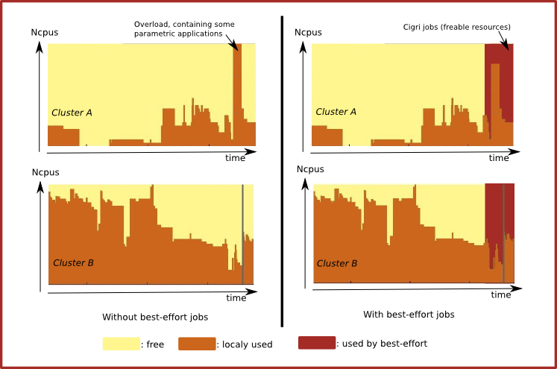
Fig ?? : Load example of a grid composed of 2 clusters

The concept of a lightweight grid concerns infrastructures that simplify the general problem of the grids. This simplification generally goes through a certain homogeneity of services and administration procedures: by adopting the same services and configurations on all interconnected clusters. Our main interest on CIGRI system, is to provide a platform that focuses on the research and development of specific problems that come along with the execution of tasks (scheduling, fault tolerance...) on distributed grid environments. Our approach does not deal with critical problems inherent on computational grids like security, authentication mechanisms and resource location.
Best-effort computing with OAR
One of the simplifications assumed by the lightweight grid concept is that CiGri relies on the OAR batch scheduler [OAR website]. A resources management software (or a batch scheduler) handles the resource allocation to users and tasks on a computing cluster. OAR is the brother of CiGri as it is developed by the same team. It has a very interesting feature used to not influence the normal functionality of the interconnected clusters on a CiGri platform. This is the concept of “best-effort” tasks. The jobs on this queue have a zero execution priority and are submitted only if there is a free resource. Moreover, if during the execution of those jobs, the resource is requested by a local cluster user, the ”best-effort” job is killed by the local batch scheduler and CiGri grid server is notified.

1) Submission of a grid ‘bag of tasks’ application
2) Request of idle resources as a normal user
4) Submission of tasks on the best-effort queue of the batch scheduler.
(ex. randomly select 5 tasks form the ‘bag’
CiGri Server
Custer Batch scheduler
3) Returns the number of idle resources (ex. 5 nodes)
5) Execution of the tasks as low-priority best-effort jobs
6) Local job
submission
requesting resources
(ex. 3 nodes)
7) Low-priority best-effort
Jobs stopped (3 jobs killed)
8) Notification of the killing of the tasks
9) Killed tasks re-entered on the ‘bag’ to be re-scheduled for later execution
CiGri User
Local User

Fig ?? : Best-effort jobs
This CiGri/OAR collaboration does not mean that OAR is mandatory for the local users tasks submissions. It means that OAR must be installed on all the clusters of a CiGri platform, but it may be coupled to another batch scheduler and act as a simple “best-effort” interface for CiGri. This coupling option has already been tested with PBSPro, Torque and SGE.
Considering this best-effort feature and the aim of scalability (large bag-of-tasks applications means > 100k tasks), it clearly appears that CiGri has a big deal with error management. It's up to CiGri to resubmit the jobs that have been killed and to manage faults like a cluster momentarily not responding. On such a grid, the walltime of the tasks is a very important parameter as the life expectancy depends on the load and the turnover of jobs of the clusters. So, the tasks have to be relatively short or we have to use some checkpointing systems. The management of checkpointable jobs is currently under development. Concerning the application discussed in this article, we were able to generate jobs small enough (less than one hour) to have a good probability of ending without being killed (see the resubmission percentage in 3.5).
But jobs have to be small enough because of overhead time submission
CiGri architecture
The CIGRI software is composed of a server which communicates with all the batch schedulers of the clusters. It acts like a normal user, submitting minimum priority jobs on the best-effort queue of the batch schedulers. There is no specific CIGRI software installed on the clusters, except OAR. Nevertheless, it just takes advantage of the classic system tools (ssh, bash, sudo, cat, ls, scp, tar...) and the NFS file system of the cluster. An optional LDAP client may be used for the authentication, but it is not mandatory and users may have different login accounts on the different clusters; then CiGri makes the binding between the grid login and the clusters' logins.
The system is designed with a modular architecture based upon two high level components. Those are an SQL database and a scripting language (in fact, two scripting languages: Perl and Ruby). The database is used to hold all the internal data and works as the only communication medium between the modules. It is used to store information such as: the state of clusters’ nodes, the state of submitted jobs, the various errors that can be obtained and logged, logging of all activities, information about the users, etc. The choice of a database as the central component ensures the management of big amounts of information and guarantees the reliability of the platform.
The central part of the CIGRI software is made of a collection of independent modules. Each of them is in charge of a specific task such as jobs scheduling, jobs monitoring, error logging, jobs submitting, statistics updating, and results collecting. The whole system is managed by a central module which is in charge of calling the other modules to perform either regular tasks (such as monitoring) or on-demand tasks (such as submission).

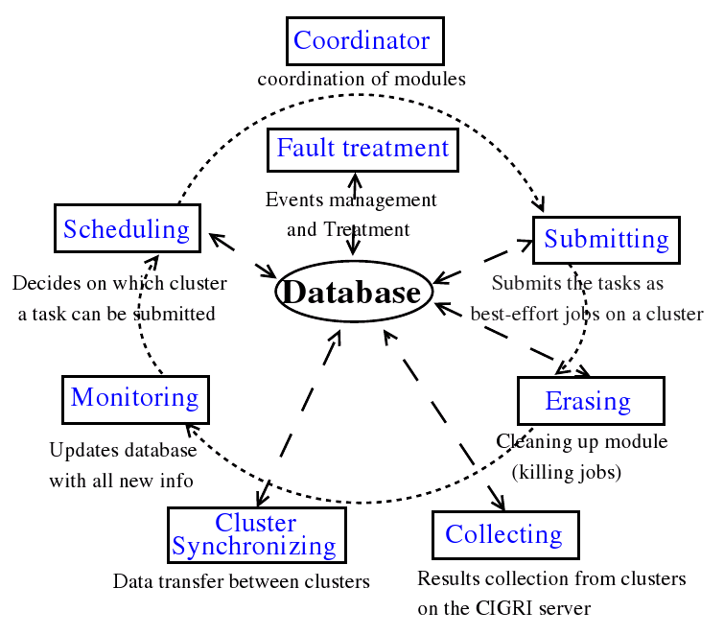

Fig ?? : CiGri modules and their operation

Another important functionality is the results’ collection from the clusters, along with the cleaning of temporary files. A specially designed module auxiliary to the system is responsible to periodically collect the result files and archive them on the grid server and on the same time erase them from the cluster. Hence, the user can collect the results of its computation on one centralised place and on the same time the cluster’s storage resources are not overbooked by grid application data. Moreover, a private web portal exists to monitor the jobs on the grid.

Jobs submission
JDL, parameters file
Input data → every clusters

Using desktop PC for nightly computing: Computemode
Another useful tool has been used, through CiGri, for the computing during this study. Computemode is a free software that creates a computing cluster with desktop PCs by restarting them on a diskless system at some scheduled times (generally on the night). Initially developed in 2004, it is now maintained by the developers of CiGri as it is a valuable tool used in conjunction with this grid. It runs on a single server that must be into the same LAN of the PCs that will be used for computation during the night. Computemode is composed of a specific PXE boot manager, a OAR server/frontend, a NFS server managing system images and home directories, and a powerful management web interface in which the administrator can create schedules for booting the PCs on specific systems at some specific times. Actually, this schedule capability may be useful not only for computing, but for example to boot a cloning tool for nightly automatic re-installation of the system. That's why the tool is used in one of a unit of the Grenoble's University. It is useful for the local administrators of the PC pool of the unit, and the CPUs are used by the CIMENT project during nights and week-ends.
Like CiGri and OAR, Computemode is build above an SQL database holding data about the workstations like MAC addresses, available OS images and the schedules. The interface is written in PHP and interacts with the system components through the database. A judicious configuration of the DHCP server and a modified TFTP server allow the workstations to be automaticaly registred into the database and to load the scheduled OS at boot time. A little http agent is provided for Windows and Linux, to be ran in the background on the workstations, polling the server to know if it's time to reboot. New worksations may be automaticaly recorded into the batch scheduler and only a simple click into the administration interface is necessary to tell that those worksations are to be in the computing mode at some schedule. When a workstation is in the computing mode, the local disk is not used at all. This ensures the local users that the local OS and data are not in danger. The computing OS is a diskless Linux easily configurable on the Computemode server, allowing the grid administrator to install applications and libraries.
On such a cluster, resources are somehow “volatiles”. They may appear or disappear at some time of the day and we don't really know in advance if a job may be completed in time before the resource disappears. Moreover, in such a cluster we generally use PCs that are in classrooms or offices and we may encounter random failures like badly connected network cables, power failures or manual reboots. That's why the use of CiGri helps a lot because it is designed to manage such “best-effort” systems.
Generally, during the day, only one or two resources are available for testing. All the other resources appear into CiGri as unavailable, like any other resource of the grid that is used by a local user or in a failure status. On the evening, if a grid campaign is running, when the Computemode PCs start to appear in the computing mode, CiGri sends the jobs on it like on any other idle resource of a normal cluster. There's no need of a human action when the resources become alive into Computemode. And CiGri will put back into the bag-of-tasks the jobs that have not been finished when the morning woke up the PCs into their production operating system, allowing to submit them on other clusters of the grid.

Monte Carlo simulation toolkit
GATE (Geant4 Application for Tomographic Emission) [Jan 2004] is a new Monte Carlo simulation toolkit based on the general-purpose simulation package Geant4 [Agostinelli 2003]. It was developed in order to model treatment and diagnosis examinations such as radiotherapy, SPECT and PET in the field of nuclear medicine (and recently CT-scan exams). GATE is an open source code which uses approximately 200 C++ classes from Geant4. User does not have to program in C++ thanks to an extended version of Geant4 scripting version. Thus, the user can easily build a simulation (macro) by using a script language. Many researchers have been using GATE for its flexibility and its accurate modelling of different detector designs [Staelens 2003] and very complex geometries [Sakellios 2006]. The major drawback of GATE is the computation time especially when simulating realistic configurations such as voxelized emission and attenuation maps. Several solutions were proposed to accelerate some of the GATE simulations: (i) setting thresholds for the production of secondary electrons, x-rays and delta-rays, (ii) limiting the emission angle to a certain range, (iii) replacing the disintegration scheme by a source of monoenergetic gammas, (iv) parametrizing replicas for the collimator hole arrays (SPECT), (v) compressing voxelized phantom [Taschereau 2007], (vi) techniques such as variance reduction, bootstrapping and jackknifing, (vii) splitting the simulation on a cluster [Beenhouwer 2006], and recently on the grid [Maigne 2004].

 | Total |  | GATE availability (max) |  | GATE availability (average)
 | Clusters | CPUs | Clusters | CPUs | Clusters | CPUs
Day | 11 | 886 | 7 | 430 | 7 | 125
Nights and Weekends | 11 | 866 | 7 | 555 | 7 | 215
Table 1 Number of clusters and CPUs available to use GATE on CiGri.
Nowadays, the ‘gridified’ version of GATE is adopted by a growing number of users. The success of this method is related to the fact that the user is able to generate a large number of events using voxilized geometries and to obtain results in a reasonable time. To distribute a long sub-divided simulation on multiple processors, one should also sub-divide the associated long Random Number Stream (RNS) into short ones. However, these short RNS have to be independent because any intra or inter-sequence correlation could lead to inaccurate results [Reuillon 2008]. The parallelization of the RNS was accomplished by using the sequence splitting method [Maigne 2004] (also known as the random spacing method). The pseudo random numbers generator (PRNG) James Random (period 2¹⁴⁴) implemented by default in GATE was replaced by the Mersenne Twister PRNG due to his huge period (2¹⁹⁹³⁷) [Reuillon 2008].
The work described in this paper was done by using GATE 3.1.1 built upon Geant4.8.1. Table 1 shows the number of clusters/CPUs on which GATE was installed. The GATE macro contains a unique random number status and an output filename. These two parameters are renamed according to their appropriate value during the distribution process. Output files were analyzed with the ROOT object oriented data analysis framework [Root website].

The γ Imager: system configuration
The γ Imager is a high resolution planar scintigraphic camera which associates a 4 mm thick NaI(Tl) crystal and a PSPMT Hamamatsu R3292 which leads to a circular 100 mm diameter field of view. While most high resolution cameras use a pixilated crystal, the scintillation crystal of the γ Imager has a continuous 120 mm diameter with a 100 mm circular diameter active area. An aluminium protection layer, 0.8 mm thick, is placed in front of the crystal. The 5 Inch diameter PSPMT is equipped with a bialkali photocathode, 11 multiplication dynodes, 1 reflective dynode and a multiwire anode with 28 (X) + 28 (Y) wires. The readout of the 56 anode signals enables to calculate the spatial position (X, Y) and the energy for each event. A removable low-energy high-resolution parallel hole collimator with 35 mm thickness is used. The flat-to-flat distance of the hexagonal holes is 1.3 mm and the septum thickness in all directions is 0.2 mm. The whole detection head is surrounded with a 15 mm thick lead shielding. The γ Imager consists of two detector heads, only one head was used in this study.
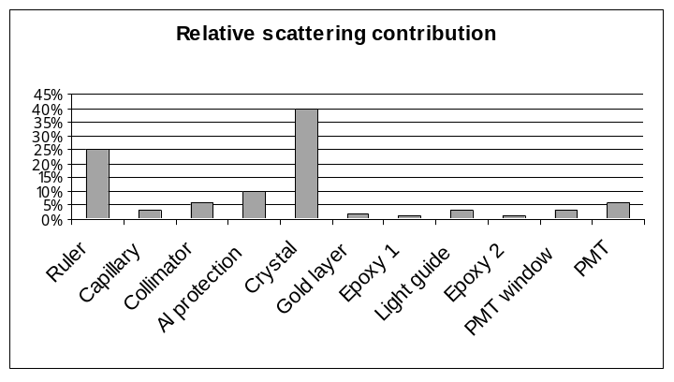
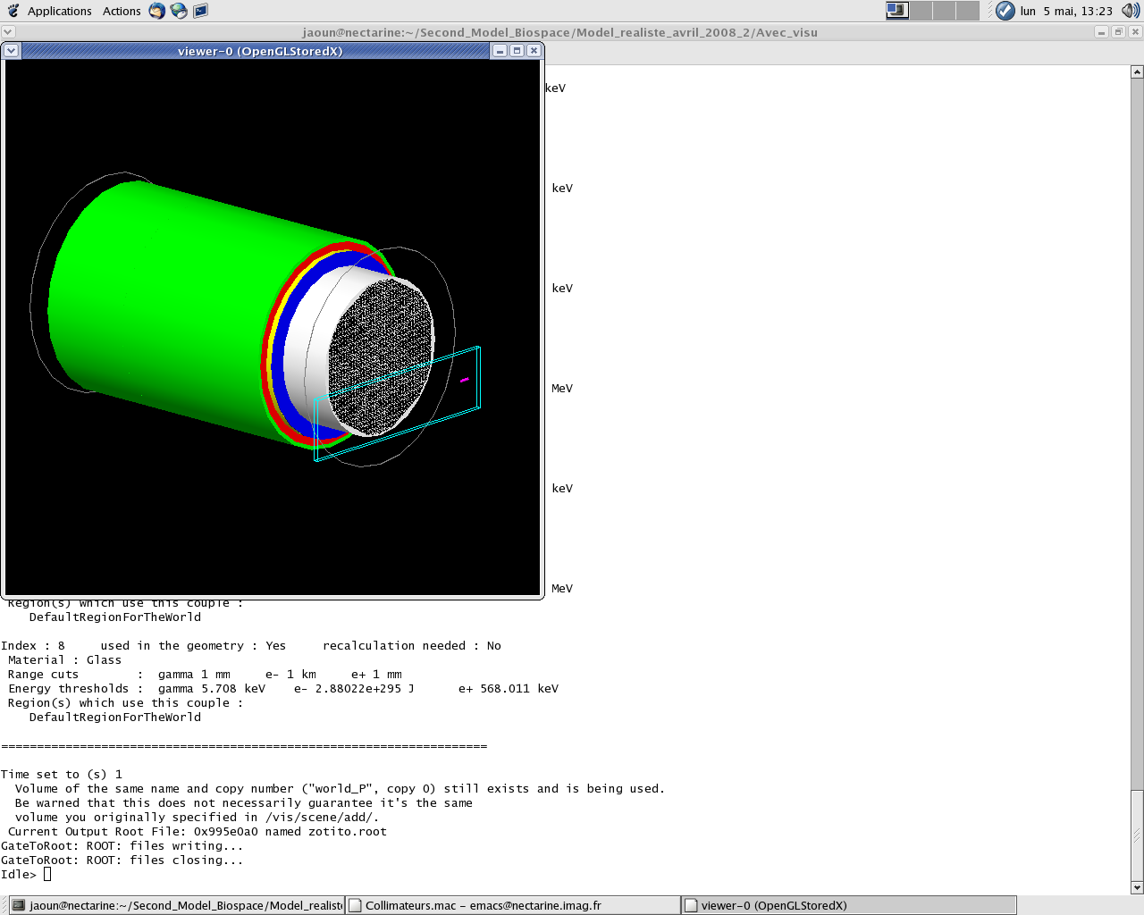
(b)
lead shielding
Al protection
crystal
light guide
PSPMT
(a)
Ruler

Figure 1 (a) The Biospace small animal camera modelled with GATE, (b) contribution of the scattered photons in each component of the simulation where the source is placed at 2 cm from the collimator.

Simulation of the Biospace gamma camera
The geometry of the γ Imager was accurately described in GATE. Figure 1 (a) shows the model of the detector head. The dimensions and the material of each part of the real camera were modelled as realistically as possible. The detector head simulation was thus composed of the lead collimator, a 1.2 mm air gap space, the aluminium protection, the NaI(Tl) crystal and the lead shielding of the whole head. As the plate scintillation crystal is 4 mm thick, about 38% of the 140 keV incident photons pass through the crystal without interacting. Thus, a significant number of photons will not be detected if we do not take into account the back-compartment. A 10 µm thick gold layer is placed behind the crystal, followed by a 0.39 mm Epoxy layer which separates it from the 1 mm light guide made of quartz. Another 0.15 thick Epoxy layer is positioned behind the light guide followed by the PSPMT, modelled as a 2 mm borosilicate glass entrance window and a 110 mm nickel back-part. The back-compartment of the detector was ended by a 15 mm rear lead shielding. Figure 1 (b) illustrates the relative scattering contribution of each layer in the model (source at 2 cm from the collimator), by counting the scattered events in each particular part divided by the total number of scatter events. During the acquisitions, a solution containing ^{99m}Tc, a photon emitter at 140 keV was put in a glass capillary of 1.4 mm inner diameter and 1.8 mm outer diameter and 6 mm length. The capillary was held by a Pyrex Ruler (150 mm x 40 mm x 3 mm). The Ruler and the capillary were also simulated.

Validation of the small animal camera
The validation of the small animal SPECT camera is based on the comparison of four parameters measured experimentally with the corresponding simulation data ; Energy Spectra, Spatial Resolution (FWHM), Sensitivity and Image of a capillary phantom. The three first parameters represent three basic features of a gamma camera, while the image of an inhomogeneous phantom allows a visual comparison between experimental and simulated data.

Experimental set-up
In this study, 16 planar acquisitions were made altogether. The radioactive background was first measured during 30 minutes without any activity and was subtracted from all the other measurements after normalizing it to the same acquisition duration. Then, 14 acquisitions were performed using a liquid source of ^{99m}Tc (140 keV) which was put in a thin capillary (1.4 mm inner diameter and 6 mm long). Total activity was 70 µCi (2.59 MBq). The capillary was first placed in the air at 2, 7, 10 and 16.5 cm from the detector’s surface. Then, the capillary at 16.5 cm was positioned above a cylindrical beaker (10.5 cm inner diameter and 15.6 cm long) which was put on the collimator. The beaker was used three times: empty, filled with 400 ml (4.62 cm height) and filled with 1000 ml (11.55 cm height) of water. All the seven configurations were performed in a first set of measurements with the source at the centre of the camera Field Of View (FOV), and a second set was performed with the source 2 cm off-centred. The sixteenth configuration was performed so as to evaluate the image of the capillary phantom. The phantom consisted of four parallel capillaries (1.4 mm inner diameter and 31.5 mm long), with a capillary-to-capillary distance of 5 mm. The capillaries were filled with ^{99m}Tc solutions of different activities (from the least (right) to the most (left) radioactive) (cf. Figures 5 (a) and (b)): 81 µCi, 129 µCi, 220 µCi and 611 µCi. The phantom was 5 cm far from the scintillation camera. Events were recorded in an energy window between 40 and 186 keV for a duration of 5 minutes for each acquisition. The size of the projections was 256 x 256 pixels (pixel size ~ 0.39 mm).
GATE simulations
The fifteen configurations mentioned above were accurately reproduced using GATE. Monoenergetic gamma rays (140 keV) were emitted in 4 π steradians. The physical processes involving photon interactions (photoelectric effect, Compton scattering and Rayleigh scattering) were modelled using the low-energy electromagnetic package of GEANT4, while gamma-conversion was disabled. The energy resolution Full Width Half Maximum (FWHMe) of the camera was modelled by the convolution of the output data using a Gaussian distribution with user-defined mean and FWHM as stated by the manufacturer (11.5% FWHMe at 140 keV). The intrinsic spatial resolution FWHMi was also modelled in the same way (2.2 mm FWHMi at 140 keV).
Parallelization of the simulations
Many models of the camera have been tested in order to obtain the most realistic detector. A big simulation of one billion events was generated for each configuration. The simulation was split into 1000 small simulations, 1 million emitted events each, and was then distributed on CiGri. The 1000 small output files were collected from the grid, merged into one file (on a local CPU) and finally analysed using ROOT. Simulating 1 million events takes 10 minutes on a local CPU (Pentium IV, 3.2 GHz, 1 Go RAM) and requires ~ 30 million random numbers. Thus, a global sequence of more than 30 billion PRN was used for each simulation (which is small for the used Mersenne Twister).
Comparison parameters
Experimental and simulated data were compared basing them on the following quantities:
• Energy Spectra. The energy spectra of events recorded in the whole FOV (40-186 keV), was sketched for five configurations: (i) in air: source placed 2 and 10 cm from the collimator, (ii) in water: source placed at 16.5 cm from the collimator above the empty beaker which then is filled with 4.62 cm and 11.55 cm of water.
• Spatial Resolution. The FWHM of the point spread function (PSF) was calculated for the 14 configurations by drawing a 6 pixels thick profile (~ 2.345 mm) through the point source (because of the symmetry suivant n’importe quel axe principal). Events were detected in the photopic window (126-154 keV) to reduce the noise effects.
• Sensitivity. The system sensitivity, defined as the number of detected events divided by the number of emitted events, was evaluated for the 7 configurations where the source is placed in the centre of the FOV. Data were acquired in 3 energy windows: (i) photopic window 126-154 keV, (ii) Compton window 92-125 keV and (iii) total Field Of View (FOV) window 40-186 keV.
• Image of a capillary phantom. The image of the capillary phantom was acquired in the whole FOV in the energy window 40-186 keV. A 6 pixels thick profile was also drawn through the 4 line sources seen on the image.

Results and discussions

Energy Spectra
Figure 2 shows the experimental and simulated energy spectra of the ^{99m}Tc point source placed in the Air at 2 and 10 cm from the collimator: contributions of the simulated photons scattered within different components of the detector head and within the capillary and the ruler are also plotted. The experimental and simulated energy spectra were normalized to the same number of counts detected at 140 keV. As illustrated in figure 1 (b), including a back-compartment model was essential as well as the simulation of the capillary and the ruler to obtain a good agreement between measured and simulated spectra between 80 and 120 keV. The contribution of the scattered photons within the capillary and the ruler is clearly higher in figure 2 (a) (source at 2 cm) than in figure 2 (b) (source at 10 cm) especially between 70 and 80 keV. The smaller the ruler-collimator distance, the more the detected back-scattered photons in the ruler.
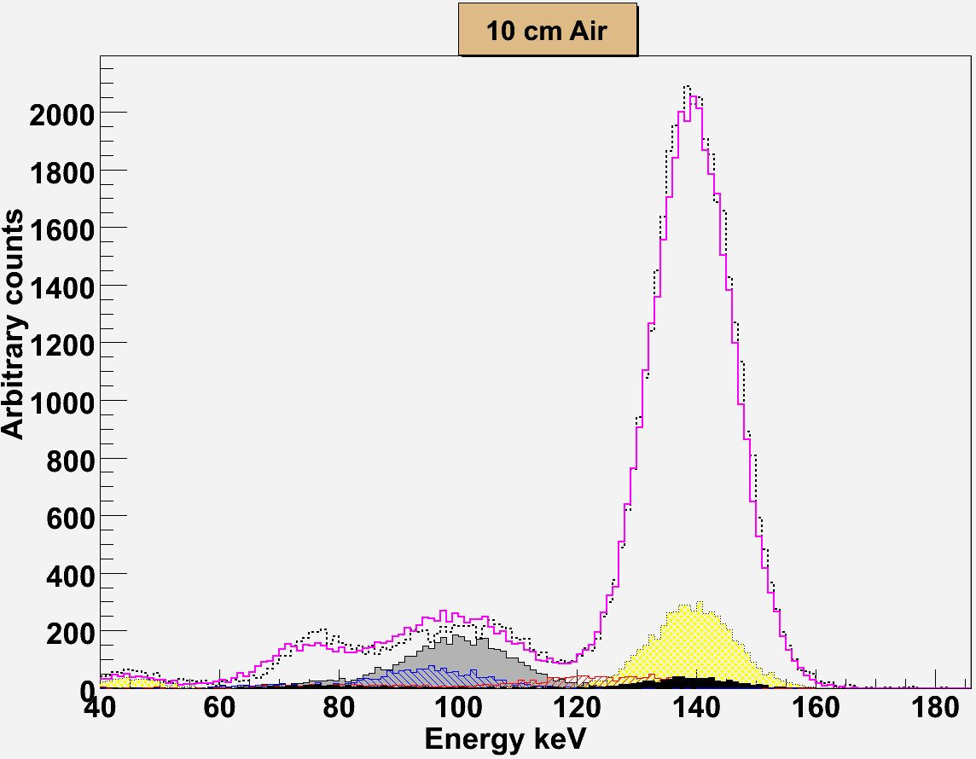
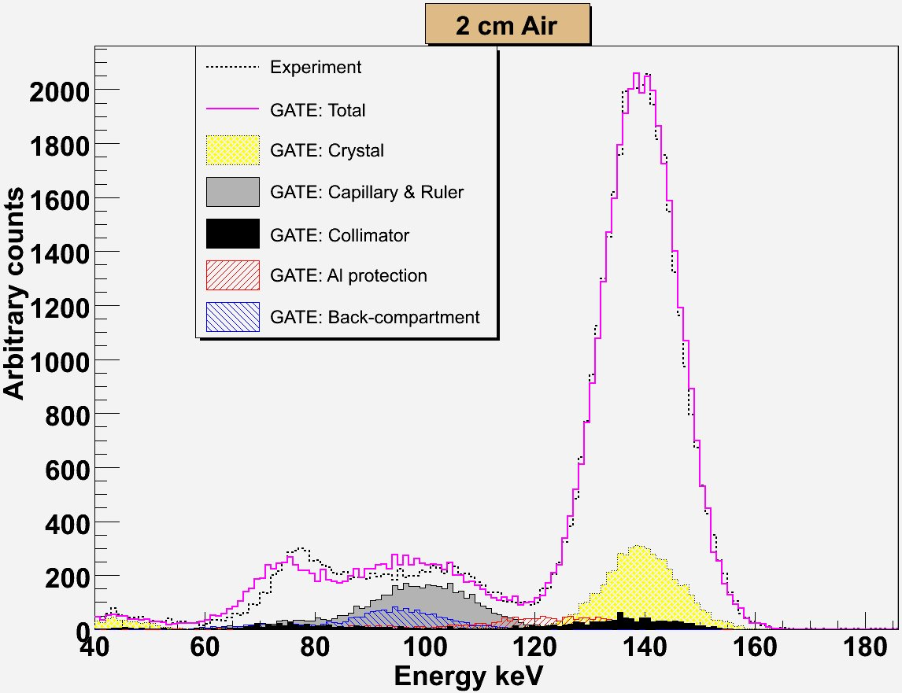
(a)
(b)

Figure 2 Experimental and simulated energy spectra for a ^{99m}Tc source positioned in Air at (a) 2 cm and (b) 10 cm from the camera.
Good agreements between experimental and simulated energy spectra can be noticed especially in the photopic and Compton window. Differences could be observed in figure 2 (a) between 60 and 100 keV. These differences are relatively the same between 90 and 100 keV in figure 2 (b) but decrease between 60 and 90 keV where the ruler has the biggest impact. Thus, the difference between 60 and 90 keV could come from the imperfect estimated shape and material of the ruler. For the other difference between 90 and 100 keV, the ruler and the back-compartment have the most important influence according to the figures. It couldn’t derive from the ruler because this difference is relatively the same in figure 2 (a) and (b). Otherwise, the number of scattered photons would increase for the source at 2 cm from the collimator. Thus, the difference between 90 and 100 keV could be the consequence of the unawareness of a layer which was not modelled behind the crystal. Considering the PSPMT as a continuous layer of Nickel could also lead to such differences.
Energy spectra obtained for the ^{99m}Tc source at 16.5 cm from the collimator, with 0, 4.62 (400 ml) and 11.55 cm (1000 ml) water thickness are shown in figure 3. The scattered photons contributions were also drawn. The scattered photons within the phantom have increased, as expected, proportionally to the water thickness. Good agreements between experimental and simulated energy spectra could be observed for the two configurations with the empty beaker which then is filled with 4.62 cm thick of water.
The same differences with the source in Air between 60 and 100 keV were maintained in figures 3 (a) and (b), which confirms that the back-part was not accurately modelled. But it is not the case in figure 3 (c) because backscattered photons (scattered within the ruler) have less influence on the Energy spectra. It was reduced by the presence of an 11.55 cm thickness of water.
The disagreement in figure 3 (b) (4.62 cm of water) between 75 and 85 keV and between 110 and 120 keV is lower than in figure 3 (c) (11.55 cm of water) and doesn’t figure at all when the beaker is empty (cf. Figure 3 (a)). Thus, these differences are proportional to the water thickness and could be the result of the impurity of the real water used in the measurements.
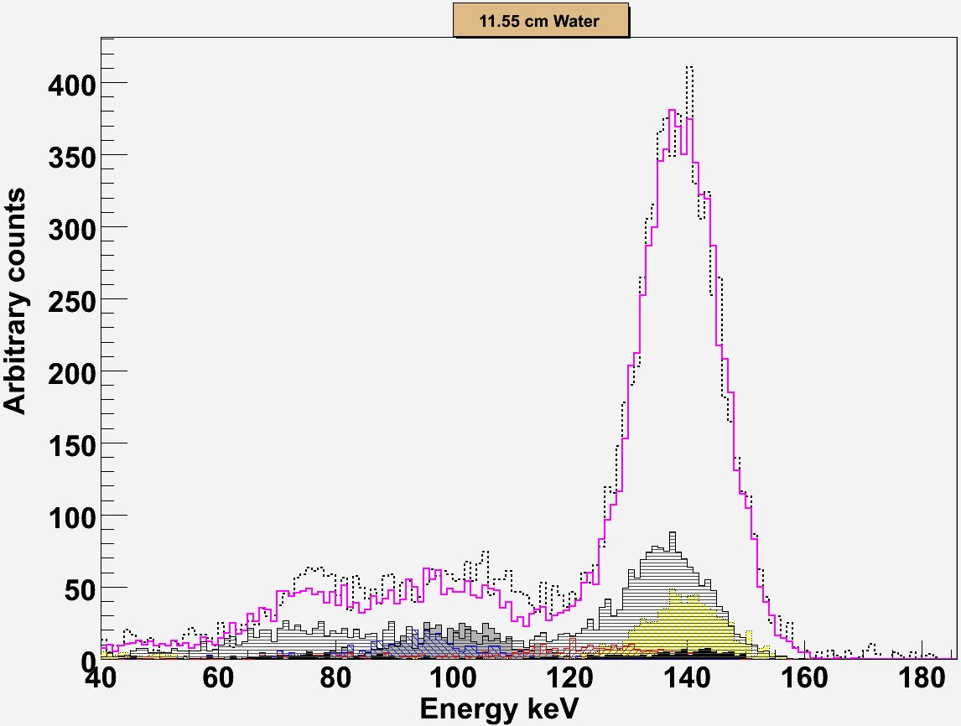
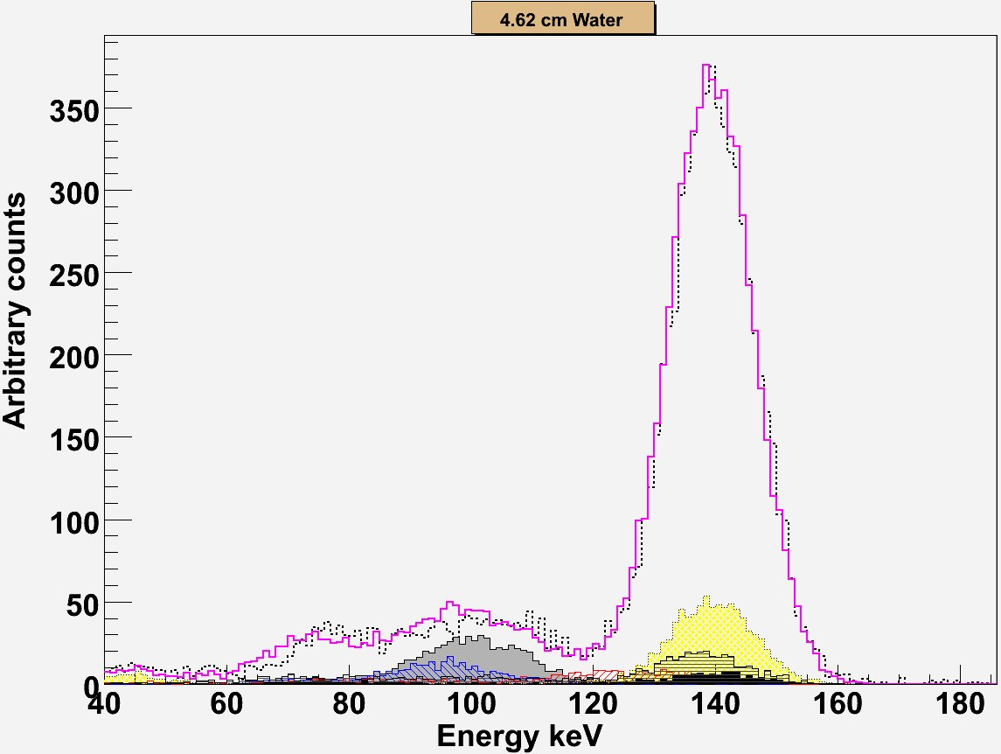
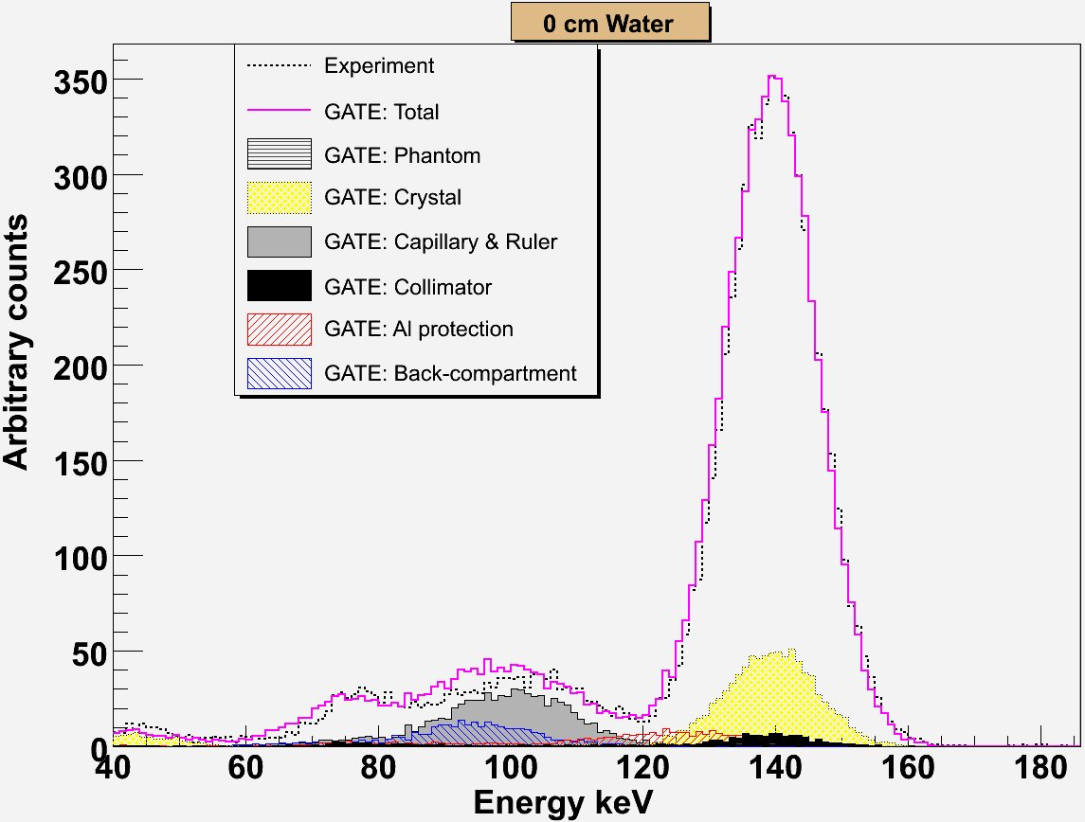
(a)
(b)
(c)

Figure 3 Experimental and simulated energy spectra for a ^{99m}Tc source positioned at 16.5 cm from the collimator above a beaker filled with (a) 0 cm, (b) 4.62 cm and (c) 11.55 cm of water.

Spatial Resolution

Distance source-collimator (water thickness) | Centred Source |  |  | Off-centred Source
Distance source-collimator (water thickness) | Experimental FWHM (mm) | Simulated FWHM (mm) | Difference (%) | Experimental FWHM (mm) | Simulated FWHM (mm) | Difference (%)
2 cm | 3.34 | 3.22 | 3.64 | 3.58 | 3.20 | 10.5
7 cm | 4.53 | 4.54 | 1.89 | 4.75 | 4.53 | 4.49
10 cm | 5.32 | 5.40 | 1.47 | 5.61 | 5.39 | 3.95
16.5 cm | 7.25 | 7.34 | 1.30 | 7.64 | 7.37 | 3.49
16.5 cm (0 cm water) | 7.27 | 7.39 | 1.63 | 7.63 | 7.38 | 3.32
16.5 cm (4.62 cm water) | 7.26 | 7.32 | 0.91 | 7.62 | 7.26 | 4.69
16.5 cm (11.55 cm water) | 7.58 | 7.65 | 0.91 | 7.83 | 7.61 | 2.85
Table 2 Comparison between experimental and simulated spatial resolution for the centred and off-centred sources placed at: 2, 7, 10 cm and 16.5 in air; 16.5 cm with three water thickness 0, 4.62 and 11.55 cm.
Experimental FWHM for a centred and off-centred source were well reproduced in all configurations by the simulations where discrepancies are below 2% and 5% respectively, except the source at 2 cm. The 5% differences might be due to the imperfect modelling of the PSPMT non-uniform response in GATE [Lazaro 2004]. The approximate modelling of the ruler was also noticed as the disagreements of the FWHM for the source centred and off-centred at 2 cm is clearly higher than the other configurations.

Sensitivity
The Biospace small animal camera sensitivity values obtained in Air in three energy windows (total FOV 40-186 keV, photopic window 126-154 keV and Compton window 92-125 keV) with GATE compared to the measured values are plotted in Figure 4 (a) for the 4 source-collimator distances 2, 7, 10 and 16.5 cm. Relative differences between experimental and calculated values were respectively: (i) 40-186 keV: 6.8%, 4.6%, 4.1% and 5.7%; (ii) 126-154 keV: 7.9%, 6%, 5.9% and 7.2%; (iii) 92-125 keV: 8.1%, 4%, 1.4% and 5.9%. The results of the system sensitivity with the phantom (empty, 400 ml and 1000 ml) derived from the experiment measurements and the simulations are drawn in figure 4 (b) for the source placed at 16.5 cm from the collimator where events were detected in three energy windows (Total FOV 40-186 keV, photopic window 126-154 keV and Compton window 92-125 keV). Relative differences between experimental and simulated values for the different water thickness (0, 4.62 and 11.55 cm) were: (i) 40-186 keV: 1.5%, 3.8% and 3.1%; (ii) 126-154 keV: 3.2%, 4.4% and 1.9%; (iii) 92-125 keV: 0.3%, 0.5% and 5.6%. The simulation was unable to reproduce the system sensitivity very accurately for the seven configurations described above. This difference could result from the inhomogeneous materials of the different components of the detector which only the constructor accurately knows.
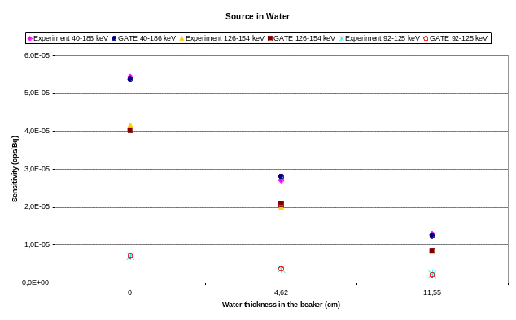
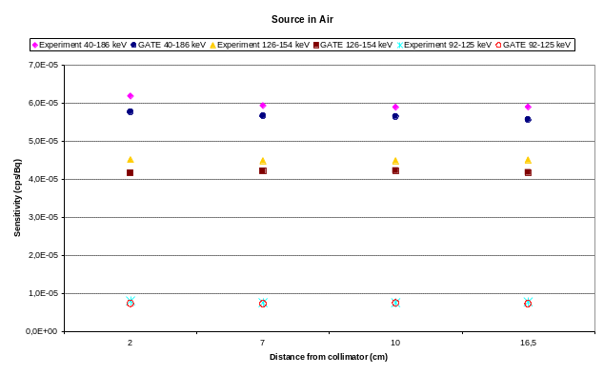
(a)
(b)

Figure 4 Comparison between experimental and simulated system sensitivities in three energy windows for the centred source placed at: 2, 7, 10 cm and 16.5 in air; 16.5 cm with three water thickness 0, 4.62 and 11.55 cm.

Image of a capillary phantom
Figure 5 shows a visual comparison between experimental (a) and the simulated (b) images of the capillary phantom as well as the horizontally drawn profiles (6 pixels thick ~ 2.345 mm) through these images (cf. figure 5 (c)). The comparison of the two images and profiles shows a good agreement. However, the simulation was unable to perfectly reproduce the local distortion which could account for the 5% differences between the experimental and the simulated FWHM for an off-centred source (cf. table 2).
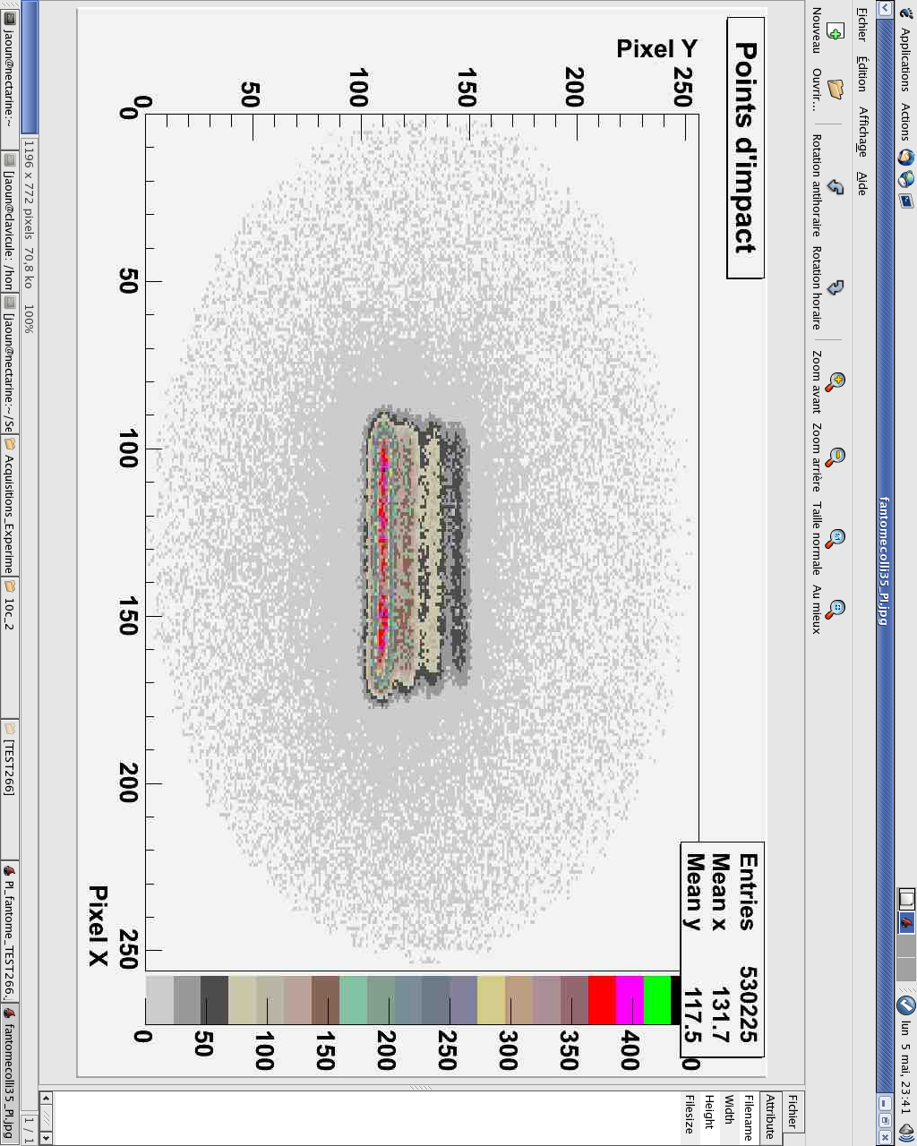
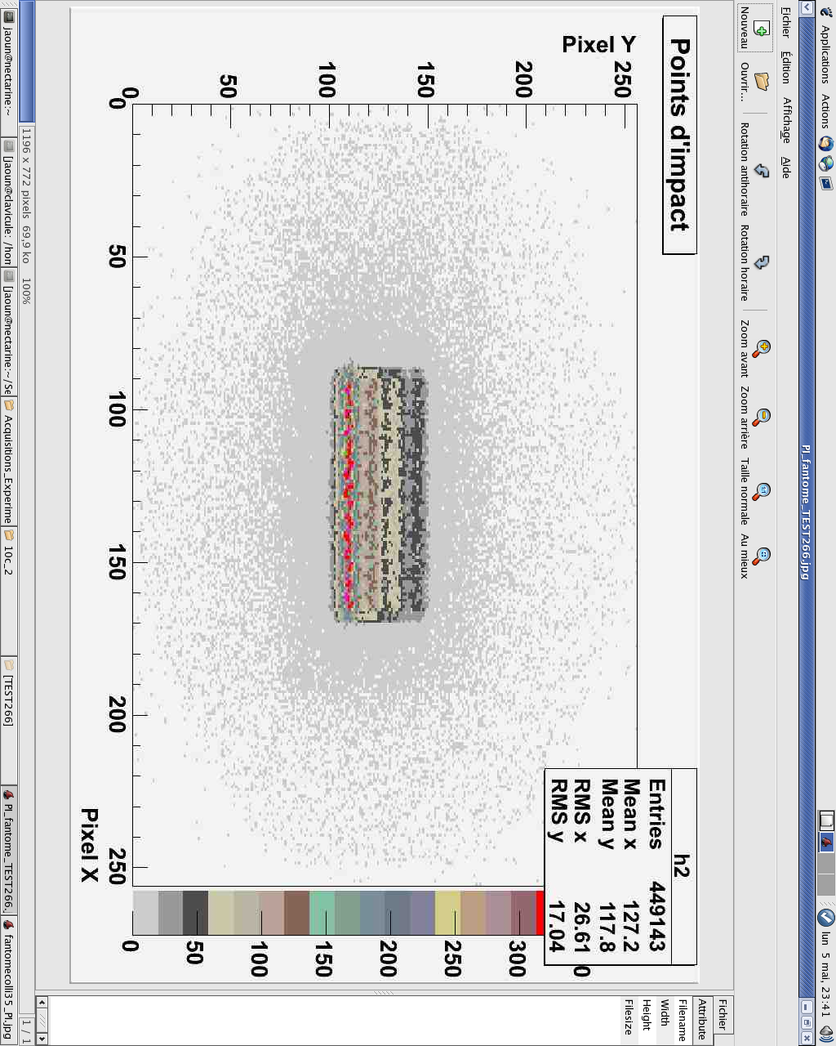
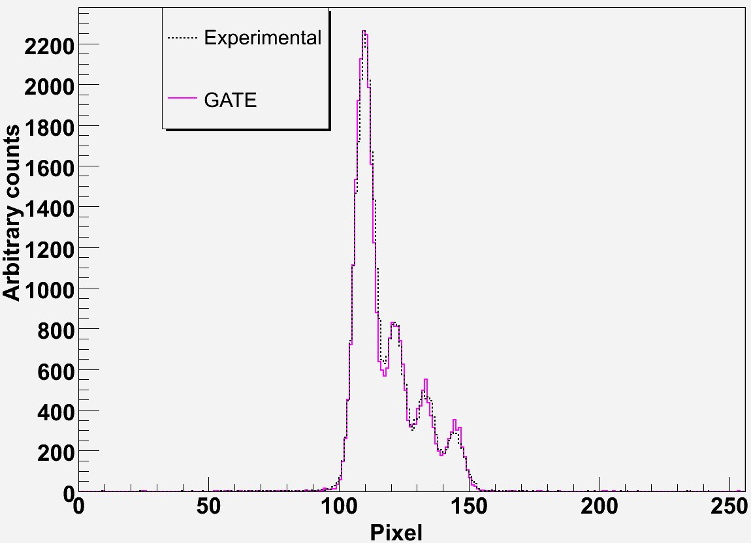

(a)
(c)
(b)

Figure 5 Comparison between experimental (a) and simulated (b) image of a four capillaries phantom filled with different ^{99m}Tc concentrations and horizontal profiles through the middle of these images (c).

Calculation time
Table 3 contains the computation time of a long simulation (1000 jobs) on a local CPU (Pentium IV, 3.2 GHz, 1 Go RAM) and on CiGri: during the day, during nights and weekends and an estimated average of the CPUs availability. CiGri has reduced the duration of a simulation compared to 1 CPU computation by a factor of respectively 42, 67 and 56. Resubmitted jobs rate on CiGri, defined as the number of resubmitted jobs divided by the number of executed jobs, is also represented in the box at the right of table 3. 16.9% of the jobs were killed and then were resubmitted by CiGri during the day which is as expected higher than the 10.2% resubmission rate during the nights and weekends. The estimated average of the resubmitted jobs is 13.4%. Each long simulation corresponds to one configuration. The material composition and the thickness of many components of the detector weren't exactly known (PSPMT, Gold layer…). In consequence, about 200 simulations were carried out in order to optimise the model of the Biospace camera. All these simulations would have taken 4 years of computation time on a local CPU, but on CiGri it took only 25 days (cf. table 3). In the ideal case, where no job is killed, the 200 simulations would have taken about 22 days on CiGri. Thus, the 200 simulations would not have been feasible on a local CPU. Reducing the number of simulations would have altered the quality of the results. So the deployment of the Grid was crucial in this study to get accurate results.

 | 1 simulation (1000 jobs) | 200 simulations | Gain | Resubmission percentage (%)
Local CPU | 167 h | 1392 days (~ 4 years) | 1 | 0
CiGri – day | 4 h | 37 days | 42 | 16.9
CiGri – nights and weekends | 2.5 h | 21 days | 67 | 10.2
CiGri – estimated average | 3 h | 25 days | 56 | 13.4
Table 3 Comparison between computing time of 1 and 200 simulations on a local CPU and on the CiGri Grid with the percentage of the resubmitted jobs (in the box at the right).

Conclusions and perspectives
Nuclear medical imaging needs a better physical model to improve the quality of the reconstructed images. Our study has brought into light that the Monte Carlo simulations toolkit GATE was able to accurately model the Biospace small field of view γ Imager. The camera model can thus be used for future researches such as developing new attenuation and diffusion correction algorithms. This paper has also proved the interest of grids in order to obtain accurate results within reasonable elapsed time. CIMENT GRID was an essential tool to carry this study to a successful conclusion. One of our coming studies will be the development of an iterative reconstruction algorithm in which long GATE simulations should be carried out at each iteration. For such studies, a higher scale of computation power is needed. The EGEE (Enabling Grid for E-sciencE) [12] Grid with a next multi-core processor generation should be able to meet our requests.
- checkpointing
- optimisation du temps de soumission grace à la fonctionnalité des array jobs dans OAR
- file system distribué pour résoudre le probleme des input data

References

A. Del Guerra, N. Belcari, State-of-the-art of PET SPECT and CT for small animal imaging, Nucl. Instr. and Meth. A 583 (2007) 119-124.

A. Constantinesco, C. Goetz, V. Israel-Jost, P. Choquet, Quel avenir pour l'imagerie TEMP du petit animal ? = What does the future hold for small animal SPECT imaging?, Médecine nucléaire 31 (2007) 183-192.

L. Smith, Z. He, D. Wehe, G. Knoll, S. Wilderman, Design and modelling of the Hybrid Portable Gamma Camera system, IEEE Tr. Nucl. Sci. 45 (1998) 963-969.

J. Berthot, V. Breton, P. Brette, S. Crespin, N. Giokaris, D. Lazaro, J. Maublant, L. Méritet, Monte Carlo simulation of gamma cameras using GEANT, IEEE Nucl. Sci. Symposium Conference Record 3 (2000) 20/110–20/113.

F. Garibaldi et al, Optimization of compact gamma cameras for breast imaging, Nucl. Instr.
and Meth. in Phys. Res A 471 (2001) 222-228.

D. Lazaro et al, Validation of the GATE Monte Carlo simulation platform for modelling a CsI(Tl) scintillation camera dedicated to small-animal imaging, Phys. Med. Biol. 49 (2004) 271-285.

F. J. Beekman, B. Vastenhouw, Design and simulation of a high-resolution stationary SPECT system for small animals, Phys. Med. Biol. 49 (2004) 4579-4592.

C. Merheb, Y. Petegnief, J.N. Talbot, Full modelling of the MOSAIC animal PET system based on the GATE Monte Carlo simulation code, Phys. Med. Biol. 52 (2007) 563-576.

E. Vandervoort, M. Camborde, S. Jan, V. Sossi, Monte Carlo modelling of singles-mode transmission data for small animal PET scanners, Phys. Med. Biol. 52 (2007) 3169-3184.

M.A. King, S.J. Glick, P.H. Pretorius, R.G. Wells, H.C. Gifford, M. Narayan, T. Farncombe, Attenuation scatter and spatial resolution compensation in SPECT, in: M.N. Wernick, J. Aarsvold (Eds.), Emission Tomography: The Fundamentals of PET and SPECT, Elsevier, 1st ed. San Diego, 2004, pp. 473–498.

A.B. Hwang, B.L. Franc, G.T. Gullberg, B.H. Hasegawa, Assessment of the sources of error affecting the quantitative accuracy of SPECT imaging in small animals, Phys. Med. Biol. 53 (2008) 2233–2252.

I. Buvat, I. Castiglioni, Monte-Carlo methods in PET and SPECT, Quarterly J. Nucl. Med. 46 (2002) 48-61.

T.A. Riauka, R.H. Hooper, Z.W. Gortel, Experimental and numerical investigation of the 3D SPECT photon detection kernel for non-uniform attenuating media, Phys. Med. Biol. 41 (1996) 1167-1189.

R.G. Wells, A. Celler, R. Harrop, Analytical calculation of photon distributions in SPECT projections, IEEE Trans. Nucl. Sci. 44 (1997) 3202-3214.

D. Lazaro, Z. El Bitar, V. Breton, D. Hill, I. Buvat, Fully 3D Monte Carlo reconstruction in SPECT: a feasibility study, Phys. Med. Biol. 50 (2005) 3739-3754.

Z. El Bitar, D. Lazaro, V. Breton, D. Hill, I. Buvat, Fully 3D Monte Carlo image reconstruction in SPECT using functional regions, Nucl. Instr. Meth. Phys. Res. A 569 (2006) 399-403.

C. Morel, La simulation Monte Carlo en médecine nucléaire = Monte Carlo simulation in nuclear medicine, Médecine Nucléaire 31 (2007) 160-164.

I. Buvat, D. Lazaro, Monte Carlo simulations in emission tomography and GATE: An overview, Nucl. Instr. and Meth. A 569 (2006) 323-329.
V. Breton, R. Medina, J. Montagnat, DataGrid Prototype of a Biomedical Grid, Meth. Inf. Med. 42 (2003) 143-147.

M. Mascagni, A. Srinivasan, Parameterizing parallel multiplicative lagged-Fibonacci generators, Parallel Comput. 30 (2004) 899-916.

[b9] Ciment and CiGri project: https://ciment.imag.fr/cigri.

[b5] OAR: http://oar.imag.fr/.

S. Jan et al, GATE: a simulation toolkit for PET and SPECT, Phys. Med. Biol. 49 (2004) 4543-4561.

Agostinelli et al, GEANT4: A simulation toolkit, Nucl. Instrum. Methods A 506 (2003) 250-3003.

S. Staelens, D. Strul, G. Santin, S. Vandenberghe, M. Koole, Y. D'Asseler, I. Lemahieu, R. Van de Walle, Monte Carlo simulations of a scintillation camera using GATE: validation and application modelling, Phys. Med. Biol. 48 (2003) 3021-3042.

N. Sakellios, J.L. Rubio, N. Karakatsanis, G. Kontaxakis, G. Loudos, A. Santos, K. Nikita, S. Majewski, GATE simulations for small animal SPECT/PET using voxelized phantoms and rotating-head detectors, IEEE Nucl. Sci. Symposium Conference Record 4 (2006) 2000-2003.

R. Taschereau, A.F. Chatziioannou, Compressed voxels for high-resolution phantom simulations in GATE, Mol. Imaging Biol. 10 (2008) 40-47.

J. De Beenhouwer, S. Staelens, Y. D'Asseler, I. Lemahieu, Optimizing the Scalability of Parallelized GATE Simulations, IEEE Nucl. Sci. Symposium Conference Record 6 (2006) 3904-3908.

L. Maigne, D. Hill, V. Breton, R. Reuillon, P. Calvat, D. Lazaro, Y. Legré, D. Donnarieix, Parallelization of Monte Carlo simulations and submission to a grid environment, Parallel Process. Lett. 14 (2004) 177-196.

R. Reuillon, D.R.C. Hill, Z. El Bitar, V. Breton, Rigorous Distribution of Stochastic Simulations Using the DistMe Toolkit, IEEE Trans. Nucl. Sci. 55 (2008) 595-603.

ROOT: http://root.cern.ch/.

[12] EGEE Project: http://public.eu-egee.org/.

[b7] Ourgrid:
W. Cirne and F. V. B. et al. Labs of the world, unite!!!
Journal of Grid Computing, 2006.

(b8) Condor:
A. R. Butt, R. Zhang, and Y. C. Hu. A self-organizing ﬂock
of condors. In SuperComputing. ACM, 2003.

[b2] Torque: http://www.clusterresources.com
[b1] PBSPro: http://www.altair.com/pbspro/
[b11] SGE: http://gridengine.sunsource.net/
[b3] LSF: http://www.platform.com/Products/platform-lsf
[b10] Computemode: http://computemode.imag.fr
[b6] I. Foster and C. Kesselman. Globus: A metacomputing infrastructure toolkit. Journal of Supercomputer Applications and High Performance Computing, 1997.
[b12]
Yiannis Georgiou, Olivier Richard, and Nicolas Capit. Evaluations of the lightweight grid cigri upon the grid5000 platform. In E-SCIENCE '07: Proceedings of the Third IEEE International Conference on e-Science and Grid Computing, pages 279-286, Washington, DC, USA, 2007. IEEE Computer Society. [ DOI ]

