MQTT for Sensor Networks (MQTT-SN) Version 2.0
Committee Specification Draft 01
01 August 2024
This stage:
…
Previous stage:
N/A
Latest stage:
…
Technical Committee:
OASIS Message Queuing Telemetry Transport (MQTT) TC
Chairs:
Ian Craggs (icraggs@gmail.com), Individual
Simon Johnson (simon.johnson@hivemq.com), HiveMQ GmbH
Editors:
Andrew Banks (andrewdjbanks@gmail.com), Individual
Andy Stanford-Clark (andysc@uk.ibm.com), IBM
Davide Lenzarini (davide.lenzarini@u-blox.com), u-blox AG
Ian Craggs (icraggs@gmail.com), Individual
Rahul Gupta (rahul.gupta@us.ibm.com), IBM
Simon Johnson (simon.johnson@hivemq.com), HiveMQ GmbH
Stefan Hagen (stefan@hagen.link), Individual
Tara E. Walker (tara.walker@microsoft.com), Microsoft Corporation
Related work:
This specification is related to:
- MQTT Version 5.0. Edited by Andrew Banks, Ed Briggs, Ken Borgendale, and Rahul Gupta. OASIS Standard. Latest version: https://docs.oasis-open.org/mqtt/mqtt/v5.0/mqtt-v5.0.html.
- MQTT Version 3.1.1. Edited by Andrew Banks and Rahul Gupta. OASIS Standard. Latest version: http://docs.oasis-open.org/mqtt/mqtt/v3.1.1/mqtt-v3.1.1.html.
- MQTT-SN Version 1.2 by Andy Stanford-Clark and Hong Linh Truong. Link: https://www.oasis-open.org/committees/download.php/66091/MQTT-SN_spec_v1.2.pdf.
Abstract:
This specification defines the MQTT for Sensor Networks protocol (MQTT-SN). It is closely related to the MQTT v3.1.1 and MQTT v5.0 standards. MQTT-SN is optimized for implementation on low-cost, battery-operated devices with limited processing and storage resources. It is designed so that it will work over a variety of networking technologies and bridge to an MQTT network.
Status:
This document was last revised or approved by the OASIS Message Queuing Telemetry Transport (MQTT) TC on the above date. The level of approval is also listed above. Check the "Latest stage" location noted above for possible later revisions of this document. Any other numbered Versions and other technical work produced by the Technical Committee (TC) are listed at https://www.oasis-open.org/committees/tc_home.php?wg_abbrev=mqtt#technical .
TC members should send comments on this document to the TC's email list. Others should send comments to the TC's public comment list, after subscribing to it by following the instructions at the "Send A Comment" button on the TC's web page at https://www.oasis-open.org/committees/mqtt/.
This specification is provided under the Non-Assertion Mode of the OASIS IPR Policy, the mode chosen when the Technical Committee was established. For information on whether any patents have been disclosed that may be essential to implementing this specification, and any offers of patent licensing terms, refer to the Intellectual Property Rights section of the TC’s web page (https://www.oasis-open.org/committees/mqtt/ipr.php).
Note that any machine-readable content (Computer Language Definitions) declared Normative for this Work Product is provided in separate plain text files. In the event of a discrepancy between any such plain text file and display content in the Work Product's prose narrative document(s), the content in the separate plain text file prevails.
Citation format:
When referencing this document, the following citation format should be used:
[MQTT-SN-v2.0]
MQTT for Sensor Networks Version 2.0. Edited by Andrew Banks, Davide Lenzarini, Ian Craggs, Rahul Gupta, Simon Johnson, Stefan Hagen, and Tara E. Walker. 01 August 2024. OASIS Committee Specification Draft 01. https://docs.oasis-open.org/mqtt/mqtt-sn/v2.0/csd01/mqtt-sn-v2.0-csd01.docx. Latest stage: https://docs.oasis-open.org/mqtt/mqtt-sn/v2.0/mqtt-sn-v2.0.docx
(Note: Publication URIs are managed by OASIS TC Administration; please don't modify. The OASIS TC Process requires that Work Products at any level of approval must use the OASIS file naming scheme, and must include the OASIS copyright notice. The URIs above have been constructed according to the file naming scheme. Remove this note before submitting for publication.)
Notices
Copyright © OASIS Open 2024. All Rights Reserved.
All capitalized terms in the following text have the meanings assigned to them in the OASIS Intellectual Property Rights Policy (the "OASIS IPR Policy"). The full Policy may be found at the OASIS website: [https://www.oasis-open.org/policies-guidelines/ipr/].
This document and translations of it may be copied and furnished to others, and derivative works that comment on or otherwise explain it or assist in its implementation may be prepared, copied, published, and distributed, in whole or in part, without restriction of any kind, provided that the above copyright notice and this section are included on all such copies and derivative works. However, this document itself may not be modified in any way, including by removing the copyright notice or references to OASIS, except as needed for the purpose of developing any document or deliverable produced by an OASIS Technical Committee (in which case the rules applicable to copyrights, as set forth in the OASIS IPR Policy, must be followed) or as required to translate it into languages other than English.
The limited permissions granted above are perpetual and will not be revoked by OASIS or its successors or assigns.
This document and the information contained herein is provided on an "AS IS" basis and OASIS DISCLAIMS ALL WARRANTIES, EXPRESS OR IMPLIED, INCLUDING BUT NOT LIMITED TO ANY WARRANTY THAT THE USE OF THE INFORMATION HEREIN WILL NOT INFRINGE ANY OWNERSHIP RIGHTS OR ANY IMPLIED WARRANTIES OF MERCHANTABILITY OR FITNESS FOR A PARTICULAR PURPOSE. OASIS AND ITS MEMBERS WILL NOT BE LIABLE FOR ANY DIRECT, INDIRECT, SPECIAL OR CONSEQUENTIAL DAMAGES ARISING OUT OF ANY USE OF THIS DOCUMENT OR ANY PART THEREOF.
As stated in the OASIS IPR Policy, the following three paragraphs in brackets apply to OASIS Standards Final Deliverable documents (Committee Specifications, OASIS Standards, or Approved Errata).
[OASIS requests that any OASIS Party or any other party that believes it has patent claims that would necessarily be infringed by implementations of this OASIS Standards Final Deliverable, to notify OASIS TC Administrator and provide an indication of its willingness to grant patent licenses to such patent claims in a manner consistent with the IPR Mode of the OASIS Technical Committee that produced this deliverable.]
[OASIS invites any party to contact the OASIS TC Administrator if it is aware of a claim of ownership of any patent claims that would necessarily be infringed by implementations of this OASIS Standards Final Deliverable by a patent holder that is not willing to provide a license to such patent claims in a manner consistent with the IPR Mode of the OASIS Technical Committee that produced this OASIS Standards Final Deliverable. OASIS may include such claims on its website, but disclaims any obligation to do so.]
[OASIS takes no position regarding the validity or scope of any intellectual property or other rights that might be claimed to pertain to the implementation or use of the technology described in this OASIS Standards Final Deliverable or the extent to which any license under such rights might or might not be available; neither does it represent that it has made any effort to identify any such rights. Information on OASIS' procedures with respect to rights in any document or deliverable produced by an OASIS Technical Committee can be found on the OASIS website. Copies of claims of rights made available for publication and any assurances of licenses to be made available, or the result of an attempt made to obtain a general license or permission for the use of such proprietary rights by implementers or users of this OASIS Standards Final Deliverable, can be obtained from the OASIS TC Administrator. OASIS makes no representation that any information or list of intellectual property rights will at any time be complete, or that any claims in such list are, in fact, Essential Claims.]
The name "OASIS" is a trademark of OASIS, the owner and developer of this document, and should be used only to refer to the organization and its official outputs. OASIS welcomes reference to, and implementation and use of, documents, while reserving the right to enforce its marks against misleading uses. See https://www.oasis-open.org/policies-guidelines/trademark/ for above guidance.
Table of Contents
1 Introduction 13
1.0 Intellectual property rights policy 13
1.1 Changes from earlier Versions 13
1.1.1 MQTT-SN 1.2 13
1.2 Organization of the MQTT-SN specification 13
1.3 Terminology 13
1.4 Normative references 18
1.5 Informative References 19
1.6 MQTT For Sensor Networks (MQTT-SN) 19
1.6.1 MQTT-SN and MQTT Differences 20
1.7 Data representation 21
1.7.1 Bits (Byte) 21
1.7.2 Two Byte Integer 21
1.7.3 Four Byte Integer 21
1.7.4 UTF-8 Encoded String 21
2 MQTT-SN Control Packet format 23
2.1 Structure of an MQTT-SN Control Packet 23
2.1.1 Packet Header 23
2.1.2 Length 23
2.1.3 MQTT-SN Control Packet Type 24
2.2 Packet Identifier 26
2.3 Reason Code 28
2.4 Topic Types 33
3 MQTT-SN Control Packets 35
3.1 ADVERTISE - Gateway Advertisement 35
3.1.1 ADVERTISE Header 35
3.1.2 Gateway Identifier 35
3.1.3 Duration 35
3.2 SEARCHGW - Search for A Gateway 35
3.2.1 SEARCHGW Header 36
3.2.2 Radius 36
3.3 GWINFO - Gateway Information 36
3.3.1 GWINFO Header 37
3.3.2 Gateway Identifier 37
3.3.3 Gateway Address 37
3.4 CONNECT - Connection Request 38
3.4.1 CONNECT Header 39
3.4.2 Connect Flags 39
3.4.2.1 Clean Start 39
3.4.2.2 Will Flag 39
3.4.2.3 Authentication Flag 40
3.4.2.4 Session Expiry Flag 40
3.4.2.5 Default Number of Awake Messages 40
3.4.3 Will Flags 40
3.4.3.1 Will Topic Type 40
3.4.3.2 Will QoS 40
3.4.3.3 Will Retain 40
3.4.4 Packet Identifier 41
3.4.5 Protocol Version 41
3.4.6 Keep Alive 41
3.4.7 Maximum Packet Size 42
3.4.8 Session Expiry Interval 42
3.4.9 Will Topic Alias or Will Topic Name Length 43
3.4.10 Will Topic Name 43
3.4.11 Will Payload Length 43
3.4.12 Will Payload 43
3.4.13 Authentication Method Length 43
3.4.14 Authentication Method 43
3.4.15 Authentication Data Length 43
3.4.16 Authentication Data 43
3.4.17 Client Identifier 44
3.4.18 CONNECT Actions 44
3.5 CONNACK - Connect Acknowledgement 45
3.5.1 CONNACK Header 46
3.5.2 CONNACK Flags 46
3.5.2.1 Session Present 47
3.5.2.2 Session Expiry Interval Flag (Sess Exp) 47
3.5.2.3 Authentication Flag 47
3.5.3 Packet Identifier 47
3.5.4 Reason Code 47
3.5.5 Session Expiry Interval 48
3.5.6 Authentication Method Length 48
3.5.7 Authentication Method 48
3.5.8 Authentication Data Length 48
3.5.9 Authentication Data 48
3.5.10 Assigned Client Identifier 48
3.6 AUTH - Authentication Exchange 48
3.6.1 AUTH Header 49
3.6.2 Packet Identifier 49
3.6.2 Reason Code 50
3.6.3 Authentication Method Length 50
3.6.4 Authentication Method 50
3.6.5 Authentication Data 50
3.6.6 AUTH Actions 50
3.7 REGISTER - Register Topic Alias Request 50
3.7.1 REGISTER Header 50
3.7.2 Packet Identifier 51
3.7.3 Topic Alias 51
3.7.4 Topic Name 51
3.7.5 REGISTER Actions 51
3.8 REGACK - Register Topic Alias Acknowledgement 51
3.8.1 REGACK Header 52
3.8.2 REGACK Flags 52
3.8.2.1 Topic Type 52
3.8.3 Packet Identifier 52
3.8.4 Topic Alias 52
3.8.5 Reason Code 52
3.9 Publish Variants 52
3.9.1 PUBWOS - Publish Without Session 53
3.9.1.1 PUBWOS Header 54
3.9.1.2 PUBWOS Flags 54
3.9.1.2.1 Topic Type 54
3.9.1.2.2 Retain 54
3.9.1.3 Topic Alias or Topic Name Length 54
3.9.1.4 Topic Name 54
3.9.1.5 Payload 54
3.9.1.6 PUBWOS Actions 55
3.9.2 PUBLISH with QoS -1 (Informative) 55
3.9.2.1 PUBLISH Header 56
3.9.2.2 PUBLISH Flags 56
3.9.2.2.1 Topic Type 57
3.9.2.2.2 QoS 57
3.9.2.2.3 DUP 57
3.9.2.2.4 Retain 57
3.9.3.3 Topic Alias 57
3.9.3.4 Topic Short Name 57
3.9.3.5 Topic Name Length 57
3.9.3.6 Topic Name 57
3.9.2.7 Payload 57
3.9.2.8 PUBLISH QoS -1 Actions 58
3.9.3 PUBLISH with QoS 0 58
3.9.3.1 PUBLISH Header 59
3.9.3.2 PUBLISH Flags 59
3.9.3.2.1 Topic Type 59
3.9.3.2.2 QoS 59
3.9.3.2.3 Retain 59
3.9.3.3 Topic Alias or Topic Name Length 59
3.9.3.4 Topic Name 59
3.9.3.5 Payload 59
3.9.3.6 PUBLISH - QoS 0 Actions 59
3.9.4 PUBLISH with QoS 1 and 2 60
3.9.4.1 PUBLISH Header 61
3.9.4.2 PUBLISH Flags 61
3.9.4.2.1 Topic Type 61
3.9.4.2.2 QoS 61
3.9.4.2.3 DUP 61
3.9.4.2.4 Retain 61
3.9.4.3 Packet Identifier 61
3.9.4.4 Topic Alias or Topic Name Length 62
3.9.4.5 Topic Name 62
3.9.4.6 Payload 62
3.9.4.7 PUBLISH Actions 62
3.9.5 PUBACK – Publish Acknowledgement (QoS 1 delivery) 63
3.9.5.1 PUBACK Header 63
3.9.5.2 Packet Identifier 63
3.9.5.3 Reason Code 63
3.9.5.4 PUBACK Actions 63
3.9.6 PUBREC - Publish Received (QoS 2 delivery part 1) 63
3.9.6.1 PUBREC Header 64
3.9.6.2 Packet Identifier 64
3.9.6.3 Reason Code 64
3.9.6.4 PUBREC Actions 64
3.9.7 PUBREL - Publish Release (QoS 2 delivery part 2) 64
3.9.7.1 PUBREL Header 64
3.9.7.2 Packet Identifier 64
3.9.7.3 Reason Code 64
3.9.7.4 PUBREL Actions 64
3.9.8 PUBCOMP - Publish Complete (QoS 2 delivery part 3) 64
3.9.8.1 PUBCOMP Header 65
3.9.8.2 Packet Identifier 65
3.9.8.3 Reason Code 65
3.9.8.4 PUBCOMP Actions 65
3.10 SUBSCRIBE - Subscribe Request 66
3.10.1 SUBSCRIBE Header 67
3.10.2 SUBSCRIBE Flags 67
3.10.2.1 Topic Type 67
3.10.2.2 Retain handling 67
3.10.2.3 Retain as Published 68
3.10.2.4 QoS 68
3.10.2.5 No Local 68
3.10.3 Packet Identifier 68
3.10.4 Topic Alias 68
3.10.5 Topic Filter 68
3.10.6 SUBSCRIBE Actions 68
3.11 SUBACK - Subscribe Acknowledgement 69
3.11.1 SUBACK Header 70
3.11.2 SUBACK Flags 70
3.11.2.1 Topic Type 70
3.11.3 Packet Identifier 71
3.11.4 Topic Alias 71
3.11.5 Reason Code 71
3.12 UNSUBSCRIBE - Unsubscribe Request 71
3.12.1 UNSUBSCRIBE Header 72
3.12.2 UNSUBSCRIBE Flags 72
3.12.2.1 Topic Type 72
3.12.3 Packet Identifier 73
3.12.4 Topic Alias 73
3.12.5 Topic Filter 73
3.12.6 UNSUBSCRIBE Actions 73
3.13 UNSUBACK - Unsubscribe Acknowledgement 74
3.13.1 UNSUBACK Header 74
3.13.2 Packet Identifier 74
3.13.3 Reason Code 74
3.14 PINGREQ - Ping Request 74
3.14.1 PINGREQ Header 75
3.14.2 Packet Identifier 75
3.14.3 Session Identifier 75
3.14.4 PINGREQ Actions 75
3.15 PINGRESP - Ping Response 75
3.15.1 PINGRESP Header 75
3.15.2 Packet Identifier 75
3.15.3 Application Messages Remaining 76
3.16 DISCONNECT - Disconnect Notification 76
3.16.1 DISCONNECT Header 77
3.16.2 DISCONNECT Flags 77
3.16.2.1 Retain Registrations 77
3.16.2.2 Packet Identifier Flag 77
3.16.2.3 Session Expiry Interval Flag 77
3.16.2.4 Reason Code Flag 77
3.16.3 Packet Identifier 78
3.16.4 Reason Code 78
3.16.5 Session Expiry Interval 78
3.16.6 Reason String 78
3.16.7 DISCONNECT Actions 78
3.17 WAKEUP - Wake up request 79
3.17.1 WAKEUP Header 79
3.17.2 WAKEUP Actions 79
3.18 SLEEPREQ - Sleep request 79
3.18.1 SLEEPREQ Header 79
3.18.2 Packet Identifier 79
3.18.3 Sleep Duration 80
3.18.4 SLEEPREQ Actions 80
3.19 SLEEPRESP - Sleep response 80
3.19.1 SLEEPRESP Header 80
3.19.2 Packet Identifier 80
3.20 Forwarder Encapsulation 80
3.20.1 Forwarder Encapsulation Header 81
3.20.2 Control Flags 81
3.20.2.1 Radius 82
3.20.3 Wireless Node Identifier 82
3.20.4 MQTT-SN Packet 82
3.21 Protection Encapsulation 83
3.21.1 Protection Encapsulation Header 86
3.21.2 Protection Flags 86
3.21.2.1 Monotonic Counter Length 86
3.21.2.2 Cryptographic Material Length 86
3.21.2.3 Authentication Tag Length 86
3.21.3 Protection Scheme 87
3.21.4 Sender Identifier 88
3.21.5 Random 89
3.21.6 Cryptographic Material 89
3.21.7 Monotonic Counter 89
3.21.8 Protected MQTT-SN Packet 89
3.21.9 Authentication Tag 90
4 Operational behavior 91
4.1 Session state 91
4.1.1 Storing Session State 91
4.1.2 Session Establishment 92
4.2 Networks and Virtual Connections 93
4.3 Quality of Service levels and protocol flows 94
4.3.1 Publish without session 94
4.3.2 QoS 0: At most once delivery 95
4.3.3 QoS 1: At least once delivery 95
4.3.4 QoS 2: Exactly once delivery 96
4.4 Packet delivery retry 97
4.4.1 Virtual Connection End 98
4.4.2 Unacknowledged Packets 98
4.4.3 Exponential Backoff (informative) 99
4.5 Application Message receipt 99
4.6 Application Message ordering 99
4.7 Topics 100
4.7.1 Topic Names and Topic Filters 100
4.7.1.1 Topic wildcards 100
4.7.1.1.1 Topic level separator 100
4.7.1.1.2 Multi-level wildcard 100
4.7.1.1.3 Single-level wildcard 101
4.7.1.2 Topics beginning with $ 101
4.7.1.3 Topic semantic and usage 102
4.7.2 Topic Aliases 102
4.7.2.1 Topic Registration 103
4.7.2.2 Topic Mapping and Aliasing 103
4.7.2.3 Predefined topic aliases and short topic names 103
4.7.2.4 Client Topic Subscribe/Unsubscribe Procedure 104
4.7.2.5 Client Publish Procedure 104
4.7.2.6 Gateway Publish Procedure 105
4.8 Subscriptions 105
4.9 Flow Control 105
4.10 Server redirection 106
4.11 Authentication 106
4.11.1 CONNECT and AUTH packets 106
4.11.1.1 Re-authentication 108
4.11.1.2 MQTT User Name and Password Support 109
4.12 Handling errors 111
4.12.1 Malformed Packet and Protocol Errors 111
4.12.2 Other errors 111
4.13 Example MQTT-SN Architectures 112
4.13.1 Transparent Gateway 112
4.13.2 Aggregating Gateway 113
4.11.3 Forwarder encapsulator 114
4.13.4 MQTT-SN broker 114
4.14 Gateway Advertisement and Discovery 115
4.15 Client states 117
4.15.1 Gateway timers 119
4.15.1.1 Timer and Counter Values (Informative) 120
4.15.2 Clean start 120
4.15.3 Sleeping clients 121
4.15.4 Keep Alive 123
4.15.5 Client Disconnect 124
4.16 Retained Messages 124
4.17 Optional Features 125
5 Security (Informative) 126
5.1 Introduction 126
5.2 MQTT-SN solutions: security and certification 126
5.3 Lightweight cryptography and constrained devices 126
5.4 Implementation notes 127
5.4.1 Authentication of Clients by the Server 127
5.4.2 Authorization of Clients by the Server 128
5.4.3 Authentication of the Server by the Client 128
5.4.4 Integrity of Application Messages and MQTT-SN Control Packets 129
5.4.5 Privacy of Application Messages and MQTT-SN Control Packets 129
5.4.6 Non-repudiation of message transmission 129
5.4.7 Detecting compromise of Clients and Servers 129
5.4.8 Detecting abnormal behaviors 130
5.4.9 Handling of Disallowed Unicode code points 130
5.4.9.1 Considerations for the use of Disallowed Unicode code points 130
5.4.9.2 Interactions between Publishers and Subscribers 131
5.4.9.3 Remedies 131
5.4.10 Other security considerations 131
5.4.11 Use of SOCKS 132
5.4.12 Security profiles 132
5.4.12.1 Clear communication profile 132
5.4.12.2 Secured network communication profile 132
5.4.12.3 Secured transport profile 132
5.4.12.4 Industry specific security profiles 133
6 Conformance 134
Appendix A. Acknowledgments 135
A.1 Special Thanks 135
A.2 Participants 135
Appendix B. Mandatory normative statements (informative) 136
Appendix C. Revision History (informative) 137

1 Introduction
[All text is normative unless otherwise labeled]

1.0 Intellectual property rights policy
This specification is provided under the Non-Assertion Mode of the OASIS IPR Policy, the mode chosen when the Technical Committee was established. For information on whether any patents have been disclosed that may be essential to implementing this specification, and any offers of patent licensing terms, refer to the Intellectual Property Rights section of the TC’s web page (https://www.oasis-open.org/committees/mqtt/ipr.php).

1.1 Changes from earlier Versions
[Optional section.]
This section provides a description of significant differences from previously published, differently numbered Versions of this specification, if any. (Detailed revision history of this numbered Version should be tracked in an Appendix.)

1.1.1 MQTT-SN 1.2
Text describing the changes/differences

1.2 Organization of the MQTT-SN specification
The specification is split into six chapters:
- Chapter 1 – Introduction
- Chapter 2 – MQTT-SN Control Packet format
- Chapter 3 – MQTT-SN Control Packets
- Chapter 4 – Operational Behavior
- Chapter 5 - Security
- Chapter 6 – Conformance

1.3 Terminology
The keywords "MUST", "MUST NOT", "REQUIRED", "SHALL", "SHALL NOT", "SHOULD", "SHOULD NOT", "RECOMMENDED", "MAY", and "OPTIONAL" in this specification are to be interpreted as described in IETF RFC 2119 [RFC2119], except where they appear in text that is marked as non-normative.
Datagram:
An independent, self-contained sequence of bytes. If received, the contents of a datagram must be correct.
Underlying Network:
The underlying network which provides the means to send datagrams from one Network Address to another.
Network Address:
A unique label provided by the Underlying Network to identify a network endpoint.
To receive datagrams, an MQTT-SN Client or Server listens to the network for packets addressed to a specific Network Address.
Unicast Address:
A Network Address which represents one device on a network. For packets intended to reach one network endpoint.
Multicast Address:
A Network Address which represents all or groups of devices on a network. For packets intended for more than one network endpoint.
Informative:
Multicast Address as used in this specification also includes the concept of broadcast addresses, for brevity.
Network Identity:
The identity used to establish that a sequence of datagrams originates from the same network source. This could be, for example:
- A Network Address
- A DTLS connection ID
- An MQTT-SN Protection Packet sender ID
Virtual Connection:
An MQTT-SN construct corresponding to the network connection in MQTT. It associates a Network Identity with a Session, by means of the Client Identifier.
Application Message:
The data carried by the MQTT-SN protocol across the network for the application. When an Application Message is transported by MQTT-SN it contains payload data, a Quality of Service (QoS), and a Topic Name.
Client:
A program or device that uses MQTT-SN. A Client:
- creates a Virtual Connection to a Server.
- publishes Application Messages that other Clients might be interested in.
- subscribes to request Application Messages that it is interested in receiving.
- unsubscribes to remove a request for Application Messages.
- deletes the Virtual Connection to the Server.
and/or:
- publishes Application Messages to a Multicast Address.
and/or:
- accepts Application Messages from a Multicast Address.
Server:
A program or device that acts as an intermediary between Clients which publish Application Messages and Clients which have made Subscriptions.
Also known as a Gateway - sometimes abbreviated to GW.
A Server:
- accepts CONNECT requests from Clients.
- accepts Application Messages published by Clients.
- processes Subscribe and Unsubscribe requests from Clients.
- forwards Application Messages that match Client Subscriptions.
- accepts DISCONNECT requests from connected Clients.
and/or
- accepts packets from a Multicast Address.
and/or
- opens an MQTT Network Connection to an MQTT Server.
- accepts Application Messages from the MQTT Server and forwards some or all to MQTT-SN Clients.
- accepts Application Messages from MQTT-SN Clients and forwards some or all to the MQTT Server.
and/or
- opens an MQTT Network Connection to an MQTT Server for every MQTT-SN CONNECT request
- forwards equivalent MQTT packets to the MQTT Server for each MQTT-SN packet received
- forwards equivalent MQTT-SN packets to the MQTT-SN Client for each MQTT packet received
- closes the MQTT Network Connection when the Virtual Connection is deleted
MQTT Client:
A program or device that uses MQTT. An MQTT Client:
- opens the Network Connection to the MQTT Server.
- publishes Application Messages that other MQTT (or MQTT-SN) Clients might be interested in.
- subscribes to request Application Messages that it is interested in receiving.
- unsubscribes to remove a request for Application Messages.
- closes the Network Connection to the Server.
MQTT Server:
A program or device that acts as an intermediary between MQTT Clients which publish Application Messages and MQTT Clients which have made Subscriptions.
Also known as a Broker.
An MQTT Server:
- accepts Network Connections from MQTT Clients.
- accepts Application Messages published by MQTT Clients.
- processes Subscribe and Unsubscribe requests from MQTT Clients.
- forwards Application Messages that match MQTT Client Subscriptions.
- closes the Network Connection from the MQTT Client.
Client Identifier:
A UTF-8 encoded character string which uniquely identifies every Client connecting to a Server.
Session:
A stateful interaction between a Client and a Gateway which is associated with a Client Identifier. Some Sessions last only as long as the Virtual Connection, others can span multiple consecutive Virtual Connections between a Client and a Gateway.
Session State:
The set of data that describes a Session. The Session State held by a Client is different to that held by a Server. See section 4.1 for details.
Subscription:
A Subscription comprises a Topic Filter and a maximum QoS. A Subscription is associated with a single Session. A Session can contain more than one Subscription. Each Subscription within a Session has a different Topic Filter.
Wildcard Subscription:
A Wildcard Subscription is a Subscription with a Topic Filter containing one or more wildcard characters. This allows the subscription to match more than one Topic Name. Refer to section 4.7.1 for a description of wildcard characters in a Topic Filter.
Topic Name:
A label attached to an Application Message which is matched against the Subscriptions known to the Server.
Topic Alias:
A Topic Alias is an integer value that is used to identify the Topic instead of using the Topic Name. This reduces Packet sizes, and is useful when the Topic Names are long and the same Topic Names are used repetitively within a Virtual Connection.
Topic Filter:
An expression contained in a Subscription to indicate an interest in one or more topics. A Topic Filter can include wildcard characters and can match more than one Topic Name.
MQTT-SN Control Packet:
A packet of information that is sent to a Network Address.
Malformed Packet:
A Control Packet that cannot be parsed according to this specification. Refer to section 4.12 for information about error handling.
Protocol Error:
An error that is detected after the packet has been parsed and found to contain data that is not allowed by the protocol or is inconsistent with the state of the Client or Server. Refer to section 4.12 for information about error handling.
Will Message:
An Application Message which is published by the Server after the Virtual Connection is deleted in cases where the Virtual Connection is not deleted normally. Refer to section 3.4.9 for information about Will Messages.
Retained Message:
An Application Message which is stored by the Server for a topic on the receipt of a Publish Packet with the retained flag set. When a Client subscribes to a topic with a Retained Message set, the Server sends the Retained Message to the Client, depending on the setting of the Retain Handling Subscribe Flags. Refer to section 3.17.2 and section 4.16 for more information about Retained Messages.
Disallowed Unicode code point:
The set of Unicode Control Codes and Unicode Noncharacters which should not be included in a UTF-8 Encoded String. Refer to section 1.7.4 for more information about the Disallowed Unicode code points.
Wireless Sensor Network:
Spatially dispersed and dedicated sensors that monitor and record the physical conditions of the environment and forward the collected data to a central location.
Also known as WSN, for short.

1.4 Normative references
[Required section.]
This appendix contains the normative and informative references that are used in this document.
While any hyperlinks included in this appendix were valid at the time of publication, OASIS cannot guarantee their long-term validity.
Note: Any normative work cited in the body of the text as needed to implement the work product must be listed in the Normative References section below. Each reference to a separate document or artifact in this work must be listed here and must be identified as either a Normative or an Informative Reference.
For all References – Normative and Informative:
Recommended approach: Set up [Reference] label elements as "Bookmarks", then create hyperlinks to them within the document at locations from which the references are cited. Citations in the body of the text should be hyperlinked to the appropriate Reference entry, not directly to targets which are not a part of this Work Product.
The proper format for citation of technical work produced by an OASIS TC (whether Standards Track or Non-Standards Track) is:

[Citation Label]
Work Product title (italicized). Edited by Albert Alston, Bob Ballston, and Calvin Carlson. Approval date (DD Month YYYY). OASIS Stage Identifier and Revision Number (e.g., OASIS Committee Specification Draft 01). Principal URI (stage-specific URI, e.g., with stage component: somespec-v1.0-csd01.html). Latest stage: (static URI, without stage identifiers, used as a symbolic link to most recently published stage of this Version).

For example:

[OpenDoc-1.2]
Open Document Format for Office Applications (OpenDocument) Version 1.2. Edited by Patrick Durusau and Michael Brauer. 19 January 2011. OASIS Committee Specification Draft 07. https://docs.oasis-open.org/office/v1.2/csd07/OpenDocument-v1.2-csd07.html. Latest stage: https://docs.oasis-open.org/office/v1.2/OpenDocument-v1.2.html.

Reference sources:
For references to IETF RFCs, use the approved citation formats at:
https://docs.oasis-open.org/templates/ietf-rfc-list/ietf-rfc-list.html.
The most recent IETF RFC references are listed by the IETF at https://www.rfc-editor.org/in-notes/rfc-ref.txt.
For references to W3C Recommendations, use the approved citation formats at:
https://docs.oasis-open.org/templates/w3c-recommendations-list/w3c-recommendations-list.html.
Remove this note before submitting for publication.
[RFC2119]
Bradner, S., "Key words for use in RFCs to Indicate Requirement Levels", BCP 14, RFC 2119, DOI 10.17487/RFC2119, March 1997,
http://www.rfc-editor.org/info/rfc2119
[RFC8174]
Leiba, B., "Ambiguity of Uppercase vs Lowercase in RFC 2119 Key Words", BCP 14, RFC 8174, DOI 10.17487/RFC8174, May 2017, <https://www.rfc-editor.org/info/rfc8174>.
[RFC3629]
Yergeau, F., "UTF-8, a transformation format of ISO 10646", STD 63, RFC 3629, DOI 10.17487/RFC3629, November 2003,
http://www.rfc-editor.org/info/rfc3629
[RFC6455]
Fette, I. and A. Melnikov, "The WebSocket Protocol", RFC 6455, DOI 10.17487/RFC6455, December 2011,
http://www.rfc-editor.org/info/rfc6455
[Unicode]
The Unicode Consortium. The Unicode Standard,
http://www.unicode.org/versions/latest/

1.5 Informative References
[RFC3552]
Rescorla, E. and B. Korver, "Guidelines for Writing RFC Text on Security Considerations", BCP 72, RFC 3552, DOI 10.17487/RFC3552, July 2003, <https://www.rfc-editor.org/info/rfc3552>.
[Reference]
[Full reference citation]

1.6 MQTT For Sensor Networks (MQTT-SN)
Sensor Networks are simple, low cost and easy to deploy. They are typically used to provide event detection, monitoring, automation, process control and more. Sensor Networks often comprise many battery-powered sensors and actuators, each containing a limited amount of storage and processing capability. They usually communicate wirelessly.
Sensor Networks are typically self-forming, continually changing, and do not have any central control. The wireless network connections and processing nodes will fail, and the batteries will run out. The nodes will be replaced, added or removed in an unplanned way. The identities of the devices are usually created when they are manufactured, this avoids the need for specialist configuration when they are deployed. Applications running outside the Sensor Network do not need to know the details of the devices in it. The applications consume information from the sensors and send instructions to actuators based only on labels created by the application designers. The labels are called Topic Names in the MQTT and MQTT-SN protocols. The MQTT-SN implementation carries information between a set of applications and the correct set of devices based on its knowledge of the network and the applications designer’s choice of Topic Names.
Consider an example of a medicine tracking application. The application needs to know the location and temperature of the medicine, but it does not want to concern itself with the network details of the devices providing the data. It may be that the number and types of the devices changes over time. There may also be other applications using the same sensor data for other purposes. The model is that the devices and applications produce and consume data addressed by the Topics rather than the other devices and applications.
This MQTT-SN specification is a variant of the MQTT version 5 specification. It is adapted to exploit low power and low bandwidth wireless networks. Low power wireless radio links typically have higher numbers of transmission errors compared to more powerful networks because they are more susceptible to interference and fading of the radio signals. They also have lower transmission rates.
For example, wireless networks based on the IEEE 802.15.4 standard used by Zigbee have a maximum bandwidth of 250 kbit/s in the 2.4 GHz band. To reduce transmission errors the packets are kept short. The maximum packet length at the physical layer is 128 bytes and half of these may be used for Media Access Control and security.
The MQTT-SN protocol is optimized for implementation on low-cost, battery-operated devices with limited processing and storage resources. The capabilities are kept simple and the specification allows partial implementations.

1.6.1 MQTT-SN and MQTT Differences
To facilitate interoperation the MQTT-SN specification is similar in many ways to MQTT, but the two are independent of each other.
MQTT-SN can work isolated from other networks or in conjunction with MQTT. The main differences between MQTT-SN and MQTT are:
- In addition to Topic Alias and long Topic Names MQTT-SN allows predefined and short two-byte Topic Names.
- If the network supports Multicast, Gateway discovery can be implemented, otherwise the Gateway addresses must be configured in the nodes.
- Support for sleeping clients allows battery operated devices to enter a low power mode. In this state, Application Messages for the Client are buffered by the Gateway and delivered when the client wakes.
- A new Quality of Service level (WITHOUT SESSION) is introduced in MQTT-SN, allowing devices to publish without a session having been established.
- MQTT-SN has fewer requirements on the underlying transport and it can use connectionless network transports such as User Datagram Protocol (UDP).
- MQTT-SN introduces the PROTECTION packet for packet-based security based on symmetric-key cryptography.

1.7 Data representation

1.7.1 Bits (Byte)
Bits in a byte are labeled 7 to 0. Bit number 7 is the most significant bit, the least significant bit is assigned bit number 0.

1.7.2 Two Byte Integer
Two Byte Integer data values are 16-bit unsigned integers in big-endian order: the high order byte precedes the lower order byte. This means that a 16-bit word is presented on the network as Most Significant Byte (MSB), followed by Least Significant Byte (LSB).

1.7.3 Four Byte Integer
Four Byte Integer data values are 32-bit unsigned integers in big-endian order: the high order byte precedes the successively lower order bytes. This means that a 32-bit word is presented on the network as Most Significant Byte (MSB), followed by the next most Significant Byte (MSB), followed by the next most Significant Byte (MSB), followed by Least Significant Byte (LSB).

1.7.4 UTF-8 Encoded String
Text fields within the MQTT-SN Control Packets are encoded as fixed length UTF-8 strings. UTF-8 [RFC3629] is an efficient encoding of Unicode [Unicode] characters that optimizes the encoding of ASCII characters in support of text-based communications.
Unless stated otherwise all variable length UTF-8 encoded strings can have any length in the range 0 to 65,535 bytes.
Figure 1-1 – Structure of UTF-8 Encoded Strings
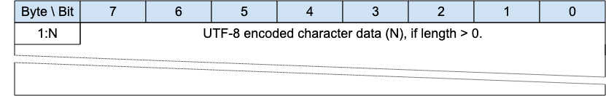
The character data in a UTF-8 Encoded String MUST be well-formed UTF-8 as defined by the Unicode specification [Unicode] and restated in RFC 3629 [RFC3629]. In particular, the character data MUST NOT include encodings of code points between U+D800 and U+DFFF [MQTT-SN-1.7.4-1].
If the Client or Server receives an MQTT-SN Control Packet containing ill-formed UTF-8 it is a Malformed Packet. Refer to section 4.12 for information about handling errors.
A UTF-8 Encoded String MUST NOT include an encoding of the null character U+0000 [MQTT-SN-1.7.4-2]. If a receiver (Server or Client) receives an Control Packet containing U+0000 in a UTF-8 Encoded String it is a Malformed Packet.
UTF-8 Encoded Strings SHOULD NOT include the Unicode [Unicode] code points listed below. If a receiver (Server or Client) receives an MQTT-SN Control Packet with UTF-8 Encoded Strings containing any of them it MAY treat it as a Malformed Packet. These are the Disallowed Unicode code points.
- U+0001..U+001F control characters
- U+007F..U+009F control characters
- Code points defined in the Unicode specification [Unicode] to be non-characters (for example U+0FFFF)
A UTF-8 encoded sequence 0xEF 0xBB 0xBF is always interpreted as U+FEFF ("ZERO WIDTH NO-BREAK SPACE") wherever it appears in a string and MUST NOT be skipped over or stripped off by a packet receiver [MQTT-SN-1.7.4-3].
Informative example
For example, the string A𪛔 which is LATIN CAPITAL Letter A followed by the code point U+2A6D4 (which represents a CJK IDEOGRAPH EXTENSION B character) is encoded as follows:
Figure 1-2 – Fixed Length UTF-8 Encoded String informative example
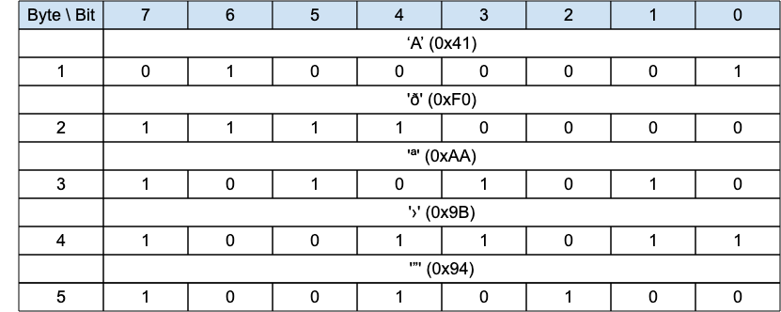

2 MQTT-SN Control Packet format

2.1 Structure of an MQTT-SN Control Packet
The MQTT-SN protocol operates by exchanging a series of MQTT-SN Control Packets in a defined way. This section describes the format of these packets.
An MQTT-SN Control Packet consists of up to two parts, always in the following order as shown below.
Figure 2-1 －Structure of an MQTT-SN Control Packet
Control Packet Header, present in all MQTT-SN Control Packets
Control Packet Variable Part, present in some MQTT-SN Control Packets

2.1.1 Packet Header
Each MQTT-SN Control Packet contains a Header of format 1 or format 2 as shown below.
Figure 2-2 – Packet Header Format 1
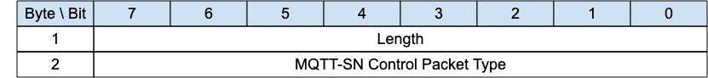
Figure 2-3 – Packet Header Format 2
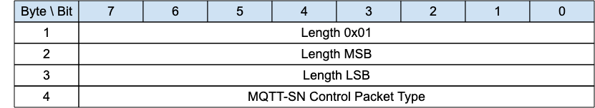

2.1.2 Length
The Length field is either 1-byte or 3-byte integer and specifies the total number of bytes contained in the packet (including the Length field itself).
If the first byte of the Length field is coded “0x01” then the Length field is 3-bytes long; in this case, the two following bytes specify the total number of bytes of the packet (most-significant byte first). Otherwise, the Length field is only 1-byte long and specifies itself the total number of bytes contained in the packet.
The 3-byte format allows the encoding of packet lengths up to 65,535 bytes. It is more efficient to use the shorter 1-byte format for packets with lengths up to and including 255 bytes.
A client or gateway receiving MQTT-SN control packets MUST be able to process both 1-byte and 3-byte length formats. [MQTT-SN-2.1.2-1]
Informative comment
MQTT-SN does not support packet fragmentation and reassembly, the maximum packet length that could be used in a network is governed by the maximum packet size that is supported by that network, and not by the maximum length that could be encoded by MQTT-SN.

2.1.3 MQTT-SN Control Packet Type
The MQTT-SN Control Packet Type field is 1-byte long and specifies the MQTT-SN Control Packet type which is one of the values shown below.
Figure 2-4 – MQTT-SN Control Packet Types
Name | Value | Direction of flow | Description
Reserved | 0x00 | Forbidden | Reserved
ADVERTISE | 0x01 | Gateway Multicast | Advertise the gateway presence
SEARCHGW | 0x02 | Client Multicast | Client GWINFO request
GWINFO | 0x03 | Gateway to Client | Response to a SEARCHGW
AUTH | 0x04 | Client to Gateway or Gateway to Client | Authentication handshake
CONNECT | 0x05 | Client to Gateway | Virtual Connection request
CONNACK | 0x06 | Gateway to Client | Virtual Connection acknowledgement
REGISTER | 0x0A | Client to Gateway | Request topic alias
REGACK | 0x0B | Gateway to Client | Supply topic alias
PUBLISH | 0x0C | Client to Gateway or  Gateway to Client | Publish message
PUBACK | 0x0D | Client to Gateway or  Gateway to Client | Publish acknowledgment (QoS 1) or Publish error (Any QoS).
PUBCOMP | 0x0E | Client to Gateway or  Gateway to Client | Publish complete (QoS 2 delivery part 3)
PUBREC | 0x0F | Client to Gateway or  Gateway to Client | Publish received (QoS 2 delivery part 1)
PUBREL | 0x10 | Client to Gateway or  Gateway to Client | Publish release (QoS 2 delivery part 2)
PUBWOS | 0x11 | Client to Gateway or  Gateway to Client | Publish packet for out of session messages which have no session on the receiver
SUBSCRIBE | 0x12 | Client to Gateway | Subscribe request
SUBACK | 0x13 | Gateway to Client | Subscribe acknowledgment
UNSUBSCRIBE | 0x14 | Client to Gateway | Unsubscribe request
UNSUBACK | 0x15 | Gateway to Client | Unsubscribe acknowledgment
PINGREQ | 0x16 | Client to Gateway | PING request
PINGRESP | 0x17 | Gateway to Client | PING response
DISCONNECT | 0x18 | Client to Gateway or  Gateway to Client | Disconnect notification
WAKEUP | 0x19 | Gateway to Client | Wake up request
SLEEPREQ | 0x1A | Client to  Gateway | Sleep request
SLEEPRESP | 0x1B | Gateway to  Client | Sleep response
Reserved | 0x1C-0xFD | Forbidden | Reserved
FORWARDER ENCAPSULATION | 0xFE | Forwarder to Client or  Forwarder to Gateway | Encapsulated MQTT-SN packet
PROTECTION ENCAPSULATION | 0xFF | Client to Gateway or  Gateway to Client | A protection envelope that can encapsulate any MQTT-SN packet with the exception of Forwarder-Encapsulation packet (0xFE)

2.2 Packet Identifier
The Variable Header component of many of the MQTT-SN Control Packet types includes a Two Byte Integer Packet Identifier field. MQTT-SN Control Packets that require a Packet Identifier are shown in Figure 2-5.
Figure 2-5 – Packets with Packet Identifier
MQTT-SN Control Packet | Packet Identifier field
ADVERTISE | NO
AUTH | YES
CONNACK | YES
CONNECT | YES
DISCONNECT | OPTIONAL
FORWARDER ENCAPSULATION | NO
GWINFO | NO
PINGREQ | YES
PINGRESP | YES
PROTECTION ENCAPSULATION | NO
PUBACK | YES
PUBCOMP | YES
PUBLISH | YES (If QoS > 0)
PUBREC | YES
PUBREL | YES
PUBWOS | NO
REGACK | YES
REGISTER | YES
SEARCHGW | NO
SLEEPREQ | YES
SLEEPRESP | YES
SUBACK | YES
SUBSCRIBE | YES
UNSUBACK | YES
UNSUBSCRIBE | YES
WAKEUP | NO
Each time a Client sends a new MQTT-SN Control Packet which is identified in the above table as requiring a Packet Identifier, it MUST assign it a non-zero Packet Identifier that is currently unused.
A PUBLISH packet MUST NOT contain a Packet Identifier if its QoS value is set to 0.
Each time a Gateway sends a new PUBLISH (with QoS > 0) MQTT-SN Control Packet it MUST assign it a non zero Packet Identifier that is currently unused.
Packet Identifiers used with PUBLISH, SUBSCRIBE and UNSUBSCRIBE packets form a single, unified set of identifiers separately for the Client and the Gateway in a Session. A Packet Identifier cannot be used by more than one Packet at any time.
The Packet Identifier becomes available for reuse after the sender has processed the corresponding acknowledgement packet, defined as follows. In the case of a QoS 1 PUBLISH, this is the corresponding PUBACK; in the case of QoS 2 PUBLISH it is PUBCOMP or a PUBREC with a Reason Code of 128 or greater. For SUBSCRIBE or UNSUBSCRIBE it is the corresponding SUBACK or UNSUBACK.
A PUBACK, PUBREC , PUBREL, or PUBCOMP packet MUST contain the same Packet Identifier as the PUBLISH packet that was originally sent. A SUBACK and UNSUBACK MUST contain the Packet Identifier that was used in the corresponding SUBSCRIBE and UNSUBSCRIBE packet respectively.
The Client and Gateway assign Packet Identifiers independently of each other. As a result, Client-Server pairs can participate in concurrent Packet exchanges using the same Packet Identifiers.
Informative comment
It is possible for a Client to send a PUBLISH packet with Packet Identifier 0x1234 and then receive a different PUBLISH packet with Packet Identifier 0x1234 from its Server before it receives a PUBACK for the PUBLISH packet that it sent.


2.3 Reason Code
A Reason Code is a one byte unsigned value that indicates the result of an operation. Reason Codes less than 0x80 indicate successful completion of an operation. The normal Reason Code for success is 0. Reason Code values of 0x80 or greater indicate failure.
The Reason Codes share a common set of values as shown below.
Figure 2-6 – Reason Codes
Identifier |  | Name | Packets | Description
Dec | Hex | Name | Packets | Description
0 | 0x00 | Success | CONNACK, SUBACK, UNSUBACK, REGACK, PUBACK, PUBREC, PUBREL, PUBCOMP, AUTH (server only) | The operation was successful.
0 | 0x00 | Normal disconnection | DISCONNECT | Delete the Virtual Connection normally. Do not send the Will Message.
0 | 0x00 | Granted QoS 0 | SUBACK | The subscription is accepted and the maximum QoS sent will be QoS 0. This might be a lower QoS than was requested.
1 | 0x01 | Granted QoS 1 | SUBACK | The subscription is accepted and the maximum QoS sent will be QoS 1. This might be a lower QoS than was requested.
2 | 0x02 | Granted QoS 2 | SUBACK | The subscription is accepted and any received QoS will be sent to this subscription.
4 | 0x04 | Disconnect with will message | DISCONNECT (client only) | The Client wishes to disconnect but requires that the Server also publishes its Will Message.
16 | 0x10 | No matching subscribers | PUBACK, PUBREC | The Application Message is accepted but there are no subscribers. If the Server knows that there are no matching subscribers, it MAY use this Reason Code instead of 0x00 (Success).
17 | 0x11 | No subscription existed | UNSUBACK | No matching Topic Filter is being used by the Client.
24 | 0x18 | Continue authentication | AUTH | Continue the authentication with another step.
25 | 0x19 | Re-authenticate | AUTH (client only) | Initiate a re-authentication.
128 | 0x80 | Unspecified error | CONNACK, PUBACK, PUBREC, SUBACK, UNSUBACK, DISCONNECT | The receiver does not accept the request but either does not want to reveal the reason, or it does not match one of the other values.
129 | 0x81 | Malformed packet | CONNACK, DISCONNECT | The received packet does not conform to this specification.
130 | 0x82 | Protocol error | CONNACK, DISCONNECT | An unexpected or out of order packet was received.
131 | 0x83 | Implementation specific error | CONNACK, PUBACK, PUBREC, REGACK, SUBACK, UNSUBACK, DISCONNECT | The packet received is valid but cannot be processed by this implementation.
132 | 0x84 | Unsupported Protocol Version | CONNACK | The Server does not support the version of the MQTT or MQTT-SN protocol requested by the Client.
133 | 0x85 | Client identifier not valid | CONNACK | The Client Identifier is a valid string but is not allowed by the Server.
134 | 0x86 | Bad user name or password | CONNACK | The Server does not accept the User Name or Password specified by the Client
135 | 0x87 | Not authorized | CONNACK, PUBACK, PUBREC, REGACK, SUBACK, UNSUBACK, DISCONNECT (server only) | The request is not authorized.
136 | 0x88 | Server unavailable | CONNACK | The MQTT-SN Server is not available or, in the case of a Transparent gateway, the MQTT server is not available.
137 | 0x89 | Server busy | CONNACK, DISCONNECT (server only) | The Server is busy and cannot continue processing requests from this Client.
138 | 0x8A | Banned | CONNACK | This Client has been banned by administrative action. Contact the server administrator.
139 | 0x8B | Server shutting down | DISCONNECT (server only) | The Server is shutting down.
140 | 0x8C | Bad authentication method | CONNACK, DISCONNECT | The authentication method is not supported or does not match the authentication method currently in use.
141 | 0x8D | Keep alive timeout | DISCONNECT (server only) | The Connection is closed because no packet has been received for 1.5 times the Keepalive time.
142 | 0x8E | Session taken over | DISCONNECT (server only) | Another Connection using the same ClientID has connected causing this Connection to be closed.
143 | 0x8F | Topic filter invalid | SUBACK, UNSUBACK, DISCONNECT (server only) | The Topic Filter is correctly formed, but is not accepted by this Server.
144 | 0x90 | Topic name invalid | CONNACK, PUBACK, PUBREC, DISCONNECT (server only) | The Topic Name is correctly formed, but is not accepted by this Client or Server.
145 | 0x91 | Packet identifier in use | PUBACK, PUBREC, SUBACK, UNSUBACK,  REGACK, PINGRESP, SLEEPRESP | The specified Packet Identifier is already in use.
146 | 0x92 | Packet identifier not found | PUBREL, PUBCOMP | The Packet Identifier is not known. This is not an error during recovery, but at other times indicates a mismatch between the Session State on the Client and Server.
147 | 0x93 | Receive maximum exceeded | DISCONNECT | The Client or Server has received more than Receive Maximum publication for which it has not sent PUBACK or PUBCOMP.
148 | 0x94 | Topic alias invalid | DISCONNECT (server only) | The Client or Server has received a PUBLISH packet containing a Topic Alias which is greater than the Maximum Topic Alias it sent in the CONNECT or CONNACK packet.  (Transparent gateway only)
149 | 0x95 | Packet too large | CONNACK,  DISCONNECT | The packet size is greater than Maximum Packet Size for this Client or Server.
150 | 0x96 | Packet rate too high | DISCONNECT | The received data rate is too high.
151 | 0x97 | Quota exceeded | REGACK, SUBACK, DISCONNECT | An implementation or administrative imposed limit has been exceeded.
152 | 0x98 | Administrative action | DISCONNECT | The Virtual Connection is deleted due to an administrative action.
153 | 0x99 | Payload format invalid | PUBACK, PUBREC, DISCONNECT (server only) | The MQTT payload format does not match the one specified by the Payload Format Indicator.  (Transparent gateway only)
154 | 0x9A | Retain not supported | CONNACK, DISCONNECT (server only) | The MQTT Server does not support retained messages.  (Transparent gateway only)
155 | 0x9B | QoS not supported | CONNACK, DISCONNECT (server only) | The Client specified a QoS greater than the QoS specified in a Maximum QoS in the MQTT CONNACK.  (Transparent gateway only)
156 | 0x9C | Use another server | CONNACK, DISCONNECT (server only) | The Client should temporarily change its Server.
157 | 0x9D | Server moved | CONNACK, DISCONNECT (server only) | The Server is moved and the Client should permanently change its server location.
158 | 0x9E | Shared subscription not supported | SUBACK, DISCONNECT (server only) | The MQTT Server does not support Shared Subscriptions.  (Transparent gateway only)
159 | 0x9F | Connection rate exceeded | CONNACK, DISCONNECT (server only) | This Virtual Connection is deleted because the connection rate is too high.
160 | 0xAD | Maximum connect time | DISCONNECT (server only) | The maximum connection time authorized for this Virtual Connection has been exceeded.
161 | 0xA1 | Subscription identifiers not supported | SUBACK, DISCONNECT (server only) | The MQTT Server does not support Subscription Identifiers; the subscription is not accepted.  (Transparent gateway only)
162 | 0xA2 | Wildcard subscription not supported | SUBACK, DISCONNECT (server only) | The MQTT Server does not support Wildcard Subscriptions; the subscription is not accepted.  (Transparent gateway only)
230 | 0xE6 | Only PROTECTION packet supported (Note 1) | Any packet except PROTECTION and Forwarder Encapsulation | Specific to MQTT-SN
231 | 0xE7 | Protection scheme invalid | DISCONNECT | Specific to MQTT-SN
232 | 0xE8 | Unknown Sender Id | DISCONNECT | Specific to MQTT-SN
240 | 0xF0 | Unknown Topic Alias | PUBACK, SUBACK, UNSUBACK, REGACK | Specific to MQTT-SN
241 | 0xF1 | Congestion | SUBACK, REGACK, CONNACK, PUBACK | Specific to MQTT-SN
242 | 0xF2 | Protection packet not supported | DISCONNECT | Specific to MQTT-SN
243 | 0xF3 | Forwarder Encapsulation not supported | DISCONNECT | Specific to MQTT-SN
244 | 0xF4 | No Virtual Connection exists | DISCONNECT | Specific to MQTT-SN
245  -  255 | 0xF5  -  0xFF | Reserved for MQTT-SN |  | Specific to MQTT-SN
Note(s):
- It is used by a receiver to indicate that it expected a packet to be protected and it wasn't.
- The MQTT-SN dedicated range of reason codes is from 0xE6 (230) to 0xFF(255).

2.4 Topic Types
Several packets refer to a Topic Type in their flags. This is a 2-bit field which determines the format of the topic value. The allowable values are as follows:
Figure 2-7 – Topic Types
 | Topic Type Value | Name | Description
0 | 0b00 | Session Topic Alias | A session Topic Alias is negotiated between the gateway and client within the scope of a session.
1 | 0b01 | Predefined Topic Alias | A predefined Topic Alias is known statically by both the Gateway and the Client outside the scope of a session. No negotiation is required since both entities have knowledge of the topic alias mapping.
2 | 0b10 |  | Reserved
3 | 0b11 | Topic Name or Filter | A Topic Name or Topic Filter, which requires no session negotiation.
Predefined and Session Topic Aliases are assigned from different pools so there is no danger of collision.
Refer to Section 4.7 for detailed descriptions of Topic Names and Topic Aliases.

3 MQTT-SN Control Packets

3.1 ADVERTISE - Gateway Advertisement
Figure 3-1 – ADVERTISE Packet
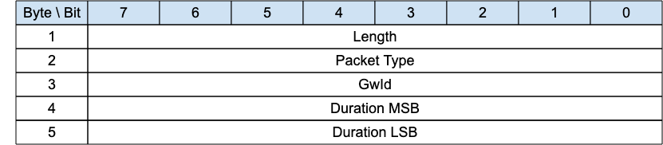
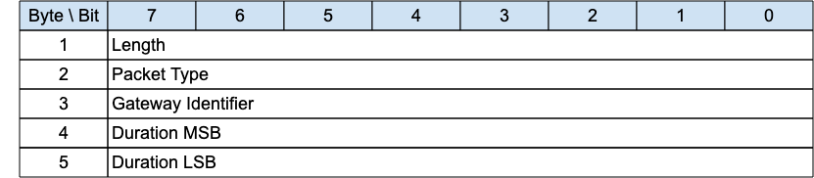
The ADVERTISE packet is sent periodically by a Gateway to advertise its presence. The time interval until the next transmission is indicated by the Duration field.
Informative comment
If the Transport Layer supports multicast, like UDP/IP, the ADVERTISE packet is generally sent using a Multicast Address as the destination.

3.1.1 ADVERTISE Header
The first 2 or 4 bytes of the packet are encoded according to the variable length packet header format. Refer to section 2.1 for a detailed description.

3.1.2 Gateway Identifier
The Gateway Identifier field is 1 byte and uniquely identifies a Gateway which is advertising its presence on the network.
The MQTT-SN protocol itself does not guarantee the uniqueness of the Gateway Identifier.
Informative comment
If the Gateway has a MAC address, it can be used as GwId.

3.1.3 Duration
The Duration field is a 2-byte integer. It specifies the time interval in seconds until the next ADVERTISE packet is transmitted by this Gateway.
The maximum value that can be encoded is approximately 18 hours.

3.2 SEARCHGW - Search for A Gateway
Figure 3-2 – SEARCHGW Packet
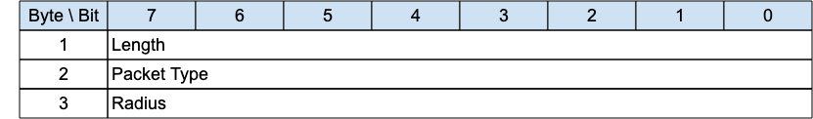
The SEARCHGW packet is sent by a client when it searches for a Gateway. The transmission radius of the SEARCHGW is limited and depends on the density of the clients’ deployment. For instance only 1-hop transmission in case of a very dense network in which every MQTT-SN client is reachable from each other within 1-hop transmission.
Informative comment
If the Transport Layer supports multicast, like UDP/IP, the SEARCHGW packet is generally sent using the Multicast Address as destination.

3.2.1 SEARCHGW Header
The first 2 or 4 bytes of the packet are encoded according to the variable length packet header format. Refer to section 2.1 for a detailed description.

3.2.2 Radius
The transmission radius is also indicated to the underlying network layer when MQTT-SN gives this packet for transmission.
A Client or a Gateway MUST NOT forward the SEARCHGW packet received if the Radius value is 0.
If a Client or a Gateway forwards the SEARCHGW packet received, it MUST reduce the Radius value by 1.

3.3 GWINFO - Gateway Information
Figure 3-3 – GWINFO Packet
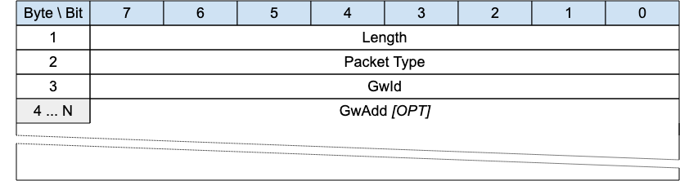
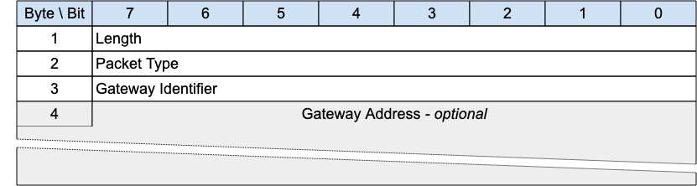
The GWINFO packet is sent as response to a SEARCHGW packet with the radius as indicated in the SEARCHGW packet. If sent by a Gateway, it contains only the id of the sending Gateway; otherwise, if sent by a client, it also includes the address of the Gateway.
Informative comment
If the Transport Layer supports multicast, like UDP/IP, the GWINFO packet is generally sent using a Multicast Address as destination.

3.3.1 GWINFO Header
The first 2 or 4 bytes of the packet are encoded according to the variable length packet header format. Refer to section 2.1 for a detailed description.

3.3.2 Gateway Identifier
The Gateway Identifier field is 1-byte long and uniquely identifies a Gateway in the network.

3.3.3 Gateway Address
The Gateway Address field has a variable length and contains the address of a Gateway. Its length depends on the type of network over which MQTT-SN operates and is specified by the Length byte. Optional, only included if the packet is sent by a client.

3.4 CONNECT - Connection Request
Figure 3-4 – CONNECT Packet
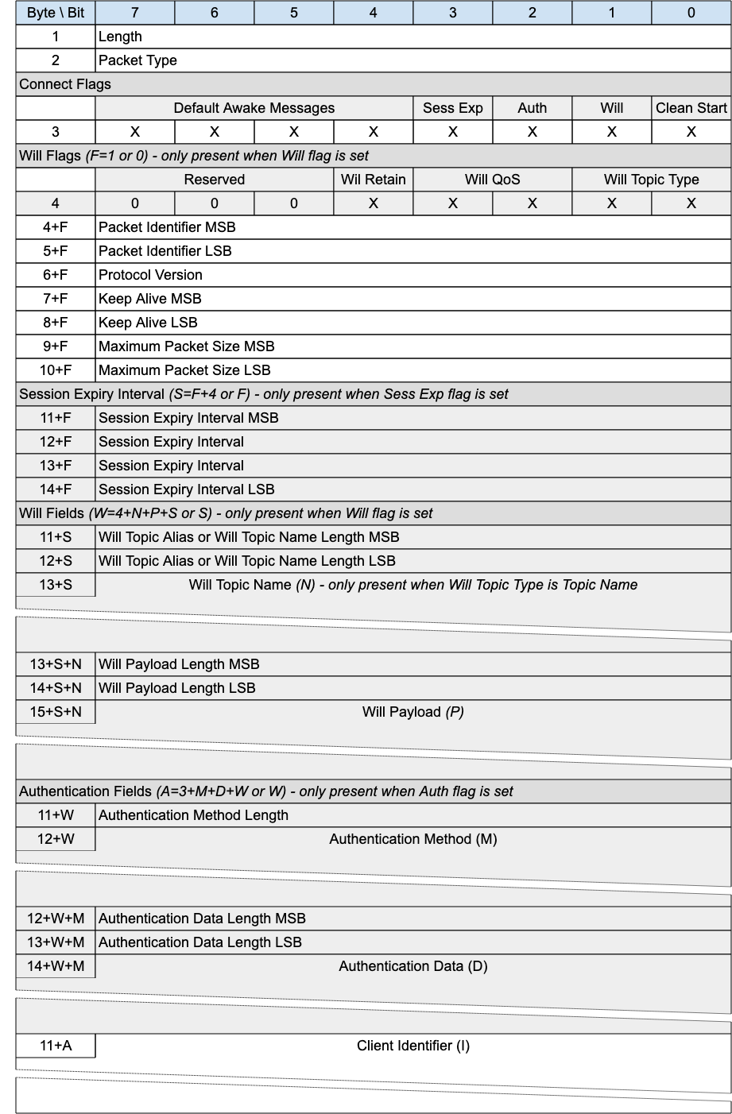
The CONNECT packet is sent from the Client to the Gateway to request the creation of or continuation of a Session.

3.4.1 CONNECT Header
The first 2 or 4 bytes of the packet are encoded according to the variable length packet header format. Refer to section 2.1 for a detailed description.

3.4.2 Connect Flags
The Connect Flags is 1 byte field which contains several parameters specifying the behavior of the MQTT-SN Virtual Connection. It also indicates the presence or absence of fields in the Packet.
The Gateway MUST validate that the reserved flags in the CONNECT packet are set to 0 [MQTT-SN-3.4.2-1]. If any of the reserved flags is not 0 it is a Malformed Packet. Refer to section 4.12 for information about handling errors.

3.4.2.1 Clean Start
Position: bit 0 of the Connect Flags byte.
This flag specifies whether the Virtual Connection starts a new Session or is a continuation of an existing Session. Refer to section 4.1 for a definition of the Session State.
If a CONNECT packet is received with Clean Start is set to 1, the Client and Server MUST discard any existing Session and start a new Session [MQTT-SN-3.4.2.1-1]. Consequently, the Session Present flag in CONNACK is always set to 0 if Clean Start is set to 1.
If a CONNECT packet is received with Clean Start set to 0 and there is a Session associated with the Client Identifier, the Server MUST resume communications with the Client based on state from the existing Session [MQTT-SN-3.4.2.1-2]. If a CONNECT packet is received with Clean Start set to 0 and there is no Session associated with the Client Identifier, the Server MUST create a new Session [MQTT-3.4.2.1-3].

3.4.2.2 Will Flag
Position: bit 1 of the Connect Flags byte.
If the Will Flag is set to 1, the Will Flags, Will Topic, and Will Payload fields MUST be present in the Packet [MQTT-SN-3.4.2.2-1].
If the Will Flag is set to 1 this indicates that a Will Message MUST be stored on the Server and associated with the Session [MQTT-SN-3.4.2.2-2]. The Will Message consists of the Will Topic, and Will Payload fields in the CONNECT Packet. The Will Message MUST be published after the Virtual Connection is deleted or the Session ends, unless the Will Message has been deleted by the Server on receipt of a DISCONNECT packet with Reason Code 0x00 (Normal disconnection) [MQTT-SN-3.4.2.2-3].
Situations in which the Will Message is published include, but are not limited to:
- The Server deletes the Virtual Connection as a result of an I/O error or network failure it has detected.
- The Client fails to communicate within the Keep Alive time.
- The Server deletes the Virtual Connection because of a protocol error.
- The Server deletes the Virtual Connection because of a Retry timeout.
The Will Message MUST be removed from the stored Session State in the Server once it has been published or the Server has received a DISCONNECT packet with a Reason Code of 0x00 (Normal disconnection) from the Client [MQTT-SN-3.4.2.2-4].
The Server SHOULD publish Will Messages promptly after the Virtual Connection is deleted or the Session ends, whichever occurs first. In the case of a Server shutdown or failure, the Server MAY defer publication of Will Messages until a subsequent restart. If this happens, there might be a delay between the time the Server experienced failure and when the Will Message is published.

3.4.2.3 Authentication Flag
Position: bit 2 of the Connect Flags byte. Labelled Auth in Figure 3-4.
If the Authentication Flag is set to 1, the Authentication Method and Authentication Data fields MUST be present in the Packet [MQTT-SN-3.4.2.3-1].

3.4.2.4 Session Expiry Flag
Position: bit 3 of the Connect Flags byte. Labelled Sess Exp in Figure 3-4.
If the Session Expiry Flag is set to 1, the Session Expiry Interval field MUST be present in the Packet [MQTT-SN-3.4.2.4-1].
If the Session Expiry Flag is set to 0, the Session Expiry Interval field MUST NOT be present in the Packet [MQTT-SN-3.4.2.4-2].

3.4.2.5 Default Number of Awake Messages
Position: bits 7 through 4 of the Connect Flags byte. Labelled Default Awake Messages in Figure 3-4.
A value between 0-15 to indicate the maximum number of messages a Client shall receive during an AWAKE session. Specifying 0 will mean it is up to the Gateway to determine how many messages it will send, which may be unbounded.

3.4.3 Will Flags
If the Will Flag is set to 0, the Will Flags MUST NOT be present in the Packet [MQTT-SN-3.4.3-1].
If the Will Flag is set to 1, the Will Flags MUST be present in the Packet [MQTT-SN-3.4.3-2].
The Will Flags is 1 byte field which contains several parameters specifying the handling of the Will Message.

3.4.3.1 Will Topic Type
Position: bits 1 and 0 of the Will Flags byte.
This is a 2-bit field which determines the format of the topic value. Refer to section 2.4 for the definition of the various topic types.

3.4.3.2 Will QoS
Position: bits 3 and 2 of the Will Flags byte.
These two bits specify the QoS level to be used. The value of Will QoS can be 0 (0x00), 1 (0x01), or 2 (0x02). A value of 3 (0x03) is a Malformed Packet.

3.4.3.3 Will Retain
Position: bit 4 of the Will Flags byte.
This specifies if the Will Message is to be retained when it is published. See section 4.16 for more information about Retained Messages.
If the Will Flag is set to 1 and Will Retain is set to 0, the Server MUST publish the Will Message as a non-retained message [MQTT-SN-3.4.3.3-1].
If the Will Flag is set to 1 and Will Retain is set to 1, the Server MUST publish the Will Message as a retained message [MQTT-SN-3.4.3.3-2].

3.4.4 Packet Identifier
Used to identify the corresponding CONNACK or AUTH packet. It should ideally be populated with a random integer value.

3.4.5 Protocol Version
The one-byte unsigned value that represents the revision level of the protocol used by the Client.
Figure 3-5 – Protocol Versions
Protocol Version | Value
Version 1.2 | 0x01
Version 2.0 | 0x02
Reserved for future use | 0x03 – 0xFF
The value of the Protocol Version field for MQTT-SN version 2.0 MUST be 2 (0x02).
A Gateway which supports multiple versions of the MQTT-SN protocol uses the Protocol Version to determine which version of MQTT-SN the Client is using. If the Protocol Version is not 2 and the Gateway does not want to accept the CONNECT packet, the Server MAY send a CONNACK packet with Reason Code 0x84 (Unsupported Protocol Version).

3.4.6 Keep Alive
The Keep Alive is a Two Byte Integer greater than 0 (1 - 65,535), which is a time interval measured in seconds. It is the maximum time interval that is permitted to elapse between the point at which the Client finishes transmitting one MQTT-SN Control Packet and the point it starts sending the next. It is the responsibility of the Client to ensure that the interval between MQTT-SN Control Packets being sent does not exceed the Keep Alive value. In the absence of sending any other MQTT-SN Control Packets, the Client MUST send a PINGREQ packet [MQTT-SN-3.4.6-1].
Informative comment
The Client can send PINGREQ at any time, irrespective of the Keep Alive value, and check for a corresponding PINGRESP to determine that the network and the Gateway are available.
If the Gateway does not receive an MQTT-SN Control Packet from the Client within one and a half times the Keep Alive time period, it MUST delete the Virtual Connection and move the Client to the Disconnected state (see section 4.15) [MQTT-SN-3.4.6-2].
If a Client does not receive a PINGRESP packet within a Tretry amount of time after it has sent a PINGREQ, it SHOULD retry the transmission according to section 4.4.2 up to the maximum number of attempts. If a PINGRESP is still not received it MUST delete the Virtual Connection to the Gateway by way of a DISCONNECT, with the understanding that the Gateway may no longer be reachable.
A Keep Alive must have a value greater than 0. It is a protocol error if a Keep Alive value of 0 or below is set.
Informative comment
The Gateway may have other reasons to disconnect the Client, for instance because it is shutting down. Setting Keep Alive does not guarantee that the Client will remain connected.
Informative comment
The actual value of the Keep Alive is application specific; typically, this is a few minutes. The maximum value of 65,535 is 18 hours 12 minutes and 15 seconds.

3.4.7 Maximum Packet Size
A Two Byte (16-bit) Integer representing the Maximum Packet Size the Client is willing to accept. If the Maximum Packet Size is set to 0, no limit on the packet size is imposed beyond the limitations in the protocol as a result of the remaining length encoding and the protocol header sizes.
Informative comment
It is the responsibility of the application to select a suitable Maximum Packet Size value if it chooses to restrict the Maximum Packet Size.
The packet size is the total number of bytes in an MQTT-SN Control Packet, as defined in section 2.1. The Client uses the Maximum Packet Size to inform the Server that it will not process packets exceeding this limit.
The Gateway MUST NOT send packets exceeding Maximum Packet Size to the Client. If a Client receives a packet whose size exceeds this limit, this is a Protocol Error, the Client uses DISCONNECT with Reason Code 0x95 (Packet too large).
Where a Packet is too large to send, the Gateway MUST discard it without sending it and then behave as if it had completed sending that Application Message.
Informative comment
Where a packet is discarded without being sent, the Gateway could take some diagnostic action including alerting the Server administrator. Such actions are outside the scope of this specification.

3.4.8 Session Expiry Interval
The Session Expiry Interval is a four-byte integer time interval measured in seconds. If the Session Expiry Interval is set to 0, the Session ends when a DISCONNECT packet is sent from either the client or gateway.
If the Session Expiry Interval is 0xFFFFFFFF (UINT_MAX), the Session does not expire.
The Client and Gateway MUST store the Session State after a DISCONNECT is issued if the Session Expiry Interval is greater than 0.
Informative comment
The clock in the Client or Gateway may not be running for part of the time interval, for instance because the Client or Gateway are not running. This might cause the deletion of the state to be delayed.
Informative comment
The client and gateway between them should negotiate a reasonable and practical session expiry interval according to the network and infrastructure environment in which they are deployed. For example, it would not be practical to set a session expiry interval of many months on a gateway whose hardware is only capable of storing a few client sessions.
Informative comment
A Client that only wants to process messages while connected will set Clean Start to 1 and set the Session Expiry Interval to 0. It will not receive Application Messages published before it is connected and has to subscribe afresh to any topics that it is interested in each time it connects.
Informative comment
The Client should always use the Session Present flag in the CONNACK to determine whether the Server has a Session State for this Client.

3.4.9 Will Topic Alias or Will Topic Name Length
If the Will Flag is set to 1, the Will Topic Alias or Will Topic Name Length is the next field in the Packet. In both cases, this is two bytes.
In the case of Will Topic Type being b11 this field will refer to the length of data assigned to the “Will Full Topic Name”, in all other cases, this will be the value used as the Will topic alias or Will short topic name.

3.4.10 Will Topic Name
If the Will Flag is set to 1 and the Will Topic Type is set to Topic Name (0b11), the Will Topic Name is the next field in the Packet. The Will Topic Name MUST be a UTF-8 Encoded String as defined in section 1.7.4 [MQTT-SN-3.4.10-1].

3.4.11 Will Payload Length
If the Will Flag is set to 1, the Will Payload Length is the next field in the Packet. It contains the length of the Will Payload field.

3.4.12 Will Payload
If the Will Flag is set to 1 the Will Payload is the next field in the Packet. The Will Payload defines the Application Message Payload that is to be published to the Will Topic as described in section 3.4.2.2. This field consists of Binary Data.

3.4.13 Authentication Method Length
If the Auth Flag is set to 1, the Authentication Method Length is the next field in the Packet. It is a single byte value (max 0-255 bytes), representing the length of field used to specify the authentication method. Refer to section 4.11 for more information about authentication.

3.4.14 Authentication Method
If the Auth Flag is set to 1, the Authentication Method is the next field in the Packet. It is a UTF-8 Encoded String containing the name of the Authentication Method.
To support the equivalent of the MQTT User Name and Password fields in the CONNECT packet, see section 4.11.1.2.
Refer to section 4.11 for more information about authentication.

3.4.15 Authentication Data Length
If the Auth Flag is set to 1, the Authentication Data Length is the next field in the Packet. It is a two byte value (max 0-65535 bytes), representing the length of the field used to specify the authentication data. Refer to section 4.11 for more information about authentication.

3.4.16 Authentication Data
If the Auth Flag is set to 1, the Authentication Data is the next field in the Packet.
Binary Data containing authentication data. The contents of this data are defined by the authentication method.
To support the equivalent of the MQTT User Name and Password CONNECT packet fields, see section 4.11.1.2.
Refer to section 4.11 for more information about authentication.

3.4.17 Client Identifier
The Client Identifier (ClientID) identifies the Client to the Gateway. Each Client connecting to the Gateway has a unique ClientID. The ClientID MUST be used by Clients and by Gateway to identify the state that they hold relating to this MQTT-SN Session between the Client and the Gateway.
Informative comment
A Client Identifier can be between 0 - 65,521 bytes. It us recommended for practicality, ClientIDs are restricted to a reasonable size (less than 243 bytes to fit within a small CONNECT packet).
When the ClientID is present (greater than 0 bytes), the Gateway MUST allow values which are between 1 and 23 UTF-8 encoded bytes in length, and that contain only the characters "0123456789abcdefghijklmnopqrstuvwxyzABCDEFGHIJKLMNOPQRSTUVWXYZ”.
The Gateway MAY choose to allow more than 23 bytes.
The Client Identifier MUST be a UTF-8 Encoded String.

3.4.18 CONNECT Actions
Note that a Server MAY support multiple protocols on the same network endpoint. If the Server determines that the protocol is MQTT-SN 2.0 then it validates the connection attempt as follows.
- The Server MUST validate that the CONNECT packet matches the format described in section 3.4 and MUST NOT create a Virtual Connection for this CONNECT if it does not match [MQTT-SN-3.4.18-1]. The Server MAY send a CONNACK with a Reason Code of 0x80 or greater as described in section 4.12.
- The Server MAY check that the contents of the CONNECT packet meet any further restrictions and SHOULD perform authentication and authorization checks. If any of these checks fail, it MUST NOT create a Virtual Connection for this CONNECT [MQTT-SN-3.4.18-2]. It MAY send an appropriate CONNACK response with a Reason Code of 0x80 or greater as described in section 3.5 and section 4.12.
If validation is successful, the Server performs the following steps.
- If the ClientID represents a Client already connected to the Server, the Server sends a DISCONNECT packet to the existing Client with Reason Code of 0x8E (Session taken over) as described in section 4.12 and MUST delete the Virtual Connection of the existing Client [MQTT-SN-3.4.18-3]. If the existing Client has a Will Message, that Will Message is published as described in section 3.4.9.
- The Server MUST perform the processing of Clean Start that is described in section 4.15.2 [MQTT-SN-3.4.18-4].
- The Server MUST acknowledge the CONNECT packet with a CONNACK packet containing a 0x00 (Success) Reason Code [MQTT-SN-3.4.18-5].
- Start Application Message delivery and Keep Alive monitoring.
Informative comment
It is recommended that authentication and authorization checks be performed if the Server is being used to process any form of business critical data. If these checks succeed, the Server responds by sending CONNACK with a 0x00 (Success) Reason Code. If they fail, it is suggested that the Server does not send a CONNACK at all, as this could alert a potential attacker to the presence of the MQTT-SN Server and encourage such an attacker to launch a denial of service or password-guessing attack.
A Client MUST wait for a CONNACK packet with a 0x00 (Success) Reason Code before sending any packet that needs a Virtual Connection [MQTT-SN-3.4.18-6].
The Server MUST NOT process any data sent by the Client after the CONNECT packet except AUTH packets [MQTT-SN-3.4.18-7].

3.5 CONNACK - Connect Acknowledgement
Figure 3-6 – CONNACK Packet
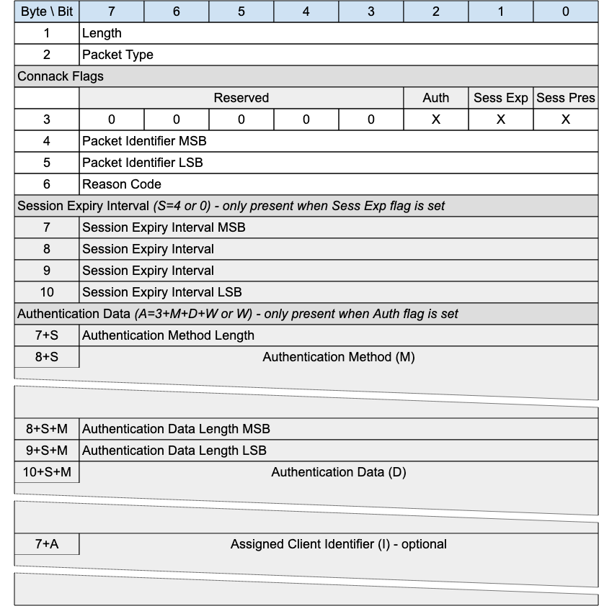
The CONNACK packet is sent by the Gateway in response to a CONNECT request from a client.

3.5.1 CONNACK Header
The first 2 or 4 bytes of the packet are encoded according to the variable length packet header format. Refer to section 2.1 for a detailed description.

3.5.2 CONNACK Flags
The CONNACK Flags is a 1 byte field which contains flags specifying the behavior of the MQTT-SN Virtual Connection on the gateway. Bits 7-2 of the CONNACK Flags are reserved and MUST be set to 0.
The Client MUST validate that the reserved flags in the CONNACK packet are set to 0. If any of the reserved flags is not 0 it is a Malformed Packet.

3.5.2.1 Session Present
Position: bit 0 of the CONNACK Flags. Labelled Sess Pres in Figure 3-6.
Specifies whether an existing session was present on the gateway for the given client identifier. A value of 1 indicates a session was present, a value 0 indicates no session was present.
If the Gateway accepts a CONNECT with Clean Start set to 1, the Gateway MUST set Session Present to 0 in the CONNACK Packet in addition to setting a 0x00 (Success) Reason Code in the CONNACK packet.
If the Gateway accepts a CONNECT with Clean Start set to 0 and the Gateway has Session State for the client identifier it MUST set Session Present to 1 in the CONNACK packet, otherwise it MUST set Session Present to 0 in the CONNACK packet. In both cases it MUST set a 0x00 (Success) Reason Code in the CONNACK packet.
If the value of Session Present received by the Client from the Gateway is not as expected, the Client proceeds as follows:
If the Client does not have Session State and receives Session Present set to 1 it MUST delete the Virtual Connection. If it wishes to restart with a new Session the Client can reconnect using Clean Start set to 1.
If the Client does have Session State and receives Session Present set to 0 it MUST discard its Session State if it continues with the Virtual Connection.
If a Gateway sends a CONNACK packet containing a non-zero Reason Code it MUST set Session Present to 0.

3.5.2.2 Session Expiry Interval Flag (Sess Exp)
Position: bit 1 of the CONNACK Flags. Labelled Sess Exp in Figure 3-6.
​​If the Session Expiry Interval Flag is set to 0, a Session Expiry Interval MUST NOT be present in the Packet [MQTT-SN-3.5.2.2-1].
If the Session Expiry Interval Flag is set to 1, a Session Expiry Interval MUST be present in the Packet [MQTT-SN-3.5.2.2-2].

3.5.2.3 Authentication Flag
Position: bit 2 of the CONNACK Flags. Labelled Auth in Figure 3-6.
Specifies whether the packet contains authentication material to be considered.
​​If the Authentication Flag is set to 0, Authentication Method and Data MUST NOT be present in the Packet [MQTT-SN-3.5.2.2-1].
If the Authentication Flag is set to 1, Authentication Method and Data MUST be present in the Packet [MQTT-SN-3.5.2.2-2].

3.5.3 Packet Identifier
The same value as the Packet Identifier in the CONNECT or AUTH Packet being acknowledged.

3.5.4 Reason Code
The values for Reason Codes are shown in section 2.3. The Server sending the CONNACK Packet MUST use one of the Reason Codes applicable to CONNACK.
If a Server sends a CONNACK packet containing a Reason code of 128 or greater it MUST then delete the Virtual Connection.

3.5.5 Session Expiry Interval
If the Session Expiry Interval is absent the value of Session Expiry Interval in the CONNECT Packet is used. The Server uses this field to inform the Client that it is using a value other than that sent by the Client in the CONNECT.

Refer to section 3.4.6 for a description of the use of Session Expiry Interval.

3.5.6 Authentication Method Length
Single byte value (max 0-255 bytes), representing the length of field used to specify the authentication method. Refer to section 4.11 for more information about authentication.

3.5.7 Authentication Method
A UTF-8 Encoded String containing the name of the authentication method. Refer to section 4.11 for more information about authentication.

3.5.8 Authentication Data Length
Two byte value (max 0-65535 bytes), representing the length of field used to specify the authentication data. Refer to section 4.11 for more information about authentication.

3.5.9 Authentication Data
Binary Data containing authentication data. The contents of this data are defined by the authentication method and the state of already exchanged authentication data. Refer to section 4.11 for more information about authentication.

3.5.10 Assigned Client Identifier
The Client Identifier assigned by the gateway when the associated CONNECT packet contained no Client Identifier. If the Client connects using a zero length Client Identifier, the Server MUST respond with a CONNACK containing an Assigned Client Identifier. The Assigned Client Identifier MUST be a new Client Identifier not used by any other Session currently in the Gateway.
The Assigned Client Identifier MUST be a UTF-8 Encoded String.
Informative comment
The length of Assigned Client Identifiers should take into account the maximum packet size allowed by the MQTT-SN implementation. For reference, RFC4122 describes Universally Unique IDentifiers (UUIDs) that are 128 bytes in size, 16 bytes or 32 hexadecimal digits. These UUIDs are commonly expressed in 36 characters, including 4 dashes as separators.
Informative comment
Where a transparent gateway obtains an Assigned Client Identifier which is deemed too large for a device, it should maintain a registry to map shorter gateway generated Client Identifiers with their versions returned from the broker.

3.6 AUTH - Authentication Exchange
Figure 3-7 – AUTH Packet
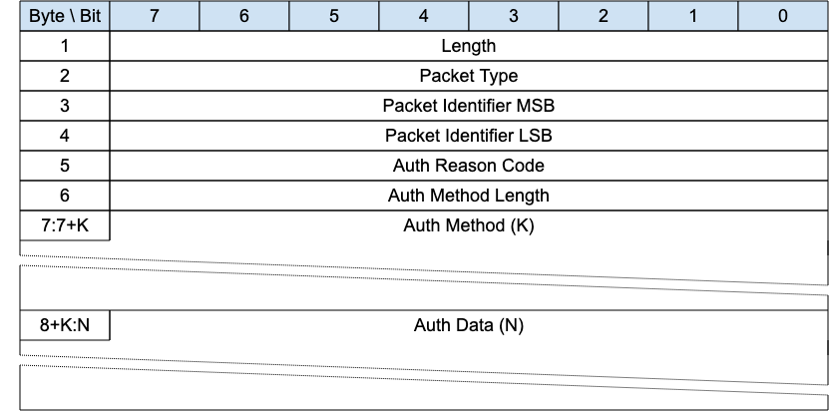
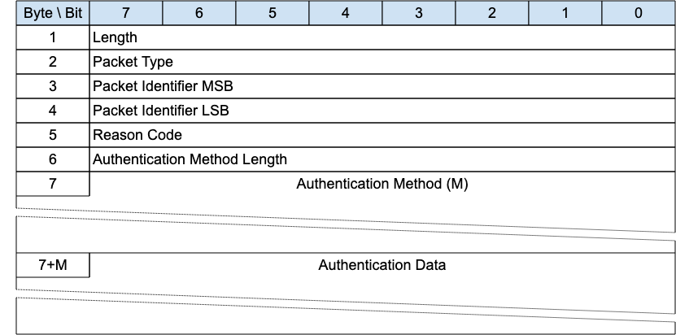
The authentication method and data is first sent by the Client as part of a CONNECT exchange. If the Server requires additional information to complete the authentication, it responds with an AUTH packet to signal that the Client generates and sends another AUTH packet with the required information and so on until the authentication is complete. The server then responds with a CONNACK message.

3.6.1 AUTH Header
The first 2 or 4 bytes of the packet are encoded according to the variable length packet header format. Refer to section 2.1 for a detailed description.

3.6.2 Packet Identifier
Used to identify the corresponding CONNECT or AUTH packet. It should ideally be populated with a random integer value when sent from Client to Server. When sent from Server to Client, it MUST contain the packet identifier of the CONNECT or AUTH packet being responded to.

3.6.2 Reason Code
The values for the Authentication Reason Code field are shown in Table 9: Reason Code Values. The sender of the AUTH Packet MUST use one of the Reason Codes shown as applicable to the AUTH packet in this table.

3.6.3 Authentication Method Length
The length of the Authentication Method string.

3.6.4 Authentication Method
A UTF-8 Encoded String containing the name of the authentication method.

3.6.5 Authentication Data
Binary Data containing authentication data. The contents of this data are defined by the authentication method.

3.6.6 AUTH Actions
Refer to section 4.11 for more information about authentication.

3.7 REGISTER - Register Topic Alias Request
Figure 3-8 – REGISTER Packet
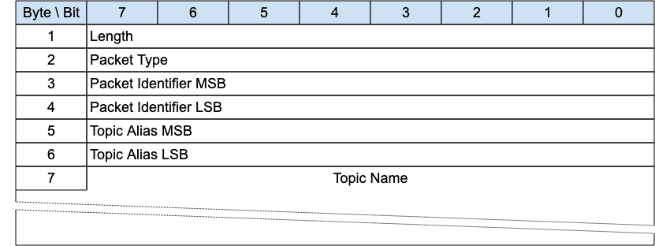
The REGISTER packet is sent by a Client to a Gateway to request a Topic Alias for the included topic name. It is also sent by a Gateway to inform a Client about the Topic Alias it has assigned to the included topic name.
Topic Aliases are always assigned by the Gateway, not the Client.

3.7.1 REGISTER Header
The first 2 or 4 bytes of the packet are encoded according to the variable length packet header format. Refer to section 2.1 for a detailed description.

3.7.2 Packet Identifier
Used to identify the corresponding REGACK packet. It should ideally be populated with a random integer value.

3.7.3 Topic Alias
If sent by a client, it is coded 0x0000 and is not relevant; if sent by a Gateway, it contains the Topic Alias value assigned to the topic name included in the Topic Name field.

3.7.4 Topic Name
Fixed Length UTF-8 Encoded String Contains the fully qualified topic name.

3.7.5 REGISTER Actions
As described in section 4.16.

3.8 REGACK - Register Topic Alias Acknowledgement
Figure 3-9 – REGACK Packet
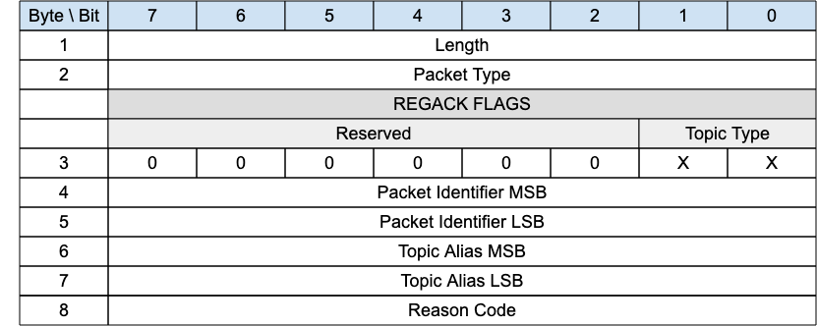
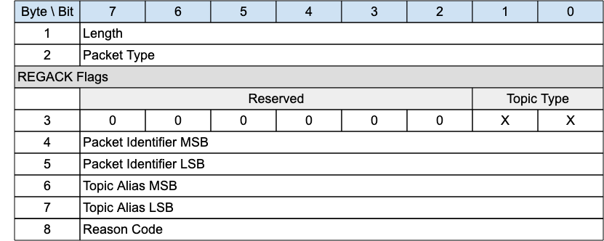
The REGACK packet is sent by a Client or by a Gateway as an acknowledgment to the receipt and processing of a REGISTER packet.

3.8.1 REGACK Header
The first 2 or 4 bytes of the packet are encoded according to the variable length packet header format. Refer to section 2.1 for a detailed description.

3.8.2 REGACK Flags
The REGACK Flags is a 1 byte field which contains flags specifying the contents of the REGACK packet. Bits 7-2 of the REGACK Flags are reserved and MUST be set to 0.
The Client MUST validate that the reserved flags in the REGACK packet are set to 0. If any of the reserved flags is not 0 it is a Malformed Packet.

3.8.2.1 Topic Type
Position: bits 0 and 1 of the REGACK Flags.
Determines the format of the topic value. Refer to Section 2.4 for the definition of the various topic types.
The Topic Type in the REGACK packet MUST be Predefined Topic Alias or Session Topic Alias. Any other value is a Protocol Error.

3.8.3 Packet Identifier
The same value as the Packet Identifier in the REGISTER packet being acknowledged.

3.8.4 Topic Alias
A Topic Alias is an integer value that is used to identify the Topic instead of the Topic Name. This numeric value is used as the Topic Alias.
If the REGACK is sent by a Gateway in response to a REGISTER request from a Client, the Topic Alias is that which has been assigned by the Gateway, and which the Client should use during the rest of the Session to refer to the Topic Name identified in the REGISTER packet.
If the REGACK is sent by a Client, it is in response to a REGISTER packet from a Gateway informing the Client which Topic Alias it should use. When sent by a Client the REGACK MUST contain the same Topic Alias that was sent in the REGISTER packet.

3.8.5 Reason Code
The values for Reason Codes are shown in section 2.3. The sender of the REGACK Packet MUST use one of the Reason Codes applicable to REGACK.

3.9 Publish Variants
MQTT-SN is designed to be optimized for packet size. For this reason, the PUBLISH packet has been split into 3 variants; Variant 1 catering for PUBLISH WITHOUT SESSION where no session is required, Variant 2 catering for Quality of Service 0 where no response ACK is required and thus no packet identifier is required and Quality of Service 1 and 2 where a response is expected. The table below breaks down the different versions of the PUBLISH packet and their respective type identifiers.
Figure 3-10 – Publish Packet Types
Packet Type | Type | Description
Publish | 0x0C | A PUBLISH packet corresponding to Quality of Service (QoS) 0, 1 or 2
Publish Without Session | 0x11 | A PUBLISH Packet sent by a Client and does not need not to have an active Session

3.9.1 PUBWOS - Publish Without Session
Figure 3-11 – PUBWOS Packet
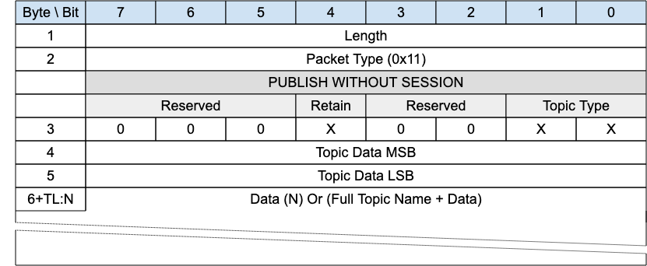
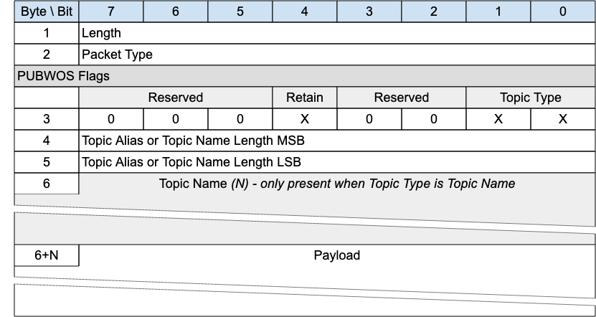
This packet is used by both clients and gateways to publish data for a certain topic.
The PUBWOS packet does not have a corresponding feature in MQTT. If forwarded to an MQTT connection, PUBWOS packets MUST have their MQTT Quality of Service level set to 0. [MQTT-SN-3.10-1]
Informative comment
If the Transport Layer supports multicast, like UDP/IP, the PUBWOS packet is generally sent to a Multicast Address.
Informative comment
PUBWOS packets received by a Gateway are not associated with a MQTT-SN Client Session and can be optionally discarded by the Gateway without being processed for onward delivery.

3.9.1.1 PUBWOS Header
The first 2 or 4 bytes of the packet are encoded according to the variable length packet header format. Refer to section 2.1 for a detailed description.

3.9.1.2 PUBWOS Flags
The PUBWOS Flags is a 1 byte field which contains flags specifying the content of the packet and the Gateway behavior on receipt. Bits 7-5 and 3-2 of the PUBWOS FLAGS are reserved and MUST be set to 0.
The Client MUST validate that the reserved flags in the PUBWOS packet are set to 0. If any of the reserved flags is not 0 it is a Malformed Packet.

3.9.1.2.1 Topic Type
Position: bits 0 and 1 of the PUBWOS Flags.
This determines the format of the topic data field. Refer to Section 2.4 for the definition of the topic types. The Topic Type in the PUBWOS packet MUST be Predefined Topic Alias or Topic Name.

3.9.1.2.2 Retain
Position: bit 4 of the PUBWOS Flags.
This field signifies whether the existing Retained Message for this topic is replaced or kept. For a detailed description of Retained Messages see section 4.16.

3.9.1.3 Topic Alias or Topic Name Length
This field is 2 bytes. It contains the Topic Name length if the Topic Type is Topic Name, or a predefined Topic Alias if the Topic Type is Predefined Topic Alias. Determines the topic which this payload will be published to.

3.9.1.4 Topic Name
If the Topic Type is Topic Name, the Topic Name field MUST be present in the PUBWOS packet.
If the Topic Type is Predefined Topic Alias, the Topic Name field MUST NOT be present in the PUBWOS packet.
If the Topic Type is Topic Name this field will be a UTF-8 encoded string value of length determined by the Topic Name Length field.

3.9.1.5 Payload
The Payload contains the Application Message that is being published. The content and format of the data is application specific. It is valid for a PUBWOS packet to contain a zero length Payload.

3.9.1.6 PUBWOS Actions
The Client or Server uses a PUBWOS packet to send an Application Message to a Network Address, for possible receipt by a Server or another Client.
If received by a Client or Server, the PUBWOS packet MUST be treated as if its QoS were 0 [MQTT-SN-3.10.5-1] as described in section 3.12.7.

3.9.2 PUBLISH with QoS -1 (Informative)
Figure 3-12 – PUBLISH Packet for QoS -1
Bit | 7 | 6 |  | 5 |  | 4 | 3 |  | 2 |  | 1 | 0
Byte 1 | Length
Byte 2 | Packet Type (0x0C)
 | FLAGS
 | DUP |  | QoS |  | Retain |  |  | Reserved | Reserved | Topic Id Type
Byte 3 | X |  | 1 | 1 | X |  |  | 0 | 0 | X |  |  | X
Byte 4 | Topic Id MSB
Byte 5 | Topic Id LSB
Byte 6 | 0x00 – Fixed Field Value
Byte 7 | 0x00 – Fixed Field Value
Byte 8 .. N | Data Or (Full Topic Name + Data)
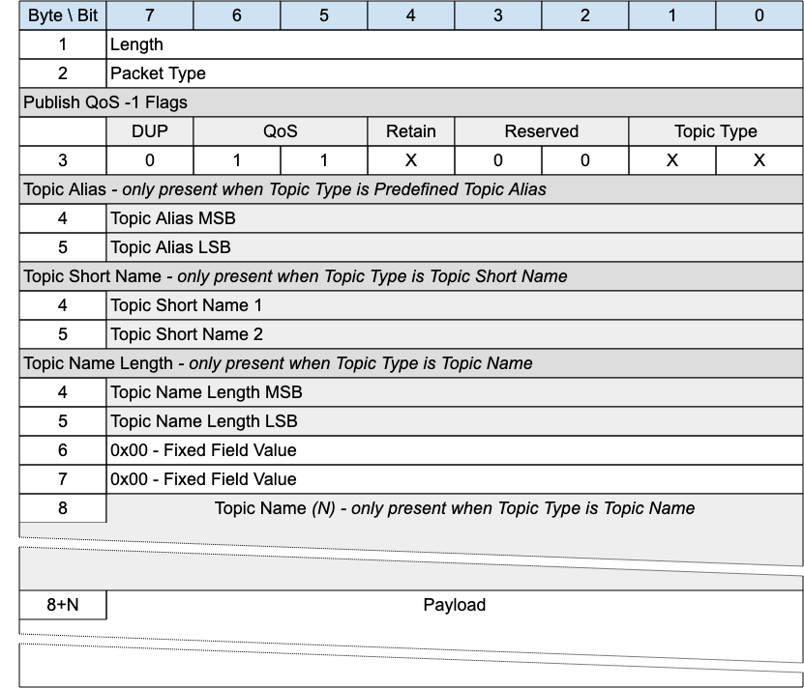
This packet is the MQTT-SN 1.2 equivalent of PUBWOS. It may be supported by a Gateway if there are existing MQTT-SN 1.2 transmitters that the Gateway wants to listen to, or receivers it wants to send to. Implementation of this packet is optional.
This packet can be used by both Clients and Gateways to publish data to a topic without establishing a Virtual Connection or Session.
Informative comment
If the Transport Layer supports multicast, like UDP/IP, the PUBLISH QoS -1 packet is generally sent using the Multicast Address as destination.

3.9.2.1 PUBLISH Header
The first 2 or 4 bytes of the packet are encoded according to the variable length packet header format. Refer to section 2.1 for a detailed description.

3.9.2.2 PUBLISH Flags
The PUBLISH Flags is a 1 byte field which contains flags specifying the content of the packet and the Gateway behavior. Bits 3-2 of the PUBLISH Flags are reserved and MUST be set to 0.
The Client MUST validate that the reserved flags in the PUBLISH packet are set to 0. If any of the reserved flags is not 0 it is a Malformed Packet.

3.9.2.2.1 Topic Type
Position: bits 0 and 1 of the PUBLISH Flags.
This determines the format of the Topic Data field.
The Topic Type in MQTT-SN 1.2 is different to that in MQTT-SN 2.0. The values applicable to QoS -1 are:
- 0b00 - Long Topic Name. The Length is in the
- 0b01 - Predefined Topic Alias.
- 0b10 - short Topic Name. A two byte Topic Name, with the same syntax as a long Topic Name. However, some 1.2 implementations treated this as a binary field.

3.9.2.2.2 QoS
Position: bits 5 and 6 of the PUBLISH Flags.
Set this field to “0b11” for QoS -1.

3.9.2.2.3 DUP
Position: bit 7 of the PUBLISH Flags.
Set to 0.

3.9.2.2.4 Retain
Position: bit 4 of the PUBLISH Flags.
This field has the same meaning as with MQTT. It signifies whether the existing retained message for this topic is replaced or kept.

3.9.3.3 Topic Alias
Only present if the Topic Type is Predefined Topic Alias. Contain a Topic Alias which is preconfigured to be known to both the sender and receiver.

3.9.3.4 Topic Short Name
Only present if the Topic Type is Short Topic Name.
This is a two byte Topic Name.

3.9.3.5 Topic Name Length
Only present if the Topic Type is Long Topic Name.
The length of the Topic Name field.

3.9.3.6 Topic Name
Only present if the Topic Type is Long Topic Name.
Topic Name is a UTF-8 encoded string of length Topic Name Length.

3.9.2.7 Payload
The Payload contains the Application Message that is being published. The content and format of the data is application specific. It is valid for a PUBLISH packet to contain a zero length Payload.

3.9.2.8 PUBLISH QoS -1 Actions
The Client or Server uses a PUBLISH QoS -1 packet to send an Application Message to a Network Address, for possible receipt by a Server or another Client.
If received by a Client or Server, the PUBLISH QoS -1 packet is treated as if its QoS were 0 as described in section 3.12.7.

3.9.3 PUBLISH with QoS 0
Figure 3-13 – PUBLISH Packet for QoS 0
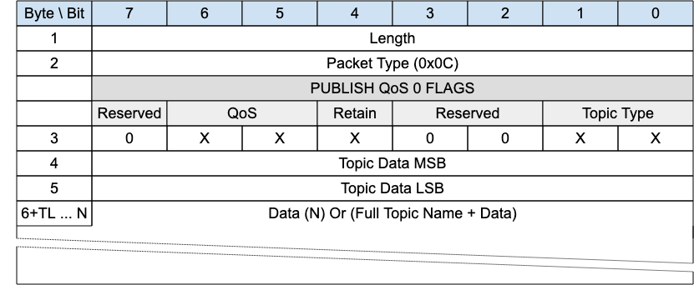
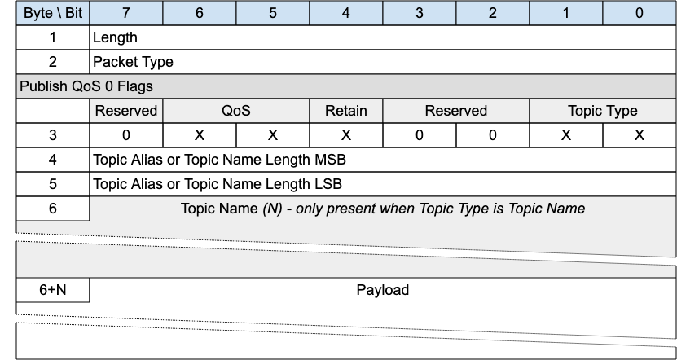
A PUBLISH packet is sent from a Client to a Server or from a Server to a Client to transport an Application Message.
PUBLISH packets with QoS equal to 0 received by a Client or Server MUST be associated with a Session [MQTT-SN-3.9.3-1].

3.9.3.1 PUBLISH Header
The first 2 or 4 bytes of the packet are encoded according to the variable length packet header format. Refer to section 2.1 for a detailed description.

3.9.3.2 PUBLISH Flags
The PUBLISH Flags is a 1 byte field which contains flags specifying the content of the packet and the Gateway behavior. Bits 7 and 3-2 of the PUBLISH Flags are reserved and MUST be set to 0.
The Client MUST validate that the reserved flags in the PUBLISH packet are set to 0. If any of the reserved flags is not 0 it is a Malformed Packet.

3.9.3.2.1 Topic Type
Position: bits 0 and 1 of the PUBLISH Flags.
This determines the content of the Topic Alias and Topic Name fields. Refer to section 2.4 for the definition of the various topic types.
The Topic Type may be Topic Name, Predefined Topic Alias or Session Topic Alias.

3.9.3.2.2 QoS
Position: bits 5 and 6 of the PUBLISH Flags.
This field is set to “0b00” for QoS 0. For a detailed description of the various Quality Of Service levels refer to section 4.3.

3.9.3.2.3 Retain
Position: bit 4 of the PUBLISH Flags.
This field has the same meaning as with MQTT. It signifies whether the existing retained message for this topic is replaced or kept. For a detailed description of Retained Messages see section 4.16.

3.9.3.3 Topic Alias or Topic Name Length
Contains 2 bytes of Topic Name Length if the Topic Type is Topic Name, or the Predefined or Session Topic Alias if the Topic Type is Predefined Topic Alias or Session Topic Alias respectively.

3.9.3.4 Topic Name
If the Topic Type is Topic Namer (0b11) the Topic Name field MUST be present in the PUBLISH packet.
If the Topic Type is Predefined Topic Alias or Session Topic Alias, then the Topic Name field MUST NOT be present in the PUBLISH packet.
Topic Name is a UTF-8 encoded string of length Topic Length.

3.9.3.5 Payload
The Payload contains the Application Message that is being published. The content and format of the data is application specific. It is valid for a PUBLISH packet to contain a zero length Payload

3.9.3.6 PUBLISH - QoS 0 Actions
As described in section 3.12.7.

3.9.4 PUBLISH with QoS 1 and 2
Figure 3-14 – PUBLISH Packet for QoS 1 and 2
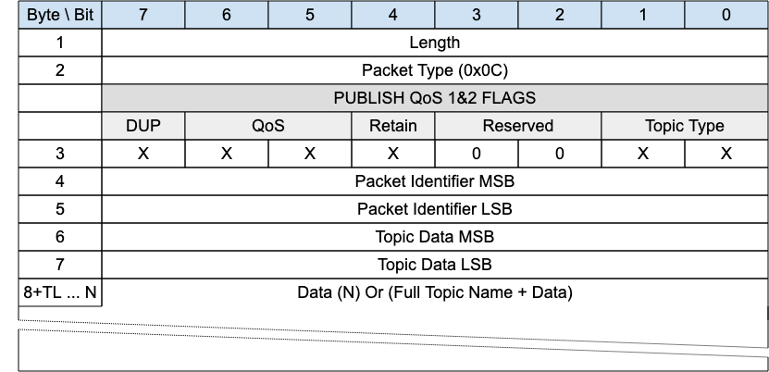
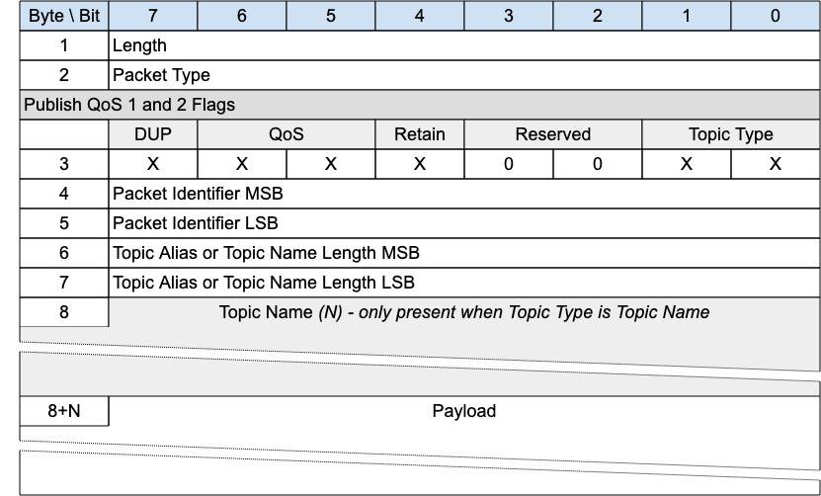
A PUBLISH packet is sent from a Client to a Server or from a Server to a Client to transport an Application Message.
PUBLISH packets with QoS equals to 1 or 2 received by a Client or Server MUST be associated with a Session [MQTT-SN-3.9.4-1].

3.9.4.1 PUBLISH Header
The first 2 or 4 bytes of the packet are encoded according to the variable length packet header format. Refer to section 2.1 for a detailed description.

3.9.4.2 PUBLISH Flags
The PUBLISH Flags is a 1 byte field which contains flags specifying the content of the packet and the Gateway behavior. Bits 7 and 3-2 of the PUBLISH Flags are reserved and MUST be set to 0.
The Client MUST validate that the reserved flags in the PUBLISH packet are set to 0. If any of the reserved flags is not 0 it is a Malformed Packet.

3.9.4.2.1 Topic Type
Position: bits 0 and 1 of the PUBLISH Flags.
This determines the format of the Topic Data field. Refer to Section 2.4 for the definition of Topic Types.
The Topic Type may be Topic Name, Predefined Topic Alias or Session Topic Alias.

3.9.4.2.2 QoS
Position: bits 5 and 6 of the PUBLISH Flags.
QoS has the same meaning as with MQTT indicating the Quality of Service. The QoS levels are shown below:
Figure 3-15 – QoS Definitions
QoS value | Bit 6 | bit 5 | Description
0 | 0 | 0 | At most once delivery
1 | 0 | 1 | At least once delivery
2 | 1 | 0 | Exactly once delivery
- | 1 | 1 | Reserved – must not be used
For a detailed description of the various Quality Of Service levels refer to section 4.3.

3.9.4.2.3 DUP
Position: bit 7 of the PUBLISH Flags.
This has the same meaning as with MQTT. It notes the duplicate delivery of packets. If the DUP flag is set to “0”, it signifies that the packet is sent for the first time. If the DUP flag is set to “1”, it signifies that the packet was retransmitted or retried.

3.9.4.2.4 Retain
Position: bit 4 of the PUBLISH Flags.
This field has the same meaning as with MQTT. It signifies whether the existing retained message for this topic is replaced or kept. For a detailed description of Retained Messages see section 4.16.

3.9.4.3 Packet Identifier
Used to identify the corresponding PUBACK packet in the case of QoS 1. Used to identify the corresponding PUBREC, PUBREL and PUBCOMP packets in the case of QoS 2. It should ideally be populated with a random integer value.

3.9.4.4 Topic Alias or Topic Name Length
Contains 2 bytes of Topic Name Length if the Topic Type is Topic Name, or the Predefined or Session Topic Alias if the Topic Type is Predefined Topic Alias or Session Topic Alias respectively.

3.9.4.5 Topic Name
If the Topic Type is Topic Namer (0b11) the Topic Name field MUST be present in the PUBLISH packet.
If the Topic Type is Predefined Topic Alias or Session Topic Alias, then the Topic Name field MUST NOT be present in the PUBLISH packet.
Topic Name is a UTF-8 encoded string of length Topic Length.

3.9.4.6 Payload
The Payload contains the Application Message that is being published. The content and format of the data is application specific. It is valid for a PUBLISH packet to contain a zero length Payload.

3.9.4.7 PUBLISH Actions
The receiver of a PUBLISH packet MUST respond with the packet as determined by the QoS in the PUBLISH Packet. [MQTT-SN-3.12.7-1].
Figure 3-16 – Expected PUBLISH packet responses
QoS Level | Expected Response
QoS 0 | None
QoS 1 | PUBACK packet
QoS 2 | PUBREC packet
The Client uses a PUBLISH packet to send an Application Message to the Server, for distribution to Clients with matching subscriptions.
The Server uses a PUBLISH packet to send an Application Message to each Client which has a matching subscription.
When Clients make subscriptions with Topic Filters that include wildcards, it is possible for a Client’s subscriptions to overlap so that a published Application Message might match multiple filters. In this case the Server MUST deliver the Application Message to the Client respecting the maximum QoS of all the matching subscriptions [MQTT-SN-3.12.7-2]. In addition, the Server MAY deliver further copies of the Application Message, one for each additional matching subscription and respecting the subscription’s QoS in each case.
The action of the recipient when it receives a PUBLISH packet depends on the QoS level as described in section 4.3.
Informative Comment
If the Server distributes Application Messages to Clients to different protocols and levels (such as MQTT V3.1.1) which do not support features provided by this specification, some information in the Application Message can be lost, and applications which depend on this information might not work correctly.
No more than one QoS 1 or 2 PUBLISH requests MUST be outstanding for a Sender at any one time. Other packets are included in this constraint - refer to section 4.9 for more information about Flow Control.
Informative comment
The Sender might choose to suspend the sending of QoS 0 PUBLISH packets when it suspends the sending of QoS 1 and QoS 2 PUBLISH packets for Flow Control reasons.

3.9.5 PUBACK – Publish Acknowledgement (QoS 1 delivery)
Figure 3-17 – PUBACK Packet
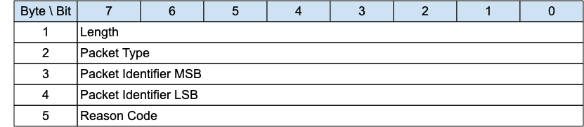
A PUBACK packet is the response to a PUBLISH packet with QoS 1.

3.9.5.1 PUBACK Header
The first 2 or 4 bytes of the packet are encoded according to the variable length packet header format. Refer to section 2.1 for a detailed description.

3.9.5.2 Packet Identifier
The same value as the Packet Identifier in the PUBLISH Packet being acknowledged.

3.9.5.3 Reason Code
The values for Reason Codes are shown in section 2.3. The sender of the PUBACK Packet MUST use one of the Reason Codes applicable to PUBACK.

3.9.5.4 PUBACK Actions
As described in section 4.3.3.

3.9.6 PUBREC - Publish Received (QoS 2 delivery part 1)
Figure 3-18 – PUBREC Packet
A PUBREC packet is the response to a PUBLISH packet with QoS 2. It is the second packet of the QoS 2 protocol exchange.

3.9.6.1 PUBREC Header
The first 2 or 4 bytes of the packet are encoded according to the variable length packet header format. Refer to section 2.1 for a detailed description.

3.9.6.2 Packet Identifier
The same value as the Packet Identifier in the PUBLISH Packet being acknowledged.

3.9.6.3 Reason Code
The values for Reason Codes are shown in section 2.3. The sender of the PUBREC Packet MUST use one of the Reason Codes applicable to PUBREC.

3.9.6.4 PUBREC Actions
As described in section 4.3.4.

3.9.7 PUBREL - Publish Release (QoS 2 delivery part 2)
Figure 3-19 – PUBREL Packet
A PUBREL packet is the response to a PUBREC packet. It is the third packet of the QoS 2 protocol exchange.

3.9.7.1 PUBREL Header
The first 2 or 4 bytes of the packet are encoded according to the variable length packet header format. Refer to section 2.1 for a detailed description.

3.9.7.2 Packet Identifier
The same value as the Packet Identifier in the PUBLISH Packet being acknowledged.

3.9.7.3 Reason Code
The values for Reason Codes are shown in section 2.3. The sender of the PUBREL Packet MUST use one of the Reason Codes applicable to PUBREL.

3.9.7.4 PUBREL Actions
As described in section 4.3.4.

3.9.8 PUBCOMP - Publish Complete (QoS 2 delivery part 3)
Figure 3-20 – PUBCOMP Packet
The PUBCOMP packet is the response to a PUBREL packet. It is the fourth and final packet of the QoS 2 protocol exchange.

3.9.8.1 PUBCOMP Header
The first 2 or 4 bytes of the packet are encoded according to the variable length packet header format. Refer to section 2.1 for a detailed description.

3.9.8.2 Packet Identifier
The same value as the Packet Identifier in the PUBLISH Packet being acknowledged.

3.9.8.3 Reason Code
The values for Reason Codes are shown in section 2.3. The sender of the PUBCOMP Packet MUST use one of the Reason Codes applicable to PUBCOMP.

3.9.8.4 PUBCOMP Actions
As described in section 4.3.4.

3.10 SUBSCRIBE - Subscribe Request
Figure 3-21 – SUBSCRIBE Packet with Topic Alias
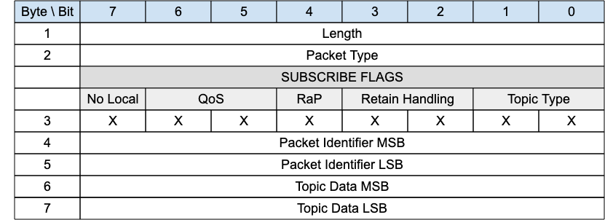
Or
Figure 3-22 – SUBSCRIBE Packet with Topic Filter
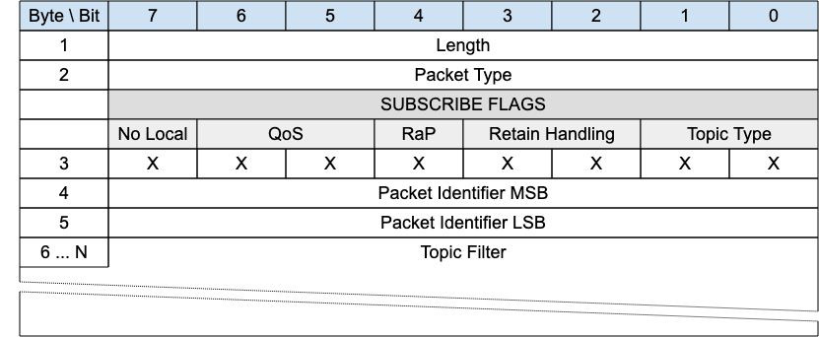
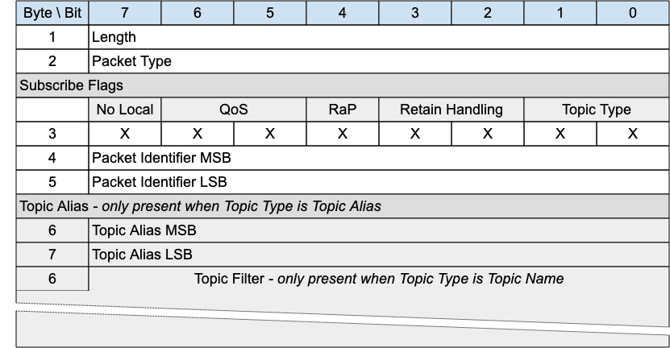
The SUBSCRIBE packet is sent from the Client to the Server a Subscription. A Subscription registers a Client’s interest in one or more Topics. The Server sends PUBLISH packets to the Client to forward Application Messages that were published to Topics that match the Subscription. The SUBSCRIBE packet also specifies the maximum QoS with which the Server can send Application Messages to the Client.

3.10.1 SUBSCRIBE Header
The first 2 or 4 bytes of the packet are encoded according to the variable length packet header format. Refer to section 2.1 for a detailed description.

3.10.2 SUBSCRIBE Flags
The SUBSCRIBE Flags field is 1 byte and governs the behavior of subscriptions.

3.10.2.1 Topic Type
Position: bits 0 and 1 of the SUBSCRIBE Flags.
This field determines the content of the Topic Alias and Topic Filter fields. Refer to section 2.4 for the definition of the various topic types.
The Topic Type may be Topic Filter, Predefined Topic Alias or Session Topic Alias.

3.10.2.2 Retain handling
Position: bits 2 and 3 of the SUBSCRIBE Flags.
This option specifies whether retained messages are sent when the subscription is established. This does not affect the sending of retained messages at any point after the subscribe. If there are no retained messages matching the Topic Filter, all these values act the same. The values are:
0: Send retained messages at the time of the subscribe
1: Send retained messages at subscribe only if the subscription does not currently exist
2: Do not send retained messages at the time of the subscribe
It is a Protocol Error to send a Retain Handling value of 3.

3.10.2.3 Retain as Published
Position: bit 4 of the SUBSCRIBE Flags. Labelled RaP in Figure 3-21.
If 1, Application Messages forwarded using this subscription keep the RETAIN flag they were published with.
If 0, Application Messages forwarded using this subscription have the RETAIN flag set to 0. Retained messages sent when the subscription is established have the RETAIN flag set to 1.

3.10.2.4 QoS
Position: bits 5 and 6 of the SUBSCRIBE Flags.
The maximum QoS. This gives the maximum QoS level at which the Server can send Application Messages to the Client. It is a Protocol Error if the Maximum QoS field has the value 3.

3.10.2.5 No Local
Position: bit 7 of the SUBSCRIBE Flags.
if the value is 1, Application Messages MUST NOT be forwarded to a Virtual Connection with a Client Identifier equal to the Client Identifier of the publishing Virtual Connection.
Informative Comment
A Session is associated with a Client Identifier. A Virtual Connection is a link between Network Identity and a Session by means of the Client Identifier. So a Virtual Connection can be matched to a Client Identifier.

3.10.3 Packet Identifier
Used to identify the corresponding SUBACK packet. It should ideally be populated with a random integer value.

3.10.4 Topic Alias
If the Topic Type is Predefined Topic Alias or Session Topic Alias, then the Topic Alias field MUST be present in the SUBSCRIBE packet.
If the Topic Type is Topic Filter (0b11) the Topic Alias field MUST NOT be present in the SUBSCRIBE packet.
Contains Fixed Length UTF-8 Encoded String topic filter, topic alias (predefined or session topic alias), or short topic name as indicated in the Topic Type field in flags. Determines the topic names which this subscription is interested in.

3.10.5 Topic Filter
If the Topic Type is Topic Filter (0b11) the Topic Filter field MUST be present in the SUBSCRIBE packet.
If the Topic Type is Predefined Topic Alias or Session Topic Alias, then the Topic Filter field MUST NOT be present in the SUBSCRIBE packet.
The Topic Filter is a UTF-8 encoded string, which may contain wildcards. A SUBSCRIBE packet with a zero length Topic Filter is a Protocol Error. Refer to section 4.12 for information about handling errors.

3.10.6 SUBSCRIBE Actions
When the Server receives a SUBSCRIBE packet from a Client, the Server MUST respond with a SUBACK packet [MQTT-SN-3.17.5-1]. The SUBACK packet MUST have the same Packet Identifier as the SUBSCRIBE packet that it is acknowledging [MQTT-SN-3.17.5-2].
If a Server receives a SUBSCRIBE packet containing a Topic Filter that is identical to a Subscription’s Topic Filter for the current Session, then it MUST replace that existing Subscription with a new Subscription [MQTT-SN-3.17.5-3]. The Topic Filter in the new Subscription will be identical to that in the previous Subscription, although its Subscription Options could be different. If the Retain Handling option is 0, any existing retained messages matching the Topic Filter MUST be re-sent, but Application Messages MUST NOT be lost due to replacing the Subscription [MQTT-SN-3.17.5-4].
If a Server receives a Topic Filter that is not identical to any Topic Filter for the current Session, a new Subscription is created. If the Retain Handling option is not 2, all matching retained messages are sent to the Client.
The SUBACK packet sent by the Server to the Client MUST contain a Reason Code [MQTT-SN-3.17.5-5]. This Reason Code MUST either show the maximum QoS that was granted for that Subscription or indicate that the subscription failed [MQTT-SN-3.17.5-6]. The Server might grant a lower Maximum QoS than the subscriber requested. The QoS of Application Messages sent in response to a Subscription MUST be the minimum of the QoS of the originally published Application message and the Maximum QoS granted by the Server [MQTT-SN-3.17.5-7]. The server is permitted to send duplicate copies of a Application message to a subscriber in the case where the original Application message was published with QoS 1 and the maximum QoS granted was QoS 0.
Informative comment
If a subscribing Client has been granted maximum QoS 1 for a particular Topic Filter, then a QoS 0 Application Message matching the filter is delivered to the Client at QoS 0. This means that at most one copy of the Application Message is received by the Client. On the other hand, a QoS 2 Application Message published to the same topic is downgraded by the Server to QoS 1 for delivery to the Client, so that Client might receive duplicate copies of the Application Message.
Informative comment
If the subscribing Client has been granted maximum QoS 0, then an Application Message originally published as QoS 2 might get lost on the hop to the Client, but the Server should never send a duplicate of that Application Message. A QoS 1 Application Message published to the same topic might either get lost or duplicated on its transmission to that Client.
Informative comment
Subscribing to a Topic Filter at QoS 2 is equivalent to saying "I would like to receive Application Messages matching this filter at the QoS with which they were published". This means a publisher is responsible for determining the maximum QoS an Application Message can be delivered at, but a subscriber is able to require that the Server downgrades the QoS to one more suitable for its usage.

3.11 SUBACK - Subscribe Acknowledgement
Figure 3-22 – SUBACK Packet
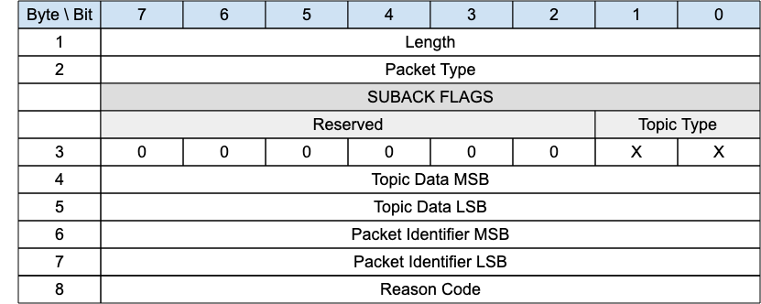
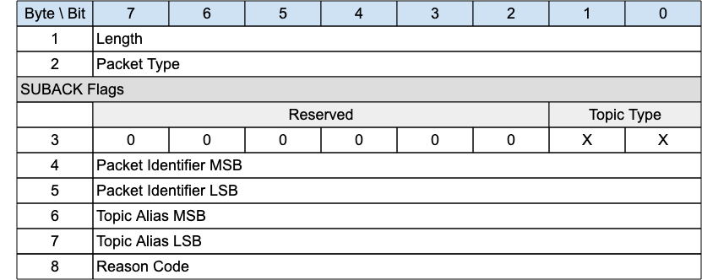
The SUBACK packet is sent by a gateway to a client as an acknowledgment to the receipt and processing of a SUBSCRIBE packet.

3.11.1 SUBACK Header
The first 2 or 4 bytes of the packet are encoded according to the variable length packet header format. Refer to section 2.1 for a detailed description.

3.11.2 SUBACK Flags
The SUBACK Flags is a 1 byte field which contains flags specifying the contents of the SUBACK packet. Bits 7-2 of the SUBACK Flags are reserved and MUST be set to 0.
The Client MUST validate that the reserved flags in the SUBACK packet are set to 0. If any of the reserved flags is not 0 it is a Malformed Packet.

3.11.2.1 Topic Type
Position: bits 0 and 1 of the SUBACK Flags.
Determines the format of the topic value. Refer to section 2.4 for the definition of the various topic types.
The Topic Type in the SUBACK packet MUST be either Predefined Topic Alias or Session Topic Alias.
If there is no Topic Alias returned the Topic Type MUST be Predefined Topic Alias.

3.11.3 Packet Identifier
The same value as the Packet Identifier in the SUBSCRIBE Packet being acknowledged.

3.11.4 Topic Alias
If a Topic Alias is returned, it MUST be used instead of the Topic Name by the Gateway when sending PUBLISH packets to the client.
If no Topic Alias is returned, the Topic Alias field in the SUBACK MUST be 0x000. This will be the case when subscribing to a Topic Filter containing wildcards, as Topic Aliases can only be applied to Topic Names.

3.11.5 Reason Code
The values for Reason Codes are shown in section 2.3. The sender of the SUBACK Packet MUST use one of the Reason Codes applicable to SUBACK.

3.12 UNSUBSCRIBE - Unsubscribe Request
Figure 3-23 – UNSUBSCRIBE Packet with Topic Alias
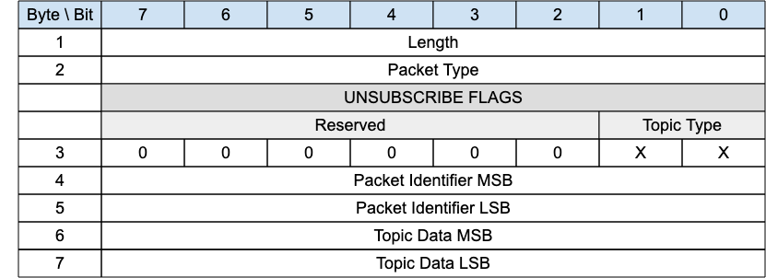
Or:
Figure 3-24 – UNSUBSCRIBE Packet with Topic Filter
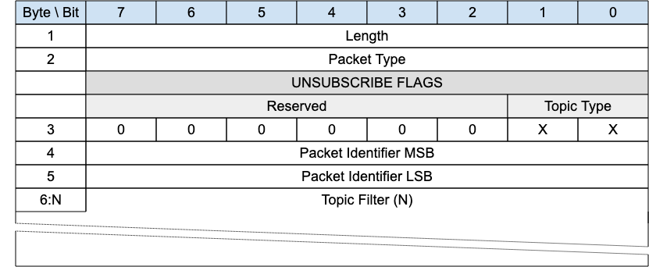
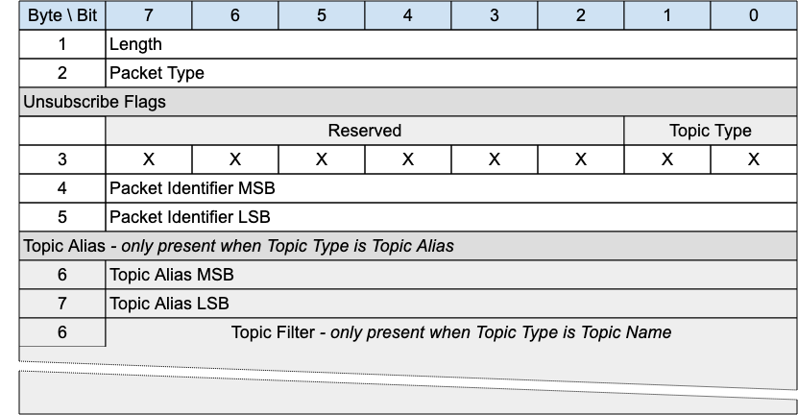
An UNSUBSCRIBE packet is sent by the Client to the Gateway to remove subscriptions to topics.

3.12.1 UNSUBSCRIBE Header
The first 2 or 4 bytes of the packet are encoded according to the variable length packet header format. Refer to section 2.1 for a detailed description.

3.12.2 UNSUBSCRIBE Flags
The UNSUBSCRIBE Flags is a 1 byte field which contains flags specifying the contents of the UNSUBSCRIBE packet. Bits 7-2 of the UNSUBSCRIBE Flags are reserved and MUST be set to 0.
The Client MUST validate that the reserved flags in the UNSUBSCRIBE packet are set to 0. If any of the reserved flags is not 0 it is a Malformed Packet.

3.12.2.1 Topic Type
Position: bits 0 and 1 of the UNSUBSCRIBE Flags.
Determines the existence of the Topic Alias or Topic Filter. Refer to section 2.4 for the definition of the various topic types.

3.12.3 Packet Identifier
Used to identify the corresponding UNSUBACK packet. It should ideally be populated with a random integer value.

3.12.4 Topic Alias
A Topic Alias MUST be present in the UNSUBSCRIBE packet if the Topic Type is Predefined or Session Topic Alias.
A Topic Alias MUST NOT be present in the UNSUBSCRIBE packet if the Topic Type is Topic Name.
Predefined or Session Topic Alias as indicated by the Topic Type. Determines the topic names which this subscription is interested in.

3.12.5 Topic Filter
A Topic Filter MUST be present in the UNSUBSCRIBE packet if the Topic Type is Topic Name.
A Topic Filter MUST NOT be present in the UNSUBSCRIBE packet if the Topic Type is Predefined or Session Topic Alias.
Contains a UTF-8 Encoded String Topic Filter occupying the rest of the packet, bounded by the packet length.

3.12.6 UNSUBSCRIBE Actions
If a Topic Alias is used in an UNSUBSCRIBE request, it MUST be translated to its equivalent Topic Name before any other action takes place.
The Topic Filter (whether it contains wildcards or not) supplied in an UNSUBSCRIBE packet MUST be compared character-by-character with the current set of Topic Filters held by the Server for the Client. If any filter matches exactly then its owning Subscription MUST be deleted [MQTT-SN-3.19.4-1], otherwise no additional processing occurs.
When a Server receives UNSUBSCRIBE :
- It MUST stop adding any new Application Messages which match the Topic Filters, for delivery to the Client [MQTT-SN-3.19.4-2].
- It MUST complete the delivery of any QoS 1 or QoS 2 Application Messages which match the Topic Filters and it has started to send to the Client [MQTT-SN-3.19.4-3].
- It MAY continue to deliver any existing Application Messages which match the Topic Filters buffered for delivery to the Client.
The Server MUST respond to an UNSUBSCRIBE request by sending an UNSUBACK packet [MQTT-3.19.4-4]. The UNSUBACK packet MUST have the same Packet Identifier as the UNSUBSCRIBE packet. Even where no Topic Subscriptions are deleted, the Server MUST respond with an UNSUBACK [MQTT-3.19.4-5].

3.13 UNSUBACK - Unsubscribe Acknowledgement
Figure 3-25 – UNSUBACK Packet
An UNSUBACK packet is sent by a Gateway to acknowledge the receipt and processing of an UNSUBSCRIBE packet.

3.13.1 UNSUBACK Header
The first 2 or 4 bytes of the packet are encoded according to the variable length packet header format. Refer to section 2.1 for a detailed description.

3.13.2 Packet Identifier
The same value as the Packet Identifier in the UNSUBSCRIBE packet being acknowledged.

3.13.3 Reason Code
The UNSUBACK Reason Codes are shown in Table 9: Reason Code Values. The server sending the UNSUBACK packet MUST use one of the UNSUBACK Reason Codes.

3.14 PINGREQ - Ping Request
Figure 3-26 – PINGREQ Packet
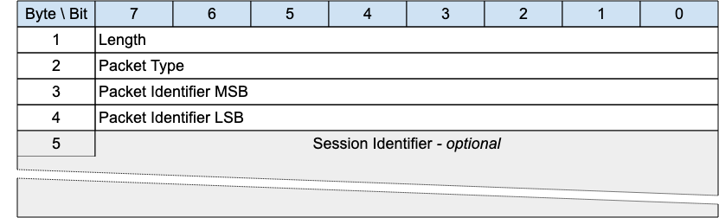
When the PINGREQ packet is sent from a Client to the Server, it can be used to:
- Indicate to the Server that the Client is alive in the absence of any other MQTT Control Packets being sent from the Client to the Server.
- Request that the Server responds to confirm that it is alive.
- Exercise the network to indicate that communications is active.
This packet is used in Keep Alive processing. Refer to section 3.4.6 for more details.
The PINGREQ packet can also be sent from the Server to a Client.

3.14.1 PINGREQ Header
The first 2 or 4 bytes of the packet are encoded according to the variable length packet header format. Refer to section 2.1 for a detailed description.

3.14.2 Packet Identifier
Used to identify the corresponding PINGRESP packet. It should ideally be set to a random integer value.

3.14.3 Session Identifier
An optional field which contains an identifier to help the Server link the sender to an existing Session. It can contain a Client Identifier or other information. This field is included by a sleeping client when it goes to the Awake state and is waiting for packets to be sent by the Gateway.

3.14.4 PINGREQ Actions
The Server MUST send a PINGRESP packet in response to a PINGREQ packet [MQTT-SN-3.21.4-1].
The Client MAY send a PINGRESP packet in response to a PINGREQ packet [MQTT-SN-3.21.4-2].

3.15 PINGRESP - Ping Response
Figure 3-27 – PINGRESP Packet
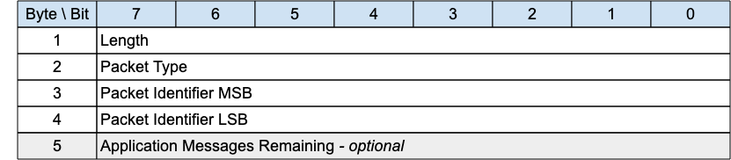
A PINGRESP packet is the response to a PINGREQ packet and means ”yes I am alive”. PINGREQ packets flow in either direction, sent either by a connected client or the gateway. it has only a header and no variable part.
A PINGRESP packet is also sent by a Gateway to inform a sleeping Client that it has no more buffered packets for that Client.

3.15.1 PINGRESP Header
The first 2 or 4 bytes of the packet are encoded according to the variable length packet header format. Refer to section 2.1 for a detailed description.

3.15.2 Packet Identifier
The same value as the Packet Identifier in the PINGREQ Packet being acknowledged.

3.15.3 Application Messages Remaining
The number of Application Messages still queued for delivery at the Server when the PINGRESP is sent to send the Client back to sleep. It is optional, intended as useful information for the Client. Values can be:
Figure 3-28 – PINGRESP continuation values
Allowed Values | Description
0 | No Application Messages are waiting to be delivered
1 – 254 (incl.) | The number of Application Messages waiting to be delivered
255 (0xFF) | An unspecified positive number of Application Messages waiting to be delivered greater than 0.

3.16 DISCONNECT - Disconnect Notification
Figure 3-29 – DISCONNECT Packet
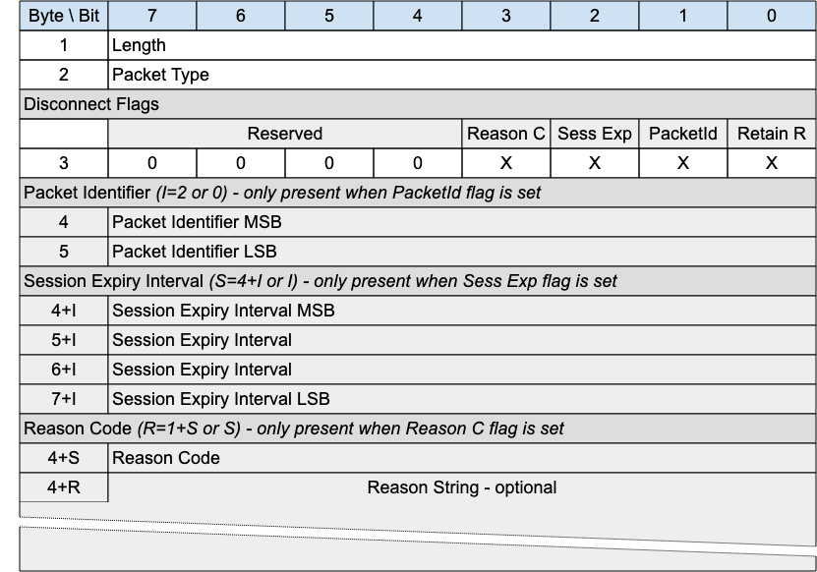
The DISCONNECT packet is sent by a Client to indicate that it is going to delete the Virtual connection and go to the Disconnected state.
DISCONNECT may be sent by a Server to indicate that it cannot continue with the Virtual Connection and is deleting it - for instance the Server might be shutting down. It should use an appropriate and allowed Reason Code - 0x8B for Server shutting down, for instance.
If a Client or Server receives a packet which requires a Virtual Connection (all packets except CONNECT, ADVERTISE, GWINFO, SEARCHGW and PUBWOS), and no Virtual Connection exists, it MAY send a DISCONNECT in response to the originator with Reason Code 0xF4 - No Virtual Connection exists.

3.16.1 DISCONNECT Header
The first 2 or 4 bytes of the packet are encoded according to the variable length packet header format. Refer to section 2.1 for a detailed description.

3.16.2 DISCONNECT Flags
The DISCONNECT Flags is a 1 byte field which contains flags specifying the contents of the DISCONNECT packet. Bits 7-5 of the DISCONNECT Flags are reserved and MUST be set to 0.
The receiver MUST validate that the reserved flags in the DISCONNECT packet are set to 0. If any of the reserved flags is not 0 it is a Malformed Packet.

3.16.2.1 Retain Registrations
Position: bit 0 of the DISCONNECT Flags.
Specifies whether Topic registrations should be retained by the Gateway during the Asleep state. “0” indicates registrations should be removed during the sleeping period and renegotiated when Awake or Active. “1” indicates registrations should be retained during the Asleep period, and therefore not nrenegotiated when Awake or Active.

3.16.2.2 Packet Identifier Flag
Position: bit 1 of the DISCONNECT Flags. Labelled PacketId in Figure 3-39.
​​If the Packet Identifier Flag is set to 0, a Packet Identifier MUST NOT be present in the Packet [MQTT-SN-3.16.2.2-1].
If the Packet Identifier Flag is set to 1, a Packet Identifier MUST be present in the Packet [MQTT-SN-3.16.2.2-2].

3.16.2.3 Session Expiry Interval Flag
Position: bit 2 of the DISCONNECT Flags. Labelled Sess Exp in Figure 3-39.
​​If the Session Expiry Interval Flag is set to 0, a Session Expiry Interval MUST NOT be present in the Packet [MQTT-SN-3.16.2.3-1].
If the Session Expiry Interval Flag is set to 1, a Session Expiry Interval MUST be present in the Packet [MQTT-SN-3.16.2.3-2].

3.16.2.4 Reason Code Flag
Position: bit 3 of the DISCONNECT Flags. Labelled Reason C in Figure 3-39.
​​If the Reason Code Flag is set to 0, a Reason Code MUST NOT be present in the Packet [MQTT-SN-3.16.2.4-1].
If the Reason Code Flag is set to 1, a Reason Code MUST be present in the Packet [MQTT-SN-3.16.2.4-2].

3.16.3 Packet Identifier
Optional. This can be used by a Gateway when responding to a Client packet for which there is no current Virtual Connection. In this case, the DISCONNECT packet can be sent by the Gateway, setting the Reason Code to 0xF4 (No Virtual Connection Exists) and including the Packet Identifier of the erroneous packet, to help with problem diagnosis.

3.16.4 Reason Code
The Reason Code for the DISCONNECT packet is optional. If not provided, 0x00 (Normal disconnection) is assumed.
The values for Reason Codes are shown in section 2.3. The sender of the DISCONNECT packet MUST use one of the Reason Code values applicable to DISCONNECT [MQTT-SN-3.23.3-1].

3.16.5 Session Expiry Interval
The Session Expiry Interval is a four-byte integer time interval measured in seconds. If the Session Expiry Interval is absent, the Session Expiry Interval in the CONNECT packet is used.
The Session Expiry Interval MUST NOT be sent on a DISCONNECT by the Server [MQTT–SN-3.23.4-1].
If the Session Expiry Interval in the CONNECT packet was zero, then it is a Protocol Error to set a non-zero Session Expiry Interval in the DISCONNECT packet sent by the Client. If such a non-zero Session Expiry Interval is received by the Server, it does not treat it as a valid DISCONNECT packet. The Server uses DISCONNECT with Reason Code 0x82 (Protocol Error) as described in section 4.12.

3.16.6 Reason String
Fixed Length UTF-8 Encoded String representing a clear text description of disconnection.

3.16.7 DISCONNECT Actions
After sending a DISCONNECT packet the sender:
- MUST NOT send any more MQTT-SN Control Packets on that Virtual Connection [MQTT-SN-3.23.6-1].
- MUST delete the Virtual Connection [MQTT-SN-3.23.6-2].
On receipt of DISCONNECT with a Reason Code of 0x00 (Success) the Server:
- MUST discard any Will Message associated with the current Connection without publishing it [MQTT-SN-3.23.6-3], as described in section 3.4.9.
On receipt of DISCONNECT, the receiver:
- MUST NOT send any more MQTT-SN Control Packets on the Virtual Connection, if one exists.
- SHOULD delete any existing Virtual Connection.
After receiving a DISCONNECT, a Client can make a new Virtual Connection by sending a CONNECT Packet to the Server.

3.17 WAKEUP - Wake up request
Figure 3-30 – WAKEUP Packet
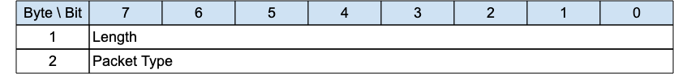
The wakeup packet is a signal sent from the gateway to a client. It is an indication from the gateway that the client should wake up. The client is not obliged to honor this request, nor may it even receive the packet. It can choose to ignore the request, or undertake one of the sequences outlined in Section 4.15.3. The client need not respond to this packet.

3.17.1 WAKEUP Header
The first 2 or 4 bytes of the packet are encoded according to the variable length packet header format. Refer to section 2.1 for a detailed description.

3.17.2 WAKEUP Actions
The Client MAY choose to follow the AWAKE procedure in response to receiving a WAKEUP packet [MQTT-SN-3.21.4-2].

3.18 SLEEPREQ - Sleep request
Figure 3-31 – SLEEPREQ Packet
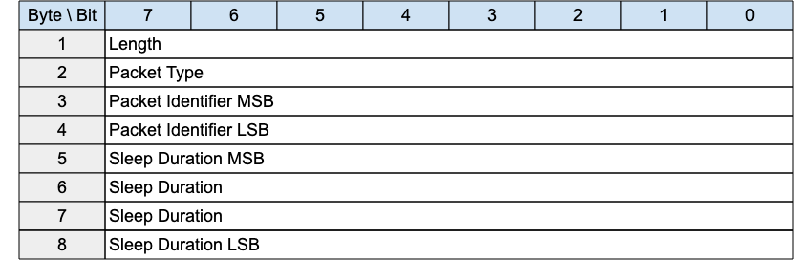
The SLEEPREQ packet is sent from the Client to the Server to indicate that it is going to sleep (that is, transitioning to the Asleep state).

3.18.1 SLEEPREQ Header
The first 2 or 4 bytes of the packet are encoded according to the variable length packet header format. Refer to section 2.1 for a detailed description.

3.18.2 Packet Identifier
Used to identify the corresponding SLEEPRESP packet. It should ideally be set to a random integer value.

3.18.3 Sleep Duration
The Sleep Duration is a four-byte integer time interval measured in seconds. It is the maximum amount of time that a client may stay asleep without being disconnected by the Gateway. For more information on sleeping clients, and the purpose of Sleep Duration, see section 4.15.3.

3.18.4 SLEEPREQ Actions
The Server MUST send a SLEEPRESP packet in response to a SLEEPREQ packet [MQTT-SN-3.24.4-1].
After sending a SLEEPREQ packet the Client:
- MAY wait for a SLEEPRESP packet in response from the Server.
A Client will wait for a response if it wishes to ascertain that the Server has received and processed its sleep request. By doing so it will avoid having to:
- reestablish a Virtual Connection on wakening if the Server did not receive the SLEEPREQ, or
- retransmit the SLEEPREQ if it does not receive a SLEEPRESP from the server.
It is important for the Client to verify that the Server recognizes that the Client is going to sleep by waiting for a SLEEPRESP response.
A Client will not wait, or stop waiting, if it is concerned that it will use excess power to determine that the Server has received the SLEEPREQ.

3.19 SLEEPRESP - Sleep response
Figure 3-32 – SLEEPRESP Packet
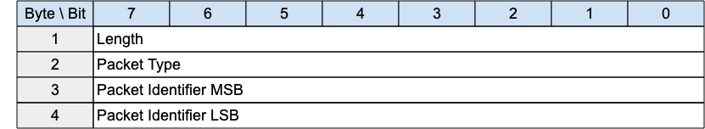

3.19.1 SLEEPRESP Header
The first 2 or 4 bytes of the packet are encoded according to the variable length packet header format. Refer to section 2.1 for a detailed description.

3.19.2 Packet Identifier
The same value as the Packet Identifier in the SLEEPREQ Packet being acknowledged.

3.20 Forwarder Encapsulation
Figure 3-33 – Format of an Forwarder Encapsulated MQTT-SN Packet
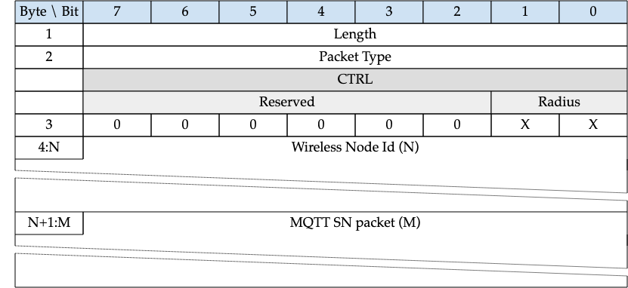
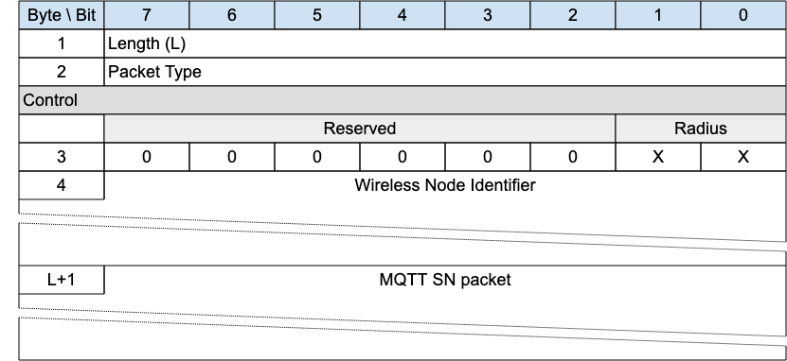
MQTT-SN clients can also access a Gateway via a forwarder in case the gateway is not directly attached to their WSNs. The forwarder simply encapsulates the MQTT-SN Packets it receives from the Clients and forwards them unchanged to the Gateway. In the opposite direction, it decapsulates the Packets it receives from the Gateway and sends them unchanged to the Clients. Refer to section 4.13 for more information.

3.20.1 Forwarder Encapsulation Header
The first 2 or 4 bytes of the packet are encoded according to the variable length packet header format. Refer to section 2.1 for a detailed description.
The Length field specifies the number of bytes up to the end of the Wireless Node Identifier field, including the Length field itself.

3.20.2 Control Flags
The Control flags contain control information exchanged between the Gsteway and the forwarder.

3.20.2.1 Radius
Position: bits 0 and 1 of the Control byte.
Transmission radius - only relevant in direction Gateway to Forwarder.

3.20.3 Wireless Node Identifier
Identifies the wireless node which has sent or should receive the encapsulated MQTT-SN packet. The mapping between this Id and the address of the wireless node is implemented by the forwarder, if needed.

3.20.4 MQTT-SN Packet
The MQTT-SN packet, encoded according to the packet type.

3.21 Protection Encapsulation
Figure 3-35 – Format of an Protection Encapsulated MQTT-SN Packet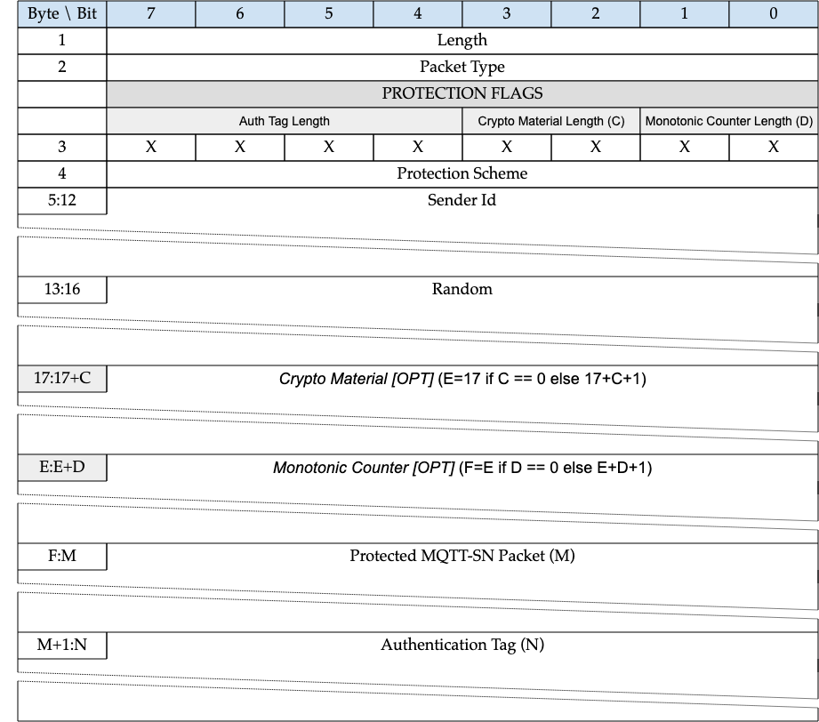
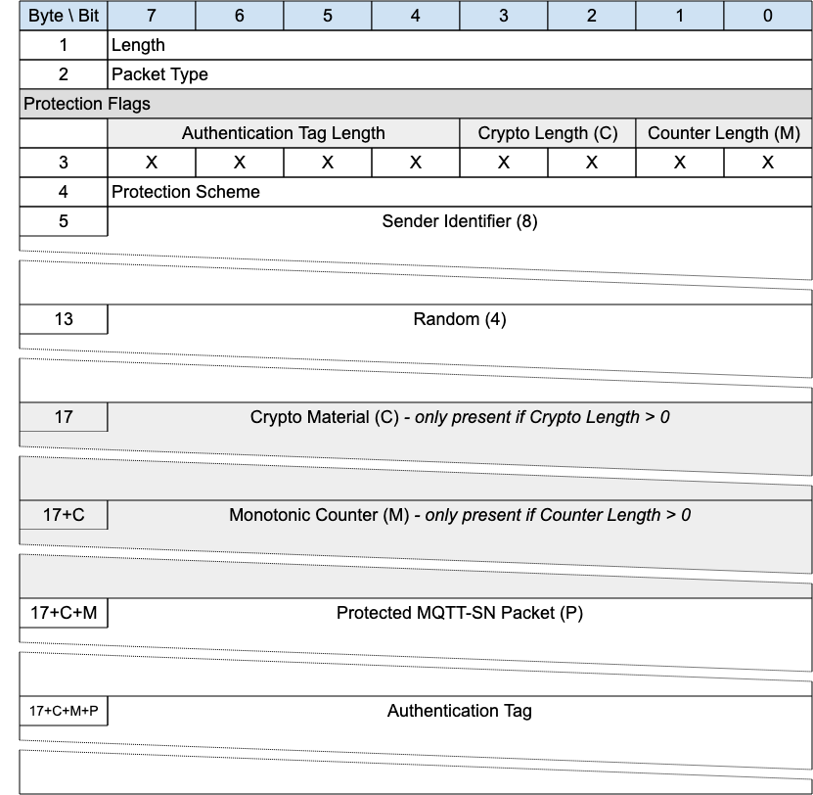
Protection encapsulation provides a secure envelope for any MQTT-SN packet (with the exception of the Forward Encapsulation packet). The fields provided by the Protection Encapsulation provide a means by which the sender is identified and the packet is protected, using a number of prescribed protection schemes.
The sender is the originator of the “Protected MQTT-SN Packet” and responsible for its protection. This responsibility MUST NOT be delegated to a third entity like a Forwarder.
The sender identification is required as the sender and the receiver of the protected packet must have access to the same shared key to be used directly or after derivation. The authentication of the sender and the receiver, their authorizations and the provisioning of the shared keys used to protect integrity and optionally confidentiality of the protected packet content are out of scope.
A protected packet, like any other one, can be the payload of a Forwarder Encapsulated packet.

//TODO - Break out the conformance aspects of this paragraph from recommendations.
When the PROTECTION packet is handled by a gateway, it is mandatory to use it to protect all MQTT-SN packets exchanged with a Client for which a shared key (indexed by its Sender Id) is available.
If the client is not enrolled to the gateway (so the gateway has no access to a key shared with it on the basis of its Sender Id) and the Client and gateway are not in a private network, it is recommended for the gateway to process only MQTT-SN packets received over a DTLS session initiated with mutual authentication by the client.
When the PROTECTION packet is handled by a Client, it is mandatory to use it to protect all MQTT-SN packets exchanged with a Gateway for which a shared key (indexed by its GwId) is available.
If the Gateway is not enrolled to the Client (so the Client has no access to a key shared with it on the basis of its GwId) and the Client and Gateway are not in a private network, it is recommended for the Client to open a DTLS session and process only MQTT-SN packets received over it.

3.21.1 Protection Encapsulation Header
The first 2 or 4 bytes of the packet are encoded according to the variable length packet header format. Refer to section 2.1 for a detailed description.

3.21.2 Protection Flags
The Protection Flags is a 1 byte field specifying the properties of the Protection Encapsulation.

3.21.2.1 Monotonic Counter Length
Position: bits 0 and 1 of the Protection Flags. Labelled Counter Length in Figure 3-35.
Specifies the number of bytes forming the monotonic counter in big-endian order. Only 3 of the 4 possible values are allowed:
- the value 0x3 is Reserved;
- if 0x2, a monotonic counter field of 32 bits (4 bytes) is present;
- if 0x1, a monotonic counter field of 16 bits (2 bytes) is present;
- if 0x0, the monotonic counter field is not present.

3.21.2.2 Cryptographic Material Length
Position: bits 2 and 3 of the Protection Flags. Labelled Crypto Length in Figure 3-35.
Specifies the number of 16 bit groups forming the cryptographic material in big-endian order. Below the meaning of each possible value:
- if 0x3, a cryptographic material field of 96 bits (12 bytes) is present
- if 0x2, a cryptographic material field of 32 bits (4 bytes) is present
- if 0x1, a cryptographic material field of 16 bits (2 bytes) is present
- if 0x0, the cryptographic material field is not present.

3.21.2.3 Authentication Tag Length
Position: bits 4 through 7 of the Protection Flags.
Defines the size of the authentication tag.
- Only 14 of the 16 possible values are allowed:
  - if 0x00, the authentication tag length is provider defined;
  - if 0x01, the authentication tag length is defined by the protection scheme nominal tag length and this is the only value allowed if the protection scheme is not “Authentication Only”;
  - the values from 0x2 to 0x3 are Reserved;
  - any other value 0xZ, so between 0x4 and 0xF, is allowed only for the truncation of “Authentication Only” protection schemes and the authentication tag length will be (0xZ)*16 bits; for example
    - if the value is 0xF, the Authentication tag length will be (0xF)*16=240 bits;
    - if the value is 0x3, the Authentication tag length will be (0x4)*16=64 bits.
- If a truncation of the output of the authentication algorithm is required, it has to be taken in most significant bits first order (leftmost bits).
- Some 0xZ values are not allowed for some “Authentication Only” protection schemes because they define a tag size bigger than the nominal tag size. For example, values from 0x09 (144 bits) to 0x0F (240 bits) are not allowed for “Authentication Only” protection schemes with a nominal tag size less than 144 bits, such as CMAC-128, CMAC-192, CMAC-256.

3.21.3 Protection Scheme
A (1 byte) field should contain one of the not Reserved indexes in the following table. In general two types of protection scheme are considered: Authentication only (like HMAC or CMAC) and AEAD (Authenticated Encryption with Associated Data, like GCM, CCM or ChaCha20/Poly1305).
Figure 3-36 – Protection Schemes
Index | Name | Authentication  Only | Key Size | Nominal Tag Size
0x00 | HMAC-SHA256 (Note 1) | Yes | Any size (Note 2) | 256 bits
0x01 | HMAC-SHA3_256 (Note 1) | Yes | Any size (Note 2) | 256 bits
0x02 | CMAC-128 (Note 3) | Yes | 128 bits | 128 bits
0x03 | CMAC-192 (Note 3) | Yes | 192 bits | 128 bits
0x04 | CMAC-256 (Note 3) | Yes | 256 bits | 128 bits
0x05-0x3B | RESERVED
0x3C-0x3F | Provider defined | Yes | Provider defined | Provider defined
0x40 | AES-CCM-64-128 (Notes 4,5) | No | 128 bits | 64 bits
0x41 | AES-CCM-64-192 (Notes 4,5) | No | 192 bits | 64 bits
0x42 | AES-CCM-64-256 (Notes 4,5) | No | 256 bits | 64 bits
0x43 | AES-CCM-128-128 (Notes 4,5) | No | 128 bits | 128 bits
0x44 | AES-CCM-128-192 (Notes 4,5) | No | 192 bits | 128 bits
0x45 | AES-CCM-128-256 (Notes 4,5) | No | 256 bits | 128 bits
0x46 | AES-GCM-128-128 (Notes 6,7) | No | 128 bits | 128 bits
0x47 | AES-GCM-128-192 (Notes 6,7) | No | 192 bits | 128 bits
0x48 | AES-GCM-128-256 (Notes 6,7) | No | 256 bits | 128 bits
0x49 | ChaCha20/Poly1305 (Notes 8,9) | No | 256 bits | 128 bits
0x4A-0xEF | RESERVED
0xF0-0xFF | Provider defined | No | Provider defined | Provider defined
Note(s):
- Reference https://www.rfc-editor.org/rfc/rfc2104
- Reference https://nvlpubs.nist.gov/nistpubs/FIPS/NIST.FIPS.198-1.pdf
- Reference https://www.rfc-editor.org/rfc/rfc4493 and https://nvlpubs.nist.gov/nistpubs/SpecialPublications/NIST.SP.800-38b.pdf and https://csrc.nist.gov/CSRC/media/Projects/Cryptographic-Standards-and-Guidelines/documents/examples/AES_CMAC.pdf
- Reference https://www.rfc-editor.org/rfc/rfc3610 and security considerations on https://www.rfc-editor.org/rfc/rfc8152#section-10.2.1
- AES CCM requires a 13 bytes nonce as indicated in https://www.rfc-editor.org/rfc/rfc8152#section-10.2 and the nonce is obtained by performing SHA256, truncated to the leftmost 104 bits, of the sequence Byte 1 to Byte R (all packet fields until Protected MQTT-SN Packet)
- Reference https://nvlpubs.nist.gov/nistpubs/Legacy/SP/nistspecialpublication800-38d.pdf and security considerations on https://www.rfc-editor.org/rfc/rfc8152#section-10.1.1
- AES GCM requires a 12 bytes IV as indicated in https://www.rfc-editor.org/rfc/rfc8152#section-10.1 and the IV is obtained by performing SHA256, truncated to the leftmost 96 bits, of the sequence Byte 1 to Byte R (all packet fields until Protected MQTT-SN Packet)
- Reference: https://www.rfc-editor.org/rfc/rfc7539 and security considerations on https://www.rfc-editor.org/rfc/rfc8152#section-10.3.1
- ChaCha20/Poly1305 requires a 12 bytes nonce as indicated in https://www.rfc-editor.org/rfc/rfc8152#section-10.3 obtained by performing SHA256 truncated to 96 bit of the sequence Byte 1 to Byte R (all packet fields until Protected MQTT-SN Packet)

3.21.4 Sender Identifier
The Sender Id field (8 bytes) should contain:
If the message is originated by the Gateway:
- The SHA256 of the GwId truncated to the leftmost 64 bits (8 bytes);
If the message is originated by the Client:
- If a session is available: the SHA256 of the [Client Identifier] truncated to the leftmost 64 bits (8 bytes);
- If a session is not available: a unique value per sender over 8 bytes (like a MAC address, or other identifying characteristics). The methods to guarantee the uniqueness of the Sender Id in this case are out of scope.
Informative comment
8 bytes for the “Sender Id” field seems enough as it is calculated with a cryptographic hash, so the probability of collision is 1/2^64=5.42x10⁻²⁰.
Client Behavior
In order to create a whitelist of authorized senders, the Client should store a map of GwId and SHA256(GwId) truncated to the leftmost 64 bits. GwId can be obtained from pre-configuration, from an ADVERTISE packet or from a GWINFO packet.

Gateway Behavior
In order to create a whitelist of authorized senders, the MQTT-SN Gateway should store a map of ClientID and SHA256(ClientID) truncated to the leftmost 64 bits (8 bytes for each registered ClientID) for the clients having an active session and store a list of authorized Sender Ids for the clients not capable to establish sessions.

3.21.5 Random
The 4 byte Random field should contain a random number which is not guessable, generated at the time of Protection Encapsulation packet creation.
- Informative comment
In case of CCM, in the worst case scenario where the “Cryptographic Material” and the “Monotonic Counter” optional fields are not present, the recommended nonce on 13 bytes will be calculated as SHA256 truncated to 104 bits of the sequence Byte 1 to Byte 16 (all packet fields until Protected MQTT-SN Packet). So considering the same Sender Id, the same nonce can be generated with a probability of 1/2^32=2.33x10⁻¹⁰. With a shorter Random field of 2 bytes, the same nonce would be calculated with a probability of only 1/2^16=1.53x10⁻⁵. As CCM is a derivation of CTR (see https://en.wikipedia.org/wiki/CCM_mode), the nonce should never be reused for the same key so the probability to generate two identical nonces should be kept as low as possible. Same for GCM and ChaCha20/Poly1305, the security depends on choosing a unique IV of 12 bytes for every encryption performed with the same key (https://en.wikipedia.org/wiki/Galois/Counter_Mode).

3.21.6 Cryptographic Material
The optional field Cryptographic Material contains 0, 2, 4 or 12 bytes of cryptographic material that when defined it can be used to derive, from a shared master secret, the same keys on the two endpoints and/or, when filled partially or totally with a random value, to further reduce the probability of IV/nonce reuse for CCM or GCM or ChaCha20/Poly1305. For instance when the Cryptographic material length is set to 0x03, the Cryptographic Material field can be partially filled with a random value of 9 bytes (the remaining 3 bytes can be set to 0 if not used) in order to reach the 13 bytes used only once recommended for the nonce used by CCM or it can be partially filled with a random value of 8 bytes in order to reach the 12 bytes used only once recommended for the IV/nonce used by GCM or ChaCha20/Poly1305 .

3.21.7 Monotonic Counter
The optional field Monotonic Counter contains a 0, 2 or 4 byte number that when defined, is increased by the Client or Gateway for every packet sent. The counters should be considered independent of session or destination. E.g. The UE will keep a counter independently from the Gateway.

3.21.8 Protected MQTT-SN Packet
The field Protected MQTT-SN Packet contains the MQTT-SN packet that is being secured, encoded as per its packet type.
The Protected MQTT-SN Packet MUST NOT be a Forwarder Encapsulated Packet as the shared key used directly or after derivation for the protection must belong to the originator of the content and not to a Forwarder that, in general, is not able to securely identify the originator.

3.21.9 Authentication Tag
The field Authentication Tag field has a length depending on the Authentication Tag Length flag and it is calculated, on the basis of the Protection Scheme selected in Byte 4, on ALL the preceding fields.

4 Operational behavior
An important design point of MQTT-SN is to be as close as possible to MQTT. Therefore, all protocol semantics should remain, as far as possible, the same as those defined by MQTT.

4.1 Session state
In order to implement QoS 1 and QoS 2 protocol flows the Client and Server need to associate state with the Client Identifier, this is referred to as the Session State. The Server also stores the subscriptions as part of the Session State.
The Session can continue across a sequence of Virtual Connections. It lasts as long as the latest Virtual Connection plus the Session Expiry Interval.
The Session State in the Client consists of:
- QoS 1 and QoS 2 PUBLISH Packets which have been sent to the Server, but have not been completely acknowledged.
- QoS 2 PUBLISH Packets which have been received from the Server, but have not been completely acknowledged.
- Session Topic Alias mappings.
The Session State in the Server consists of:
- The existence of a Session, even if the rest of the Session State is empty.
- The Client’s subscriptions.
- QoS 1 and QoS 2 PUBLISH Packets which have been sent to the Client, but have not been completely acknowledged.
- QoS 1 and QoS 2 PUBLISH Packets pending transmission to the Client and OPTIONALLY QoS 0 PUBLISH Packets pending transmission to the Client.
- QoS 2 PUBLISH Packets which have been received from the Client, but have not been completely acknowledged.
- The Will Message and associated Will data.
- If the Session is currently not connected, the time at which the Session will end and Session State will be discarded.
- Session Topic Alias mappings.
Retained messages do not form part of the Session State in the Server, they are not deleted as a result of a Session ending.

4.1.1 Storing Session State
The Server MUST NOT discard the Session State while the Virtual Connection exists [MQTT-SN-4.1.1-1].
The Client MUST NOT discard the Session State while the Virtual Connection exists [MQTT-SN-4.1.1-2].
The Server MUST discard the Session State when the Virtual Connection is deleted and the Session Expiry Interval has passed [MQTT-SN-4.1.1-3]. A Session Expiry Interval of 0xFFFFFFFF is an infinite amount of time, so never passes.
Informative comment
The storage capabilities of Client and Server implementations will of course have limits in terms of capacity and may be subject to administrative policies. Stored Session State can be discarded as a result of an administrator action, including an automated response to defined conditions. This has the effect of terminating the Session. These actions might be prompted by resource constraints or for other operational reasons. It is possible that hardware or software failures may result in loss or corruption of Session State stored by the Client or Server. It is prudent to evaluate the storage capabilities of the Client and Server to ensure that they are sufficient.

4.1.2 Session Establishment
As with MQTT, an MQTT-SN client needs to set up a session on the server, unless it is publishing ONLY using PUBLISH WITHOUT SESSION packets. The procedure for setting up a session with a server is illustrated in Fig. 3a and 3b.
The CONNECT packet contains flags to communicate to the gateway that Auth interactions should take place.
Figure 4-1 – Connect Procedure (without Auth flag set, or no further authentication data required)

Figure 4-2 – Connect Procedure (with Auth flag set and further authentication data required)

In case the gateway could not accept the CONNECT request (e.g. because of congestion or it does not support a feature indicated in the CONNECT packet), the gateway returns a CONNACK packet with the rejection reason.
In the case where the client provides no client identifier, the Server MUST respond with a CONNACK containing an Assigned Client Identifier.
The Assigned Client Identifier MUST be a new Client Identifier not used by any other Session currently in the Gateway.

4.2 Networks and Virtual Connections
The MQTT-SN protocol requires an Underlying Network to create a Virtual Connection. This carries Packets from a Client to a Gateway and from a Gateway to a Client. The Underlying Network may also multicast Packets from a Client to more than one Gateway, and from a Gateway to more than one Client.
MQTT-SN Packets which are received must be unaltered and complete.
- The Underlying Network does not need to be reliable, it is expected that Packets can be lost or delivered out of order.
- If the Underlying Network might deliver a Packet more than once, for connection-oriented communications (CONNECT, DISCONNECT and other packets in between) the PROTECTION ENCAPSULATION Monotonic Counter MUST be used to eliminate duplicates. (In the case that a protected packet is duplicated, the Monotonic Counter will be the same on all the duplicates of a packet).
- The MQTT-SN protocol will tolerate out of order Packets and it will retransmit lost Packets in the case that an expected acknowledgement has not been received.
- There is no packet error correction in MQTT-SN. If a corrupted or partial packet is received it will cause a protocol error.
- The MQTT-SN implementation may use the origin network address, the DTLS connection identifier, the sender identifier in the PROTECTION ENCAPSULATION, or some other identifier in the Underlying Network to determine the identity of the Virtual Connection.
- The Underlying Network may be connectionless. Virtual Connections do not need to have an Underlying Network event that signals their creation or deletion.
- The Underlying Network may be a radio network.
Informative comment
UDP as defined in [RFC0768] can be used for MQTT-SN if the Maximum Transmission Unit is configured to be more than the maximum MQTT-SN Packet size used and no Packet fragmentation occurs. Depending on the network configuration, UDP can duplicate Packets. If this can happen, the PROTECTION ENCAPSULATION monotonic counter should be used.
Examples of possible consequences of allowing duplicate Packets are:
– DISCONNECT Packet applied to the wrong Virtual Connection
– SUBSCRIBE and UNSUBSCRIBE Packets applied to the wrong Virtual Connection
– PUBLISH QOS=2 published more than once
The following transport protocols are also suitable but if not capable of multicast the implementation of the optional ADVERTISE, SEARCHGW, GWINFO packets may not be possible:
- DTLS v1.2 [RFC6347]
- DTLS v1.3 [RFC9147]
- QUIC [RFC9000]
- Non-IP protocols

- TCP/IP [RFC0793]
- TLS [RFC5246]
- WebSocket [RFC6455].
Informative comment
Both TCP and UDP ports 1883 and 8883 are registered with IANA for MQTT and secure communication respectively.
A Virtual Connection, which associates a Network Address with a Session, is:
- created with a CONNECT packet
- deleted by any of:
  - a retry timeout
  - DISCONNECT packet
  - protocol error
- required for any MQTT-SN packet to be sent between MQTT-SN clients and servers, except any of the following Packets, including if they are Protection or Forwarder Encapsulated:
  - CONNECT, which creates a Virtual Connection
  - PUBWOS (and PUBLISH QoS -1 if implemented)
  - ADVERTISE, SEARCHGW, GWINFO

4.3 Quality of Service levels and protocol flows
MQTT-SN delivers Application Messages according to the Quality of Service (QoS) levels defined in the following sections. The delivery protocol is symmetric, in the description below the Client and Server can each take the role of either sender or receiver. When the Gateway is delivering an Application Message to more than one Client, each Client is treated independently. The QoS level used to deliver an Application Message outbound to the Client could differ from that of the inbound Application Message.

4.3.1 Publish without session
No Session or Virtual Connection is required to send a message. The message is delivered according to the capabilities of the underlying network. No response is sent by the receiver and no retry is performed by the sender. The message arrives at the receiver either once or not at all..
The sender:
- MUST send a PUBWOS packet.
The receiver:
- MAY decide to accept ownership of the message when it receives a PUBWOS packet.
- MUST treat any accepted messages as QoS 0.
Informative Comment:
PUBWOS packets may be Multicast or Unicast.

4.3.2 QoS 0: At most once delivery
The message is delivered according to the capabilities of the underlying network. No response is sent by the receiver and no retry is performed by the sender. The message arrives at the receiver either once or not at all.
In the QoS 0 delivery protocol, the sender
- MUST send a PUBLISH packet with QoS 0.
In the QoS 0 delivery protocol, the receiver
- Accepts ownership of the message when it receives the PUBLISH packet.
Figure 4-3 – QoS 0 protocol flow, informative example
Sender Action | Control Packet | Receiver Action
PUBLISH QoS 0
 | ---------->
 |  | Deliver Application Message to appropriate onward recipient(s)

4.3.3 QoS 1: At least once delivery
This Quality of Service level ensures that the message arrives at the receiver at least once. A QoS 1 PUBLISH packet has a Packet Identifier in its Variable Header and is acknowledged by a PUBACK packet.
In the QoS 1 delivery protocol, the sender
- MUST assign an unused Packet Identifier each time it has a new Application Message to publish [MQTT-SN-4.3.3-1].
- MUST send a PUBLISH packet containing this Packet Identifier with QoS 1 and DUP flag set to 0 [MQTT-SN-4.3.3-2].
- MUST treat the PUBLISH packet as “unacknowledged” until it has received the corresponding PUBACK packet from the receiver [MQTT-SN-4.3.3-3].
The Packet Identifier becomes available for reuse once the sender has received the PUBACK packet.
The sender is NOT permitted to send further packets with different Packet Identifiers while it is waiting to receive acknowledgements. At all times a Sender MUST have a maximum of one unacknowledged packet.
In the QoS 1 delivery protocol, the receiver
- MUST respond with a PUBACK packet containing the Packet Identifier from the incoming PUBLISH packet, having accepted ownership of the Application Message.
- After it has sent a PUBACK packet the receiver MUST treat any incoming PUBLISH packet that contains the same Packet Identifier as being a new Application Message.

Figure 4-4 – QoS 1 protocol flow, informative example
Sender Action | MQTT Control Packet | Receiver action
Store message
Send PUBLISH QoS 1, DUP=0, <Packet Identifier> | ---------->
 |  | Initiate onward delivery of the Application Message¹
 | <---------- | Send PUBACK <Packet Identifier>
Discard message
¹The receiver does not need to complete delivery of the Application Message before sending the PUBACK. When its original sender receives the PUBACK packet, ownership of the Application Message is transferred to the receiver.

4.3.4 QoS 2: Exactly once delivery
This is the highest Quality of Service level, for use when neither loss nor duplication of Application Messages are acceptable. There is an increased overhead associated with QoS 2.
In the QoS 2 delivery protocol, the sender:
- MUST assign an unused Packet Identifier when it has a new Application Message to publish
- MUST send a PUBLISH packet containing this Packet Identifier with QoS 2 and DUP flag set to 0
- MUST treat the PUBLISH packet as “unacknowledged” until it has received the corresponding PUBREC packet from the receiver
- MUST send a PUBREL packet when it receives a PUBREC packet from the receiver with a Reason Code value less than 0x80. This PUBREL packet MUST contain the same Packet Identifier as the original PUBLISH packet
- MUST treat the PUBREL packet as “unacknowledged” until it has received the corresponding PUBCOMP packet from the receiver
- MUST NOT resend the PUBLISH once it has sent the corresponding PUBREL packet
The Packet Identifier becomes available for reuse once the sender has received the PUBCOMP packet or a PUBREC with a Reason Code of 0x80 or greater.
In the QoS 2 delivery protocol, the receiver:
- MUST respond with a PUBREC containing the Packet Identifier from the incoming PUBLISH packet, having accepted ownership of the Application Message
- If it has sent a PUBREC with a Reason Code of 0x80 or greater, the receiver MUST treat any subsequent PUBLISH packet that contains that Packet Identifier as being a new Application Message
- Until it has received the corresponding PUBREL packet, the receiver MUST acknowledge any subsequent PUBLISH packet with the same Packet Identifier by sending a PUBREC. It MUST NOT cause duplicate messages to be delivered to any onward recipients in this case
- MUST respond to a PUBREL packet by sending a PUBCOMP packet containing the same Packet Identifier as the PUBREL
- After it has sent a PUBCOMP, the receiver MUST treat any subsequent PUBLISH packet that contains that Packet Identifier as being a new Application Message, irrespective of the setting of its DUP flag
Figure 4-5 – QoS 2 protocol flow, informative example
Sender Action | MQTT Control Packet | Receiver Action
Store message
PUBLISH QoS 2, DUP=0
<Packet Identifier>
 | ---------->
 |  | Store <Packet Identifier> then Initiate onward delivery of the Application Message¹
 |  | PUBREC <Packet Identifier><Reason Code>
 | <----------
Discard message, Store PUBREC received <Packet Identifier>
PUBREL <Packet Identifier>
 | ---------->
 |  | Discard <Packet Identifier>
 |  | Send PUBCOMP <Packet Identifier>
 | <----------
Discard stored state
¹ The receiver does not need to complete delivery of the Application Message before sending the PUBREC or PUBCOMP. When its original sender receives the PUBREC packet, ownership of the Application Message is transferred to the receiver. However, the receiver needs to perform all checks for conditions which might result in a forwarding failure (e.g. quota exceeded, authorization, etc.) before accepting ownership. The receiver indicates success or failure using the appropriate Reason Code in the PUBREC.

4.4 Packet delivery retry
There are two situations when packets that require acknowledgement are resent by the sender:
- when a Virtual Connection is deleted before the acknowledgement is received by the requester (and Clean Start is 0)
- when no acknowledgment is received by the requester within a configured timeout period during the existence of a Virtual Connection
These two situations are described in the following two sections.

4.4.1 Virtual Connection End
When a Client reconnects with Clean Start set to 0 and a Session is present, both the Client and Server MUST resend any unacknowledged PUBLISH packets (where QoS > 0) and PUBREL packets using their original Packet Identifiers [MQTT-SN-4.4-1].
If PUBACK or PUBREC is received containing a Reason Code of 0x80 or greater the corresponding PUBLISH packet is treated as acknowledged, and MUST NOT be retransmitted [MQTT-SN-4.4-2].
The DUP flag MUST be set to 1 by the Client or Server when it attempts to re-deliver or retransmit a PUBLISH QoS 2 packet. [MQTT-SN-4.4-3].

4.4.2 Unacknowledged Packets
The Client or Gateway will start a retransmission retry timer, T_{retry}, when in the following use cases..
A Client MUST retransmit AUTH, REGISTER, PUBLISH (QoS 1 or 2, not 0), PUBREL, SLEEPREQ, SUBSCRIBE, PINGREQ, UNSUBSCRIBE Packets, including a PROTECTION encapsulation if there is one, after T_{retry} has passed or the Virtual Connection deleted.
A Gateway MUST retransmit PUBLISH (QoS 1 or 2, not 0), REGISTER, AUTH, PUBREL Packets, including a PROTECTION encapsulation if there is one, after T_{retry} has passed or the Virtual Connection deleted.
The timer is canceled if the corresponding acknowledgement packet is received. The Client or Gateway MUST retransmit the Packet after T_{retry} has passed or delete the Virtual Connection.
If a Packet is retransmitted it MUST be identical to the previously transmitted Packet, the PROTECTION encapsulation need not be identical.
PUBLISH (used for QoS 0) and PUBLISH WITHOUT SESSION Packets MUST NOT be retransmitted.
Informative comment
The value of the retry interval T_{retry} is not specified by the protocol, however, to be useful it ought to be longer than the network round trip time. If it is excessively long, the time taken to detect and retransmit lost Packets will also be excessively long. Implementers need to take care not to use a retry interval that might cause the network to become congested with retried Packets.
The PINGREQ Packet described in section 3.14 can also be used to determine whether the Virtual Connection exists.

4.4.3 Exponential Backoff (informative)
The following error handling strategy should be used for networked devices to avoid overwhelming recipient network entities whilst providing for efficient reestablishment handling. The client shall periodically retry a failed packet with increasing delays between attempts, constrained by a max retry time and interleaved with a suitable seed of randomness.
Algorithm:
An exponential backoff algorithm retries requests exponentially, increasing the waiting time between retries up to a maximum backoff time. For example:
- Initial packet sent.
- If the operation fails, wait 1000 + (random number) milliseconds (ran) and retry the operation.
- If the operation fails, wait 2000 + (random number) milliseconds (ran) and retry the operation.
- If the operation fails, wait 4000 + (random number) milliseconds (ran) and retry the operation.
- Continued, up to a maximum backoff M_{BACKOFF}.
- Continue waiting and retrying up to some maximum number of retries, but do not increase the wait period between retries.
The wait time is min(((2^n * sf) + ran), max) with n incremented by 1 for each iteration (or operation) and the scaling factor (sf) being set to some reasonable value (suggested 1000 as in the example above).
The random number helps to avoid cases where many clients are synchronized by some situation, and all retry at once. The value of the random number ran is recalculated after each retry. The random number (ran) should be no larger than the scaling factor (sf).

4.5 Application Message receipt
When a Server takes ownership of an incoming Application Message it MUST add it to the Session State for those Clients that have matching Subscriptions [MQTT-SN-4.5-1]. Matching rules are defined in section 4.7.
Under normal circumstances Clients receive Application Messages in response to Subscriptions they have created. A Client could also receive Application Messages that do not match any of its explicit Subscriptions. This can happen if the Server automatically assigned a subscription to the Client. A Client could also receive Application Messages while an UNSUBSCRIBE operation is in progress. The Client MUST acknowledge any Publish packet it receives according to the applicable QoS rules regardless of whether it elects to process the Application Message that it contains [MQTT-SN-4.5-2].

4.6 Application Message ordering
An Ordered Topic is a Topic where the Client can be certain that the Application Messages in that Topic from the same Client and at the same QoS are received in the order they were published. When a Server processes a Application Message that has been published to an Ordered Topic, it MUST send PUBLISH packets to consumers (for the same Topic and QoS) in the order that they were received from any given Client [MQTT-SN-4.6-1].
By default, a Server MUST treat every Topic as an Ordered Topic when it is forwarding Application Messages [MQTT-SN-4.6-2]. A Server MAY provide an administrative or other mechanism to allow one or more Topics to not be treated as an Ordered Topic.
Informative comment
When a stream of messages is published and subscribed to an Ordered Topic with QoS 1, the final copy of each message received by the subscribers will be in the order that they were published.
As no more than one message is “in-flight” at any one time, no QoS 1 message will be received after any later one even on re-connection. For example a subscriber might receive them in the order 1,2,3,3,4 but not 1,2,3,2,3,4.

4.7 Topics

4.7.1 Topic Names and Topic Filters
Topic Names are a label for a message, consisting of a series of topic levels, each level separated by the topic level separator.
Topic Filters can match several Topic Names by replacing the topic levels with wildcards.

4.7.1.1 Topic wildcards
The topic level separator is used to introduce structure into the Topic Name. If present, it divides the Topic Name into multiple “topic levels”.
A subscription’s Topic Filter can contain special wildcard characters, which allow a Client to subscribe to multiple topics at once.
A Topic Name, the target of a PUBLISH packet, MUST NOT contain special wildcard characters. [MQTT-SN-4.7.1-1].

4.7.1.1.1 Topic level separator
The forward slash (‘/’ U+002F) is used to separate each level within a topic tree and provide a hierarchical structure to the Topic Names. The use of the topic level separator is significant when either of the two wildcard characters is encountered in Topic Filters specified by subscribing Clients. Topic level separators can appear anywhere in a Topic Filter or Topic Name. Adjacent Topic level separators indicate a zero-length topic level.

4.7.1.1.2 Multi-level wildcard
The number sign (‘#’ U+0023) is a wildcard character that matches any number of levels within a topic. The multi-level wildcard represents the parent and any number of child levels. The multi-level wildcard character MUST be specified either on its own or following a topic level separator. In either case it MUST be the last character specified in the Topic Filter [MQTT-SN-4.7.1.2-1].
Informative comment
For example, if a Client subscribes to “sport/tennis/player1/#”, it would receive Application Messages published using these Topic Names:
- “sport/tennis/player1”
- “sport/tennis/player1/ranking
- “sport/tennis/player1/score/wimbledon”
Informative comment
- “sport/#” also matches the singular “sport”, since # includes the parent level.
- “#” is valid and will receive every Application Message
- “sport/tennis/#” is valid
- “sport/tennis#” is not valid
- “sport/tennis/#/ranking” is not valid

4.7.1.1.3 Single-level wildcard
The plus sign (‘+’ U+002B) is a wildcard character that matches only one topic level.
The single-level wildcard can be used at any level in the Topic Filter, including first and last levels. Where it is used, it MUST occupy an entire level of the filter [MQTT-SN-4.7.1.3-1]. It can be used at more than one level in the Topic Filter and can be used in conjunction with the multi-level wildcard.
Informative comment
For example, “sport/tennis/+” matches “sport/tennis/player1” and “sport/tennis/player2”, but not “sport/tennis/player1/ranking”. Also, because the single-level wildcard matches only a single level, “sport/+” does not match “sport” but it does match “sport/”.
- “+” is valid
- “+/tennis/#” is valid
- “sport+” is not valid
- “sport/+/player1” is valid
- “/finance” matches “+/+” and “/+”, but not “+”

4.7.1.2 Topics beginning with $
The Server MUST NOT match Topic Filters starting with a wildcard character (# or +) with Topic Names beginning with a $ character [MQTT-SN-4.7.2-1]. The Server SHOULD prevent Clients from using such Topic Names to exchange messages with other Clients. Server implementations MAY use Topic Names that start with a leading $ character for other purposes.
Informative comment
- $SYS/ has been widely adopted as a prefix to topics that contain Server-specific information or control APIs
- Applications cannot use a topic with a leading $ character for their own purposes
Informative comment
- A subscription to “#” will not receive any messages published to a topic beginning with a $
- A subscription to “+/monitor/Clients” will not receive any messages published to “$SYS/monitor/Clients”
- A subscription to “$SYS/#” will receive messages published to topics beginning with “$SYS/”
- A subscription to “$SYS/monitor/+” will receive messages published to “$SYS/monitor/Clients”
- For a Client to receive messages from topics that begin with $SYS/ and from topics that don’t begin with a $, it has to subscribe to both “#” and “$SYS/#”

4.7.1.3 Topic semantic and usage
The following rules apply to Topic Names and Topic Filters:
- All Topic Names and Topic Filters MUST be at least one character long [MQTT-SN-4.7.3-1]
- Topic Names and Topic Filters are case sensitive
- Topic Names and Topic Filters can include the space character
- A leading or trailing ‘/’ creates a distinct Topic Name or Topic Filter
- A Topic Name or Topic Filter consisting only of the ‘/’ character is valid
- Topic Names and Topic Filters MUST NOT include the null character (Unicode U+0000) [Unicode] [MQTT-SN-4.7.3-2]
- Topic Names and Topic Filters are UTF-8 Encoded Strings; they MUST NOT encode to more than 65,535 bytes [MQTT-SN-4.7.3-4]. Refer to section 1.7.4.
There is no limit to the number of levels in a Topic Name or Topic Filter, other than that imposed by the overall length of a UTF-8 Encoded String.
When it performs subscription matching the Server MUST NOT perform any normalization of Topic Names or Topic Filters, or any modification or substitution of unrecognized characters [MQTT-SN-4.7.3-4]. Each non-wildcarded level in the Topic Filter has to match the corresponding level in the Topic Name character for character for the match to succeed.
Informative comment
The UTF-8 encoding rules mean that the comparison of Topic Filter and Topic Name could be performed either by comparing the encoded UTF-8 bytes, or by comparing decoded Unicode characters.
Informative comment
- “ACCOUNTS” and “Accounts” are two different Topic Names
- “Accounts payable” is a valid Topic Name
- “/finance” is different from “finance”
An Application Message is sent to each Client Subscription whose Topic Filter matches the Topic Name attached to an Application Message. The topic resource MAY be either predefined in the Server by an administrator or it MAY be dynamically created by the Server when it receives the first subscription or an Application Message with that Topic Name. The Server MAY also use a security component to authorize particular actions on the topic resource for a given Client.

4.7.2 Topic Aliases
A Topic Alias is an integer value that is used to identify the Topic instead of using the Topic Name. This reduces the size of the PUBLISH packet, and is useful when the Topic Names are long and the same Topic Names are used repetitively within a Virtual Connection.

4.7.2.1 Topic Registration
A Topic Alias is a two-byte long replacement of the string-based topic name. A client needs to use the REGISTER procedure to inform the gateway about the topic name it wants to employ and gets the corresponding topic alias from the gateway. It then will use this topic alias in the PUBLISH packets it sends to the gateway. In the opposite direction, the PUBLISH packets also contain a 2-byte topic alias (instead of the string-based topic name). The client is informed about the relation between topic alias and topic name by means of either a former SUBSCRIBE procedure, or a REGISTER procedure started by the gateway.
To register a topic name a client sends a REGISTER packet to the Server. If the registration could be accepted, the gateway assigns a topic alias to the received topic name and returns it with a REGACK packet to the client.
If the client initiates a REGISTER against a topic which is known by the Server to have a predefined topic alias associated with it, it is an error case, but one which should not be terminal to the session since gateway updates could lead to this scenario. The gateway will specify in the REGACK its topic alias type to be predefined and set the topic alias value to match that predefined on the gateway in the REGACK, it will also set a reason code on the REGACK to indicate the issue. The client can then choose to update its registry of predefined topic aliases if it so wishes.
If a Client sends a PUBLISH to a predefined topic alias, which is not defined on the Server, this is considered a protocol error. [MQTT-SN-???]
If there are no predefined topic aliases, the gateway will pass back a Session topic alias type. If the registration can not be accepted, a REGACK is also returned to the client with the failure reason encoded in the ReasonCode field.
After having received the REGACK packet with ReasonCode =“accepted”, the client shall use the assigned topic alias to publish data of the corresponding topic name. If, however, the REGACK contains a rejection code, the client may try to register later again. If the Reason Code was “Congestion”, the client should wait for a time T_{WAIT} before restarting the registration procedure.
At any point in time a client may have only one REGISTER packet outstanding, i.e., it must wait for a REGACK packet before it can register another topic name.
A gateway sends a REGISTER packet to a client if it wants to inform that client about the topic name and the assigned topic alias that it will use later when sending PUBLISH packets of the corresponding topic name. This happens for example when no prior registrations exists, or when the client has DISCONNECTED with retain registration false, or the client re-connects without having set the “CleanStart” flag or the client has subscribed to topic names that contain wildcard characters such as # or +.
Informative comment
The Gateway should attempt to make the best effort to reuse the same topic alias mappings that existed during any initial associated ACTIVE states.

4.7.2.2 Topic Mapping and Aliasing
On the Gateway the mapping table between registered session Topic Aliases and topic names MUST be implemented per client (and not by a single shared pool between all clients), to reduce the risk of an incorrect topic alias from a client matching another client’s valid topic.
For performance and efficiency reasons the broker may choose to align topic aliases for registered session topic aliases between multiple clients. The mapping table of predefined topic aliases is separate from session normal registered aliases. It is global and shared between all clients and gateways and may overlap with session registered aliases, since it is in a different pool.

4.7.2.3 Predefined topic aliases and short topic names
A “predefined” topic alias is a topic alias whose mapping to a topic name is known in advance by both the client’ application and the gateway. This is indicated in the Flags field of the packet. When using pre-defined topic aliases, both sides can start immediately with the sending of PUBLISH packets; there is no need for the REGISTER procedure as in the case of Session”normal” topic aliases. When receiving a PUBLISH packet with a predefined topic alias, of which the mapping to a topic name is unknown, the receiver should return a PUBACK with the ReasonCode= “Unknown Topic Alias”.
The presence of a pre-defined topic alias does not imply any other meaning onto the topic name / topic filter itself. All lifecycle operations, for example SUBSCRIBE / UNSUBSCRIBE may still be used in the use of these aliases except for REGISTER.
A “short” topic name is a topic name that has a fixed length of two bytes. It could be carried together with the data within a PUBLISH packet, thus no REGISTER procedure is needed for a short topic name. Otherwise, all rules that apply to session normal topic names also apply to short topic names. Note however that it does not make sense to do wildcarding in subscriptions to short topic names, because it is not possible to define a meaningful name hierarchy with only two characters.

4.7.2.4 Client Topic Subscribe/Unsubscribe Procedure
To subscribe to a topic name, a client sends a SUBSCRIBE packet to the gateway with the Topic Filter included in that packet. If the gateway is able accept the subscription, it assigns a topic alias to the received topic name and returns it within a SUBACK packet to the client. If the subscription cannot be accepted, then a SUBACK packet is also returned to the client with the rejection cause encoded in the ReasonCode field. If the rejection cause is “Congestion”, the client should wait for the time T_{WAIT} before resending the SUBSCRIBE packet to the gateway.
If the client subscribes to a Topic Filter which contains a wildcard character, the returning SUBACK packet will contain the topic data alias value 0x0000. The gateway will use the REGISTER packet to inform the client about the to-be-used topic alias value when it has the first PUBLISH packet with a matching topic name to be sent to the client.
Similar to the client’s PUBLISH procedure, Topic Aliases may also be predefined for certain topic names. Short topic names may be used as well. In those two cases the client still needs to subscribe to those predefined topic aliases or short topic names.
To unsubscribe, a client sends an UNSUBSCRIBE packet to the gateway, which will then be answered by means of an UNSUBACK packet.
As for the REGISTER procedure, a client may have only one SUBSCRIBE or one UNSUBSCRIBE transaction open at a time.

4.7.2.5 Client Publish Procedure
After having registered successfully a topic name with the gateway, the client can start publishing data relating to the registered topic name by sending PUBLISH packets to the gateway. The PUBLISH packets contain the assigned topic alias.
All three QoS levels and their corresponding packet flows are supported as defined in MQTT. The only difference is the use of topic alias instead of topic names in the PUBLISH packets.
For QoS 1 or 2 PUBLISH packets the client may receive in response to its PUBLISH an error reason code:
- The ReasonCode= “Unknown Topic Alias”: in this case the client needs to register the topic name again before it can publish data related to that topic name; or
- The ReasonCode= “Congestion”: in this the client shall stop publishing toward the gateway for at least the time T_{WAIT}.
A Client or Gateway processes a single outbound QoS 1 or QoS 2 message at a time. This prevents retransmitted Qos 1 and Qos 2 messages from being received out of order.
Informative Comment
It is possible to publish QoS 0 or PUBWOS packets in the middle of a QoS 1 or QoS 2 exchange, because neither of those packets include a Packet Identifier.
A Client MUST NOT send a Qos 1 or Qos 2 PUBLISH packet with a new Application Message until it has received a PUBACK or PUBCOMP Packet with the Packet Identifier corresponding to the PUBLISH packet previously sent [MQTT-SN-4.21-1].

4.7.2.6 Gateway Publish Procedure
Like the client publish procedure described in Section 4.7.2.5, the gateway sends PUBLISH packets with the topic alias value that was returned in the SUBACK packet to the client.
Preceding the PUBLISH packet the gateway may send a REGISTER packet to inform the client about the topic name and its assigned topic alias value. This will happen for example when the client re-connects without a clean start or has subscribed to topic names with wildcard characters. Upon receiving a REGISTER packet the client replies with a REGACK packet. The gateway will wait for the REGACK packet before it sends the PUBLISH packet to the client.
The client could reject the REGISTER packet with a REGACK packet indicating the rejection reason; this corresponds to an unsubscribe to the topic name indicated in the REGISTER packet. Note that unsubscribe to a topic name with wildcard characters can only be done with the unsubscribe procedure and not with the rejection of a REGISTER packet, since a REGISTER packet never contains a topic name with wildcard characters.
If the client receives a PUBLISH packet with an unknown topic alias value, it shall respond with a PUBACK packet with the ReasonCode=“Unknown Topic Alias”. This will trigger the gateway to delete or correct the wrong topic alias assignment.
Note that in case either the topic name or the data is too long to fit into a REGISTER or a PUBLISH packet, the gateway silently aborts the publish procedure, i.e. no warning is sent to the affected subscribers.
A Gateway MUST NOT send a Qos 1 or Qos 2 PUBLISH packet with a new Application Message until it has received a PUBACK or PUBCOMP Packet with the Packet Identifier corresponding to the PUBLISH packet previously sent.

4.8 Subscriptions
A Subscription is associated only with the Session that created it. Each Subscription includes a Topic Filter, indicating the topic(s) for which messages are to be delivered on that Session, and Subscription Options. The Server is responsible for collecting messages that match the subscription and transmitting them on the Session's Virtual Connection if and when that Virtual Connection exists.
A Session cannot have more than one Subscription with the same Topic Filter, so the Topic Filter can be used as a key to identify the subscription within that Session.
If there are multiple Clients, each with its own Subscription to the same Topic, each Client gets its own copy of the Application Messages that are published on that Topic. This means that the Subscriptions cannot be used to load-balance Application Messages across multiple consuming Clients as in such cases every message is delivered to every subscribing Client.

4.9 Flow Control
The maximum number of unacknowledged MQTT-SN requests in one direction within a Virtual Connection for both Clients and Servers is 1. The packets which need acknowledgement and are included in this constraint are:
- PUBLISH (QoS 1 and 2), PUBREC and PUBREL
- REGISTER
- SUBSCRIBE
- UNSUBSCRIBE
- PINGREQ
- SLEEPREQ
- AUTH
If a Client or Server receives an MQTT-SN request (from the above list) and there is already a request outstanding from the other party within the same Virtual Connection and a different Packet Identifier, then it MUST issue a DISCONNECT with Reason Code 147 (Receive Maximum Exceeded) and delete the Virtual Connection [MQTT-SN-4.9-1].
A Server or Client MUST NOT send a new Packet of a type from the above list, when it has an acknowledgement outstanding for another Packet for which it has not received an acknowledgement [MQTT-3.3.4-7].
A sender MAY retry a request (send the same Packet) when it is expecting an acknowledgement and none has been received. See section 4.4 for more information on Packet retries.
Informative comment
The Sender might choose to suspend the sending of QoS 0 PUBLISH packets when it suspends the sending of QoS 1 and QoS 2 PUBLISH packets because a request is outstanding.
Refer to section 3.12.7 for a description of how Clients and Servers react if they are sent more than one unacknowledged packet.

4.10 Server redirection
A Server can request that the Client uses another Server by sending a CONNACK or DISCONNECT packet with Reason Codes 0x9C (Use another server), or 0x9D (Server moved) as described in section 4.12.
The Reason Code 0x9C (Use another server) specifies that the Client SHOULD temporarily switch to using another Server. The other Server is already known to the Client.
The Reason Code 0x9D (Server moved) specifies that the Client SHOULD permanently switch to using another Server. The other Server is already known to the Client.

4.11 Authentication
The MQTT-SN CONNECT and AUTH packets contain Authentication Method and Data fields for use in authentication.
Authentication in MQTT-SN is equivalent to Enhanced Authentication in MQTT 5.0. For an implementation of MQTT 3.1.1 Authentication or MQTT 5.0 Basic Authentication (User Name and Password), refer to section 4.11.1.2.
Alternatively, the Underlying Network may support authentication technology, such as DTLS in the case that the Underlying Network is UDP.

4.11.1 CONNECT and AUTH packets
The authentication information in MQTT-SN CONNECT and AUTH packets allows a range of options from username and password to challenge / response style authentication. It might involve the exchange of AUTH packets between the Client and the Server after the CONNECT and before the CONNACK packets.
To begin authentication, the Client sets the AUTH flag in the CONNECT packet and includes an Authentication Method and optionally Data, depending on the Authentication Method, used in the CONNECT packet. This specifies the authentication method to use and its parameters. If the Server does not support the Authentication Method supplied by the Client, it MAY send a CONNACK with a Reason Code of 0x8C (Bad authentication method) or 0x87 (Not Authorized) as described in section 2.3 and MUST delete the Virtual Connection [MQTT-SN-4.10-1].
The Authentication Method is an agreement between the Client and Server about the meaning of the data sent in the Authentication Data and optionally the Client Identifier, and the exchanges and processing needed by the Client and Server to complete the authentication.
Informative comment
The Authentication Method is commonly a SASL mechanism, and using such a registered name aids interchange. However, the Authentication Method is not constrained to using registered SASL mechanisms.
If the Authentication Method selected by the Client specifies that the Client sends data first, the Client SHOULD include the Authentication Data in the CONNECT packet. The contents of the Authentication Data are defined by the authentication method.
If the Server requires additional information to complete the authentication, it can send an AUTH packet to the Client. This packet MUST contain a Reason Code of 0x18 (Continue authentication) [MQTT-SN-4.10-2]. If the authentication method requires the Server to send authentication data to the Client, it is sent in the Authentication Data field of the AUTH packet.
The Client responds to an AUTH packet from the Server by sending a further AUTH packet. This packet MUST contain a Reason Code of 0x18 (Continue authentication) [MQTT-SN-4.10-3]. If the authentication method requires the Client to send authentication data for the Server, it is sent in the Authentication Data field of the AUTH packet.
The Client and Server exchange AUTH packets as needed until the Server accepts the authentication by sending a CONNACK with a Reason Code of 0. If the acceptance of the authentication requires data to be sent to the Client, it is sent in the Authentication Data field of the CONNACK packet.
The Client can terminate the Virtual Connection at any point in this process by sending a DISCONNECT packet. The Server can reject the authentication at any point in this process. It MUST send a CONNACK with a Reason Code of 0x80 or above as described in section 4.12 [MQTT-SN-4.10-4].
If the initial CONNECT packet included an Authentication Method then all AUTH packets, and any successful CONNACK packet MUST include an Authentication Method with the same value as in the CONNECT packet [MQTT-SN-4.10-5].
If the Client does not include an Authentication Method in the CONNECT, the Server MUST NOT send an AUTH packet, and it MUST NOT send an Authentication Method in the CONNACK packet [MQTT-SN-4.10-6]. If the Client does not include an Authentication Method in the CONNECT, the Client MUST NOT send an AUTH packet to the Server [MQTT-SN-4.10-7].
If the Client does not include an Authentication Method in the CONNECT packet, the Server SHOULD authenticate using some or all of the information in the CONNECT packet in conjunction with the underlying transport layer or alternatively use the Protection Encapsulation.
Informative example showing a SCRAM challenge
- Client to Server: CONNECT Authentication Method="SCRAM-SHA-1" Authentication Data=client-first-data
- Server to Client: AUTH rc=0x18 Authentication Method="SCRAM-SHA-1" Authentication Data=server-first-data
- Client to Server AUTH rc=0x18 Authentication Method="SCRAM-SHA-1" Authentication Data=client-final-data
- Server to Client CONNACK rc=0 Authentication Method="SCRAM-SHA-1" Authentication Data=server-final-data
Informative example showing a Kerberos challenge
- Client to Server CONNECT Authentication Method="GS2-KRB5"
- Server to Client AUTH rc=0x18 Authentication Method="GS2-KRB5"
- Client to Server AUTH rc=0x18 Authentication Method="GS2-KRB5" Authentication Data=initial context token
- Server to Client AUTH rc=0x18 Authentication Method="GS2-KRB5" Authentication Data=reply context token
- Client to Server AUTH rc=0x18 Authentication Method="GS2-KRB5"
- Server to Client CONNACK rc=0 Authentication Method="GS2-KRB5" Authentication Data=outcome of authentication

4.11.1.1 Re-authentication
If the Client supplied an Authentication Method in the CONNECT packet, it can initiate a re-authentication at any time after receiving a CONNACK. It does this by sending an AUTH packet with a Reason Code of 0x19 (Re-authentication). The Client MUST set the Authentication Method to the same value as the Authentication Method originally used to authenticate the Virtual Connection [MQTT-SN-4.10.1-1]. If the authentication method requires Client data first, this AUTH packet contains the first piece of authentication data in the Authentication Data field.
The Server responds to this re-authentication request by sending an AUTH packet to the Client with a Reason Code of 0x00 (Success) to indicate that the re-authentication is complete, or a Reason Code of 0x18 (Continue authentication) to indicate that more authentication data is needed. The Client can respond with additional authentication data by sending an AUTH packet with a Reason Code of 0x18 (Continue authentication). This flow continues as with the original authentication until the re-authentication is complete or the re-authentication fails.
If the re-authentication fails, the Client or Server MUST send DISCONNECT with an appropriate Reason Code as described in section 4.12, and MUST delete the Virtual Connection [MQTT-SN-4.10.1-2].
During this re-authentication sequence, the flow of other packets between the Client and Server is paused, pending the new authentication outcome.
Informative comment
The Server might limit the scope of the changes the Client can attempt in a re-authentication by rejecting the re-authentication. For instance, if the Server does not allow the User Name to be changed it can fail any re-authentication attempt which changes the User Name.

4.11.1.2 MQTT User Name and Password Support
To support the equivalent of the MQTT User Name and Password fields in the CONNECT packet, do the following:
- Set the Authentication Method field to MQTT-BASIC.
- Set the Authentication Data field to to:
- MQTT User Name: a Two Byte Integer length followed by a UTF-8 Encoded String as defined in section 1.7.4.
- MQTT Password: a Two Byte Integer length followed by binary data.
The User Name string and Password binary data must have the same length as the values in their corresponding preceding length fields.
This is a one-way transfer of information - the response MUST be a CONNACK, not an AUTH packet.
Informative comment
The length field in front of the password is not strictly necessary as the Authentication Data field length is known, but including it makes the transfer to and from the MQTT Connect packet simpler.

Figure 4-6 – CONNECT with MQTT User Name and Password, informative example
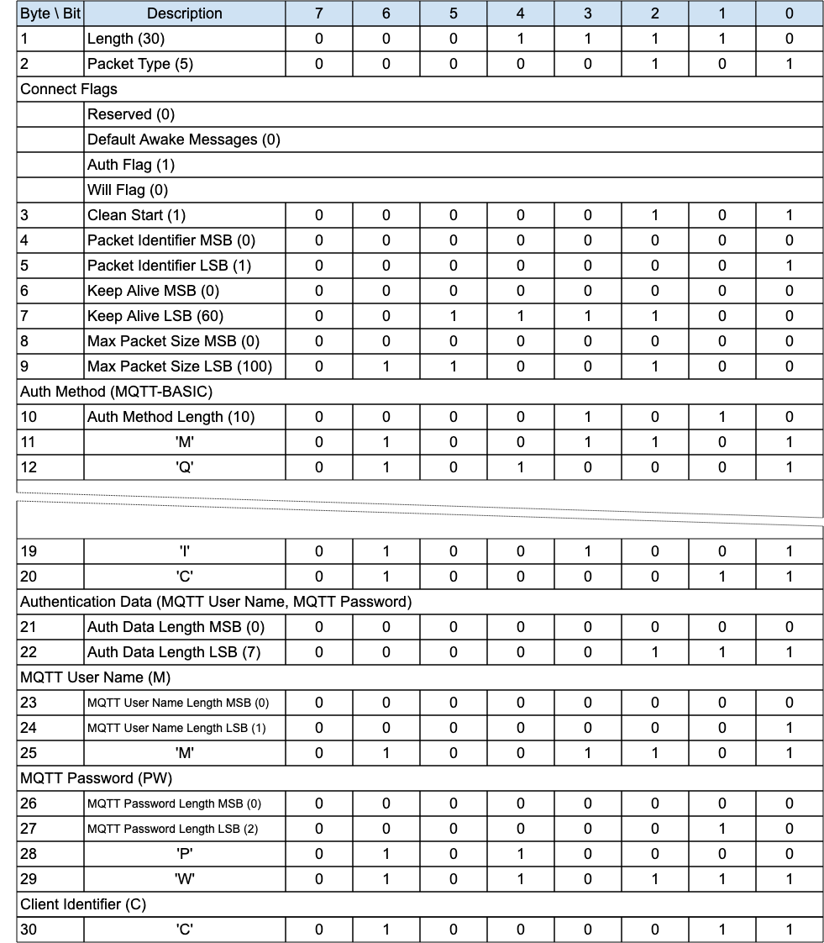
To support the equivalent of the MQTT User Name and Password together with MQTT Enhanced Authentication, in the CONNECT packet do the following:
- Set the Authentication Method field to MQTT-ENHANCED.
- Set the Authentication Data field to:
  - MQTT User Name: a Two Byte Integer length followed by a UTF-8 Encoded String as defined in section 1.7.4.
  - MQTT Password: a Two Byte Integer length followed by binary data.
  - MQTT Authentication Method: a Two Byte Integer length followed by a UTF-8 Encoded String as defined in section 1.7.4 .
  - MQTT Authentication Data: a Two Byte Integer length followed by binary data.
In any subsequent AUTH and CONNACK packets of the authentication exchange:
- The MQTT User Name and MQTT Password fields MUST not be included.
- The Authentication Method MUST remain MQTT-ENHANCED throughout.

4.12 Handling errors

4.12.1 Malformed Packet and Protocol Errors
Definitions of Malformed Packet and Protocol Errors are contained in section 1.3, some but not all of these error cases are noted throughout the specification. The rigor with which a Client or Server checks an MQTT-SN Control Packet it has received will be a compromise between:
- The size of the Client or Server implementation.
- The capabilities that the implementation supports.
- The degree to which the receiver trusts the sender to send correct Control Packets.
- The degree to which the receiver trusts the network to deliver Control Packets correctly.
- The consequences of continuing to process a packet that is incorrect.
If the sender is compliant with this specification it will not send Malformed Packets or cause Protocol Errors. The Reason Codes used for Malformed Packet and Protocol Errors include:
- 0x81 Malformed Packet
- 0x82 Protocol Error
- 0x93 Receive Maximum exceeded
- 0x95 Packet too large
When a Client detects a Malformed Packet or Protocol Error associated with a Virtual Connection it SHOULD send a DISCONNECT packet containing an appropriate Reason Code and MUST delete the associated Virtual Connection. Use Reason Code 0x81 (Malformed Packet) or 0x82 (Protocol Error) unless a more specific Reason Code has been defined in section 2.3.
When a Server detects a Malformed Packet or Protocol Error for any packet except ADVERTISE, SEARCHGW, GWINFO, PUBWOS and CONNECT, the Server MAY send a DISCONNECT packet with an appropriate Reason Code and MUST delete the associated Virtual Connection if one exists. [MQTT-4.13.1-1] In the case of an error in a CONNECT packet it MAY send a CONNACK packet containing the Reason Code. Use Reason Code 0x81 (Malformed Packet) or 0x82 (Protocol Error) unless a more specific Reason Code has been defined in section 2.3. There are no consequences for other Sessions.
If either the Server or Client omits to check some feature of a Control Packet, it might fail to detect an error, consequently it might allow data to be damaged.

4.12.2 Other errors
Errors other than Malformed Packet and Protocol Errors cannot be anticipated by the sender because the receiver might have constraints which it has not communicated to the sender. A receiving Client or Server might encounter a transient error, such as a shortage of memory, that prevents successful processing of an individual Control Packet.
Acknowledgment packets PUBACK, PUBREC, PUBREL, PUBCOMP, REGACK, SUBACK, UNSUBACK with a Reason Code of 0x80 or greater indicate that the received packet, identified by a Packet Identifier, was in error. There are no consequences for other Sessions or other Packets flowing on the same Session.
The CONNACK and DISCONNECT packets allow a Reason Code of 0x80 or greater to indicate that the Virtual Connection will be deleted. If a Reason Code of 0x80 or greater is specified, then the Virtual Connection MUST be deleted whether or not the CONNACK or DISCONNECT is sent [MQTT-4.13.2-1]. Sending one of these Reason Codes has no consequences for any other Session.
If the Control Packet contains multiple errors the receiver of the Packet can validate the Packet in any order and take the appropriate action for any of the errors found.
Refer to section 5.4.9 for information about handling Disallowed Unicode code points.

4.13 Example MQTT-SN Architectures
There are three kinds of MQTT-SN components, MQTT-SN clients, MQTT-SN gateways, and MQTT-SN forwarders. MQTT-SN clients connect to an MQTT-SN Gateway or to an MQTT server via an MQTT-SN Gateway using the MQTT-SN protocol. An MQTT-SN Gateway may or may not be integrated with a MQTT server. Where an MQTT broker is involved, the MQTT protocol is used between the MQTT broker and the MQTT-SN Gateway. Its main function is the translation between MQTT and MQTT-SN.
MQTT-SN clients can also access a Gateway via a forwarder in case the Gateway is not directly attached to their network. The forwarder simply encapsulates the MQTT-SN frames it receives on the wireless side and forwards them unchanged to the Gateway; in the opposite direction, it decapsulates the frames it receives from the gateway and sends them to the clients, unchanged too.
Informative comment
The architectures described below are meant as examples and are not exhaustive.

4.13.1 Transparent Gateway
For each connected MQTT-SN client a transparent Gateway will set up and maintain a MQTT connection to the MQTT server. This MQTT connection is reserved exclusively for the end-to-end and almost transparent packet exchange between the client and the server. There will be as many MQTT connections between the Gateway and the MQTT Broker as MQTT-SN clients connected to the Gateway. The transparent Gateway will perform a “syntax” translation between the two protocols. Since all packet exchanges are end-to-end between the MQTT-SN client and the MQTT Server, all functions and features that are implemented by the server can be offered to the client.
Although the implementation of the transparent Gateway is simpler when compared to the one of an aggregating Gateway, it requires the MQTT server to support a separate connection for each active client. Some MQTT server implementations might impose a limitation on the number of concurrent connections that they support.
Figure 4-7 – Transparent Gateway

Informative comment
Because PUBLISH WITHOUT SESSION could be sent at any time by clients (even with no Virtual Connection setup) a transparent Gateway needs to maintain for those packets a dedicated MQTT connection with the MQTT Server. An aggregating or hybrid Gateway may use any aggregating MQTT connection to forward those packets to the MQTT Server.

4.13.2 Aggregating Gateway
Instead of having one MQTT connection for each connected MQTT-SN client, an aggregating Gateway will have only one MQTT connection to the Server. All packet exchanges between an MQTT-SN client and an aggregating Gateway end at the Gateway. The Gateway then decides which information will be given further to the MQTT Broker. Although its implementation is more complex than the one of a transparent Gateway, an aggregating Gateway may be helpful in case of WSNs with a very large number of devices because it reduces the number of MQTT connections that the Gateway must support concurrently.
Figure 4-8 – Aggregating Gateway


4.11.3 Forwarder encapsulator
Figure 4-9 – Forwarder with Transparent Gateway

Figure 4-10 – Forwarder with Aggregating Gateway


4.13.4 MQTT-SN broker
Figure 4-11 – MQTT-SN Broker


4.14 Gateway Advertisement and Discovery
A Gateway may announce its presence by periodically sending an ADVERTISE packet to some or all devices that are currently parts of the network. A Gateway should only advertise its presence if it is able to accept Subscriptions and forward messages. For instance, a simple Transparent Gateway which is not currently connected to an MQTT Broker, should not advertise.
Multiple Gateways may be active at the same time in the same network. In this case they will have different identifiers. It is up to the Client to decide to which Gateway it wants to connect. At any point in time a Client is allowed to have a Virtual Connection to only one Gateway on the same network.
A client should maintain a list of active gateways together with their network addresses. This list is populated by means of the ADVERTISE and GWINFO packets received.
The time duration T_{ADV} until the gateway sends the next ADVERTISE packet is indicated in the Duration field of the ADVERTISE packets. A client may use this information to monitor the availability of a gateway. For example, if it does not receive ADVERTISE packets from a gateway for N_{ADV} consecutive times, it may assume that the gateway is down and remove it from its list of active gateways. Similarly, gateways in stand-by mode will become active (i.e. start sending ADVERTISE packets) if they miss successively a couple of times advertisements from a certain gateway.
Since the ADVERTISE packets are transmitted into the whole wireless network, the time interval T_{ADV} between two ADVERTISE packets sent by a gateway should be large enough (e.g. greater than 15 min) to avoid bandwidth congestion in the network.
The large value of T_{ADV} will lead to a long waiting time for new clients which are looking for a gateway. To shorten this waiting time a client may send a SEARCHGW packet. To prevent network flooding when multiple clients start searching for gateway almost at the same time, the sending of the SEARCHGW packet is delayed by a random time between 0 and T_{SEARCHGW}. A client will cancel its transmission of the SEARCHGW packet if it receives during this delay time a SEARCHGW packet sent by another client and identical to the one it wants to send, and behaves as if the SEARCHGW packet was sent by itself.
The transmission radius R_{b} of the SEARCHGW packet is limited, e.g. to a single hop in case of a dense deployment of MQTT-SN clients.
Upon receiving a SEARCHGW packet a gateway replies with a GWINFO packet containing its id. Similarly, a client answers with a GWINFO packet if it has at least one active gateway in its list of active gateways. If the client has multiple gateways in its list, it selects one gateway out of its list and includes that information into the GWINFO packet.
Like the SEARCHGW packet, the GWINFO packet is transmitted with the same radius R_{b}, which is indicated in the SEARCHGW packet. The radius R_{b} is also given to the underlying layer when these two packets are passed down for transmission.
To give priority to the gateways a client will delay its sending of the GWINFO packet for a random time T_{GWINFO}. If during this delay time the client receives a GWINFO packet it will cancel the transmission of its GWINFO packet.
In case of no response the SEARCHGW packet may be retransmitted. In this case the time intervals between consecutive SEARCHGW packets should be increased by the exponential backoff algorithm described in Appendix F.4.

4.15 Client states
Figure 4-12 – Server View of Client States
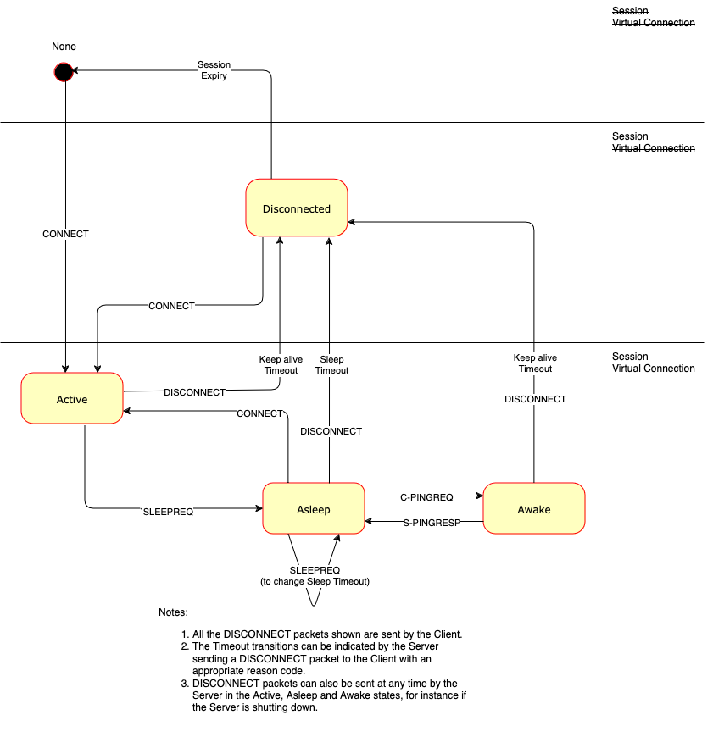
At any given point in time, a Client may be in one of 4 states from the perspective of the Gateway. Transition through these states is governed by a sequence of packets between Client and Gateway and mediated by timers resident on the gateway. A Client is in the Active state when the Gateway receives a CONNECT packet from that Client. This state is supervised by the gateway with the Keep Alive timer. If the gateway does not receive any packet from the client for a time longer than the keep alive interval (set in the CONNECT packet) plus grace period of 50%, the Gateway will consider that client as Disconnected and activate for example the Will feature for that client. The Disconnected state is governed by the Session Expiry timer - on expiry the Gateway is free to remove the Client session and delete the Client from its records (no state, or None). A client moves into the Asleep state by issuing a SLEEPREQ packet, and confirming that request by waiting for a SLEEPRESP packet. For more information on the sleep state, please refer to section 4.15.3.
Figure 4-13 – Client View of Client States
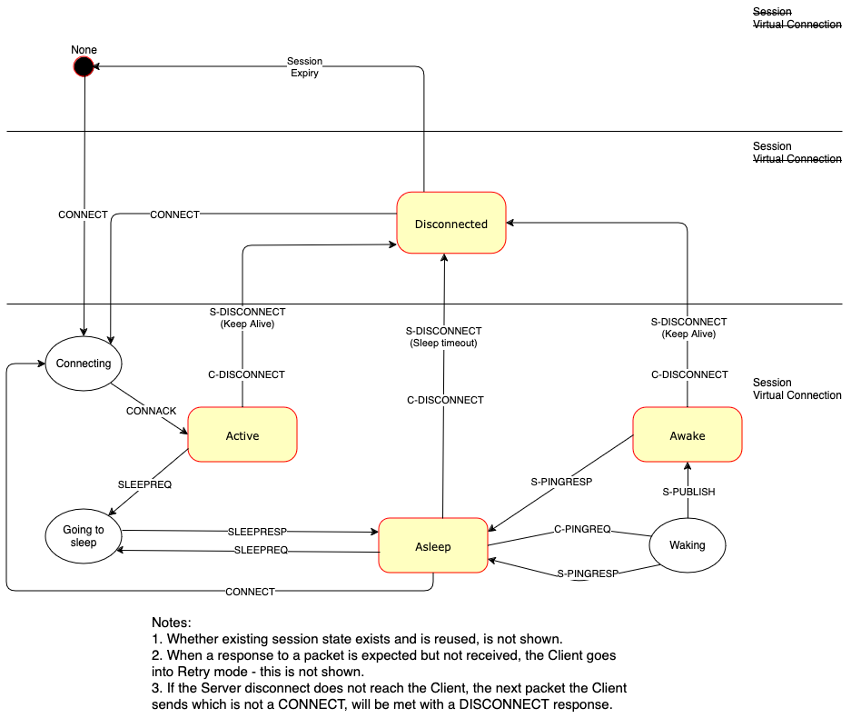
Informative Comment
In the previous version of MQTT-SN there existed the idea of a Lost state, which was identical to the Disconnected state, except that it was reached by a timer expiry on the Gateway rather than an explicit Disconnect request from the Client. As the Lost state was not really different from Disconnected except for the history of Client events, similar information may be kept by the Gateway, in for instance its administrative logs.
Here follows a summary of the Client states and transitions set out in a table.
Figure 4-14 – Client States
State | State Description | Possible Transitions
None | The Client is unknown to the Gateway. There is no Session State nor Virtual Connection. | Active
Disconnected | The Client is considered offline and not able to receive packets until it has re-established a session with the Gateway by way of a CONNECT. The Gateway has Session state for this Client, but there is no Virtual Connection.  The Gateway must not attempt to send packets to a Disconnected client.  Any packet received from a Disconnected Client should not be processed and a DISCONNECT with error should be sent in response, unless the packet received is PUBWOS.  From here a Client may transition to Active with a CONNECT, or to None on Session expiry. | Active  None
Active | The Client is actively engaged in the Session. A Virtual Connection exists. It should be able to send and receive packets. Its state is supervised by the gateway with the associated Keep Alive timer.  From here the client may transition to Asleep by way of a SLEEPREQ or Disconnected by way of a DISCONNECT, Keep Alive timeout or Retry timeout. | Asleep  Disconnected
Asleep | The Client is engaged in an ongoing Session, and a Virtual Connection exists. The Client cannot receive packets; it can send packets. The Gateway should not expect a response from the client in this state until further packets are received from the client. From here the client may transition to Awake (by way of PINGREQ), Active by way of CONNECT, Disconnected (by way of DISCONNECT, Sleep timeout or Retry timeout). | Awake  Active  Disconnected
Awake | The Client is partially engaged in an ongoing session and a Virtual Connection exists. The Client MUST not send ANY packets other than those involved in the receipt of PUBLISH packets (PUBACK, PUBREC, PUBCOMP, REGACK) or a DISCONNECT to transition to Disconnected. The client transitions back to the Asleep state on receipt of a PINGRESP packet or Disconnected (on Keep Alive or Retry timeout for the possible PUBACK, PUBREL, PUBREC, PUBCOMP or REGACK packets to be received from the Client). | Asleep  Disconnected

4.15.1 Gateway timers
The following timers are managed by a Gateway per Client to handle the Client states:
Figure 4-15 – Gateway Timers
Timer Name | State(s) | Resulting State | Defined in | Information
Keep Alive | Active | Disconnected | CONNECT | section 4.15.4
Sleep Duration | Asleep | Disconnected | SLEEPREQ | section 4.15.3
Session Expiry | Disconnected | None | CONNECT, DISCONNECT | section 4.1.1
Retry | Active, Awake,  Asleep | Disconnected | Sender  configuration | section 4.4

4.15.1.1 Timer and Counter Values (Informative)
Figure 4-16 shows the “best practice” values for the timers and counters defined in this specification.
Figure 4-16 – Best practice values for timers and counters
Timer/Counter | Recommended value
T_{ADV} | Greater than 15 minutes
N_{ADV} | 2 -3
T_{SEARCHGW} | 5 seconds
T_{GWINFO} | 5 seconds
T_{WAIT} | Greater than 5 minutes
T_{RETRY} | Implement section F.4 with a starting value of 1 second after an initial wait period of 5 seconds. So the first retry will be ~6 seconds.
N_{RETRY} | 3 – 5
M_{BACKOFF} | 60 seconds
The “tolerance” of the sleep and keep-alive timers at the server/gateway depends on the values indicated by the clients. For example, the timer values should be 10% higher than the indicated values for periods larger than 1 minute, and 50% higher if less.

4.15.2 Clean start
When a client disconnects, its session state is retained for no less than the session expiration interval. The session state is persistent and valid for new (non clean start) sessions, until the client establishes a new session with the “clean start” flag set or the idle time exceeds the session expiry interval associated with the session.
The two flags “CleanStart” and “Will” in the CONNECT Packet have the following meanings:
- CleanStart=true, Will=true: The Gateway will delete all session state data related to the client, including Will data if present, and it will set the Will data in the Session state with the content of the CONNECT Will fields and will return CONNACK.
- CleanStart=true, Will=false: The gateway will delete all session state data and Will data, if present, related to the client and it will return CONNACK.
- CleanStart=false, Will=true: The gateway will keep all the client’s session state data and it will overwrite, if present, or add the Will data related to the client with the content of the CONNECT Will optional fields and it will return CONNACK.
- CleanStart=false, Will=false: The Gateway will keep all the client’s session state dataand it will delete any Will data, if present, and it will return CONNACK.
Note that if a client wants to delete only its Will data at Virtual Connection creation, it could send a CONNECT packet with “CleanStart=false” and “Will=false”.

4.15.3 Sleeping clients
Sleeping Clients are Clients residing on (battery-operated) devices that want to save as much energy as possible. These devices need to enter a sleep mode whenever they are not active and will wake up whenever they have data to send or to receive. The Gateway needs to be aware of the sleeping state of these Clients and will buffer messages destined to them for later delivery when they wake up.
If a Client wants to sleep, it sends a SLEEPREQ packet which contains a sleep duration in seconds. The gateway acknowledges that packet with a SLEEPRESP packet and considers the client to be Asleep. The Asleep state is supervised by the gateway with the indicated sleep duration. If the gateway does not receive any packet from the client for a period longer than the sleep duration, the Gateway will consider that client Disconnected and - as with the keep alive procedure - will activate for example the Will feature.
During the Asleep state, packets that need to be sent to the client are buffered at the Gateway. The Gateway MUST buffer application messages of quality-of-service 1 and 2.
Informative comment
The gateway may choose to buffer messages of QoS 0, while the client is sleeping and is within its sleep duration.
The sleep duration timer is stopped when the Gateway receives a PINGREQ from the client. Like the CONNECT packet, this PINGREQ packet contains the Client Id. The identified client is then in the awake state. If the Gateway has buffered packets for the client, it will send these packets to the client, acknowledging the Default Awake Messages value sent in the CONNECT packet. If the number of messages buffered on the gateway waiting to be sent exceeds the value specified by the client in the Default Awake Messages field, the gateway shall send only the Default Awake Messages value number of messages, and cut short the AWAKE cycle, responding with a PINGRESP with a messages-left value of either the number of messages remaining in the gateway buffer or 0xFFFF (meaning undetermined number of messages greater than 0 remaining).
During the AWAKE state, for each packet the gateway sends to the client, the application messages’ quality of service shall be honored, and a full packet interaction shall take place including all normative phases of acknowledgement, including any associated retransmission logic. If, during the delivery of application messages from the gateway to the client, the gateway detects a timeout in the delivery, it should transition the client state to LOST and a DISCONNECT packet with error sent to the device.
The transfer of packets to the client is closed by the gateway by means of a PINGRESP packet, i.e. the gateway will consider the client as asleep and restart the sleep timer again after having sent the PINGRESP packet. If the gateway does not have any packets buffered for the client, it answers immediately with a PINGRESP packet, returns the client back to the asleep state, and restarts the sleep timer for that client.
After having sent the PINGREQ to the gateway, the client uses the retransmission procedure of section 4.4 to supervise the arrival of packets sent by the server/gateway, i.e. it restarts timer T_{retry} when it receives a packet other than a PINGRESP, and stops it when it receives a PINGRESP. The PINGREQ packet is retransmitted, and timer T_{retry} restarted when timer T_{retry} times out. To avoid a flattening of its battery due to excessive retransmission of the PINGREQ packet (e.g. if it loses the gateway), the client should limit the retransmission of the PINGREQ packet (e.g. by a retry counter) and go back to sleep when the limit is reached and it still does not receive a PINGRESP packet.
From the asleep state, a client can return either to the active state by sending a CONNECT packet or to the disconnected state by sending a normal DISCONNECT packet (i.e. without session expiry interval field). The client can also modify its sleep configuration by sending a DISCONNECT packet with a new value of the session expiry interval.
Note that a sleeping client should go to the awake state only if it just wants to check whether the server/gateway has any messages buffered for it and return as soon as possible to the asleep state without sending any packets to the server/gateway. Otherwise, it should return to the active state by sending a CONNECT packet to the server/gateway.
//TODO SIMON – add some worlds around retain registration behavior
Session Topic Alias mappings last for the duration of a Session which exists throughout the sleep cycle, re-registration is not necessary.

Figure 4-17 – Awake PINGRESP Packet flush


4.15.4 Keep Alive
As with MQTT, the value of the Keep Alive timer is indicated in the CONNECT packet. The Client should send at least one packet within each Keep Alive interval. If no other packet is sent within this time, the Client should send a PINGREQ, which the gateway acknowledges with a PINGRESP.
Unlike MQTT, the MQTT-SN Keep Alive timeout can not be turned off (by setting a value of 0). This is because there is no other indication in MQTT-SN of a connection failure, as there is in MQTT with the underlying TCP/IP connection.
A client answers with a PINGRESP packet when it receives a PINGREQ packet from the Gateway to which it is Virtually Connected. Otherwise, the received PINGREQ packet is ignored.
Clients should use this procedure to supervise the liveliness of the Gateway to which they are connected. If a client does not receive a PINGRESP from the gateway even after multiple retransmissions of the PINGREQ packet, it might try to connect to another Gateway before trying to reconnect to this Gateway. Note that because the client Keep Alive timers are not synchronized with each other, in case of a Gateway failure there is a low risk of a storm of CONNECT packets sent almost at the same time by all affected clients towards a new Gateway.
See also section 3.4.5.

4.15.5 Client Disconnect
A Client sends a DISCONNECT packet to the gateway to indicate that it is about to delete its Virtual Connection. After this point, the Client is then required to create a new Virtual Connection with the Gateway before it can exchange information with that Gateway again.
Sending the DISCONNECT packet does not necessarily affect the Client Session data. It is persistent until it is either expired or explicitly deleted, or modified by the Client, or if the Client creates a new Virtual Connection with the CleanStart flag set. If the Session Expiry value on the DISCONNECT packet from the Client is 0, or the Session Expiry was 0 on the CONNECT and was not overridden in the DISCONNECT, then the Session state data will expire immediately the DISCONNECT is received by the Gateway and may be deleted.
A client may receive an unsolicited DISCONNECT sent by the gateway. This may happen for example when the gateway, due to an error, cannot identify the client to which a received packet belongs. Upon receiving such a DISCONNECT packet a client should try to create another Virtual Connection by sending a CONNECT packet to the gateway.

4.16 Retained Messages
If the RETAIN flag is set to 1 in a PUBLISH or PUBWOS packet received by a Server, the Server MUST replace any existing Retained Message for this topic and store the Application Message [MQTT-SN-4.26-1], so that it can be delivered to future subscribers whose subscriptions match its Topic Name. If the Publish Data contains zero bytes it is processed normally by the Server but any retained message with the same topic name MUST be removed and any future subscribers for the topic will not receive a retained message [MQTT-SN-4.26-2]. A Retained Message with a Publish Data containing zero bytes MUST NOT be stored as a Retained Message on the Server [MQTT-SN-4.26-3].
If the RETAIN flag is 0 in a PUBLISH packet sent by a Client to a Server, the Server MUST NOT store the message as a Retained Message and MUST NOT remove or replace any existing Retained Message [MQTT-SN-4.26-4].
When a new Subscription is made, the last retained message, if any, on each matching topic name is sent to the Client as directed by the Retain Handling Subscribe Flag. These messages are sent with the RETAIN flag set to 1. Which retained messages are sent is controlled by the Retain Handling Subscribe Flag. At the time of the Subscription:
- If Retain Handling is set to 0 the Server MUST send the retained messages matching the Topic Filter of the subscription to the Client [MQTT-SN-4.26-5].
- If Retain Handling is set to 1 then if the subscription did not already exist, the Server MUST send all retained messages matching the Topic Filter of the subscription to the Client, and if the subscription did exist the Server MUST NOT send the retained messages. [MQTT-SN-4.26-6].
- If Retain Handling is set to 2, the Server MUST NOT send the retained messages [MQTT-SN-4.26-7].
Refer to section 3.17.2 for a definition of the Subscription Flags.
If the Server receives a PUBLISH packet with the RETAIN flag set to 1, and QoS 0 it SHOULD store the new QoS 0 message as the new retained message for that topic, but MAY choose to discard it at any time. If this happens there will be no retained message for that topic.
The setting of the RETAIN flag in an Application Message forwarded by the Server from an established Virtual Connection is controlled by the Retain As Published subscription option. Refer to section 3.17.2 for a definition of the Subscription Flags.
- If the value of Retain As Published subscription option is set to 0, the Server MUST set the RETAIN flag to 0 when forwarding an Application Message regardless of how the RETAIN flag was set in the received PUBLISH packet [MQTT-SN-4.26-8].
- If the value of Retain As Published subscription option is set to 1, the Server MUST set the RETAIN flag equal to the RETAIN flag in the received PUBLISH packet [MQTT-SN-4.26-9].
Informative comment
Retained messages are useful where publishers send state messages on an irregular basis. A new subscriber will receive the most recent state.
Informative comment
As in MQTT 3.1.1 there is no notion of message expiry in MQTT-SN, including expiry of Retained Messages. It is an administrative decision under what conditions to remove Retained Messages, if at all. They should be kept long enough to support the expectations of the applications that will use the Server, at a minimum.

4.17 Optional Features
Support for the ADVERTISE, SEARCHGW, GWINFO and PUBWOS packet types is optional.
The Forwarder Encapsulation packet type support is optional. For instance, it is not required if the MQTT-SN Clients are able to directly reach a MQTT-SN Gateway.
The Protection Encapsulation packet type support is optional. For instance, it is not required if the MQTT-SN Gateway and the MQTT-SN Clients interact over a secure communication channel, such as DTLS or any communication channel assuring the authenticity and optionally the confidentiality protection.

5 Security (Informative)

5.1 Introduction
MQTT-SN is a transport protocol specification for message transmission, allowing implementers a choice of network, privacy, authentication and authorization technologies. Since the exact security technologies chosen will be context specific, it is the implementer's responsibility to include the appropriate features as part of their design.
MQTT-SN solutions are likely to also include MQTT communications - this section should be read alongside the Security chapters in the MQTT standards: MQTT 3.1.1 and MQTT 5.0.
MQTT-SN implementations will likely need to keep pace with an evolving security landscape. This Chapter provides general implementation guidance so as not to restrict choices available. Examples of threats that solution providers should consider are:
- Devices could be compromised
- Data at rest in Clients and Servers might be accessible
- Protocol behaviors could have side effects (e.g. “timing attacks”)
- Denial of Service (DoS) attacks
- Communications could be intercepted, altered, re-routed or disclosed
- Injection of spoofed MQTT-SN Control Packets
When MQTT-SN solutions are deployed in hostile communication environments, implementations will often need to provide mechanisms for:
- Authentication of users and devices
- Authorization of access to Server resources
- Integrity of MQTT-SN Control Packets and application data contained therein
- Privacy of MQTT-SN Control Packets and application data contained therein
In addition to technical security issues there could also be geographic (e.g. U.S.-EU Privacy Shield Framework [USEUPRIVSH]), industry specific (e.g. PCI DSS [PCIDSS]) and regulatory considerations (e.g. Sarbanes-Oxley [SARBANES]).

5.2 MQTT-SN solutions: security and certification
An implementation might want to provide conformance with specific industry security standards such as NIST Cyber Security Framework [NISTCSF], PCI-DSS [PCIDSS]), FIPS-140-3 [FIPS1403] and Commercial National Security Algorithm Suite (CNSA) 2.0 [CNSA20]. The use of industry proven, independently verified and certified technologies will help meet compliance requirements.

5.3 Lightweight cryptography and constrained devices
MQTT-SN is targeted at the most power saving and constrained devices. In contrast to MQTT where there is principally one underlying network technology - TCP/IP - MQTT-SN is intended to be agnostic to the underlying network as long as it conforms to the requirements outlined in Section 4.2.
Previous versions of MQTT-SN did not include specific security and integrity features, preferring to leave that to the underlying network. That approach is still supported, but to aid interoperability the Protection Encapsulation is introduced, in Section 3.26. In order to disassociate the security model from the rest of the MQTT-SN specification, the Protection Encapsulation allows all the packet types, including CONNECT, to be wrapped in a security envelope. Furthermore the security material is self-contained in each Protection Encapsulation envelope, so it is completely decoupled from the Virtual Connection.
The schemes defined by the Protection Encapsulation are especially suited for implementation by constrained devices:
- HMAC and AES CMAC are widely adopted authentication only standard schemes.
- The Advanced Encryption Standard [AES] is the most widely adopted encryption algorithm. There is hardware support for AES in many processors, but not commonly for embedded processors.
- The encryption algorithm ChaCha20 [CHACHA20] encrypts and decrypts much faster in software, but is not as widely available as AES.
The Protection Encapsulation approach is informed by the OSCORE [RFC 8613] standard and CBOR Initial Algorithms [RFC 9053] informational document. The ISO 29192 [ISO29192] standard makes recommendations for cryptographic primitives specifically tuned to perform on constrained, low end, devices.
The MQTT-SN Protection Encapsulation also allows for user defined protection schemes, although these will of necessity have lower interoperability compared to the built-in schemes, as implementations of both Client and Server will have to be aware of them.

5.4 Implementation notes
When the underlying network layer for MQTT-SN is UDP, DTLS [RFC9147] can be used to secure MQTT-SN communications instead of or in conjunction with the Protection Encapsulation. It is recommended that Server implementations that offer DTLS use UDP port 8883 (IANA service name: secure-mqtt).
For other underlying network technologies, a security solution particular to that technology must be found, which could involve using the MQTT-SN Protection Encapsulation and/or Authentication.
There are many security concerns to consider when implementing or using MQTT-SN. The following section should not be considered a comprehensive checklist.
An implementation might want to achieve some, or all, of the following:

5.4.1 Authentication of Clients by the Server
The CONNECT packet contains an Authentication Data field which can contain a user name and password if the Authentication Method is SASL PLAIN (see section 4.11.1.2). Implementations can choose how to make use of the content of these fields. They may provide their own authentication mechanism, use an external authentication system such as LDAP [RFC4511] or OAuth [RFC6749] tokens, or leverage operating system authentication mechanisms.
MQTT-SN provides an Authentication mechanism as described in section 4.11. Using this requires support for it in both the Client and Server.
Implementations passing authentication data in clear text, obfuscating such data elements or requiring no authentication data should be aware this can give rise to Man-in-the-Middle and replay attacks. Section 5.4.5 introduces approaches to ensure data privacy.
A Virtual Private Network (VPN) between the Clients and Servers can provide confidence that data is only being received from authorized Clients.
Where DTLS [RFC9147] is used, X.509 Certificates sent from the Client can be used by the Server to authenticate the Client to achieve mutual authentication.

5.4.2 Authorization of Clients by the Server
If a Client has been successfully authenticated, a Server implementation should check that it is authorized before accepting its connection.
Authorization may be based on information provided by the Client such as User Name, the hostname/network address of the Client, or the outcome of authentication mechanisms.
In particular, the implementation should check that the Client is authorized to use the Client Identifier as this gives access to the MQTT-SN Session State (described in section 4.1). This authorization check is to protect against the case where one Client, accidentally or maliciously, provides a Client Identifier that is already being used by some other Client.
An implementation should provide access controls that take place after CONNECT to restrict the Client's ability to publish to particular Topics or to subscribe using particular Topic Filters. An implementation should consider limiting access to Topic Filters that have broad scope, such as the # Topic Filter.

5.4.3 Authentication of the Server by the Client
The MQTT-SN protocol is not trust symmetrical. When using basic Username and Password authentication, there is no mechanism for the Client to authenticate the Server. Some forms of authentication do allow for mutual authentication.
Where DTLS is used, X.509 Certificates sent from the Server can be used by the Client to authenticate the Server.
MQTT-SN provides an Authentication mechanism as described in section 4.11, which can be used to authenticate the Server to the Client. Using this requires support for it in both the Client and Server.
A VPN between Clients and Servers can provide confidence that Clients are connecting to the intended Server.

5.4.4 Integrity of Application Messages and MQTT-SN Control Packets
Applications can independently include hash values in their Application Messages. This can provide integrity of the contents of Publish packets across the network and at rest.
DTLS and the Protection Encapsulation provide hash algorithms to verify the integrity of data sent over the network.
The use of VPNs to connect Clients and Servers can provide integrity of data across the section of the network covered by a VPN.

5.4.5 Privacy of Application Messages and MQTT-SN Control Packets
DTLS [RFC9147] can provide encryption of data sent over the network. There are valid DTLS cipher suites that include a NULL encryption algorithm that does not encrypt data. To ensure privacy Clients and Servers should avoid these cipher suites.
An application might independently encrypt the contents of its Application Messages. This could provide privacy of the Application Message both over the network and at rest. This would not provide privacy for other Properties of the Application Message such as Topic Name.
Client and Server implementations can provide encrypted storage for data at rest such as Application Messages stored as part of a Session.
The use of VPNs to connect Clients and Servers can provide privacy of data across the section of the network covered by a VPN.

5.4.6 Non-repudiation of message transmission
Application designers might need to consider appropriate strategies to achieve end to end non-repudiation.

5.4.7 Detecting compromise of Clients and Servers
Client and Server implementations using DTLS should provide capabilities to ensure that any X.509 certificates provided when initiating a DTLS session are associated with the hostname of the Client connecting or Server being connected to.
Client and Server implementations using DTLS can choose to provide capabilities to check Certificate Revocation Lists (CRLs [RFC5280]) and Online Certificate Status Protocol (OSCP) [RFC6960] to prevent revoked certificates from being used.
Physical deployments might combine tamper-proof hardware with the transmission of specific data in Application Messages. For example, a meter might have an embedded GPS to ensure it is not used in an unauthorized location. [IEEE8021AR] is a standard for implementing mechanisms to authenticate a device’s identity using a cryptographically bound identifier.

5.4.8 Detecting abnormal behaviors
Server implementations might monitor Client behavior to detect potential security incidents. For example:
- Repeated connection attempts
- Repeated authentication attempts
- Abnormal termination of connections
- Topic scanning (attempts to send or subscribe to many topics)
- Sending undeliverable messages (no subscribers to the topics)
- Clients that connect but do not send data
Server implementations might delete the Virtual Connection of Clients that breach its security rules.
Server implementations detecting unwelcome behavior might implement a dynamic block list based on identifiers such as IP address or Client Identifier.
Deployments might use network-level controls (where available) to implement rate limiting or blocking based on IP address or other information.

5.4.9 Handling of Disallowed Unicode code points
Section 1.7.4 describes the Disallowed Unicode code points, which should not be included in a UTF-8 Encoded String. A Client or Server implementation can choose whether to validate that these code points are not used in UTF-8 Encoded Strings such as the Topic Name or Properties.
If the Server does not validate the code points in a UTF-8 Encoded String but a subscribing Client does, then a second Client might be able to cause the subscribing Client to delete the Virtual Connection by publishing on a Topic Name or using Properties that contain a Disallowed Unicode code point. This section recommends some steps that can be taken to prevent this problem.
A similar problem can occur when the Client validates that the payload matches the Payload Format Indicator and the Server does not. The considerations and remedies for this are similar to those for handling Disallowed Unicode code points.

5.4.9.1 Considerations for the use of Disallowed Unicode code points
An implementation would normally choose to validate UTF-8 Encoded strings, checking that the Disallowed Unicode code points are not used. This avoids implementation difficulties such as the use of libraries that are sensitive to these code points, it also protects applications from having to process them.
Validating that these code points are not used removes some security exposures. There are possible security exploits which use control characters in log files to mask entries in the logs or confuse the tools which process log files. The Unicode Noncharacters are commonly used as special markers and allowing them into UTF-8 Encoded Strings could permit such exploits.

5.4.9.2 Interactions between Publishers and Subscribers
The publisher of an Application Message normally expects that the Servers will forward the message to subscribers, and that these subscribers are capable of processing the messages.
These are some conditions under which a publishing Client can cause the subscribing Client to delete the Virtual Connection. Consider a situation where:
- A Client publishes an Application Message using a Topic Name containing one of the Disallowed Unicode code points.
- The publishing Client library allows the Disallowed Unicode code point to be used in a Topic Name rather than rejecting it.
- The publishing Client is authorized to send the publication.
- A subscribing Client is authorized to use a Topic Filter which matches the Topic Name. Note that the Disallowed Unicode code point might occur in a part of the Topic Name matching a wildcard character in the Topic Filter.
- The Server forwards the message to the matching subscriber rather than disconnecting the publisher.
- In this case the subscribing Client might:
  - Delete the Virtual Connection because it does not allow the use of Disallowed Unicode code points, possibly sending a DISCONNECT before doing so. For QoS 1 and QoS 2 messages this might cause the Server to send the message again, causing the Client to delete the Virtual Connection again.
  - Reject the Application Message by sending a Reason Code greater than or equal to 0x80 in a PUBACK (QoS 1) or PUBREC (QoS 2).
  - Accept the Application Message but fail to process it because it contains one of the Disallowed Unicode code points.
  - Successfully process the Application Message.
The potential for the Client to delete the Virtual Connection might go unnoticed until a publisher uses one of the Disallowed Unicode code points.

5.4.9.3 Remedies
If there is a possibility that a Disallowed Unicode code point could be included in a Topic Name or other Properties delivered to a Client, the solution owner can adopt one of the following suggestions:
- Change the Server implementation to one that rejects UTF-8 Encoded Strings containing a Disallowed Unicode code point either by sending a Reason Code greater than or equal to 0x80 or deleting the Virtual Connection.
- Change the Client library used by the subscribers to one that tolerates the use of Disallowed Code points. The client can either process or discard messages with UTF-8 Encoded Strings that contain Disallowed Unicode code points so long as it continues the protocol.

5.4.10 Other security considerations
If Client or Server X.509 certificates are lost or it is considered that they might be compromised they should be revoked (using CRLs [RFC5280] and/or OSCP [RFC6960]).
Client or Server authentication credentials, such as User Name and Password, that are lost or considered compromised should be revoked and/or reissued.
In the case of long lasting connections:
- Where applicable, Client and Server implementations should allow for session renegotiation to establish new cryptographic parameters (replace session keys, change cipher suites, change authentication credentials).
- Servers may close the Virtual Connection of Clients and require them to re-authenticate with new credentials.
- Servers may require their Client to reauthenticate periodically using the mechanism described in section 4.11.1.
Clients connected to a Server have a transitive trust relationship with other Clients connected to the same Server and who have authority to publish data on the same topics.

5.4.11 Use of SOCKS
Implementations of Clients should be aware that some environments will require the use of SOCKSv5 [RFC1928] proxies to transmit data. Some MQTT-SN implementations could make use of alternative secured tunnels through the use of SOCKS. Where implementations choose to use SOCKS, they should support both anonymous and User Name, Password authenticating SOCKS proxies. In the latter case, implementations should be aware that SOCKS authentication might occur in plain-text and so should avoid using the same credentials for connection to an MQTT-SN Server.

5.4.12 Security profiles
Implementers and solution designers might wish to consider security as a set of profiles which can be applied to the MQTT-SN protocol. An example of a layered security hierarchy is presented below.

5.4.12.1 Clear communication profile
When using the clear communication profile, the MQTT-SN protocol runs over an open network with no additional secure communication mechanisms in place.

5.4.12.2 Secured network communication profile
When using the secured network communication profile, the MQTT-SN protocol runs over a physical or virtual network which has security controls e.g., VPNs or physically secure network.

5.4.12.3 Secured transport profile
When using the secured transport profile, the MQTT-SN protocol runs over a physical or virtual network and uses MQTT-SN Authentication, Protection Encapsulation, DTLS and/or other technologies to provide authentication, integrity and privacy.
DTLS Client authentication can be used in addition to – or in place of – MQTT-SN Client authentication as provided by the Authentication Method and Data fields.

5.4.12.4 Industry specific security profiles
It is anticipated that the MQTT-SN (and MQTT) protocols will be designed into industry specific application profiles, each defining a threat model and the specific security mechanisms to be used to address these threats. Recommendations for specific security mechanisms will often be taken from existing works including:
[NISTCSF] NIST Cyber Security Framework
[NIST7628] NISTIR 7628 Guidelines for Smart Grid Cyber Security
[FIPS1403] Security Requirements for Cryptographic Modules (FIPS PUB 140-3)
[PCIDSS] PCI-DSS Payment Card Industry Data Security Standard
[CNSA20] Commercial National Security Algorithm Suite (CNSA) 2.0
[NSAB] NSA Suite B Cryptography

6 Conformance
(Note: The OASIS TC Process requires that a specification approved by the TC at the Committee Specification Public Review Draft, Committee Specification or OASIS Standard level must include a separate section, listing a set of numbered conformance clauses, to which any implementation of the specification must adhere in order to claim conformance to the specification (or any optional portion thereof). This is done by listing the conformance clauses here.
For the definition of "conformance clause," see OASIS Defined Terms.
See "Guidelines to Writing Conformance Clauses":
https://docs.oasis-open.org/templates/TCHandbook/ConformanceGuidelines.html.
Remove this note before submitting for publication.)

Appendix A. Acknowledgments
[Required section.]
Note: A Work Product approved by the TC must include a list of people who participated in the development of the Work Product. This is generally done by collecting the list of names in this appendix. This list shall be initially compiled by the Chair, and any Member of the TC may add or remove their names from the list by request.
Remove these yellow notes before submitting for publication.

A.1 Special Thanks
Note: This is an optional subsection to call out contributions from TC members. If a TC wants to thank non-TC members then they should avoid using the term "contribution" and instead thank them for their "expertise" or "assistance".
Substantial contributions to this document from the following individuals are gratefully acknowledged:
[Participant Name, Affiliation | Individual Member]

A.2 Participants
Note: A TC can determine who they list here, however, Observers must not be listed. It is common practice for TCs to list everyone that was part of the TC during the creation of the document, but this is ultimately a TC decision on who they want to list and not list.
The following individuals were members of this Technical Committee during the creation of this document and their contributions are gratefully acknowledged:
[Participant Name, Affiliation | Individual Member]

Appendix B. Mandatory normative statements (informative)

Appendix C. Revision History (informative)
[Optional section.]
Revisions made since the initial stage of this numbered Version of this document may be tracked here.
Note: If revision tracking is handled in another system like github, provide a link to it instead of using this table, if desired. Remove this note before submitting for publication.
Revision | Date | Editor | Changes Made
WD-01 | [27th February 2020] | [Andrew Banks] | [Merge Initial Document and Input Specification]
WD-02 | [4th April 2020] | [Andrew Banks]  [Rahul Gupta] | [Terminology, DataTypes, CONNECT packet]  [Specification Diagrams]
WD-05 | [21st February 2021] | [Simon Johnson] | [Packet Diagrams, Bit Tables, Field Definitions]
WD-06 | [10th March 2021] | [Simon Johnson] | [Sleeping client operational behavior, Terminology changes, 13 JIRA resolutions added to specification, Section numbering changes]
WD-07 | [15th March 2021] | [Simon Johnson] | [Added 4 byte (32 bit) integer description]
WD-08 | [26th March 2021] | [Simon Johnson] | [Added max packet size to CONNECT, Added Session Expiry Interval to CONNACK, Removed ZigBee references, Removed capabilities flag from CONNECT, AUTH packet added along with Authentication operational behavior. Standardized page margins]
WD-09 | [05th May 2021] | [Simon Johnson] | [Added long topic type to topicIdTypes, updated PUBLISH to accommodate new topic type, added topic type matrix]
WD-10 | [October 2021] | [Simon Johnson] | [Document format aligned with core specification, removal of introduction, addition of packet ID table, adding error code]
WD-11 | [October 2021] | [Simon Johnson] | [MQTT-SN Architecture moved into operational behavior, removal of variable integer definition, addition of session state section, normative comments added to sleeping client operational behaviour]
WD-12 | [November 2021] | [Andrew Banks] | Rework 1.5 Background
WD-13 | [November 2021] | [Simon Johnson] | [Move Authentication and Retained messages into operational behavior, rationalized tables and figures, separated packet definitions of similar structures into distinct sections.]
WD-14 | [Decmeber 2021] | [Simon Johnson] | [First implementation attempt, Fixed table references, Fixed PingResp packet]
WD-15 | [December 2021] | [Simon Johnson] | [Tara added as editor, return code additions]
WD-15 | [February 2022] | [Tara Walker] | Changed Return Code nomenclature to be more consistent w/5.0. Added Reason Codes to each control packet type
WD-16 | March 2022 | [Tara Walker] | Updated WILL*Types to correct Packet Type. Added Global Flags Table to Section 2. Updated each Control Packet Flags in Section 3 adding missing Flag Sections. Formatting: Auto update of Table numbering, Auto update of WD Revision numbering for footer.
WD-17 | April 2022 | [Simon Johnson] | Updated use of topic name and topic filter to be aligned with MQTT 5. Topic alias becomes topic alias type. Added quality of service protocol flow as it differed to MQTT 5 (inflight). Conformance references removed as these will need to be wholly owned OR externally referenced.
WD-18 | June 2022 | [Tara E. Walker] | Updated items based upon the feedback from Alex Kritikos.
WD-19 | August 2022 | [Simon Johnson] | Remove change tracking as document was becoming unworkable.
WD-20 | September 2022 | [Simon Johnson] | Integrate feedback from committee meeting relating to the work by Miroslav Prymek. Added resolution of CONNACK session present per MQTT 585
WD-21 | October 2022 | [Simon Johnson] | Client States section added to describe the 5 states.  Updated the state transition diagram to accommodate new disconnect field and new transitions between Awake -> Lost and Asleep -> Disconnected.  Security section added.  Figure 2 – MQTT-SN Architecture diagram updated.  Font updated to Arial from bespoke font.  QoS -1 – Section added to the QoS chapter (NOTE: updated text to allow for bi-directional -1 PUBLISHING).  Introduction of Exponential backoff algorithm.  Applied issue issue 587 (max messages set in CONNECT flags).
WD-22 | November 2022 | [Simon Johnson] | Integrate MQTT 591 (sleep behavior)  Replace instances of “return code” to “reason code”  PINGREQ timeout aligned with Tretry (15 seconds) from the ill defined “reasonable amount of time”  Exponential Algo fix (using the factor n assuming it was the product!)  Client Identifier size clarification.  Publish variants added; distinguish variant based on QoS field to save 2 bytes for single flight PUBLISH packets.  Incorporated B4. Into retry timer.
WD-23 | December 2022 | [Simon Johnson] | CONNECT Client Identifier Informative and Normative définition update.  CONNACK Client Identifier Informative and Normative définition update.  CONNACK reason codes updated.  KeepAlive boundary specified removing 0 as an option per the committee call.  Added Session Expiry “reasonable” setting statement.  Added sequence diagrams for CONNECT, CONNECT with WILL, CONNECT with AUTH.  Network Connection Section (IANA Omitted but we need to add this to agenda)
WD-24 | December 2022 | [Simon Johnson, Davide Lenzarini, Ian Craggs] | Removal of Network Connection references.  Modified PUBLISH -1 & 0 tables to remove topic length field  Modified PUBLISH 1 & 2 tables to remove topic length field  Changed Data field description on the above  Updated sleeping device section  Ensured the references to the Packet Length and type section was consistent in all packet types.
WD-25 | January 2023 | [Simon Johnson] | Broken out PUBLISH -1 into its own packet type  Disconnect flags field moved and added existence flags for optional fields  Introduction titles changed to better sign post where the information resides in the document
WD-26 | May 2023 | [Simon Johnson, Davide Lenzarini] | Backwards compatible PUBLISH -1, new OOS Publish message to repace it. Removal of security section to allow to rewrite.
WD-27 | November 2023 | [Simon Johnson, Davide Lenzarini] | Network Transport Layer chapter updated to define the impact of lower layers features on the MQTT-SN protocol.  Replaced the term MQTT-SN “connection” with the term “Virtual Connection”.
WD-28 | December 2023 | [Davide Lenzarini, Stefan Hagen] | Ensured document structure is intact and replaced table footnotes with simple text tags and a subsequent notes listing.
 | February 2024 | [Ian Craggs, Simon Johnson] | Issue 560 resolution - full reason code table and add reason code fields to PUBREC, PUBREL and PUBCOMP. Duplicate reason code tables removed from packet descriptions.  Will Data Sent in CONNECT  Auth Data Sent in CONNECT & CONNACK  Suback granted QoS 0,1,2 now reason codes not flags.  Moved PUBLISH -1 to new Backward compatibility appendix
WD-29 | March 2024 | [Ian Craggs, Davide Lenzarini, Simon Johnson] | Update Terminology section. Add Operational Behavior sections from MQTT 5.0. Workshop revisions to Operational Behavior responding to Davide’s review.

