Some text in the beginning! This is just a test with a test with an image and sufficient text to make an image break! Let's see how this is working out!

That's Text in a frame in 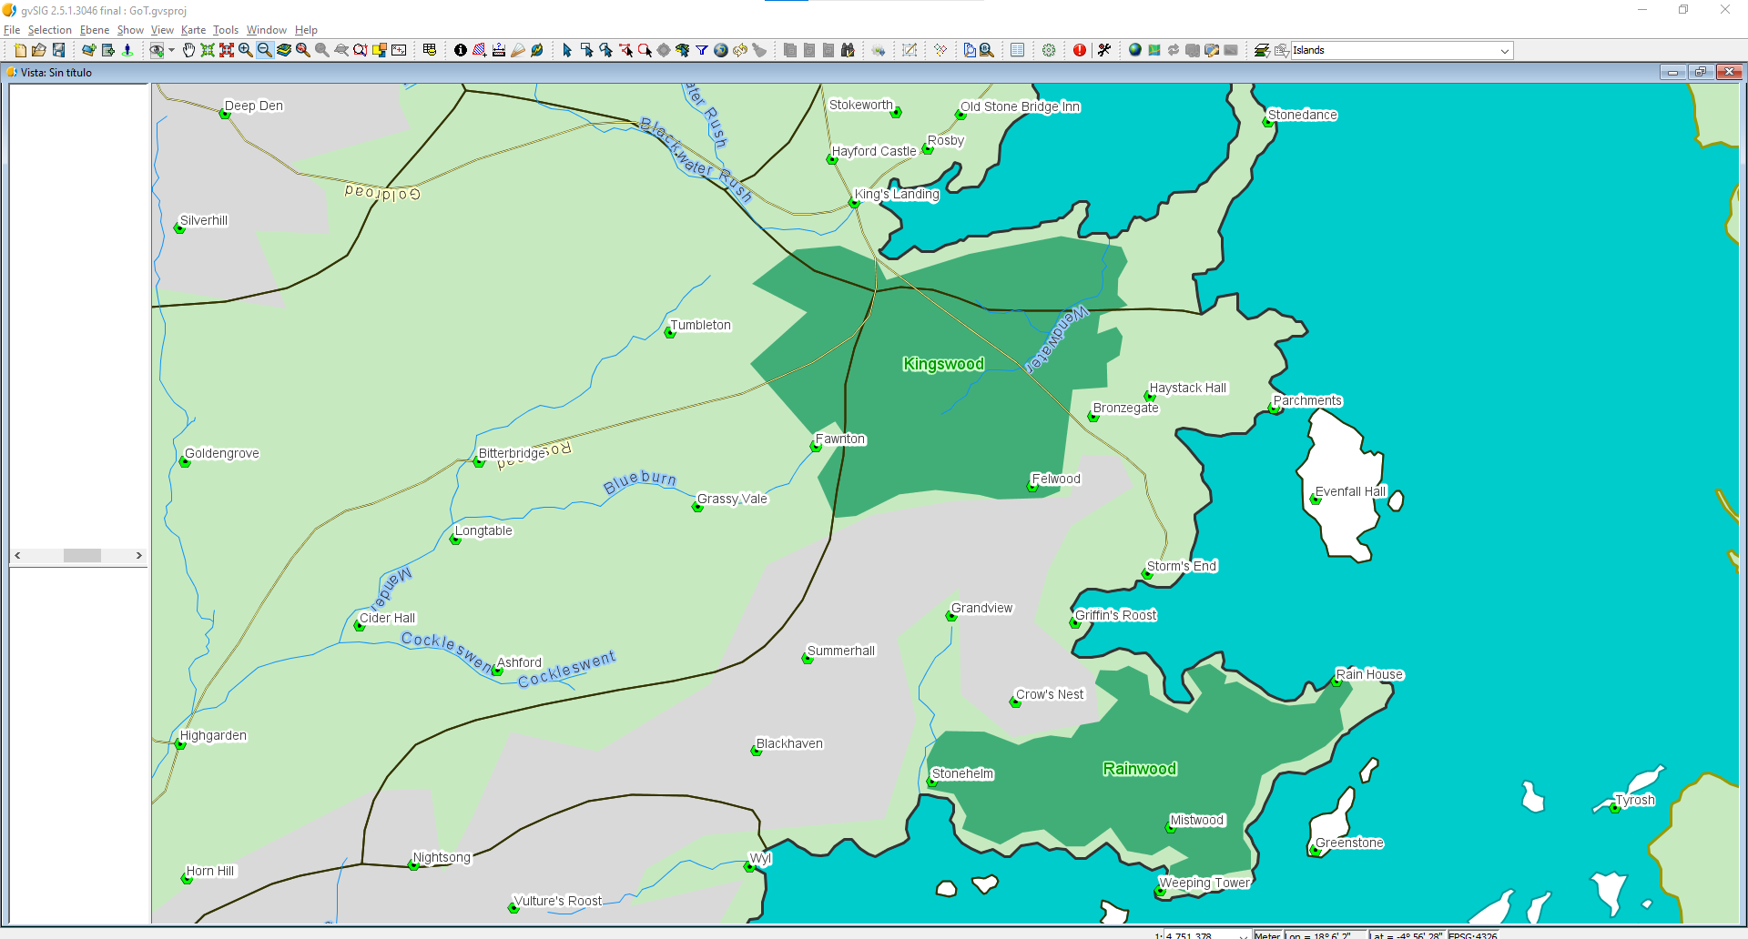 the first column!

