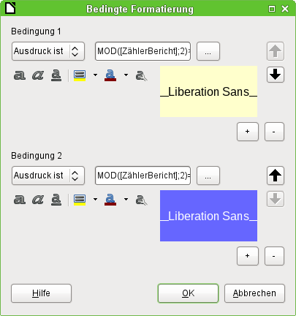
Image is cut at the bottom. Should be shown in the same proportion than the image above.

